**Background**

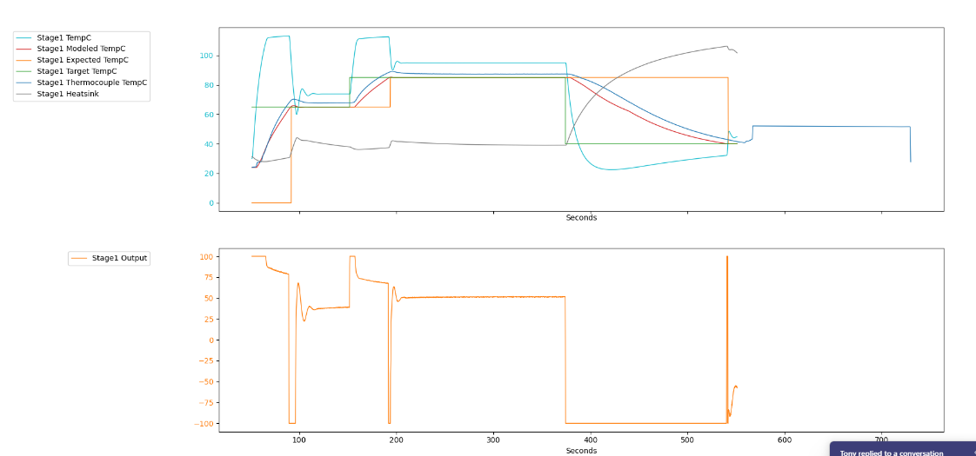The purpose of the treatment chamber in the At-Home PCR test is to treat a person’s saliva sample with Proteinase K (PK), an enzyme that cleaves proteins found in the saliva, like RNases, that may inhibit PCR. The PK is dried inside the treatment chamber and is hydrated by the user’s oral rinse. After the PK is hydrated, it needs to be activated and killed before the sample can be introduced to the PCR reagents. To activate the PK, the sample in the treatment chamber needs to be heated to about 65c for 60 seconds and to kill the PK it needs to reach at least 85c for 2 to 3 minutes.

**Contact Stuff**

The treatment chamber sits on top of an aluminum slug that is meant to transfer heat into the sample. The bottom of the chamber is a thin film that separates the slug from the sample and ideally the film will form around the slug creating uniform contact between the two surfaces. An example of the temperature data from an ideal scenario is shown on the right. A model was designed to control the instrument to the desired temperatures. The thermal model utilizes a modified version of the lumped capacitance heat transfer method along with a Kalman filter to predict the temperature of the sample during the run.

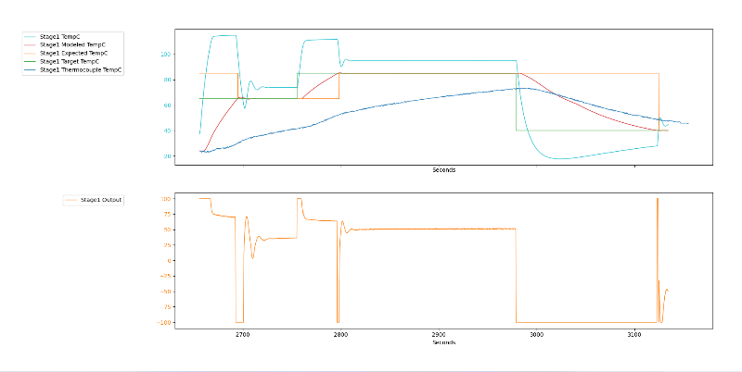 Ideal contact is not always achieved for various reasons. Some potential causes are the vacuum in the chamber fails to equilibrate or the sleeve surrounding the cup absorbs the pressure induced by the cup hold down spring. Examples of temperature data from poor contact scenarios are shown below.

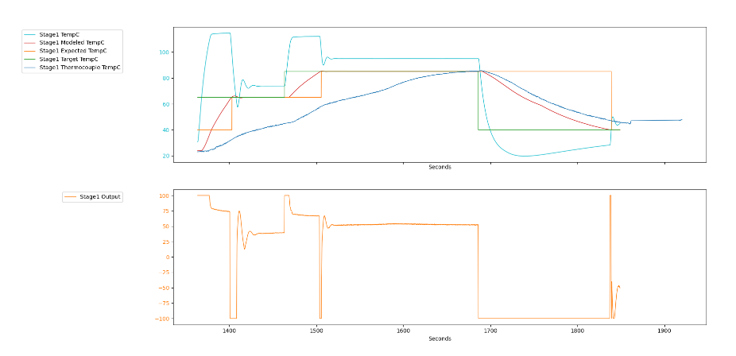

**Difficulty in Measuring**

The current method of collecting temperature data of the sample is to use a thermocouple plunger. To utilize this plunger the user needs to first fill the collection chamber and pop open the treatment chamber by screwing on a typical cap/plunger. Then the typical cap/plunger is removed and the thermocouple plunger is inserted. When this manipulation occurs, the system may not reliably be representative of a typical chemistry run. The volumes of water and air may change which may influence the thermal profile. A short study was performed and it appears that the volume does change while replacing plungers but this study had a small sample size. It was Chart, histogram
also discovered by using a double thermocouple plunger that the treatment chamber sample can have a gradient of up to ~5c

**Initial Insert Stuff**

When the insert was introduced, it appeared to remedy the contact issue by manually pushing the film down against the slug and the thermal data was consistently within 5 degrees of the model (1). It also appeared that while the insert was improving thermal consistency, there was a large variation in insert heights (4.9-5.2), so some inserts were so tall it prevented the PTC to seal consistently. The height was decreased to 4.6mm. Once the 4.6mm inserts were implemented there was an increase in thermal testing failures where the sample temperature was much lower than the model temperature and out of spec.

**Worst Case Scenario Test**

To replicate the results from the failed tests, cups were filled while pushing against the bottom film up into the treatment chamber to simulate the scenario of poor contact. This was done for the taller and shorter inserts to compare, and the data is shown below.

|  |  |  |
| --- | --- | --- |
| Insert height | Normal fill | Worst case fill |
| 4.6 |  |  |
| 5.0 |  |  |

For a normal fill both the 4.6 and the 5.0 inserts show acceptable results. For a worst case fill the 4.6 insert performs very poorly while the 5.0 gets significantly closer to the target. This suggests that the 5.0 insert will perform better than the 4.6 if the cup has not been filled properly.

**Pedestal/Initial testing**

Further testing was needed to determine the optimal insert height. Heights in question were 4.4, 4.6, 5.0, and 5.2mm (2). A fixture was printed to be able to consistently simulate a worst-case fill. The testing was started on V08 and there appeared to be no significant differences between the 4.6 and 5.0 inserts. 5.2 inserts showed slightly improved thermals but did not completely solve the problem. Testing did not proceed on 4.4 inserts because it is not expected for a shorter insert to perform significantly different from 4.6.

**Go Taller**

It was suggested that 5.2mm inserts simply were not tall enough so similar testing was done with 5.4 and 5.7mm inserts. 5.4mm is just shy of being flush with the bottom of the consumable and 5.7 is slightly proud. Both 5.4 and 5.7 had mixed results, with some runs proving to be acceptable while others were as bad as the 5.2 inserts.

**Sleeve Interference**

It was suggested that the sleeve around the cup was taking the pressure from the cup hold down spring and distributing the force along the edge of the cup instead of the sample itself, so a quick test was run comparing the thermal results from a cup with a sleeve and without a sleeve.

Without Sleeve

With Sleeve

The cup without the sleeve performed better than the cup with the sleeve. A possible solution to this is to mill out the deck around the slug so there is more room for the sleeve to be pushed down and the treatment chamber can fit more effectively around the slug.

**Recessed Deck**

Testing was started using the recessed deck to compare 4.6 and 5.0mm inserts but there were multiple deviations from the desired protocol, including failure to use the pedestal fixture 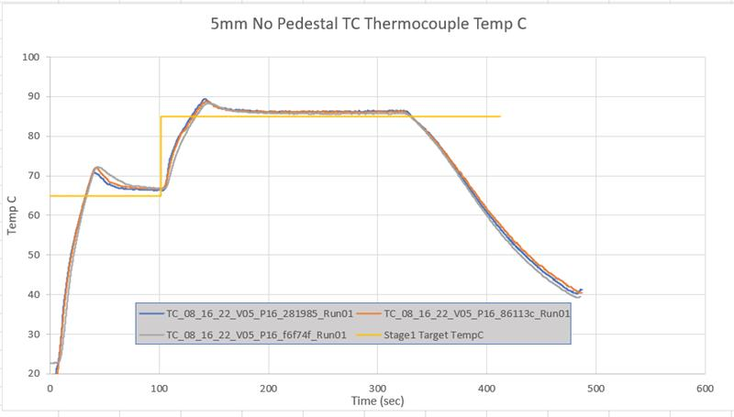and sealing the PTC before the cup was run. The results from these cups look acceptable and consistent but they cannot be compared to previous data where the pedestal was used.

1. <https://codx.sharepoint.com/:f:/s/ACIMaverick/EpzQt_1c5bhFrAGgkb5Xi6QBD4UgNQMuIK03s92VhpImNQ?e=YdbOKa> (original vbuild testing)
2. <https://codx.sharepoint.com/:w:/s/ACIMaverick/EYiatQK76HZNvkxFMuFInEABiNqV5016-eqpVVmSOHxIag> (protocol for 4.4-5.2 inserts w/ pedestal)
3. [8/4/2022 Compare Insert Heights](onenote:https://codx.sharepoint.com/sites/ACIMaverick/SiteAssets/ACI%20Maverick%20Notebook/Instrument%20Experiments/EUA%20Verification.one#8/4/2022%20Compare%20Insert%20Heights&section-id={0A56C02D-E03B-4F86-B8F6-E74C5126FC79}&page-id={B8A50800-6575-47C5-A268-3212F5F29503}&end)  ([Web view](https://codx.sharepoint.com/sites/ACIMaverick/_layouts/OneNote.aspx?id=%2Fsites%2FACIMaverick%2FSiteAssets%2FACI%20Maverick%20Notebook&wd=target%28Instrument%20Experiments%2FEUA%20Verification.one%7C0A56C02D-E03B-4F86-B8F6-E74C5126FC79%2F8%5C%2F4%5C%2F2022%20Compare%20Insert%20Heights%7CB8A50800-6575-47C5-A268-3212F5F29503%2F%29))
4. [8/10/2022 5.2mm insert thermal study](onenote:https://codx.sharepoint.com/sites/ACIMaverick/SiteAssets/ACI%20Maverick%20Notebook/Instrument%20Experiments/EUA%20Verification.one#8/10/2022%205.2mm%20insert%20thermal%20study&section-id={0A56C02D-E03B-4F86-B8F6-E74C5126FC79}&page-id={D175270D-562E-4633-BF13-38CF59552DC0}&end)  ([Web view](https://codx.sharepoint.com/sites/ACIMaverick/_layouts/OneNote.aspx?id=%2Fsites%2FACIMaverick%2FSiteAssets%2FACI%20Maverick%20Notebook&wd=target%28Instrument%20Experiments%2FEUA%20Verification.one%7C0A56C02D-E03B-4F86-B8F6-E74C5126FC79%2F8%5C%2F10%5C%2F2022%205.2mm%20insert%20thermal%20study%7CD175270D-562E-4633-BF13-38CF59552DC0%2F%29))
5. [8/10/2022 5.4mm insert thermal study](onenote:https://codx.sharepoint.com/sites/ACIMaverick/SiteAssets/ACI%20Maverick%20Notebook/Instrument%20Experiments/EUA%20Verification.one#8/10/2022%205.4mm%20insert%20thermal%20study&section-id={0A56C02D-E03B-4F86-B8F6-E74C5126FC79}&page-id={D1E311B1-50A3-4F7A-8712-A6F8FCB89BF6}&end)  ([Web view](https://codx.sharepoint.com/sites/ACIMaverick/_layouts/OneNote.aspx?id=%2Fsites%2FACIMaverick%2FSiteAssets%2FACI%20Maverick%20Notebook&wd=target%28Instrument%20Experiments%2FEUA%20Verification.one%7C0A56C02D-E03B-4F86-B8F6-E74C5126FC79%2F8%5C%2F10%5C%2F2022%205.4mm%20insert%20thermal%20study%7CD1E311B1-50A3-4F7A-8712-A6F8FCB89BF6%2F%29))
6. [8/10/2022 5.7mm insert thermal study](onenote:https://codx.sharepoint.com/sites/ACIMaverick/SiteAssets/ACI%20Maverick%20Notebook/Instrument%20Experiments/EUA%20Verification.one#8/10/2022%205.7mm%20insert%20thermal%20study&section-id={0A56C02D-E03B-4F86-B8F6-E74C5126FC79}&page-id={C55993A3-C0F0-496B-AE0C-B2A672102036}&end)  ([Web view](https://codx.sharepoint.com/sites/ACIMaverick/_layouts/OneNote.aspx?id=%2Fsites%2FACIMaverick%2FSiteAssets%2FACI%20Maverick%20Notebook&wd=target%28Instrument%20Experiments%2FEUA%20Verification.one%7C0A56C02D-E03B-4F86-B8F6-E74C5126FC79%2F8%5C%2F10%5C%2F2022%205.7mm%20insert%20thermal%20study%7CC55993A3-C0F0-496B-AE0C-B2A672102036%2F%29))
7. [8/12/22 Recessed Deck Thermal Study](onenote:https://codx.sharepoint.com/sites/ACIMaverick/SiteAssets/ACI%20Maverick%20Notebook/Instrument%20Experiments/EUA%20Verification.one#8/12/22%20Recessed%20Deck%20Thermal%20Study&section-id={0A56C02D-E03B-4F86-B8F6-E74C5126FC79}&page-id={30DEC662-40D1-4324-8B03-F544E51D96E9}&end)  ([Web view](https://codx.sharepoint.com/sites/ACIMaverick/_layouts/OneNote.aspx?id=%2Fsites%2FACIMaverick%2FSiteAssets%2FACI%20Maverick%20Notebook&wd=target%28Instrument%20Experiments%2FEUA%20Verification.one%7C0A56C02D-E03B-4F86-B8F6-E74C5126FC79%2F8%5C%2F12%5C%2F22%20Recessed%20Deck%20Thermal%20Study%7C30DEC662-40D1-4324-8B03-F544E51D96E9%2F%29))
8. [8/16/22 Recessed Deck Thermal Study, with Pedestal](onenote:https://codx.sharepoint.com/sites/ACIMaverick/SiteAssets/ACI%20Maverick%20Notebook/Instrument%20Experiments/EUA%20Verification.one#8/16/22%20Recessed%20Deck%20Thermal%20Study,%20with%20Pedestal&section-id={0A56C02D-E03B-4F86-B8F6-E74C5126FC79}&page-id={12FDFAC6-3577-4A93-B61A-3512945A0726}&end)  ([Web view](https://codx.sharepoint.com/sites/ACIMaverick/_layouts/OneNote.aspx?id=%2Fsites%2FACIMaverick%2FSiteAssets%2FACI%20Maverick%20Notebook&wd=target%28Instrument%20Experiments%2FEUA%20Verification.one%7C0A56C02D-E03B-4F86-B8F6-E74C5126FC79%2F8%5C%2F16%5C%2F22%20Recessed%20Deck%20Thermal%20Study%2C%20with%20Pedestal%7C12FDFAC6-3577-4A93-B61A-3512945A0726%2F%29))
9. [7/28/2022 Difference in TC Fill with Thermocouple Plunger](onenote:https://codx.sharepoint.com/sites/ACIMaverick/SiteAssets/ACI%20Maverick%20Notebook/Instrument%20Experiments/EUA%20Verification.one#7/28/2022%20Difference%20in%20TC%20Fill%20with%20Thermocouple%20Plunger&section-id={0A56C02D-E03B-4F86-B8F6-E74C5126FC79}&page-id={4242039E-B0EF-4B67-A961-DD163F0DC76C}&end)  ([Web view](https://codx.sharepoint.com/sites/ACIMaverick/_layouts/OneNote.aspx?id=%2Fsites%2FACIMaverick%2FSiteAssets%2FACI%20Maverick%20Notebook&wd=target%28Instrument%20Experiments%2FEUA%20Verification.one%7C0A56C02D-E03B-4F86-B8F6-E74C5126FC79%2F7%5C%2F28%5C%2F2022%20Difference%20in%20TC%20Fill%20with%20Thermocouple%20Plunger%7C4242039E-B0EF-4B67-A961-DD163F0DC76C%2F%29))

* Insert
* Different height insert/pedestal
* Sleeve/deck