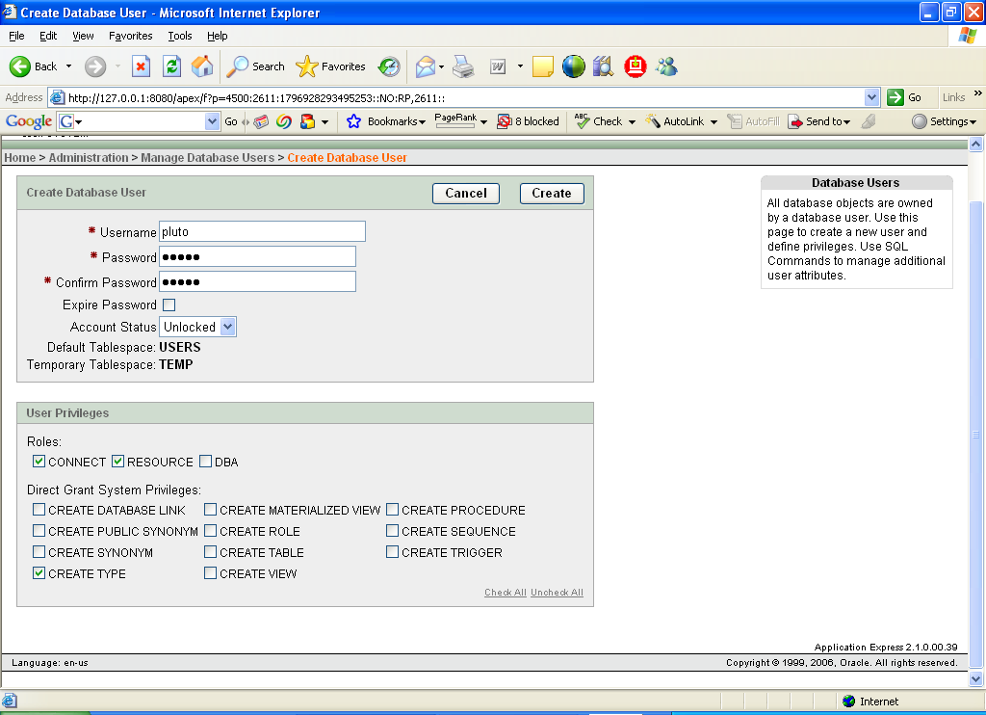

C:\Documents and Settings\jmcadams\workspace\pluto-test-framework>sqlplus pluto/pluto@xe @install.sql

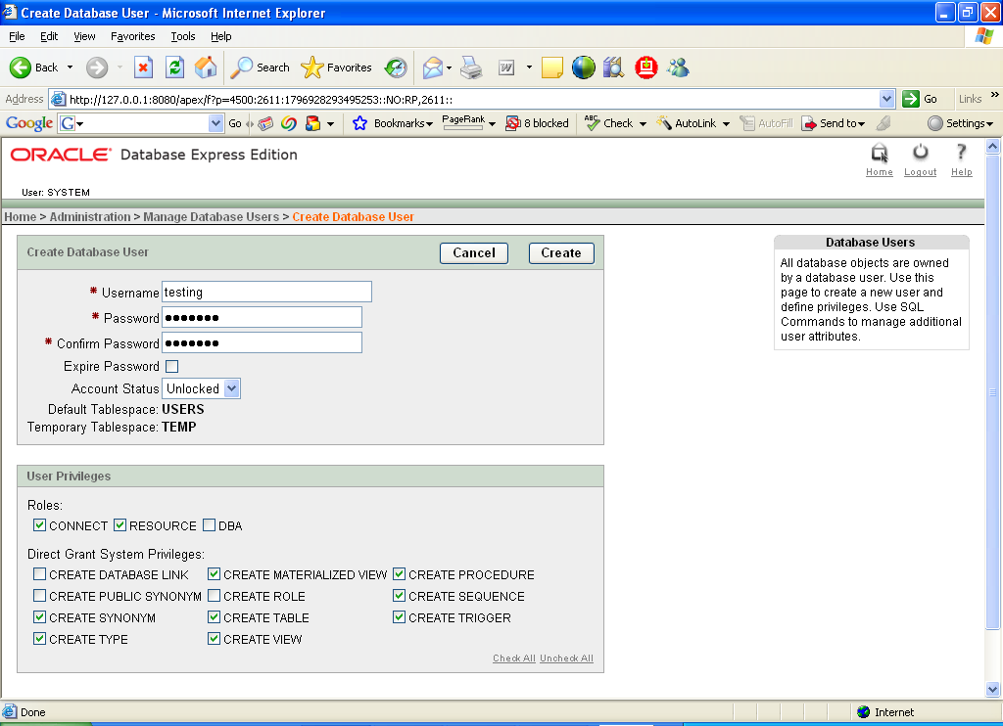

grant execute on pluto_obj to unit_tester;

grant debug on pluto_obj to unit_tester;

