**Bloom**

**By**

**Kevin Hendrix**

**Seven Gun Games**

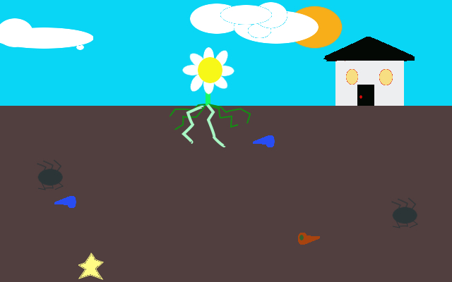

**\*Many elements subject to change\***

**Summary**

Player will control the roots of a flower by tapping/clicking the screen to send a root to that point, where nourishment icons might be water, rich soil, etc. while avoiding chemicals and insects. Draw the path of the roots on screen, when that finger lifts the root will follow the drawn path absorbing any items it comes into contact with until it completes the drawn path when it will begin to retract along the same path.

**Difficulty Settings:**

Difficulty scales by adding flowers that must be fed nutrients in cycles to keep all plants alive, as a plant nears death it looks more and more wilted. Tap/Click a flower to begin controlling that plants roots.

**Gameplay**

Points are accumulated by getting water while at full health or snagging energy at any time. If a root comes into contact with an insect or chemicals then health is lost, if not at full health water does not give points but restore health. Nutrients begin moving across screen faster as play persists. During the day there are more water and energy objects, during the night there are more dangers and the speed of all objects is doubled. Music and aesthetics change with the night cycle to evoke anxiety and panic at break neck speeds, then subdue as night turns to day and music and aesthetics are more subtle and inviting.

**Scope**

Bloom is focused on getting the player from there device home straight to the game and its strength stems from rapid level loading and moderately low play times to accumulate score that are tracked on leaderboards allowing friends to compete with each other and globally.

**Audience**

Low skill floor high skill ceiling allows young and casual gamers to come in and grasp the reigns with an intuitive design as well as more seasoned gamers to survive long enough to yield truly high scores. Additionally, the different difficulty tiers will keep the competition more on par with the player skill level.

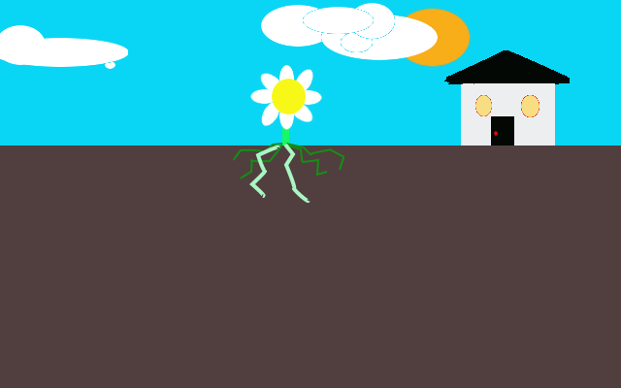

### The Board Items

**The Good Stuff**

### Water

Macintosh HD:Users:kevinhendrix:Desktop:Water.jpg

Properties:

* Mildly transparent, magnifying the images behind them
* Blue/Teal in color, with a light reflection spot

Behaviors:

* Moves from one side of the screen to the next at a sluggish to fast pace, depending on length of level.

Attributes:

* Rewards the player with one point if at full health, otherwise replenishes one health point to flower.

### Energy:

Macintosh HD:Users:kevinhendrix:Desktop:Energy.jpg

Properties:

* A light yellow color, emits an aura as it passes through the screen
* Resembles a star

Behaviors:

* Moves from one side of the screen to the next
* Can switch lanes

Attributes:

* Awards the player with two points regardless of health

**The Bad Stuff**

### Bugs:

Macintosh HD:Users:kevinhendrix:Desktop:Bug.jpg

Properties:

* Black, shiny exoskeleton
* Six Legs, maybe a pair of antennae

Behaviors:

* The bug moves from one side of the screen to the other
* On occasion, the bug will pause to clean itself then continue on its path

Attributes:

* If a root touches the bug, or if a bug runs into a root as it is extending the bug will climb the root to the flower
  + Forcing that root to be stunned temporarily
  + Removes one health point
* Bugs will switch lanes if it encounters a rock
* Bugs will suck water from soft soil
* Bugs will switch lanes and/or directions if a chemical drop touches them at twice speed

### Chemical Waste

Macintosh HD:Users:kevinhendrix:Desktop:Chemical.jpg

Properties:

* Orange/Brown glints shaped like water but with a green spot (re-skinned)
* Clouds and distorts images behind it as it passes

Behaviors:

* Moves from one side of the screen to the other
* Pace is dependent on length of play time

Attributes:

* Will remove two health points from the player
  + Stuns both roots temporarily
* If a chemical drop encounters a water drop, the water drop will become a chemical drop
  + Both drops continue path uninterrupted

# Obstacles

### Stones:

Macintosh HD:Users:kevinhendrix:Desktop:Stone.jpg

Properties:

* Grey in color, rounded and jagged edges

Behaviors:

* The rock is a stationary object; it remains where it is spawned during the random generated level.

Attributes:

* These will cause a bug to move to a different lane either above the stone or below it.
* Water will be destroyed.
* Energy will be destroyed.
* Chemical will be destroyed.
* Roots cannot pass a stone.

### Soft Soil:



* Bugs:
  + Ignore soft soil, unless it has water or chemicals in it:
    - Water: the bug pauses to drink the water, and then goes back the way it came.
    - Chemical: the bug will randomly switch lanes and directions at twice speed.
* Water
  + Is absorbed by soft soil, two consecutive waters releases an energy pick-up.
* Chemicals
  + Will be absorbed by soft soil
  + Two consecutive chemical drops create a stone.
* Roots
  + Pass through soft soil, unless:
    - The soft soil has a water drop, in which case the protocol for water drop is followed
    - The soft soil has a chemical drop stored, in which case the protocol for chemical drop is followed.

**Game Board:**

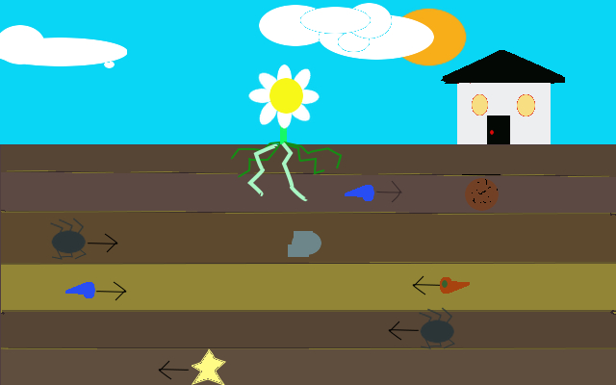

### Day/Night Phases

The game cycles from day to night to offer a change of pace to the game play as well as aesthetics.

Day Time:

* Objects move at regular speed, dictated by length of play time
* Color pallet is bright
* Style is water color
* Music is slow paced ambient

Night Time:

* Objects move at set speed x.5
* Color pallet is Fluorescent
* Style is Comic book
* Music is fast paced, anxiety evoking noises
* Certain Objects strobe fast others blink slow

The cycling of day/night also offers an engaging dynamic where the player will see the sun going down and begin to anticipate the coming darkness and get pumped for the intensified music and gameplay elements. Then, from night to day the player is let down slowly back into the safety of the light. These are a vague boss for this game.

**Flower Health Phases:**

The flower has a total of eight pedals, each indicate a single health point. When the flower receives damage from chemicals or insects, pedals are removed from the flower while the remaining pedals color fades darker (every two pedals lost results in a color fade). See *The Board Pieces* to see what increments health positively or negatively.

**Flower Health Storyboard**

