Architectural Review Checklist

caCORE API
4.0

Revision Document History
Date | Version | Description | Author
3/26/2007 | 1.0 | First draft | Doug Mason

Table of Contents

1. Introduction 6
Purpose 6
Guidelines for Completing the ARC 6
2. Project Details (To be answered by development team) 6
General Information 6
Project Description 6
Contact Information 6
Major Deployment Milestones 6
Architectural Details 7
High level architectural description: 7
High Level Design Diagram (If available): 7
Implementation language(s) used? 7
Will connections/requests to the application be session based (i.e. statefull versus stateless)? If so, is there any reason why application would not support “sticky session” load balancing? 7
Will the application be caching data? If so, what is being cached and how much data will be cached? 7
What data files will be created (if any)? How much data will be saved on an on going basis? 7
Will this application need a database schema(s) created on the NCICB infrastructure? If so, what is the maximum number of objects to be stored? 7
Are there any external/non-NCICB data sources that will be accessed by the application? 7
If this is a web-based application, what are the preferred virtual hosts names to be registered? 7
Any additional architectural details that may be of significance to the needed deployment environment. 7
Performance Requirements 8
Total number of users for this application? 8
Peak number of concurrent users? 8
Peak number of requests/minute? 8
Up time requirements? 8
Acceptable down time when recovering from major systems disaster? 8
NCICB Project Dependencies 8
Configuration Management Details 8
Version Control 8
Change Control 8
Migration to CVS 8
Users 8
Build Process 8
Other CM Needs 8
Additional Notes 8
3. System Requirements (To be answered by both development & systems team) 9
Operating System 9
<<Solaris/LINUX/Windows 2000/…>> 9
Software (Technology Stack) 9
Web Server: <<Apache/Tomcat/ZOPE/…>> 9
App Server: <<Tomcat/JBoss/Oracle 9iAS/…>> 9
Database Server: <<Oracle/MySQL/PostgreSQL/…>> 9
Other software components: <<PERL x.x, Python x.x, …>> 9
Server Hardware 9
Server: <<type, model, …>> 9
Minimum processor speed: 9
Minimum memory: 9
Minimum local drive space: 9
Storage 9
Expected file server disk storage (in MB): 9
Expected database storage (in MB): 9
Expected ftp storage (in MB): 9
Expected media/image storage (in MB): 9
Load Balancing/Fault Tolerance 9
Does the application support load balancing? 9
Implement load balancing – YES/NO 9
Networking 9
Any application specific port assignments? 9
Any additional configuration? 9
Additional Notes 9
4. Proposed NCICB Deployment Environment (To be answered by systems team) 9
Hardware 9
Technology Stack 10
File Server 10
Database 10
Networking 10
Other Resources 10
5. Impact Assessment (To be answered by systems team) 10
Overview 10
Cost 10
Timeline to implement 10
Additional Notes 10
6. Acceptance 10
7. Appendix 1 - Future Systems Requirements 11
New Architecture Diagram 11
Notes on the design change 11
Hardware 11
Servers 11
Processor speed 11
Memory 11
Drive Space 11
Software (Technology Stack) 11
Web Server 11
App Server 11
Other components 11
Fault Tolerance (Redundancy) 11
Does the application support load balancing? 11
Implement load balancing – YES/NO 11
Load balancing requirements 11
Fault tolerance solution suggested 11
Additional requirements (if any) 11
Performance Enhancements 11
Processing Power 11
Memory 11
I/O 11
Other needs 11

Introduction

Purpose
The purpose of the Architectural Review Checklist (ARC) is to help identify the deployment environment (both hardware and software components) necessary for an application to execute optimally within the NCICB IT infrastructure. The ARC is considered to be a dynamic artifact for any NCICB project and should be maintained in the configuration library (i.e. CVS) for each project. For new projects, this document template will be automatically checked into the projects repository by the SCM team upon project initiation. The ARC should be reviewed on at least a quarterly basis to capture any application design changes that may effect the deployment environment necessary for optimal performance.

Guidelines for Completing the ARC
The ARC is divided into 4 main sections. The first section (Project Details) is meant to capture general information about the project. The project development team should fill out the Project Details section and return it to the systems team. The second section (Systems Requirements) is meant to capture details of specific system requirements for the project. Both the development and system teams will preferably answer the Systems Requirement section jointly. However, depending on the development teams familiarity with the NCICB infrastructure, they may choose to answer either all or parts of this section on their own. The third section (Planned Deployment Environment) specifies the proposed deployment environment for the application and is to be answered by the systems team based on the response to section 1 & 2. Finally, the last section (Impact Assessment) describes the impact (additional hardware/software costs, staffing resources…) to the existing NCICB IT infrastructure in order to support this application. Upon completion of the Deployment Environment and Impact Assessment sections, the systems team will return the ARC to the development team for final review and comments.

Project Details (To be answered by development team)

General Information

Project Description
The NCICB Core Infrastructure provides the building blocks needed to develop interoperable cancer information management systems. caCORE is the central element of this Infrastructure. The API provides programmatic interfaces to EVS, caDSR, and caBIO data repositories.

Contact Information
Title | Name | Phone | Email
Project Manager | Avinash Shanbhag (caCORE API) | 301.496.4034 | shanbhagk@mail.nih.gov
 | Denise Warzel (caDSR / caCORE Release Manager) | 303.722.9446 | warzeld@mail.nih.gov
 | Frank Hartel (EVS) | 301.435.3869 | hartel@mail.nih.gov
 | Juli Klemm (caBIO) | 978.443.2431 | klemmj@mail.nih.gov
Team Lead/Architect | Doug Mason | 301.594.4744 | masondo@mail.nih.gov
SCM Coordinator | Doug Kanoza | 301.496.0268 | kanozad@mail.nih.gov

Major Deployment Milestones
Milestone | Date
Planned Release to QA | TBD
Planned Release to Staging | TBD
Planned Release to Production | TBD

Architectural Details

High level architectural description:
The caCORE infrastructure exhibits an n-tiered architecture with client interfaces, server components, backend objects, data sources, and additional backend systems (Figure 1.1). This n-tiered system divides tasks or requests among different servers and data stores. This isolates the client from the details of where and how data is retrieved from different data stores.

The system also performs common tasks such as logging and provides a level of security. Clients (browsers, applications) receive information from backend objects. Java applications also communicate with backend objects via domain objects packaged within the client.jar. Non-Java applications can communicate via SOAP (Simple Object Access Protocol). Back-end objects communicate directly with data sources, either relational databases (using Hibernate) or non-relational systems, such as EVS LexBIG’s API.

Most of the caCORE infrastructure is written in the Java programming language and leverages reusable, third-party components. The infrastructure is composed of the following layers:

The Application Service layer—consolidates incoming requests from the various interfaces and translates them to native query requests that are then passed to the data layers. This layer is also responsible for handling client authentication and access control using the Java API. (This feature is currently disabled for the caCORE system running at NCICB; all interfaces provide full, anonymous read-only access to all data.)
The Data Source Delegation layer—is responsible for conveying each query that it receives to the respective data source that can perform the query. The presence of this layer enables multiple data sources to be exposed by a single running instance of a caCORE server.
Object-Relational Mapping (ORM)— is implemented using Hibernate. Hibernate is a high performance object/relational persistence and query service for Java. Hibernate provides the ability to develop persistent classes following common object-oriented (OO) design methodologies such as association, inheritance, polymorphism, and com-position. The Hibernate Query Language (hql), designed as a "minimal" object-oriented extension to SQL, provides a bridge between the object and relational databases. Hibernate allows for real world modeling of biological entities without creating complete SQL-based queries to represent them. Access to non-relational (non-ORM data sources), such as Enterprise Vocabulary Services (EVS), is performed by objects that follow the façade design pattern. These objects make the task of accessing a large number of modules/functions much simpler by providing an additional interface layer that allows it to interact with the rest of the caCORE system.

Security is provided by the Common Security Module (CSM). The CSM provides highly granular access control and authorization schemes

High Level Design Diagram:
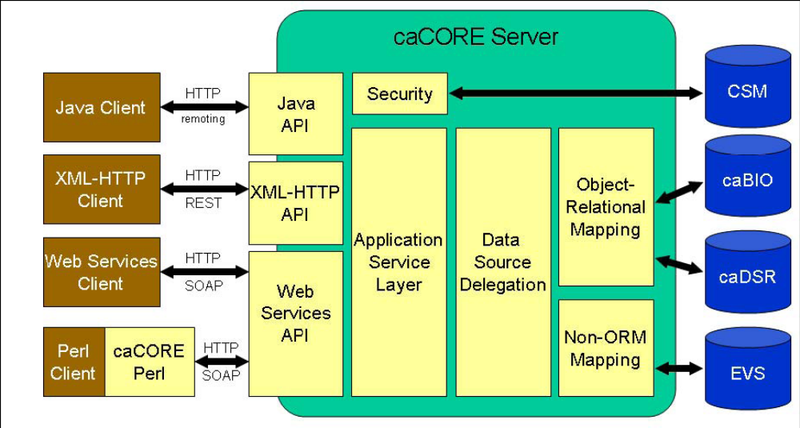

Figure 1.1: Overview of the caCORE Architecture

Implementation language(s) used:
The caCORE Server is 100% Java, using J2EE technologies. Client access is provided by the Java API, LexBIG distributed interface (Java), Web Services, REST interface, and finally CaCORE Perl (Perl programming language)

Will connections/requests to the application be session based (i.e. statefull versus stateless)? The caCORE API is a stateless server (NOTE: The CSM provides a “near” stateful implementation. But this functionality is not used in the caCORE API.)

Will the application be caching data? If so, what is being cached and how much data will be cached? Yes, the caCORE implements a cache mechanism. caCORE uses EHCache (integrated with Hibernate) for all queries. In addition, EVS uses a similar mechanism in caching results from LexBIG (TDB, need to evalutate in the 4.0 release.) Both caches are disk based; time bound; size bound.

What data files will be created (if any)? How much data will be saved on an on going basis?
The caCORE uses /local/content to store configuration files and indexes files (Lucent.) The EVS API will use ~150GB to store the required indexes for all the provided vocabularies. In addition, caBIO will provide a text based search in the 4.0 release. This search mechanism also uses Lucene indexes. The approx size is also 150GB (NOTE: TBD, sizing is only an est. Need to refine)

In addition, the caCORE uses the JBoss log directory for logging.

Will this application need a database schema(s) created on the NCICB infrastructure? If so, what is the maximum number of objects to be stored?
caBIO - 67 GB
caDSR - 8 GB
EVS / LexBIG - 75 GB

Are there any external/non-NCICB data sources that will be accessed by the application?
Data is retrieved from external sources, processed and stored locally. Currently, all accesses are made to local data stores.

If this is a web-based application, what are the preferred virtual hosts names to be registered?
cabio.nci.nih.gov/cacore40 (NOTE: need to evaluate.)

Any additional architectural details that may be of significance to the needed deployment environment.
The caCORE search API and LexBIG install both use external Lucene index files (as describe previously. It is important that the indexes are located on a fast local drive (or FAST SANs drive.)

Performance Requirements

Total number of users for this application?
400

Peak number of concurrent users?
50

Peak number of requests/minute?
50

Up time requirements?
24x7 (TBD)

Acceptable down time when recovering from major systems disaster?
2 hrs

NCICB Project Dependencies
The 4.0 caCORE API does not depend on external resources or servers. The caCORE API does depend on the latest version of the caCORE SDK.

Configuration Management Details

Version Control
The caCORE API is currently using cvs. The code is in the following repository: cacoresystem.

Change Control
All production change request go through the CCG. The one exception is the caBIO data refreshes.

Migration to CVS
No change required.

Users
No change required.

Build Process
The caCORE API makes use of the caCORE SDK. The following steps explain the process of checking out and build the caCORE API / SDK system (Example using MS windows terminology. Same general process is used for Unix builds.)

- Check out the cacoresdk and cacoresystem to separate repositories:
  - cvs –d pserver:<user>@biocvs2.nci.nih.gov:/share/content/cvsroot checkout -P – cacoresystem
  - cvs –d pserver:<user>@biocvs2.nci.nih.gov:/share/content/cvsoot checkout -P – cacoresdk

You should now have something like:
C:\workspace\cacoresdk
C:\workspace\cacoresystem

- If you directory structure does not match the above, you many need to modify the build.xml file. Inside the cacoresystem directory,

  - Set the basedir attribute of the project element to the path where the cacoresdk module is located (e.g. c:/<my install>/cacoresdk)

  - Set the value attribute of the property cacore_home element to the path where the cacoresystem module is located (e.g. c:/<my install>/cacoresystem)

- Open a command prompt window, change to the cacoresystem directory and type ant build-system to generate the war file

- The server war file, client jar file and a sample client will be generated and placed in the output directory under cacoresystem (e.g., c:\workspace\cacoresystem\output)

Other CM Needs
No.

Additional Notes

System Requirements

Operating System

The caCORE API system deployment is system agnostic.

Software (Technology Stack)

Web Server: Apache

App Server: JBoss 4.0.5

Database Server:
caBIO – Oracle (ORM1)
caDSR – Oracle (ORM2)
EVS / LexBIG - MySQL

Other software components: <<PERL x.x, Python x.x, …>>

Server Hardware

Server: <<type, model, …>>

Minimum processor speed:

Minimum memory:

Minimum local drive space:

Storage

Expected file server disk storage (in MB):
EVS / LexBIG – 150GB
caCORE Search API – 130GB (TBD)

Expected database storage (in MB):
caBIO - 67 GB
caDSR - 8 GB
EVS / LexBIG - 75 GB

Expected ftp storage (in MB):
0 MG

Expected media/image storage (in MB):

Load Balancing/Fault Tolerance

Does the application support load balancing?
No

Implement load balancing – No

Networking

Any application specific port assignments?

Any additional configuration?

Additional Notes

Proposed NCICB Deployment Environment (To be answered by systems team)

Hardware
<<dev, qa, staging, production servers to be used>>

Technology Stack
<<specific technology stack to be used>>

File Server
<<space allocation on big IP, NFS mount points, initial size allocation…>>

Database
<<database server to used, schema names to be created, initial size, maximum size…>>

Networking
<<e.g. any BigIP configuration necessary, …>>

Other Resources
<<e.g. ftp server access, media server access, …>>

Impact Assessment (To be answered by systems team)

Overview

Cost

Timeline to implement

Additional Notes

Acceptance
Project Lead ( ) | Project Coordinator – NCICB ( )
Systems Team | SCM Administrator

Appendix 1 - Future Systems Requirements
In this section, describe any projected future anticipated requirements for your system.

New Architecture Diagram

Notes on the design change

Hardware

Servers

Processor speed

Memory

Drive Space

Software (Technology Stack)

Web Server

App Server

Other components

Fault Tolerance (Redundancy)

Does the application support load balancing?

Implement load balancing – YES/NO

Load balancing requirements

Fault tolerance solution suggested

Additional requirements (if any)

Performance Enhancements

Processing Power

Memory

I/O

Other needs

