CHAPTER 1

INTRODUCTION
Students today have access to a wide range of educational and career opportunities such as scholarships, internships, certification courses, hackathons, workshops, competitions, and placement opportunities. However, information about these opportunities is distributed across numerous websites, social media platforms, institutional portals, and other online sources. Students are therefore required to search through multiple platforms to identify opportunities that are relevant to their academic background, skills, interests, and eligibility.
The scattered nature of opportunity information creates several difficulties. Students may spend considerable time searching for suitable opportunities, miss important application deadlines, or fail to discover opportunities that match their profiles. In addition, manually checking eligibility requirements for every opportunity can be time-consuming. There is a need for a centralized platform that can organize opportunity information and provide students with relevant recommendations based on their individual profiles.
To address these challenges, EduConnect – Unified Student Opportunity Platform is proposed as a centralized web application for discovering and managing educational and career opportunities. The platform brings different categories of opportunities together in a single system and allows students to create academic profiles containing information such as department, year of study, CGPA, skills, interests, and other eligibility-related details.
EduConnect provides personalized recommendations by comparing student profile information with opportunity eligibility criteria. Students can search and filter opportunities, view detailed information, bookmark opportunities for later reference, track their applications, and receive deadline reminders and notifications. An administrator dashboard enables authorized administrators to manage opportunity information through manual entry, CSV import, or API integration. Web scraping may be considered as a future enhancement for automating opportunity collection.
The proposed application is designed using React.js, Node.js, Express.js, MongoDB, and Firebase Authentication, providing a scalable web-based architecture with secure user authentication and centralized data management. The system consists primarily of student and administrator modules and aims to simplify the process of discovering, evaluating, and tracking opportunities.

1.1 Project Overview
EduConnect is a centralized web application designed to provide students with a unified platform for discovering educational and career-related opportunities. Instead of requiring students to visit multiple websites separately, the system organizes different opportunity types within a single platform. The major opportunity categories supported by EduConnect include:
- Scholarships
- Internships
- Certification courses
- Hackathons
- Workshops
- Competitions
- Placement opportunities
Students can register and create their profiles by providing relevant academic and personal information. The profile information is used by the recommendation and eligibility modules to identify opportunities that are suitable for the student.
The system allows students to browse available opportunities and apply filters according to factors such as opportunity type, eligibility requirements, deadline, department, skills, and other relevant attributes. Students can bookmark opportunities that they are interested in and maintain an application-tracking record.
A personalized recommendation mechanism is included to reduce the effort required to manually search through all available opportunities. The recommendation process considers information such as the student's department, year of study, CGPA, skills, interests, and eligibility criteria associated with opportunities.
The administrator module provides centralized management of opportunity data. Administrators can add, update, and remove opportunities and can populate the platform through manual entry, CSV import, or API integration. This provides flexibility in maintaining the opportunity database.
The system also provides deadline reminders and notifications so that students can keep track of important application dates. Through these features, EduConnect aims to make the discovery and management of educational and career opportunities more organized and accessible.

1.2 System Requirements
This section specifies the hardware and software requirements required for developing, testing, and deploying the EduConnect web application.
1.2.1 Hardware Requirements
Component | Minimum Specification | Recommended Specification
Processor | Intel Core i3 / AMD Ryzen 3 | Intel Core i5 or above / AMD Ryzen 5 or above
RAM | 4 GB | 8 GB or above
Storage | 10 GB free space | 20 GB or above
Display | 1366 × 768 | 1920 × 1080 Full HD
Internet | Required for development and deployment | Stable broadband connection
Operating System | Windows 10 / Linux / macOS | Windows 11 / latest supported Linux / macOS

1.2.2 Software Requirements
Software / Technology | Requirement
React.js | Current project-supported version
Node.js | Current LTS version
Express.js | Current project-supported version
MongoDB | Current supported version
Firebase Authentication | Firebase service
Web Browser | Chrome / Edge / Firefox
Visual Studio Code | Current version
Git | Current version
npm | Bundled with Node.js

1.3 Technology Overview
EduConnect uses a modern web development stack consisting of React.js, Node.js, Express.js, MongoDB, and Firebase Authentication. Each technology contributes to a specific layer of the application and supports the overall goal of creating a centralized and scalable student opportunity platform.

1.3.1 React.js
React.js is used to develop the front-end of EduConnect. It enables the application interface to be divided into reusable components, making the user interface modular and easier to maintain.
React.js is used for implementing major screens such as the login and registration pages, student dashboard, opportunity listing page, opportunity details page, bookmarks, application tracking, profile management, and administrator dashboard.
The component-based structure also allows common interface elements such as navigation bars, opportunity cards, filters, buttons, and notification components to be reused throughout the application.

1.3.2 Node.js
Node.js provides the runtime environment for the server-side portion of EduConnect. It allows JavaScript to be executed on the backend and supports the development of APIs required for communication between the front-end and database.
The backend is responsible for processing requests from the React.js application, validating data, managing opportunity information, handling application records, and communicating with MongoDB.

1.3.3 Express.js
Express.js is used as the backend web framework for developing RESTful APIs. It provides a structured mechanism for defining routes and processing HTTP requests. In EduConnect, Express.js can be used to provide APIs for:
- User-related operations
- Opportunity management
- Opportunity searching and filtering
- Bookmark management
- Application tracking
- Student profile management
- Recommendation-related operations
- Administrator operations
The use of a REST-based backend separates the presentation layer from the application logic and database layer.

1.3.4 MongoDB
MongoDB is used as the primary database for storing EduConnect data. It is a NoSQL document-oriented database that is suitable for storing different types of opportunity information. The database can store information such as student profiles, opportunities, eligibility criteria, bookmarks, applications, and notification-related data.
The flexible document structure of MongoDB is useful because different opportunity categories may contain different attributes. For example, a scholarship may contain information about scholarship amount and academic eligibility, whereas an internship may include duration, skills, and organization details.

1.3.5 Firebase Authentication
Firebase Authentication provides the authentication mechanism for EduConnect. It allows users to register and log in securely without requiring the application to implement its own password-management system.
Authentication can be used to distinguish between different users and provide appropriate access to student and administrator functionality. Students can access their profiles, bookmarks, recommendations, and application records after authentication, while administrator functionality can be restricted to authorized administrator accounts.

1.3.6 Notification and Reminder Mechanism
EduConnect includes deadline reminders and notifications as part of its student-support functionality. These features are intended to help students remain aware of approaching application deadlines.
The notification mechanism can use stored opportunity deadlines and application information to identify relevant reminders for students. This reduces the possibility of students overlooking important deadlines.

1.3.7 Recommendation and Eligibility Module
The recommendation module is one of the major components of EduConnect. It uses information available in the student's profile and compares it with opportunity requirements. Relevant profile attributes include:
- Department
- Year of study
- CGPA
- Skills
- Interests
- Eligibility information
The system can identify opportunities for which the student satisfies the available eligibility requirements and present relevant opportunities through the student dashboard.
The recommendation mechanism is intended to reduce the amount of manual searching required from students and make the opportunity discovery process more personalized.

1.4 Architectural Concepts and Framework
EduConnect follows a client-server web application architecture. The React.js front-end communicates with the Node.js and Express.js backend through APIs. The backend processes application requests and interacts with MongoDB for persistent data storage.
Firebase Authentication provides the authentication service, while the database stores application-specific information such as student profiles, opportunities, bookmarks, and application records.
The major architectural layers are:

1.4.1 Client Layer
The client layer consists of the React.js application through which students and administrators interact with EduConnect. The student interface provides access to:
- Dashboard
- Opportunity search
- Filters
- Opportunity details
- Recommendations
- Bookmarks
- Application tracking
- Profile management
- Notifications
The administrator interface provides access to opportunity management and related administrative functions.

1.4.2 Backend Layer
The backend layer is implemented using Node.js and Express.js. It acts as the intermediary between the React.js front-end and MongoDB database.
The backend handles requests such as retrieving opportunities, filtering records, creating application records, updating bookmarks, and managing opportunity data.
This separation allows application logic to be maintained independently of the user interface.

1.4.3 Data Layer
MongoDB acts as the primary persistent data layer. It stores the information required by different modules of the application.
The major data categories include:
- Student profiles
- Opportunities
- Bookmarked opportunities
- Application records
- Notification and reminder information
The database design is intended to support efficient retrieval of opportunities and user-specific information.

1.4.4 Authentication and Access Control
Firebase Authentication provides the identity-management mechanism. After successful authentication, the application identifies the logged-in user and provides access to the corresponding functionality.
Role-based access can be applied to distinguish between student and administrator accounts. Student users are provided with opportunity discovery and tracking functionality, while administrators are provided with opportunity-management capabilities.

CHAPTER 2

SYSTEM ANALYSIS
System analysis is the process of studying the existing problem, identifying limitations, defining the requirements, and determining the features necessary for the proposed system. This chapter analyzes the existing methods used by students to discover opportunities and presents the proposed EduConnect system along with its functional and non-functional requirements.

2.1 Existing System
Currently, students use multiple independent sources to discover scholarships, internships, certification courses, hackathons, workshops, competitions, and placement opportunities. Information may be available through institutional websites, company websites, scholarship portals, learning platforms, social media, and other opportunity websites.
Since these sources operate independently, students are required to search multiple platforms to find opportunities relevant to their academic profile and interests. The existing approach generally involves manually searching for an opportunity, opening its website, reading its eligibility requirements, checking the deadline, and separately maintaining information about opportunities that the student intends to apply for.

2.1.1 Drawbacks of the Existing System
Drawback | Impact on Student
Information distributed across multiple platforms | Students spend more time searching
No centralized opportunity database | Difficult to discover opportunities in one place
Manual eligibility checking | Students must individually verify requirements
Lack of personalized recommendations | Relevant opportunities may be overlooked
Deadlines spread across different websites | Students may miss application deadlines
No unified bookmarking system | Students must maintain opportunities separately
No centralized application tracking | Difficult to monitor application progress
Different interfaces and search methods | Opportunity discovery becomes inconsistent
The existing approach therefore creates a need for a centralized platform capable of collecting, organizing, filtering, and presenting opportunity information in a student-friendly manner.

2.2 Proposed System
EduConnect is proposed as a centralized web application that integrates educational and career opportunities into a single platform.
The proposed system allows students to register and create academic profiles containing information such as department, year of study, CGPA, skills, and interests. The platform uses this information to provide personalized recommendations and eligibility-based opportunity discovery. Students can search and filter opportunities according to their requirements. Each opportunity provides relevant information such as title, organization, category, eligibility criteria, deadline, and application details.
The system also allows students to bookmark opportunities and track their applications. Deadline reminders and notifications help students monitor important dates. An administrator dashboard is provided for maintaining opportunity information. Administrators can enter opportunities manually or use CSV import and API integration. Web scraping is considered as a possible future enhancement for automatically collecting information from external websites.

2.2.1 Advantages of the Proposed System
- Centralized opportunity platform — provides access to scholarships, internships, certification courses, hackathons, workshops, competitions, and placement opportunities in one platform
- Personalized recommendations — suggests relevant opportunities based on the student’s academic profile, skills, interests, and eligibility
- Eligibility-based matching — helps students identify opportunities that match their academic and eligibility requirements
- Advanced search and filtering — enables students to quickly find opportunities based on category, skills, eligibility, and other relevant criteria
- Opportunity bookmarking — allows students to save interesting opportunities for future reference
- Application tracking — helps students maintain and monitor the status of their applications in one place
- Deadline reminders and notifications — alerts students about important deadlines and relevant opportunity updates
- Student profile management — allows students to maintain their academic details, skills, interests, and other profile information
- Administrator dashboard — enables administrators to efficiently manage and maintain opportunity-related data
- Manual opportunity management — allows administrators to add, update, and remove opportunity details manually
- CSV-based opportunity import — supports bulk addition of opportunity data through CSV files, reducing manual data entry
- API-based integration — allows opportunity data to be integrated from external sources through APIs
- Scalable web-based architecture — supports the addition of more users, opportunities, and features while allowing the system to be extended with minimal changes to the existing architecture

2.3 Functional Requirements
Functional requirements define the operations and services that EduConnect must provide.

User Registration and Authentication
- Students should be able to register for an account.
- Students should be able to log in using their registered credentials.
- The system should authenticate users securely.
- The system should provide appropriate access according to the user's role.

Student Profile Management
- Students should be able to create their academic profiles.
- Students should be able to update their department.
- Students should be able to specify their year of study.
- Students should be able to provide their CGPA.
- Students should be able to add their skills.
- Students should be able to specify their interests.
- Students should be able to update profile information when required.

Opportunity Management
- The system should display available opportunities.
- Opportunities should be organized according to their categories.
- Students should be able to view complete opportunity details.
- Administrators should be able to add new opportunities.
- Administrators should be able to update existing opportunities.
- Administrators should be able to remove outdated opportunities.
- Administrators should be able to import opportunity information using CSV files.
- The system should support API-based opportunity integration.

Search and Filtering
Students should be able to search for opportunities based on keywords and apply filters according to relevant attributes such as opportunity category, eligibility, deadline, skills, or other available criteria.

Personalized Recommendations
The recommendation module should compare student profile information with opportunity requirements and identify opportunities relevant to the student's academic background, skills, interests, and eligibility.

Eligibility Checking
The system should provide eligibility-related information for opportunities and compare available eligibility criteria with student profile information wherever sufficient data is available.

Bookmark Management
- Students should be able to bookmark opportunities.
- Students should be able to view their bookmarked opportunities.
- Students should be able to remove opportunities from their bookmarks.

Application Tracking
Students should be able to maintain records of opportunities they have applied for. The system should allow students to track the status of their applications.

Notifications and Deadline Reminders
The system should identify important opportunity deadlines and provide reminders or notifications to students so that they can take action before deadlines expire.

Administrator Dashboard
The administrator dashboard should allow authorized administrators to:
- Manage opportunity records
- Add opportunities
- Edit opportunities
- Delete opportunities
- Import opportunity data
- Monitor opportunity information
- Maintain the centralized opportunity database

2.4 Non-Functional Requirements
Non-functional requirements define the quality attributes and operational constraints of the EduConnect system.

Performance : The application should provide responsive interaction while loading opportunities, searching, filtering, and retrieving student-specific information.

Security : User authentication should be handled securely using Firebase Authentication. Student-specific information and application records should only be accessible to authorized users.

Usability : The interface should be simple and intuitive so that students can discover opportunities without requiring extensive technical knowledge.

Scalability : The system should support an increasing number of students and opportunities. The separation between the React.js front-end, Express.js backend, and MongoDB database supports future expansion.

Maintainability : The application should use modular components and separated frontend, backend, and database responsibilities so that individual features can be modified without affecting the entire system.

Reliability : The system should provide consistent access to stored opportunity and student information. Database operations and backend requests should be handled appropriately to reduce errors.

Availability : The web application should be accessible whenever the deployed application and its supporting services are available.

Portability : Since EduConnect is a web application, it should be accessible through commonly used modern web browsers and different desktop or mobile screen sizes.

2.5 Major Modules
The proposed EduConnect system can be divided into the following major modules:
- Authentication Module - Handles student and administrator registration, login, authentication, and role-based access.

Student Profile Module - Stores and manages academic and interest-related information required for personalization and eligibility checking.

Opportunity Module - Manages the display and organization of scholarships, internships, courses, hackathons, workshops, competitions, and placement opportunities.

Recommendation Module - Analyzes the relationship between student profile information and opportunity requirements to provide relevant opportunity recommendations.

Eligibility Module - Helps students determine whether their profile satisfies the eligibility conditions associated with an opportunity.

Search and Filter Module - Allows students to locate opportunities using keywords and filtering criteria.

Bookmark Module - Allows students to save opportunities that they are interested in reviewing or applying for later.

Application Tracking Module - Allows students to maintain records of opportunities they have applied for and monitor their application status.

Notification Module - Provides deadline reminders and notifications related to saved or tracked opportunities.

Administrator Module - Allows authorized administrators to maintain the opportunity database through manual entry, CSV import, and API-based data integration.

CHAPTER 3

SYSTEM DESIGN
System design converts the requirements identified during system analysis into a technical blueprint for implementation. This chapter presents the architecture, system flow, major entities, and database design of EduConnect.

3.1 System Architecture
EduConnect follows a client-server architecture consisting of a React.js frontend, Node.js and Express.js backend, MongoDB database, and Firebase Authentication service.
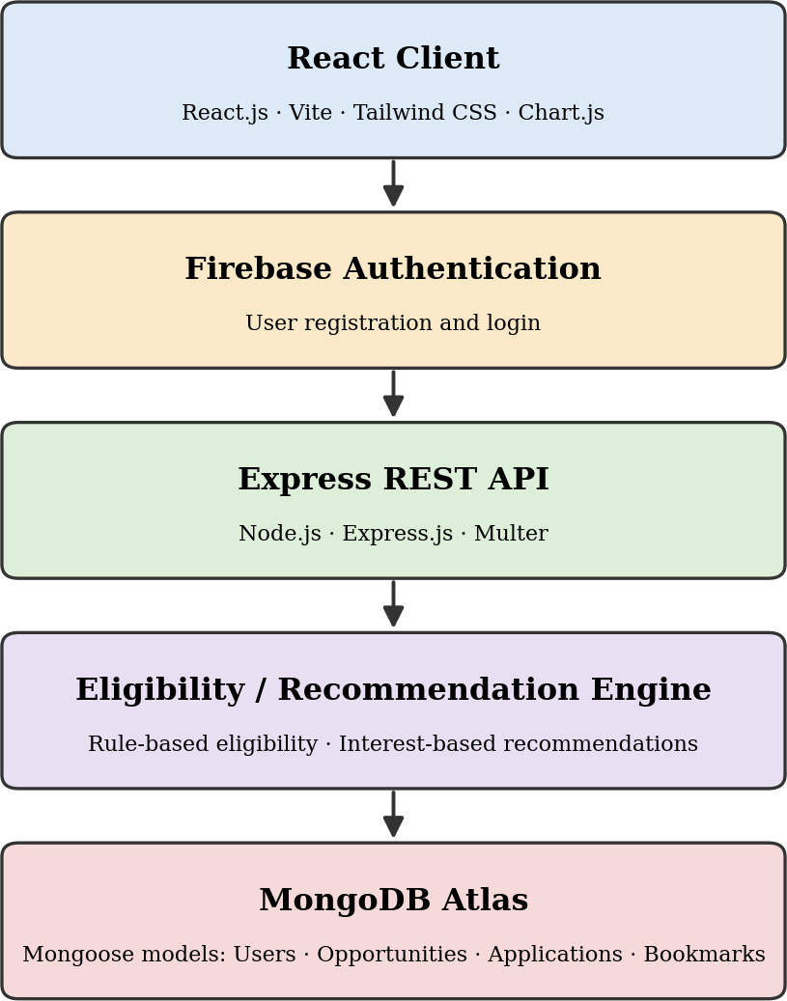
The React.js front-end is responsible for presentation and user interaction. The Express.js backend handles business logic and API requests. MongoDB stores application data, while Firebase Authentication manages user identity.
3.2 System Flow Diagram
The system flow of EduConnect begins when a user opens the application. The first stage is the Application Launch, followed by an authentication check. If the user is not authenticated, the system displays the Login or Registration screen. After successful authentication, the system identifies the user's role and redirects the user to the appropriate dashboard.
For a student, the flow proceeds to the Student Dashboard. The dashboard can display recommended opportunities, upcoming deadlines, bookmarked opportunities, and application-related information.
From the dashboard, the student can perform several actions:
- Search opportunities
- Filter opportunities
- View opportunity details
- Check eligibility
- Bookmark an opportunity
- Track an application
- Update profile information
- View notifications
When a student searches or filters opportunities, the React.js front-end sends a request to the Express.js backend. The backend retrieves matching opportunity records from MongoDB and returns the results to the front-end.
When the student views an opportunity, the system displays its details, including eligibility information and deadline. The eligibility module can compare available opportunity requirements with the student's stored profile information.
When a student bookmarks an opportunity, the corresponding bookmark information is stored for that user. Similarly, when a student records an application, the application information is associated with the student's account.
The system also checks upcoming deadlines for relevant opportunities. When a deadline approaches, the notification mechanism can provide an appropriate reminder.
For an administrator, successful authentication leads to the Administrator Dashboard. The administrator can add, edit, delete, or import opportunity information. Data submitted through the administrator interface is processed by the Express.js backend and stored in MongoDB.
The overall flow can therefore be summarized as
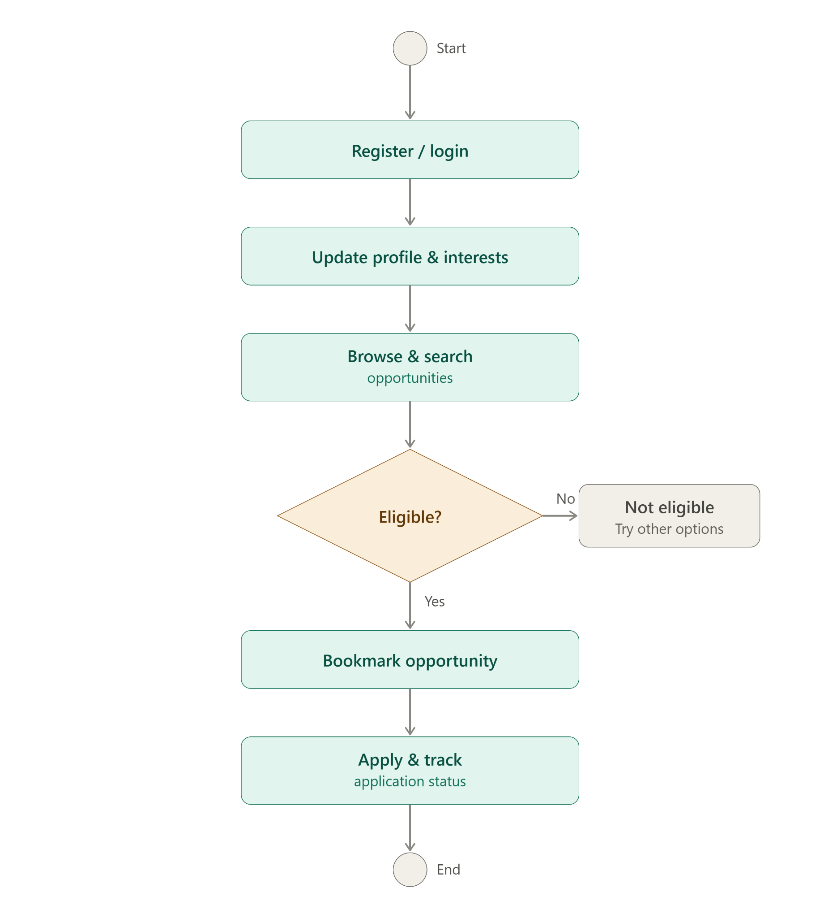

3.3 Entity-Relationship Design
The EduConnect data model consists of several major entities that represent users, opportunities, applications, bookmarks, and notifications.
The primary entities are:
- USER
- OPPORTUNITY
- APPLICATION
- BOOKMARK
- NOTIFICATION

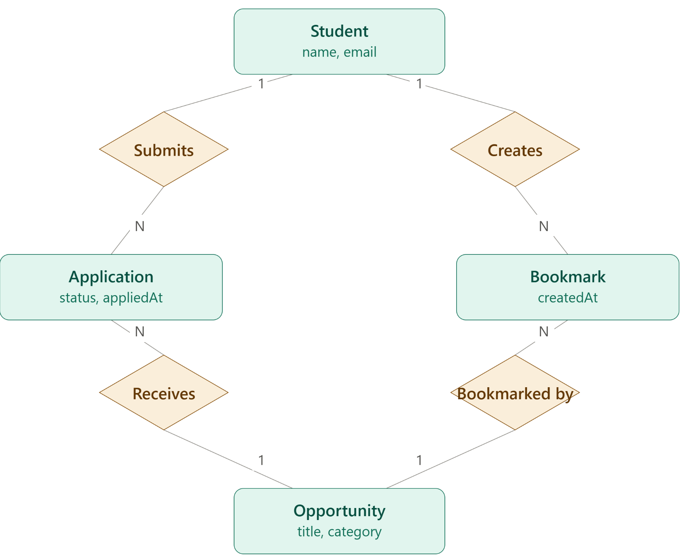
USER Entity
The USER entity represents registered students and administrators. The attributes are
- userId — Primary Key
- name
- email
- role
- department
- yearOfStudy
- CGPA
- skills
- interests
The role attribute distinguishes student accounts from administrator accounts.

OPPORTUNITY Entity
The OPPORTUNITY entity stores information about educational and career opportunities.
Important attributes include:
- opportunityId — Primary Key
- title
- organization
- category
- description
- eligibility
- deadline
- skills
- applicationLink
- source
- createdAt
- updatedAt
The category attribute identifies whether the opportunity is a scholarship, internship, certification course, hackathon, workshop, competition, placement opportunity, or another supported category.

APPLICATION Entity
The APPLICATION entity records opportunities for which a student has applied.
Important attributes include:
- applicationId — Primary Key
- userId — Foreign Key
- opportunityId — Foreign Key
- appliedDate
- status
A student can have multiple application records, while each application record refers to one opportunity.

BOOKMARK Entity
The BOOKMARK entity stores opportunities saved by students for later reference.
Important attributes include:
- bookmarkId — Primary Key
- userId — Foreign Key
- opportunityId — Foreign Key
- bookmarkedDate
A student can bookmark multiple opportunities, and an opportunity can be bookmarked by multiple students.

NOTIFICATION Entity
The NOTIFICATION entity stores reminders and notification information associated with users.
- notificationId — Primary Key
- userId — Foreign Key
- opportunityId — Foreign Key
- message
- notificationType
- notificationDate
- isRead
The notification information can be used to inform students about upcoming deadlines and other relevant opportunity updates.

3.4 Database Design
MongoDB is used as the database for EduConnect. The database can be organized into collections representing the major entities of the system.

User Collection
Field | Data Type | Description
userId | String | Unique user identifier
name | String | Student/administrator name
email | String | Registered email
role | String | Student or administrator
department | String | Student department
yearOfStudy | Number | Current year of study
cgpa | Number | Student CGPA
skills | Array | Student skills
interests | Array | Student interests

Opportunity Collection
Field | Data Type | Description
opportunityId | String | Unique opportunity identifier
title | String | Opportunity title
organization | String | Providing organization
category | String | Opportunity category
description | String | Detailed description
eligibility | Object / Array | Eligibility requirements
deadline | Date | Application deadline
skills | Array | Relevant skills
applicationLink | String | Application URL
source | String | Source of opportunity
createdAt | Date | Record creation date
updatedAt | Date | Last update date

Application Collection
Field | Data Type | Description
applicationId | String | Unique application identifier
userId | String | Student reference
opportunityId | String | Opportunity reference
appliedDate | Date | Application date
status | String | Application status

Bookmark Collection
Field | Data Type | Description
bookmarkId | String | Unique bookmark identifier
userId | String | Student reference
opportunityId | String | Opportunity reference
bookmarkedDate | Date | Bookmark creation date

Notification Collection
Field | Data Type | Description
notificationId | String | Unique notification identifier
userId | String | Student reference
opportunityId | String | Related opportunity
message | String | Notification message
notificationType | String | Type of notification
notificationDate | Date | Notification date
isRead | Boolean | Read/unread status

