Session10
import java.io.*;
import java.util.*;

public class Solution {

public static void main(String[] args) {
Scanner sc = new Scanner(System.in);
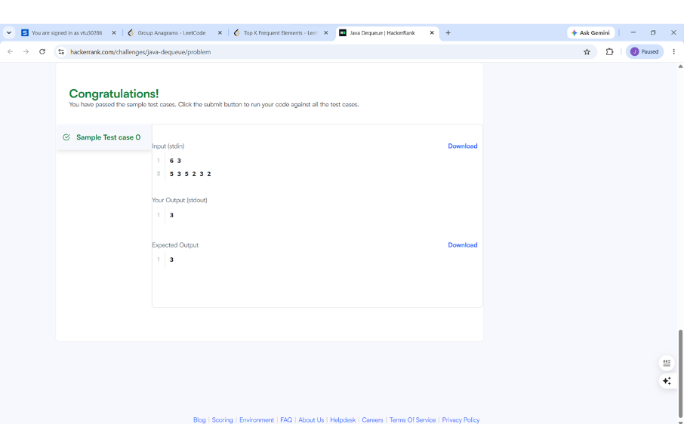
int n = sc.nextInt();
int m = sc.nextInt();

Deque<Integer> deque = new ArrayDeque<>();
HashSet<Integer> set = new HashSet<>();

int maxUnique = 0;

for (int i = 0; i < n; i++) {
int num = sc.nextInt();

deque.addLast(num);
set.add(num);

// Window size becomes greater than m
if (deque.size() > m) {
int removed = deque.removeFirst();

// Check whether removed element still exists in deque
if (!deque.contains(removed)) {
set.remove(removed);
}
}

// When window size is m
if (deque.size() == m) {
maxUnique = Math.max(maxUnique, set.size());
}
}

System.out.println(maxUnique);

sc.close();
}
}\

Session10.2
import java.io.*;
import java.util.*;

public class Solution {

public static void main(String[] args) {
Scanner sc = new Scanner(System.in);

int n = sc.nextInt();

Set<String> set = new HashSet<>();

for (int i = 0; i < n; i++) {
String first = sc.next();
String second = sc.next();

String pair = first + " " + second;

set.add(pair);

System.out.println(set.size());
}

sc.close();
}
}