Session11
import java.util.*;

class Result {

public static String findDay(int month, int day, int year) {

Calendar cal = Calendar.getInstance();

cal.set(year, month - 1, day);

String[] days = {
"SUNDAY",
"MONDAY",
"TUESDAY",
"WEDNESDAY",
"THURSDAY",
"FRIDAY",
"SATURDAY"
};

return days[cal.get(Calendar.DAY_OF_WEEK) - 1];
}
}

public class Solution {
public static void main(String[] args) {
Scanner sc = new Scanner(System.in);

int month = sc.nextInt();
int day = sc.nextInt();
int year = sc.nextInt();

System.out.println(Result.findDay(month, day, year));

sc.close();
}
} 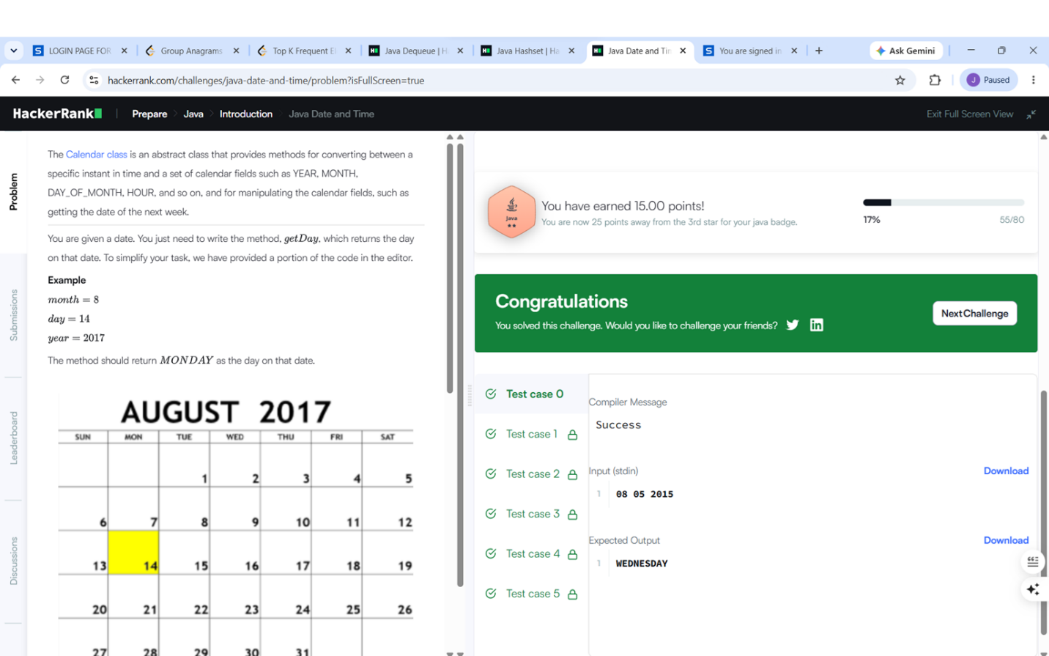

Session11.2
import java.time.LocalDate;
import java.time.temporal.ChronoUnit;

class Solution {
public int daysBetweenDates(String date1, String date2) {

LocalDate d1 = LocalDate.parse(date1);
LocalDate d2 = LocalDate.parse(date2);

return (int) Math.abs(ChronoUnit.DAYS.between(d1, d2));
}
} 