Session12
import java.time.LocalDate;

class Solution {
public int dayOfYear(String date) {
LocalDate d = LocalDate.parse(date);
return d.getDayOfYear();
}
} 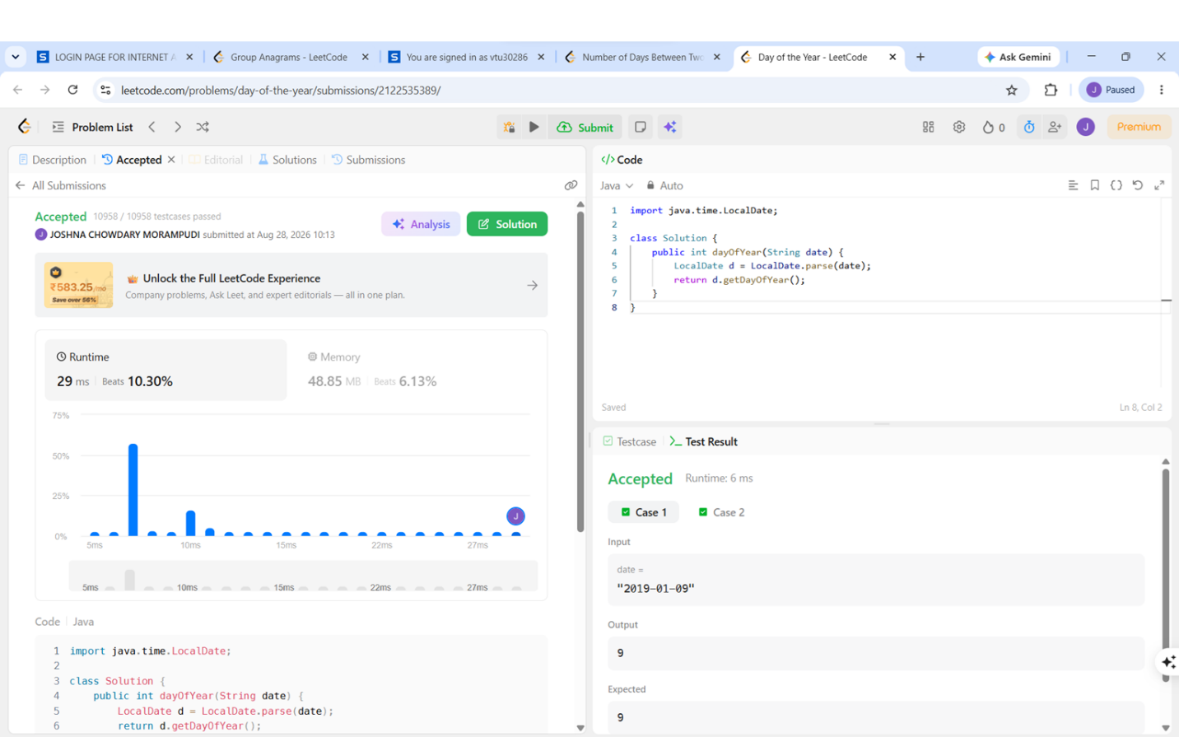
Session12.2
import java.time.LocalDate;

class Solution {
public String dayOfTheWeek(int day, int month, int year) {

LocalDate date = LocalDate.of(year, month, day);

return date.getDayOfWeek().toString().substring(0, 1)
+ date.getDayOfWeek().toString().substring(1).toLowerCase();
}
}
