**Explain React Components**

A React Component is a reusable piece of code that represents a part of the UI (like a button, form, or header).

Think of components like building blocks of a React app.  
They take input (called props) and return JSX (React’s HTML-like syntax) that defines what should appear on the screen.

**Difference Between React Components & JavaScript Functions**

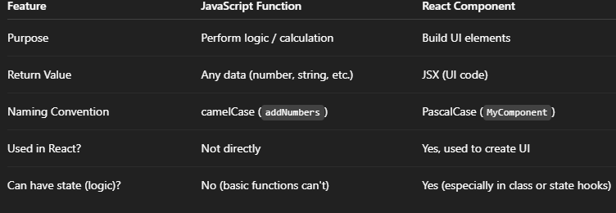

**Types of React Components**

|  |  |
| --- | --- |
| 1. Class Component: Uses ES6 classes. Has lifecycle methods and state. 2. Function Component: Simpler. Uses functions. Can use state with hooks.   **Explain Class Component**  A Class Component is a JavaScript class that extends React.Component and must include a render() function to return JSX.  Class components can have:   * State * Lifecycle methods (like componentDidMount)   **Explain Function Component**  A Function Component is a simple JavaScript function that returns JSX.  Function components are now powerful thanks to React Hooks (like useState, useEffect) and are used more in modern apps.  **Define Component Constructor**  A **constructor** is a special method in class components used to:   * Initialize **state** * Bind event handlers   It’s called automatically when a component is created.  **Define render() Function**  The render() function is required in every class component. It returns the JSX (UI) that should be displayed.  Create a react app for Student Management Portal named StudentApp and create a component named Home which will display the Message “Welcome to the Home page of Student Management Portal”. Create another component named About and display the Message “Welcome to the About page of the Student Management Portal”. Create a third component named Contact and display the Message “Welcome to the Contact page of the Student Management Portal”. Call all the three components.   1. Create a React project named “StudentApp” type the following command in terminal of Visual studio:      1. Create a new folder under Src folder with the name “Components”. Add a new file named “Home.js” 2. Type the following code in Home.js   import React from 'react';  function Home() {  return (  <div>  <h2>Welcome to the Home page of Student Management Portal</h2>  </div>  );  }  export default Home;  About.js  import React from 'react';  function About() {  return (  <div>  <h2>Welcome to the About page of the Student Management Portal</h2>  </div>  );  }  export default About;  **Contact.js**  import React from 'react';  function Contact() {  return (  <div>  <h2>Welcome to the Contact page of the Student Management Portal</h2>  </div>  );  }  export default Contact;  4.Edit the App.js to invoke the Home, About and Contact component as follows:  import React from 'react';  import Home from './Components/Home';  import About from './Components/About';  import Contact from './Components/Contact';  function App() {  return (  <div className="App">  <Home />  <About />  <Contact />  </div>  );  }  export default App;  5.In command Prompt, navigate into StudentApp and execute the code by typing the following command:    6.Open browser and type “localhost:3000” in the address bar: |  |
|  |  |
|  |  |