**Ex-11 ReactJs_Hol**

**1.Explain React Events**

React uses its own event system to handle user interactions like clicks, typing, form submission, etc. These events are very similar to the DOM events in HTML, but they are wrapped in React's synthetic event system for consistency across browsers.

2. **Explain About Event Handlers**

**Event handlers** are functions you define to respond to specific user actions (events).

* handleClick is an event handler.
* It's **not called** directly; React calls it when the event occurs.
* You can also write it as an arrow function:

3. **Define Synthetic Event**

A SyntheticEvent is a cross-browser wrapper around the browser’s native event system. React uses synthetic events to ensure the event behaves the same across different browsers.

4. **Identify React Event Naming Convention**

React event names:

* Use camelCase instead of lowercase.
* Take a function reference instead of a string.

**Lab:**

Create a React Application “eventexamplesapp” to handle various events of the form elements in HTML.

import React, { Component } from "react";

class CurrencyConvertor extends Component {

  constructor(props) {

    super(props);

    this.state = {

      rupees: "",

      euro: ""

    };

  }

  handleChange = (e) => {

    this.setState({ rupees: e.target.value });

  };

  handleSubmit = (e) => {

    e.preventDefault();

    const rupees = parseFloat(this.state.rupees);

    if (!isNaN(rupees)) {

      const euro = rupees * 0.011; // Example conversion rate

      this.setState({ euro: euro.toFixed(2) });

    }

  };

  render() {

    return (

      <div style={{ marginTop: "40px" }}>

        <h2>Currency Convertor (INR to Euro)</h2>

        <form onSubmit={this.handleSubmit}>

          <input

            type="number"

            placeholder="Enter INR"

            value={this.state.rupees}

            onChange={this.handleChange}

            style={{ marginRight: "10px" }}

          />

          <button type="submit">Convert</button>

        </form>

        <p>Euro: € {this.state.euro}</p>

      </div>

    );

  }

}

export default CurrencyConvertor;

App.js

import React, { Component } from "react";

import CurrencyConvertor from "./CurrencyConvertor";

class App extends Component {

constructor(props) {

super(props);

this.state = {

count: 0

};

}

increment = () => {

this.setState({ count: this.state.count + 1 });

};

decrement = () => {

this.setState({ count: this.state.count - 1 });

};

sayHello = () => {

alert("Hello! This is a static message.");

};

handleIncreaseClick = () => {

this.increment();

this.sayHello();

};

sayWelcome = (message) => {

alert(message);

};

handleSyntheticEvent = (e) => {

alert("I was clicked");

console.log("Synthetic Event:", e); // SyntheticEvent

};

render() {

return (

<div style={{ textAlign: "center", padding: "30px" }}>

<h1>React Event Examples</h1>

<h2>Counter: {this.state.count}</h2>

<button onClick={this.increment}>Increment</button>{" "}

<button onClick={this.decrement}>Decrement</button>{" "}

<button onClick={this.handleIncreaseClick}>Increase</button>

<hr />

<button onClick={() => this.sayWelcome("Welcome to React Events!")}>

Say Welcome

</button>

<hr />

<button onClick={this.handleSyntheticEvent}>

Synthetic Event Button

</button>

<hr />

<CurrencyConvertor />

</div>

);

}

}

export default App;

1. Create “Increment” button to increase the value of the counter and “Decrement” button to decrease the value of the counter. The “Increase” button should invoke multiple methods.
   1. To increment the value
   2. Say Hello followed by a static message.
2. Create a button “Say Welcome” which invokes the function which takes “welcome” as an argument.

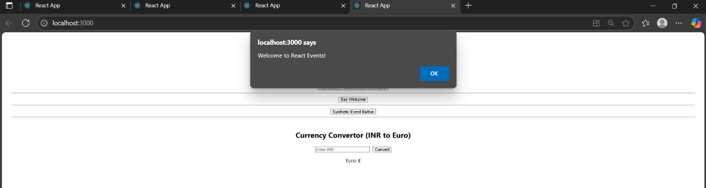3.Create a button which invokes synthetic event “OnPress” which display “I was clicked”

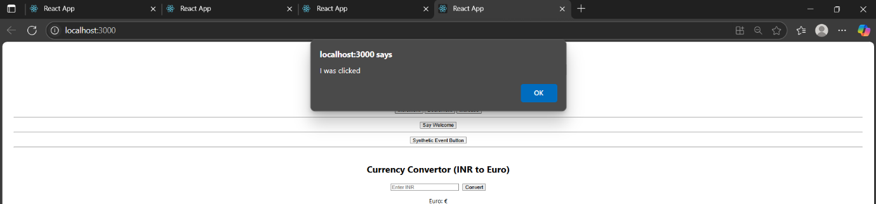

4. Create a “CurrencyConvertor” component which will convert the Indian Rupees to Euro when the Convert button is clicked.

Handle the Click event of the button to invoke the handleSubmit event and handle the conversion of the euro to rupees.

