**Ex-9: ReactJs_Hol**

1. **List the features of ES6**

* let and const: Block-scoped variable declarations.
* Arrow Functions: Shorter syntax and lexical this.
* Classes: Syntactic sugar for constructor functions and inheritance.
* Default Parameters: Default values for function parameters.
* Template Literals: Backtick syntax (`) for multiline and interpolated strings.
* Destructuring: Unpack arrays or objects into variables.
* Modules: import and export for modular JavaScript.
* Spread and Rest Operators: ... for copying or collecting items.

1. **Explain JavaScript let**

let is used to declare block-scoped variables.

It prevents redeclaration within the same scope**.**

1. **Identify the differences between var and let**

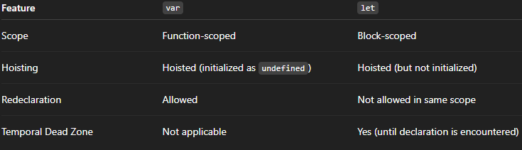

1. **Explain const in JavaScript**

* Used to declare constants (values that won't be reassigned).
* Block-scoped like let.
* For objects and arrays, the reference is constant, but contents can be modified.

1. **Explain ES6 Class Fundamentals**

ES6 classes are a new way to write object-oriented code in JavaScript. They provide a cleaner, more familiar syntax for creating objects and working with inheritance.

Key Features:

* Declared using the class keyword.
* Have a constructor() method to initialize objects.
* Methods are defined directly inside the class.

1. **Explain ES6 Class Inheritance**

Inheritance in ES6 allows one class to use the properties and methods of another class using the extends keyword.

Key Points:

* Use extends to inherit from a parent class.
* Use super() to call the parent class's constructor.

1. **Define ES6 Arrow Functions**

Arrow functions are a shorter syntax for writing functions in JavaScript.

Key Features:

* Use => syntax.
* Do not have their own this (lexical this).
* Great for short functions and callbacks.

1. **Identify Set() and Map() in ES6**

Set:

* A collection of unique values.
* Automatically removes duplicates.

Map:

* A collection of key-value pairs.
* Keys can be of any type (string, number, object, etc.).

**Lab:**

Create a React Application named “cricketapp” with the following components:

1. ListofPlayers

* Declare an array with 11 players and store details of their names and scores using the map feature of ES6
* Filter the players with scores below 70 using arrow functions of ES6

**ListofPlayers.js**

import React from "react";

const ListofPlayers = () => {

  const players = [

    { name: "Virat", score: 85 },

    { name: "Rohit", score: 45 },

    { name: "Dhoni", score: 95 },

    { name: "Hardik", score: 35 },

    { name: "Kohli", score: 60 },

    { name: "Gill", score: 90 },

    { name: "Bumrah", score: 50 },

    { name: "Shami", score: 80 },

    { name: "Rahul", score: 55 },

    { name: "Pant", score: 88 },

    { name: "Surya", score: 40 }

  ];

  // Players with score < 70

  const filtered = players.filter(player => player.score < 70);

  return (

    <div>

      <h2>All Players with Scores</h2>

      <table border="1" cellPadding="10">

        <thead>

          <tr>

            <th>Player Name</th>

            <th>Score</th>

          </tr>

        </thead>

        <tbody>

          {players.map((p, index) => (

            <tr key={index}>

              <td>{p.name}</td>

              <td>{p.score}</td>

            </tr>

          ))}

        </tbody>

      </table>

      <h2>Filtered Players (Score &lt; 70)</h2>

      <ul>

        {filtered.map((p, index) => (

          <li key={index}>

            {p.name} - {p.score}

          </li>

        ))}

      </ul>

    </div>

  );

};

export default ListofPlayers;

**IndianPlayers.js**

import React from "react";

const IndianPlayers = () => {

  const team = ["Virat", "Rohit", "Dhoni", "Hardik", "Kohli", "Gill"];

  const [p1, p2, p3, p4, p5, p6] = team;

  const oddTeam = [p1, p3, p5]; // 1st, 3rd, 5th

  const evenTeam = [p2, p4, p6]; // 2nd, 4th, 6th

  const T20players = ["Shikhar", "Rishabh", "Jadeja"];

  const RanjiTrophy = ["Pujara", "Rahane", "Ashwin"];

  const mergedPlayers = [...T20players, ...RanjiTrophy];

  return (

    <div>

      <h2>Odd Team Players</h2>

      <ul>

        {oddTeam.map((p, i) => (

          <li key={i}>{p}</li>

        ))}

      </ul>

      <h2>Even Team Players</h2>

      <ul>

        {evenTeam.map((p, i) => (

          <li key={i}>{p}</li>

        ))}

      </ul>

      <h2>Merged Players (T20 + Ranji)</h2>

      <ul>

        {mergedPlayers.map((p, i) => (

          <li key={i}>{p}</li>

        ))}

      </ul>

    </div>

  );

};

export default IndianPlayers;

**App.js**

import React from "react";

import ListofPlayers from "./ListofPlayers";

import IndianPlayers from "./IndianPlayers";

function App() {

  const flag = false; // Change to false to see the other component

  return (

    <div className="App">

      <h1 style={{ textAlign: "center" }}>🏏 Cricket App</h1>

      {flag ? <ListofPlayers /> : <IndianPlayers />}

    </div>

  );

}

export default App;

Output:

flag=true;

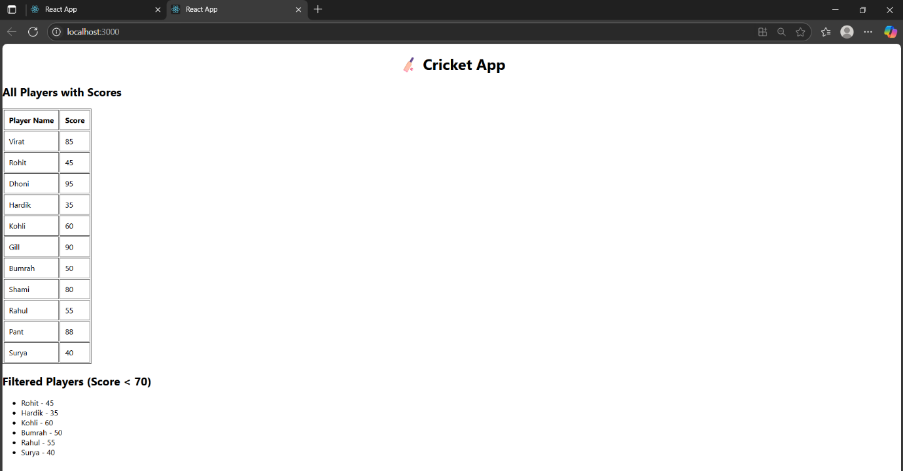

flag=false;

