**Ex.1-GIT_HOL**

**Step 1: Setup your machine with Git Configuration**

To create a new repository, signup with GitLab and register your credentials

Login to GitLab and create a “GitDemo” project

1. To check if Git client is installed properly: Open Git bash shell and execute

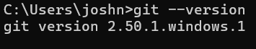

1. To configure user level configuration of user ID and email ID execute



1. To check if the configuration is properly set, execute the following command.

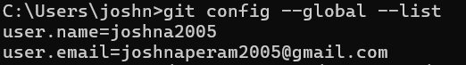

**Step 2: Integrate notepad++.exe to Git and make it a default editor**

1. To configure the editor, execute the command.



1. To verify if notepad++ is the default editor, execute the command

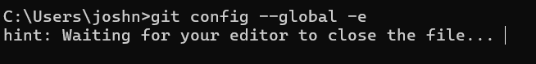

It will show the entire global configuration as shown below,

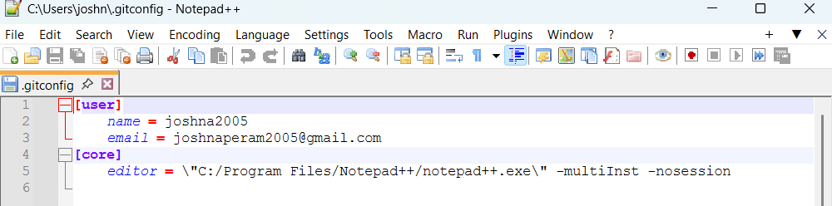

**Step 3: Add a file to source code repository**

1. Open Git bash shell and create a new project “**GitDemo**” by executing the command



1. Git bash initializes the “**GitDemo**” repository. To verify, execute the command

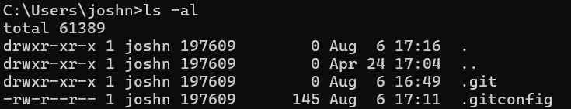

1. To create a file **“welcome.txt”** and add content to the file, execute the command



1. To verify if the file “welcome.txt” is created, execute

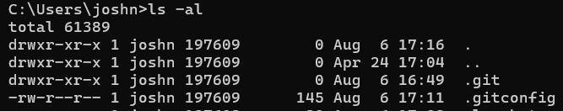

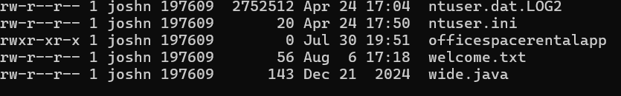

1. To verify the content, execute the command

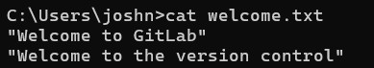

1. Check the status by executing

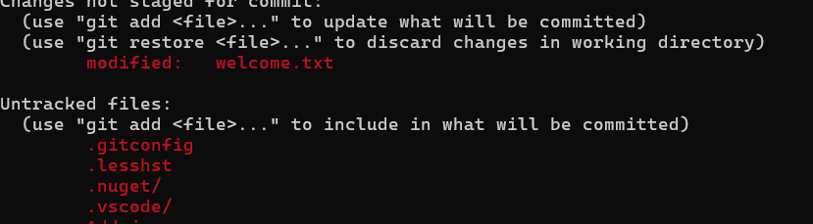

1. To make the file to be tracked by Git repository, execute the command

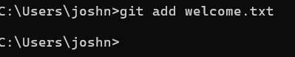

1. To add multi line comments, we are opening default editor to comment. Execute the command



1. To check if local and “Working Directory” git repository are same, execute git status



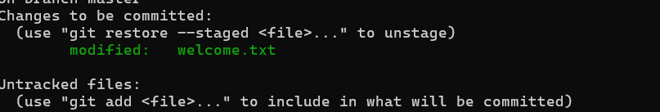

1. Signup with GitLab and create a remote repository **“GitDemo”**

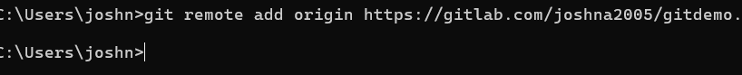

1. To push the local to remote repository, execute git push origin master
2. To pull the remote repository, execute git pull origin master

