**4. Git-HOL**

## **Objectives**

* **Explain how to resolve the conflict during merge.**

To resolve a merge conflict in Git:

1. Open the conflicted file — Git marks conflicts like:

<<<<<<< HEAD

your changes

=======

incoming branch changes

>>>>>>> branch-name

1. Edit the file to keep the correct content, remove the <<<<<<<, =======, and >>>>>>> markers.
2. Mark the conflict as resolved:

git add <file>

1. Complete the merge:

git commit

This commits the resolved version and finishes the merge.

**Hands-on**

1. Verify if master is in clean state.

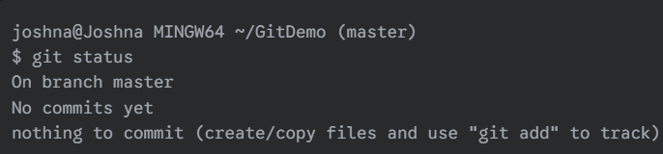

1. Create a branch **“GitWork”.** Add a file “hello.xml”.

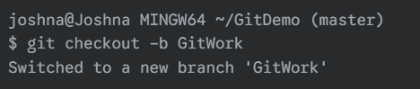

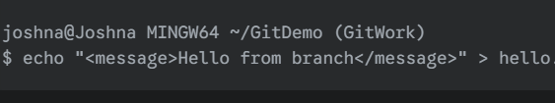

1. Update the content of “hello.xml” and observe the status

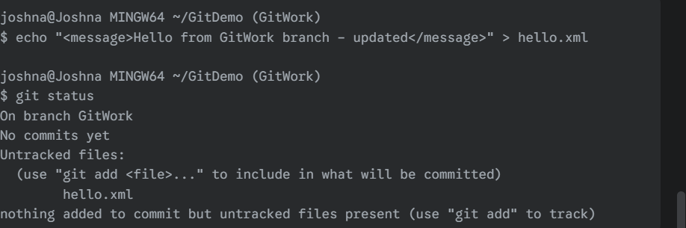

1. Commit the changes to reflect in the branch

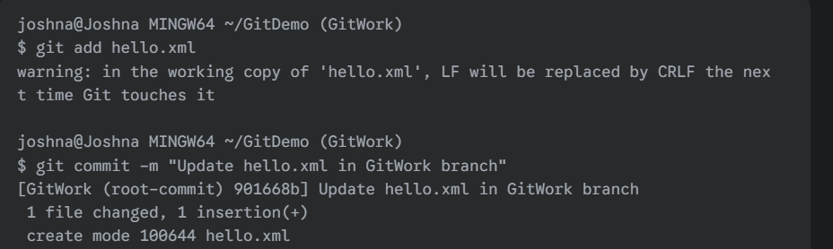

1. Switch to master.

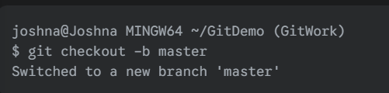

1. Add a file **“hello.xml”** to the master and add some different content than previous.



1. Commit the changes to the master

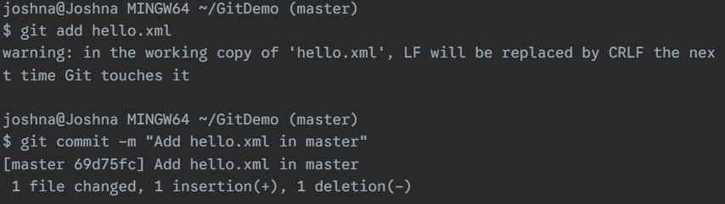

1. Observe the log by executing **“git log –oneline –graph –decorate –all”**

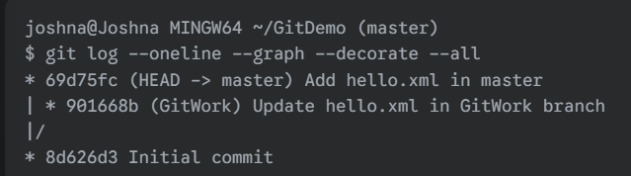

1. Check the differences with Git diff tool

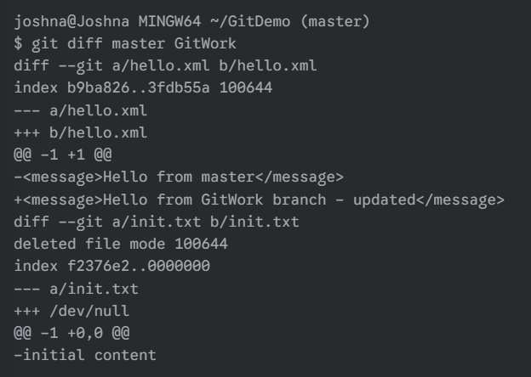

1. For better visualization, use P4Merge tool to list out all the differences between master and branch

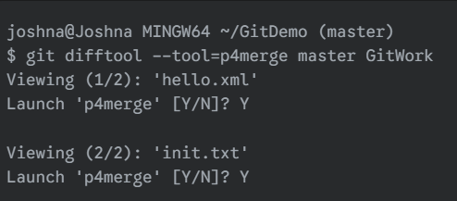

1. Merge the bran to the master

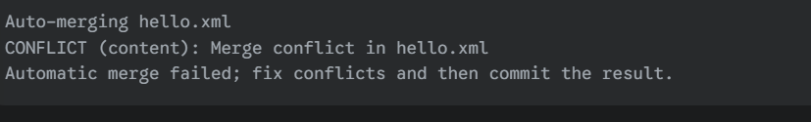

1. Observe the git mark up.

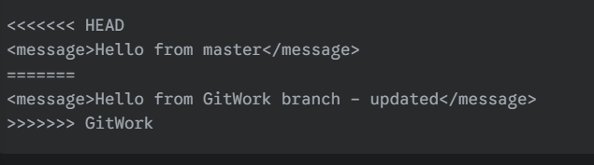

1. Use 3-way merge tool to resolve the conflict

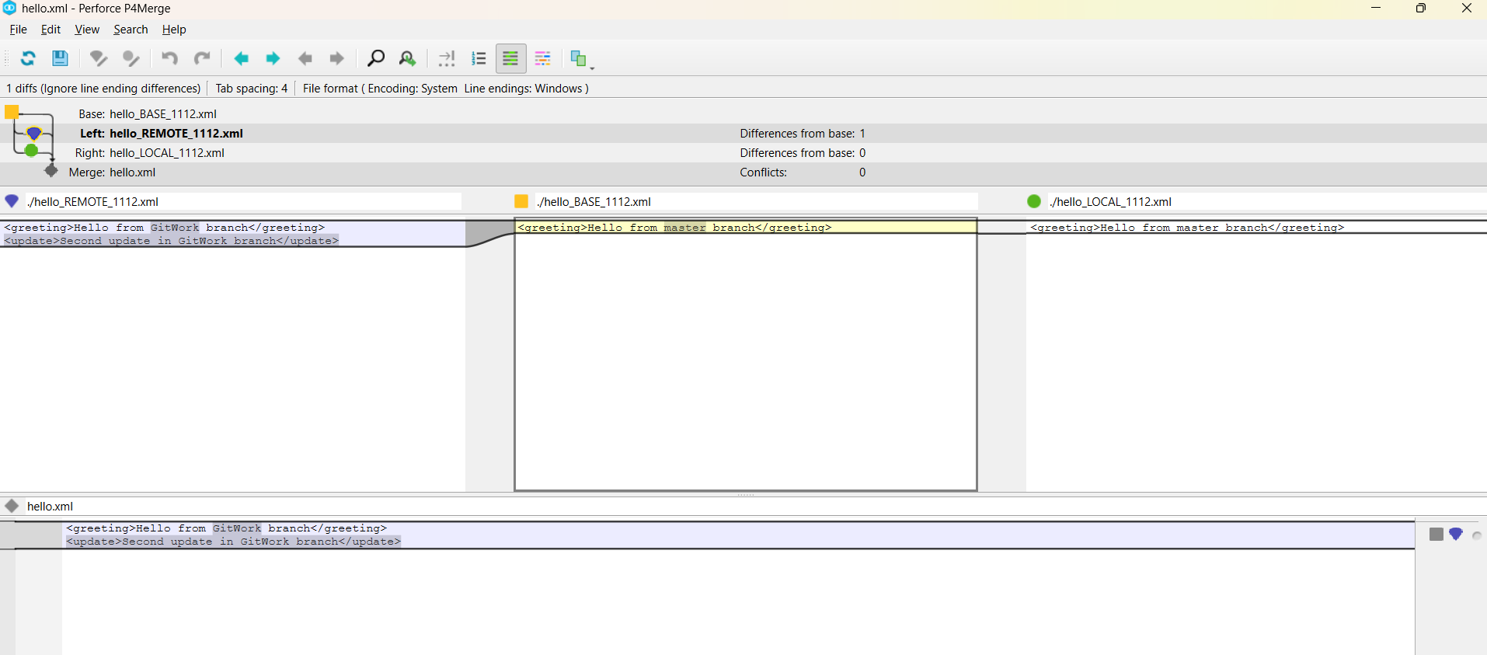

1. Commit the changes to the master, once done with conflict

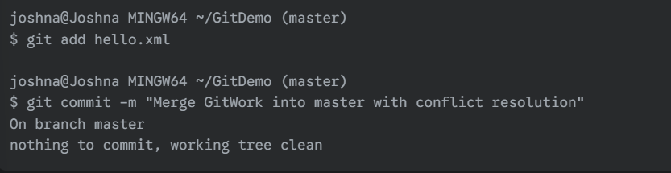

1. Observe the git status and add backup file to the .gitignore file.

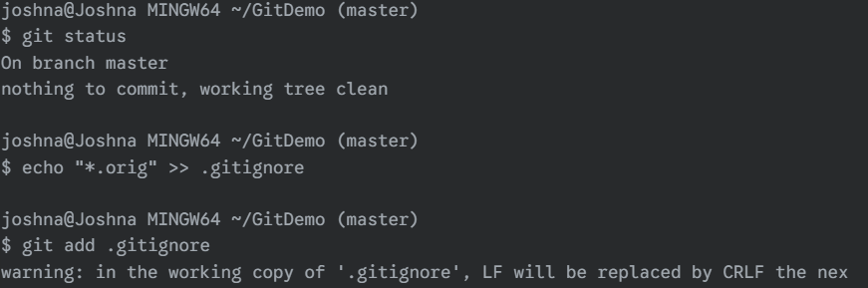

1. Commit the changes to the .gitignore

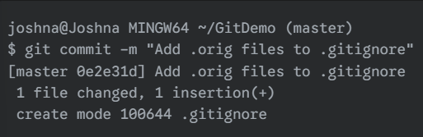

1. List out all the available branches

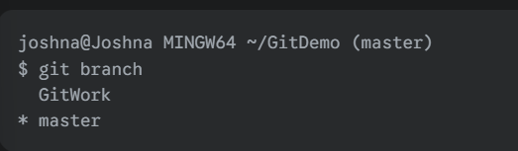

1. Delete the branch, which merge to master.

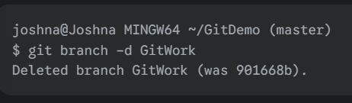

1. Observe the log by executing **“git log –oneline –graph –decorate”**

