Name:B.Joshna Reg no:192472097
ASSESSMENT TOOL 3 – CODING CHALLENGE

Section 1: Intelligent Email and Password Validator using Regular Expressions

Code:
import re

# Function to validate Email
def validate_email(email):
pattern = r'^[A-Za-z][A-Za-z0-9._]*@[A-Za-z]+\.(com|org|edu|net|in)$'
if re.fullmatch(pattern, email):
return "Valid Email"
else:
return "Invalid Email"

# Function to validate Password
def validate_password(password):
pattern = r'^(?=.*[A-Z])(?=.*[a-z])(?=.*\d)(?=.*[@#$%&!])[A-Za-z\d@#$%&!]{8,}$'
if re.fullmatch(pattern, password):
return "Strong Password"
else:
return "Weak Password"

# Function to validate Mobile Number
def validate_mobile(mobile):
pattern = r'^[6-9]\d{9}$'
if re.fullmatch(pattern, mobile):
return "Valid Mobile Number"
else:
return "Invalid Mobile Number"

# User Input
email = input("Enter Email Address: ")
password = input("Enter Password: ")
mobile = input("Enter Mobile Number: ")

# Display Results
print("\nValidation Results")
print("-------------------")
print(validate_email(email))
print(validate_password(password))
print(validate_mobile(mobile))

Output:
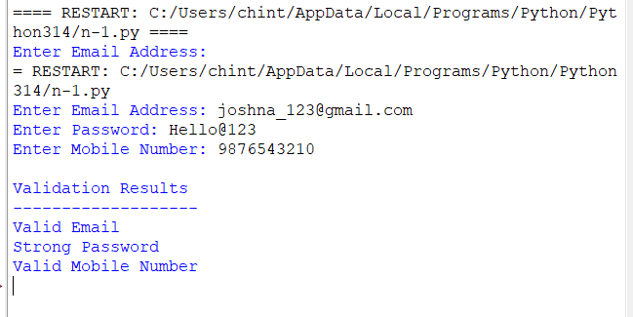

Section 2: Design a Finite State Automata (FSA) Simulator
Code:
# DFA Simulator

# DFA Description
states = {'q0', 'q1', 'q2'}
alphabet = {'a', 'b'}

# Transition Table
transitions = {
('q0', 'a'): 'q1',
('q0', 'b'): 'q0',
('q1', 'a'): 'q1',
('q1', 'b'): 'q2',
('q2', 'a'): 'q1',
('q2', 'b'): 'q0'
}

# Initial State
initial_state = 'q0'

# Final State
final_states = {'q2'}

# Function to simulate DFA
def simulate_dfa(input_string):
current_state = initial_state

print("\nProcessing String:", input_string)
print("State Transitions:")

for symbol in input_string:
if symbol not in alphabet:
print("Invalid Symbol:", symbol)
return

print(current_state, "--", symbol, "-->", end=" ")

current_state = transitions[(current_state, symbol)]
print(current_state)

if current_state in final_states:
print("Result: Accepted")
else:
print("Result: Rejected")

# Accept multiple strings
n = int(input("Enter number of input strings: "))

for i in range(n):
s = input(f"\nEnter String {i+1}: ")
simulate_dfa(s)

Output:
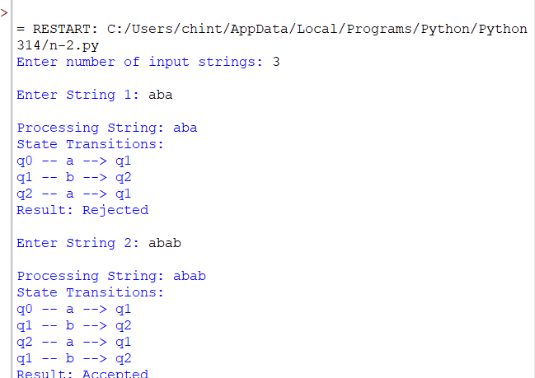

Section 3: Smart Pattern Matching Engine using Regular Expressions
Code:

import re

# Sample Text
text = """
Meeting on 12/09/2026
Call 9876543210
#NLP
@OpenAI
natural language processing
Machine learning is interesting.
"""

while True:
print("\n===== TEXT SEARCH ENGINE =====")
print("1. Search Date")
print("2. Search Phone Number")
print("3. Search Hashtag")
print("4. Search Mention")
print("5. Search Prefix")
print("6. Search Suffix")
print("7. Search Word")
print("8. Exit")

choice = int(input("Enter your choice: "))

if choice == 1:
pattern = r'\b\d{2}/\d{2}/\d{4}\b'
result = re.findall(pattern, text)
print("Dates Found:", result)

elif choice == 2:
pattern = r'\b[6-9]\d{9}\b'
result = re.findall(pattern, text)
print("Phone Numbers Found:", result)

elif choice == 3:
pattern = r'#\w+'
result = re.findall(pattern, text)
print("Hashtags Found:", result)

elif choice == 4:
pattern = r'@\w+'
result = re.findall(pattern, text)
print("Mentions Found:", result)

elif choice == 5:
prefix = input("Enter Prefix: ")
pattern = r'\b' + re.escape(prefix) + r'\w*\b'
result = re.findall(pattern, text, re.IGNORECASE)
print("Matching Words:", result)

elif choice == 6:
suffix = input("Enter Suffix: ")
pattern = r'\b\w*' + re.escape(suffix) + r'\b'
result = re.findall(pattern, text, re.IGNORECASE)
print("Matching Words:", result)

elif choice == 7:
word = input("Enter Word: ")
pattern = r'\b' + re.escape(word) + r'\b'
result = re.findall(pattern, text, re.IGNORECASE)

if result:
print("Word Found:", result)
else:
print("Word Not Found")

elif choice == 8:
print("Exiting Program...")
break

else:
print("Invalid Choice!")
Output:
