STUDENT IMPLEMENTATION
Student Record and Academic Management System
Data Organization using Python
Student Details | Value
Student | KARRI JOSHNAVI
Program | B.Tech - AIML
Year | First Year
Division | B
University | Sanjivani University
PNR | 2126UMLF1265

Complete assignment based strictly on the uploaded Student Implementation brief.

1. Objective
The objective of the student project is to apply Python's built-in data structures to develop a Student Record Management System capable of storing, organizing, updating, and retrieving academic information efficiently.
The required workflow is followed in order: problem understanding → algorithm design → flowchart → pseudocode → Python implementation → testing → documentation.

2. Problem Analysis
Requirement | Inputs | Expected Output | Suitable Data Structure
Student information | Roll number, registration number, name, department, subjects, marks, attendance, DOB, contact | Complete student profile | Dictionary + required collections
Add new student | New student details | Added record or duplicate warning | List + Dictionary
Search by roll number | Roll number | Matching record or not found | List + Dictionary
Update information | Roll number, field, new value | Updated record | Dictionary
Delete record | Roll number | Record removed | List
Calculate average marks | Marks | Average | List
Find highest scorer | All student records | Highest average scorer | List + Dictionary
List by department | Department | Matching records | List + Dictionary
Count students | Student collection | Total number | List
Generate reports | Student collection | Academic summary | Sets + List + Dictionary

3. Data Structure Selection Report
Data Structure | Required Use | Reason
Strings | Student names, departments, addresses, email IDs | Text data is represented as strings.
Lists | Student records, subject lists, marks, attendance | Ordered, changeable collections can grow or shrink.
Tuples | Roll number, registration number, date of birth | Fixed values are stored as immutable tuples.
Sets | Departments, subjects, student clubs | Unique values are needed; duplicates are removed automatically.
Dictionaries | Complete student profile | Named key-value fields make records easy to access and update.

4. Algorithm Design

4.1 Add New Student
1. Accept student information.
2. Check whether the roll number already exists.
3. If it exists, reject the duplicate record.
4. Otherwise create the complete student dictionary using the required collections.
5. Append the record to the student list.
6. Display confirmation.

4.2 Search Student by Roll Number
1. Accept the roll number.
2. Compare it with each stored record.
3. If a match is found, display/return the record.
4. If no match is found, display 'Student not found'.

4.3 Update Student Information
1. Accept the roll number.
2. Search for the record.
3. If not found, display 'Student not found'.
4. Read the field and new value.
5. Update the selected field.
6. Display confirmation.

4.4 Delete Student Record
1. Accept the roll number.
2. Search for the record.
3. If not found, display 'Student not found'.
4. Remove the record from the list.
5. Display confirmation.

4.5 Calculate Average Marks
1. Read the marks list.
2. If empty, return 0.
3. Add the marks and divide by the number of marks.
4. Return the average.

4.6 Find Highest Scorer
1. Check whether records exist.
2. Calculate the average marks of each student.
3. Select the student with the highest average.
4. Display the highest scorer.

4.7 List Students by Department
1. Accept the department.
2. Convert it to a consistent form.
3. Check every student.
4. Collect matching records.
5. Display the result.

4.8 Count Students
1. Read the student collection.
2. Count its records.
3. Display the total.

5. Flowchart Collection
The following diagrams cover exactly the seven flowchart operations requested in the assignment.

5.1 Add Student
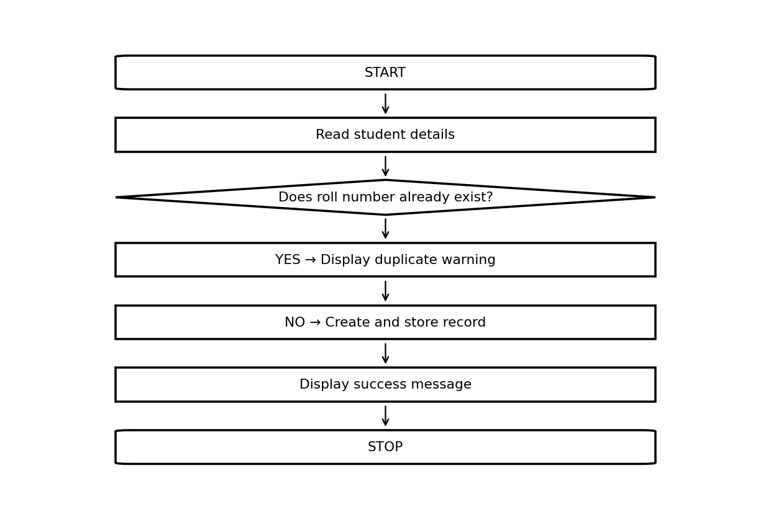

5.2 Search Student
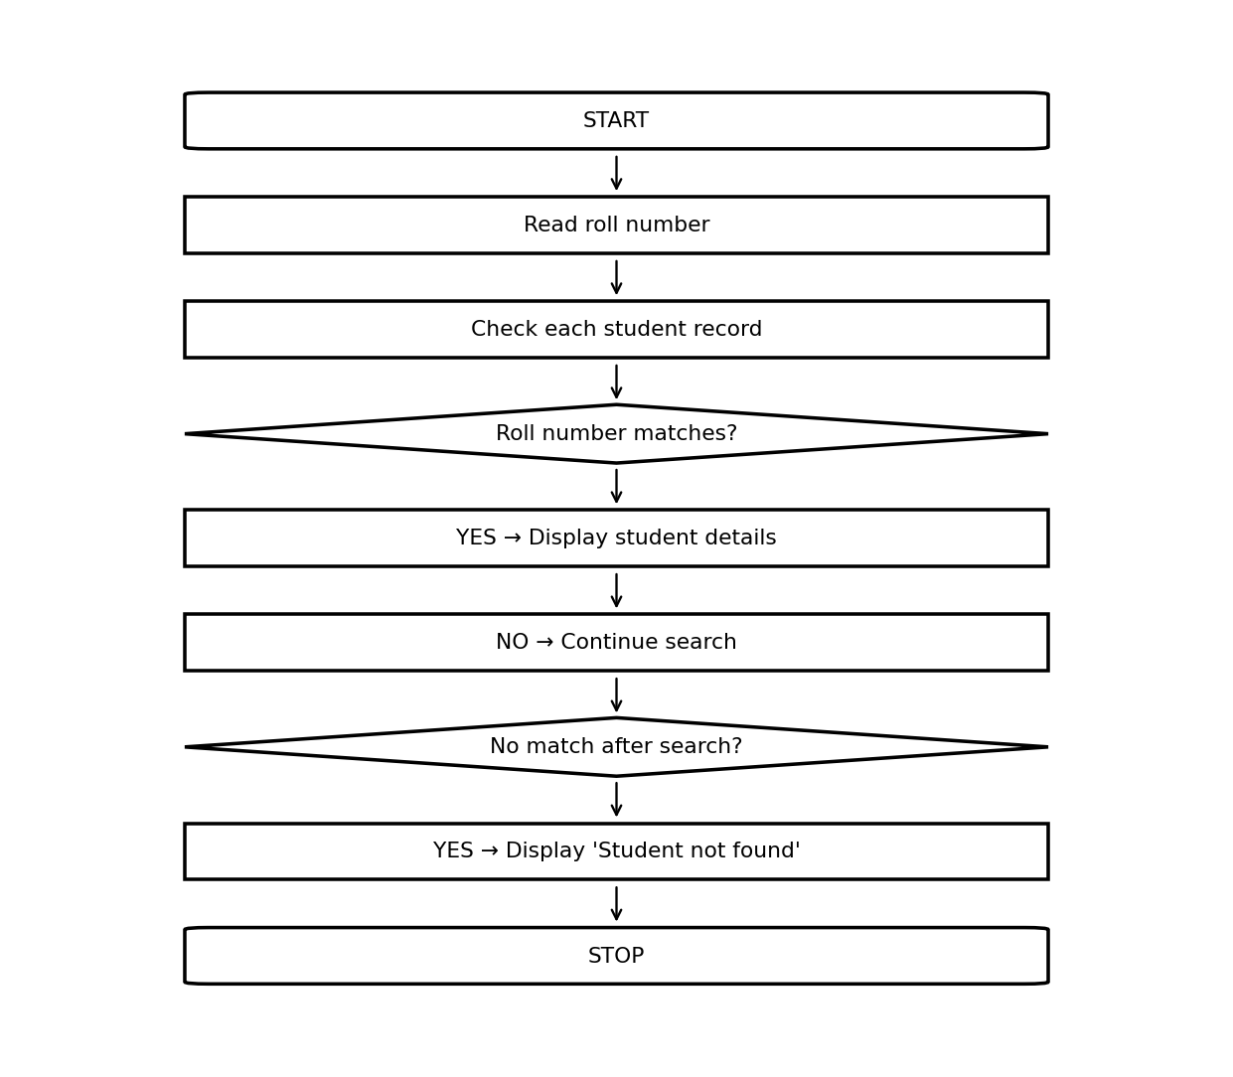

5.3 Update Record
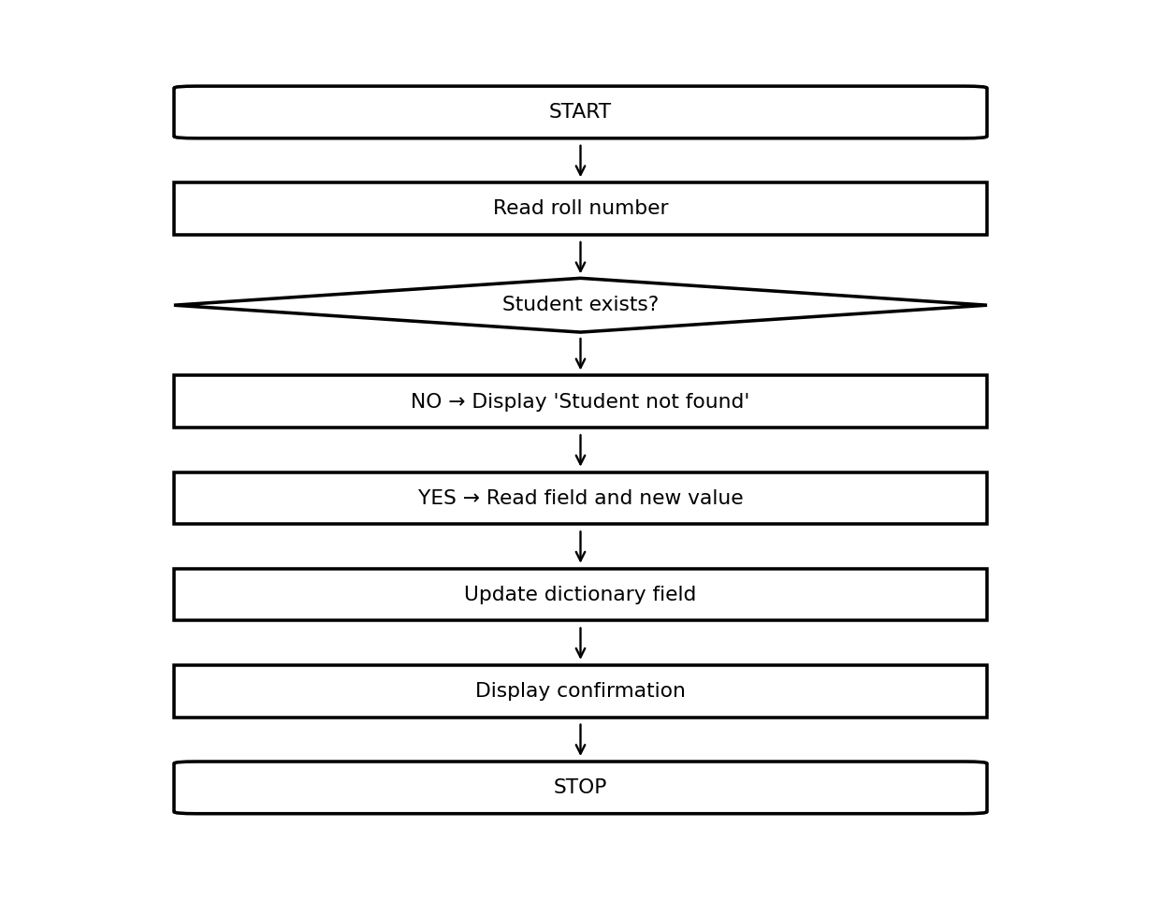

5.4 Delete Record
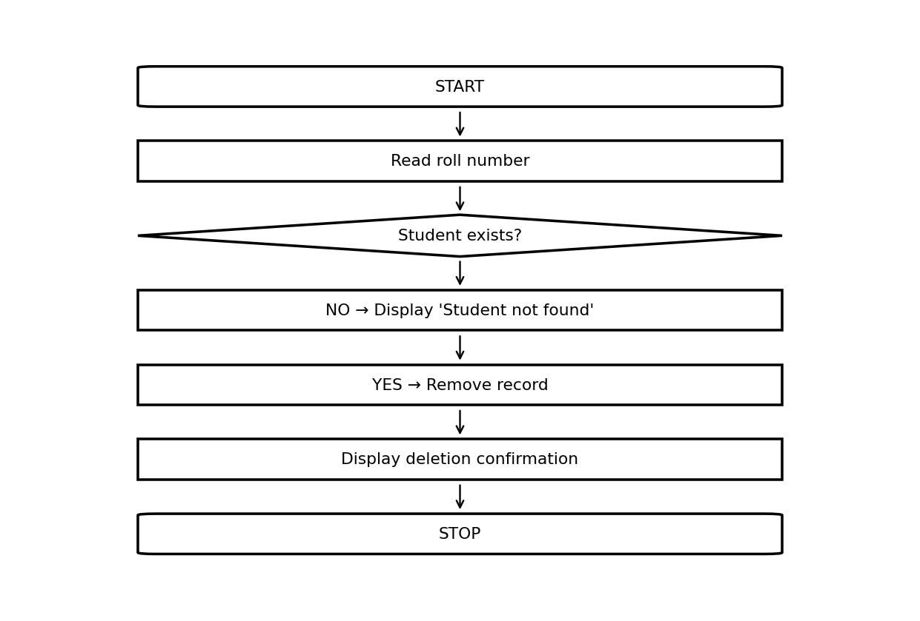

5.5 Display Records
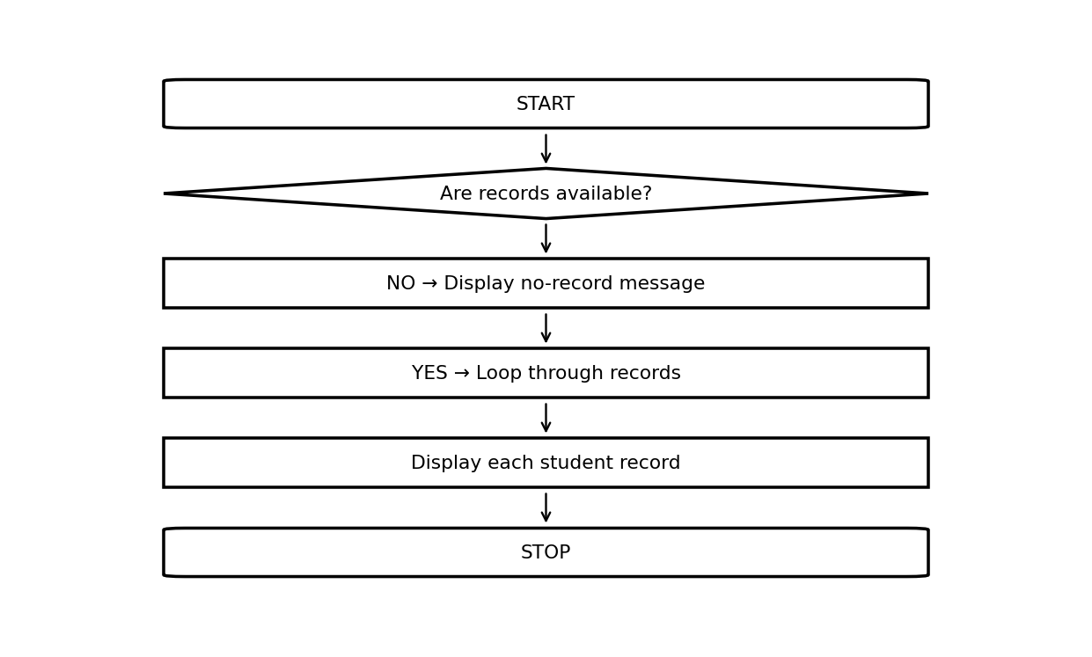

5.6 Calculate Average
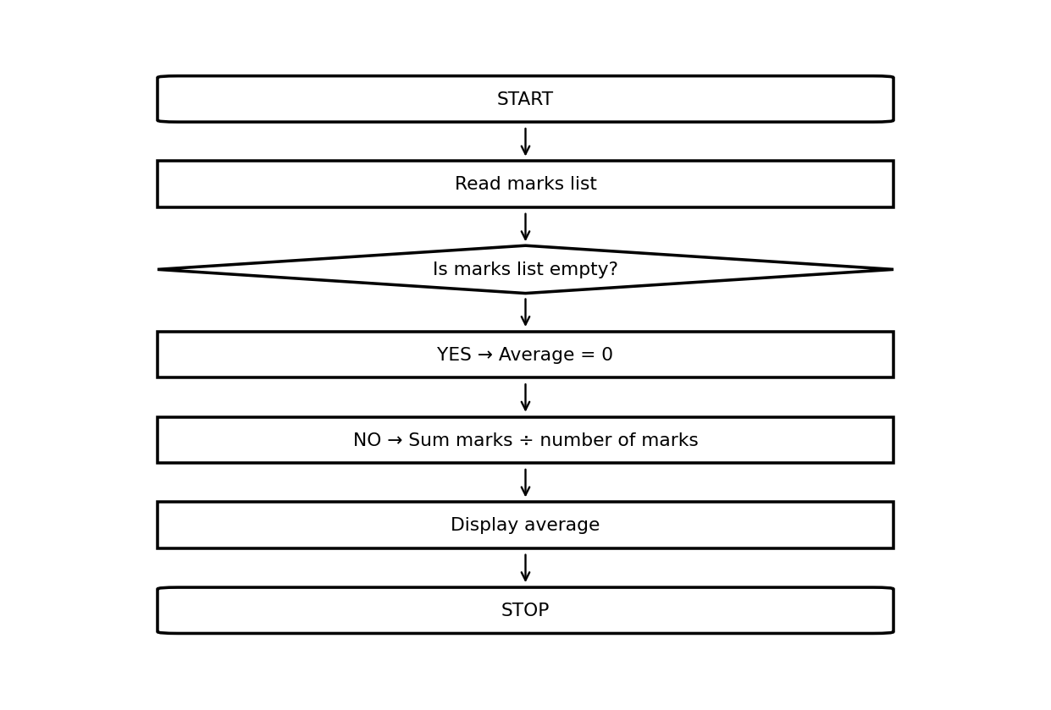

5.7 Generate Reports
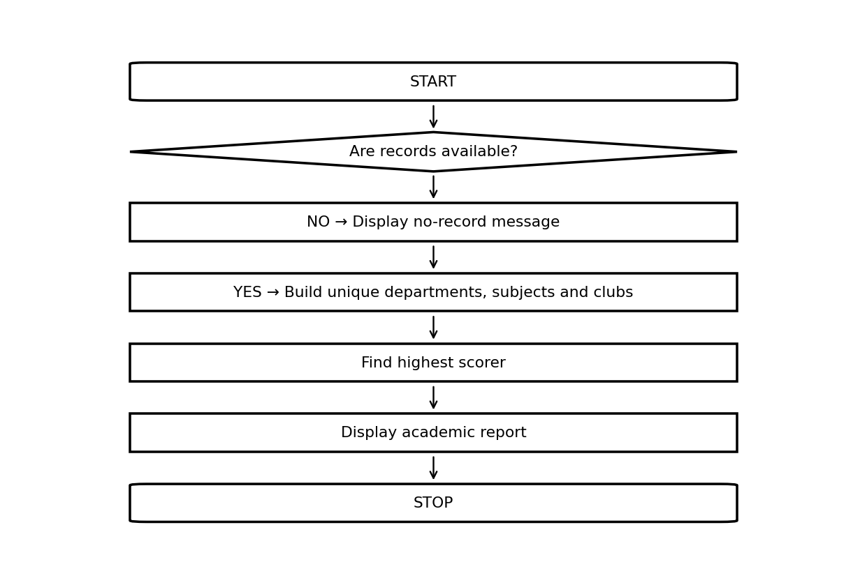

6. Pseudocode Document

Add Student
START
READ student details
IF roll number already exists THEN
DISPLAY "Student already exists"
ELSE
CREATE student dictionary
STORE roll number, registration number and DOB as tuples
STORE subjects, marks and attendance as lists
STORE clubs as a set
APPEND dictionary to student collection
DISPLAY "Student added successfully"
END IF
STOP

Search Student
START
READ roll number
SET found = False
FOR each student in collection
IF roll number matches THEN
DISPLAY student details
SET found = True
EXIT LOOP
END IF
END FOR
IF found == False THEN
DISPLAY "Student not found"
END IF
STOP

Update Record
START
READ roll number
SEARCH for student
IF student does not exist THEN
DISPLAY "Student not found"
ELSE
READ field and new value
UPDATE selected field
DISPLAY confirmation
END IF
STOP

Delete Record
START
READ roll number
SEARCH for student
IF student does not exist THEN
DISPLAY "Student not found"
ELSE
REMOVE student from collection
DISPLAY confirmation
END IF
STOP

Display Records
START
IF collection is empty THEN
DISPLAY "No student records available"
ELSE
FOR each student
DISPLAY all fields
DISPLAY average marks
END FOR
END IF
STOP

Calculate Average
START
READ marks
IF marks list is empty THEN
SET average = 0
ELSE
SET average = SUM(marks) / NUMBER OF marks
END IF
DISPLAY average
STOP

Generate Reports
START
IF collection is empty THEN
DISPLAY "No records available for report"
ELSE
CREATE unique department, subject and club sets
FIND highest scorer
COUNT students
DISPLAY report
END IF
STOP

Find Highest Scorer
START
IF collection is empty THEN
RETURN no result
ELSE
CALCULATE average for every student
SELECT maximum average
DISPLAY highest scorer
END IF
STOP

List by Department
START
READ department
CREATE empty result list
FOR each student
IF department matches THEN
APPEND student to result list
END IF
END FOR
DISPLAY result list
STOP

Count Students
START
SET count = number of records
DISPLAY count
STOP

7. String Programming Exercises
title = " python programming "
print(title.upper())
print(title.lower())
print(title.title())
print(title.capitalize())
print(title.strip())
print("python,java,c".split(","))
print(", ".join(["Python", "Java", "C"]))
print("Dune".replace("u", "o"))
print("library".find("brar"))
print("banana".count("a"))
print("1984".startswith("19"))
print("report.pdf".endswith(".pdf"))
name = " aarav kumar "
print(name.strip().title())

8. List Management Programs
books = ["1984", "Dune", "Emma"]
books.append("Atomic Habits")
books.insert(0, "Python Basics")
books.extend(["Clean Code", "The Alchemist"])
books.remove("Dune")
removed = books.pop(0)
books.sort()
print(books.index("Emma"))
print(books.count("Emma"))
books.reverse()
temporary = ["A", "B"]
temporary.clear()
print(temporary)

9. Tuple-Based Programs
roll_number = ("S001",)
registration_number = ("REG001",)
dob = ("2006", "04", "19")
roll, = roll_number
reg, = registration_number
year, month, day = dob
print(roll, reg, year, month, day)
# roll_number[0] = "S002" # TypeError: tuple is immutable

10. Set Operations Programs
a = {"CSE", "AIML", "ECE"}
b = {"AIML", "EEE", "ECE"}
print("Union:", a | b)
print("Intersection:", a & b)
print("Difference:", a - b)
values = ["CSE", "AIML", "CSE", "ECE"]
unique_values = set(values)
print("Unique:", unique_values)
unique_values.add("EEE")
unique_values.discard("ECE")

11. Dictionary-Based Student Record Management System
student = {
"roll_number": ("S001",),
"registration_number": ("REG001",),
"name": "Aarav Kumar",
"department": "CSE",
"subjects": ["Python", "Mathematics"],
"marks": [86, 94],
"attendance": [92, 95],
"dob": ("2006", "04", "19"),
"contact": {
"email": "aarav@example.com",
"address": "Guntur"
},
"clubs": {"AI Club", "Coding Club"}
}
print(student.keys())
print(student.get("name"))
student.update({"department": "AIML"})
print(student)

12. Data Structure Integration
The complete application integrates all five required collections. A list stores multiple student dictionaries. Each dictionary contains strings, lists, tuples, sets and contact information. Reports use sets to obtain unique departments, subjects and clubs.
Structure | Integrated Use
String | Name, department, address, email, messages
List | Students, subjects, marks, attendance
Tuple | Roll number, registration number, date of birth
Set | Departments/subjects/clubs in reports; student clubs in records
Dictionary | Complete student profile and contact information

12.1 Complete Python Implementation
"""
Student Record and Academic Management System
Data Organization using Python
B.Tech - AI & ML | First Year | Division B
Sanjivani University
"""
students = []
def clean_text(value):
if isinstance(value, tuple):
return value[0].strip() if value else ""
return str(value).strip() if value is not None else ""
def add_student(roll_number, registration_number, name, department,
subjects, marks, attendance, dob, email, address, clubs):
"""Add a new student record after checking for duplicate roll numbers."""
roll_number = (clean_text(roll_number).upper(),) # Tuple
registration_number = (clean_text(registration_number).upper(),) # Tuple
name = clean_text(name).title() # String
department = clean_text(department).upper() # String
email = clean_text(email).lower() # String
address = clean_text(address) # String
dob = tuple(clean_text(dob).split("-")) # Tuple
for student in students:
if student["roll_number"] == roll_number:
print("Student already exists.")
return False
student = {
"roll_number": roll_number,
"registration_number": registration_number,
"name": name,
"department": department,
"subjects": list(subjects), # List
"marks": list(marks), # List
"attendance": list(attendance), # List
"dob": dob,
"contact": {"email": email, "address": address},
"clubs": set(clubs) # Set
}
students.append(student) # List of dictionaries
print("Student added successfully.")
return True
def search_student(roll_number):
"""Search for a student by roll number."""
roll_number = (clean_text(roll_number).upper(),)
for student in students:
if student["roll_number"] == roll_number:
return student
return None
def update_student(roll_number, field, new_value):
"""Update an allowed student field."""
student = search_student(roll_number)
if student is None:
print("Student not found.")
return False
field = clean_text(field).lower()
if field == "roll_number":
new_roll = (clean_text(new_value).upper(),)
for s in students:
if s is not student and s["roll_number"] == new_roll:
print("Error: Roll number already exists for another student.")
return False
student["roll_number"] = new_roll
elif field == "registration_number":
student["registration_number"] = (clean_text(new_value).upper(),)
elif field == "name":
student["name"] = clean_text(new_value).title()
elif field == "department":
student["department"] = clean_text(new_value).upper()
elif field == "email":
student["contact"]["email"] = clean_text(new_value).lower()
elif field == "address":
student["contact"]["address"] = clean_text(new_value)
elif field == "dob":
student["dob"] = tuple(clean_text(new_value).split("-"))
elif field == "subjects":
student["subjects"] = list(new_value)
elif field == "attendance":
student["attendance"] = list(new_value)
elif field == "marks":
student["marks"] = list(new_value)
elif field == "clubs":
student["clubs"] = set(new_value)
else:
print("Invalid field.")
return False
print("Student record updated successfully.")
return True
def delete_student(roll_number):
"""Delete a student record by roll number."""
student = search_student(roll_number)
if student is None:
print("Student not found.")
return False
students.remove(student)
print("Student record deleted successfully.")
return True
def calculate_average(student):
"""Calculate the average of a student's marks."""
if not student:
return 0.0
marks = student.get("marks", [])
if not marks:
return 0.0
return sum(marks) / len(marks)
def find_highest_scorer():
"""Return the student with the highest average marks."""
if not students:
return None
return max(students, key=calculate_average)
def list_by_department(department):
"""Return all students belonging to a department."""
department = clean_text(department).upper()
return [student for student in students
if student["department"] == department]
def count_students():
return len(students)
def display_records(records=None):
"""Display all records or a supplied collection."""
records = students if records is None else records
if not records:
print("No student records available.")
return
print("\n" + "=" * 72)
print("STUDENT RECORDS")
print("=" * 72)
for student in records:
print(f"Roll Number : {student['roll_number'][0]}")
print(f"Registration: {student['registration_number'][0]}")
print(f"Name : {student['name']}")
print(f"Department : {student['department']}")
print(f"Subjects : {', '.join(student['subjects'])}")
print(f"Marks : {student['marks']}")
print(f"Average : {calculate_average(student):.2f}")
print(f"Attendance : {student['attendance']}")
print(f"DOB : {'-'.join(student['dob'])}")
print(f"Email : {student['contact']['email']}")
print(f"Address : {student['contact']['address']}")
print(f"Clubs : {', '.join(sorted(student['clubs']))}")
print("-" * 72)
def generate_report():
"""Generate a summary report using sets."""
if not students:
print("No records available for report.")
return
departments = {student["department"] for student in students}
subjects = {subject for student in students for subject in student["subjects"]}
clubs = {club for student in students for club in student["clubs"]}
print("\n" + "=" * 72)
print("ACADEMIC REPORT")
print("=" * 72)
print(f"Total students : {count_students()}")
print(f"Departments : {', '.join(sorted(departments))}")
print(f"Unique subjects : {', '.join(sorted(subjects))}")
print(f"Student clubs : {', '.join(sorted(clubs))}")
top = find_highest_scorer()
if top:
print(f"Highest scorer : {top['name']} ({calculate_average(top):.2f})")
print("\nStudents by department:")
for department in sorted(departments):
print(f" {department}: {len(list_by_department(department))}")
def seed_demo_data():
add_student("S001", "REG001", "Aarav Kumar", "CSE",
["Python", "Mathematics", "Physics"], [86, 91, 84], [92, 95, 90],
"2006-04-19", "aarav@example.com", "Guntur, Andhra Pradesh",
["Coding Club", "AI Club"])
add_student("S002", "REG002", "Meera Sharma", "AIML",
["Python", "Mathematics", "AI"], [94, 89, 96], [97, 91, 95],
"2006-08-12", "meera@example.com", "Vijayawada, Andhra Pradesh",
["AI Club"])
def main():
seed_demo_data()
while True:
print("\n" + "=" * 72)
print("STUDENT RECORD AND ACADEMIC MANAGEMENT SYSTEM")
print("=" * 72)
print("1. Add Student")
print("2. Search Student")
print("3. Update Student")
print("4. Delete Student")
print("5. Display Records")
print("6. Calculate Average")
print("7. Generate Reports")
print("8. Find Highest Scorer")
print("9. List Students by Department")
print("10. Count Students")
print("0. Exit")
choice = input("Enter your choice: ").strip()
if choice == "1":
roll = input("Roll number: ")
reg = input("Registration number: ")
name = input("Name: ")
dept = input("Department: ")
subjects = [s.strip() for s in input("Subjects (comma-separated): ").split(",") if s.strip()]
marks_input = input("Marks (comma-separated): ")
attendance_input = input("Attendance (comma-separated): ")
try:
marks = [float(x.strip()) for x in marks_input.split(",") if x.strip()]
attendance = [float(x.strip()) for x in attendance_input.split(",") if x.strip()]
except ValueError:
print("Error: Marks and attendance must be numbers.")
continue
dob = input("Date of birth (YYYY-MM-DD): ")
email = input("Email: ")
address = input("Address: ")
clubs = [c.strip() for c in input("Clubs (comma-separated): ").split(",") if c.strip()]
add_student(roll, reg, name, dept, subjects, marks, attendance, dob, email, address, clubs)
elif choice == "2":
result = search_student(input("Enter roll number: "))
if result:
display_records([result])
else:
print("Student not found.")
elif choice == "3":
roll = input("Enter roll number: ")
field = input("Field (roll_number/registration_number/name/department/email/address/dob/subjects/marks/attendance/clubs): ").strip().lower()
if field in {"marks", "attendance"}:
try:
values = [float(v.strip()) for v in input("Enter comma-separated values: ").split(",") if v.strip()]
update_student(roll, field, values)
except ValueError:
print("Error: Marks and attendance must be numbers.")
elif field in {"subjects", "clubs"}:
values = [v.strip() for v in input("Enter comma-separated values: ").split(",") if v.strip()]
update_student(roll, field, values)
else:
update_student(roll, field, input("New value: "))
elif choice == "4":
delete_student(input("Enter roll number: "))
elif choice == "5":
display_records()
elif choice == "6":
result = search_student(input("Enter roll number: "))
if result:
print(f"Average marks: {calculate_average(result):.2f}")
else:
print("Student not found.")
elif choice == "7":
generate_report()
elif choice == "8":
top = find_highest_scorer()
if top:
print(f"Highest scorer: {top['name']} - {calculate_average(top):.2f}")
else:
print("No student records available.")
elif choice == "9":
dept = input("Enter department: ")
records = list_by_department(dept)
if records:
display_records(records)
else:
print(f"No students found in department '{dept.strip().upper()}'.")
elif choice == "10":
print(f"Total students: {count_students()}")
elif choice == "0":
print("Thank you. Program ended.")
break
else:
print("Invalid choice. Please try again.")
if __name__ == "__main__":
main()

13. Testing Report
ID | Test Type | Action | Expected Result | Status
T01 | Manual/Normal | Add valid student | Record added | PASS
T02 | Search | Search existing S001 | Correct record displayed | PASS
T03 | Invalid | Search S999 | Student not found; no crash | PASS
T04 | Duplicate | Add S001 again | Duplicate rejected | PASS
T05 | Update | Change S001 email | Email updated | PASS
T06 | Delete | Delete S002 | Record removed | PASS
T07 | Empty | Highest scorer with empty list | No result; no crash | PASS
T08 | Boundary | Average of empty marks | 0.0 returned | PASS
T09 | Department | List CSE students | Only matching records | PASS
T10 | Count | Count after deletion | Correct total | PASS
T11 | Report | Generate report | Unique sets + scorer displayed | PASS

13.1 Dry-Run / Trace Table
Step | Action | Result
1 | Start with empty student list | []
2 | Add S001 | No duplicate
3 | Store record | One dictionary appended
4 | Calculate average | (86+94)/2 = 90.00
5 | Search S001 | Aarav Kumar found
6 | Try duplicate S001 | Rejected

13.2 Debugging / Verification
The supplied Python implementation was executed with automated assertions covering adding, searching, updating, deleting, average calculation, highest scorer, department filtering, counting, duplicate rejection and empty-data behavior.
Automated verification: ALL TESTS PASSED

14. Observations
- The list provides a changeable collection of student records.
- Each dictionary gives the student profile named fields instead of position-based values.
- Lists are appropriate for subjects, marks and attendance.
- Tuples keep roll number, registration number and date of birth fixed after creation.
- Sets provide unique department, subject and club values for reporting.
- Strings handle names, departments, addresses, emails and messages.
- The integrated design is easier to update and test than separate variables for every student.

15. Screenshots
The assignment explicitly asks for screenshots. Two representative program-output screenshots are included below. They are generated from the same program outputs shown in the implementation.
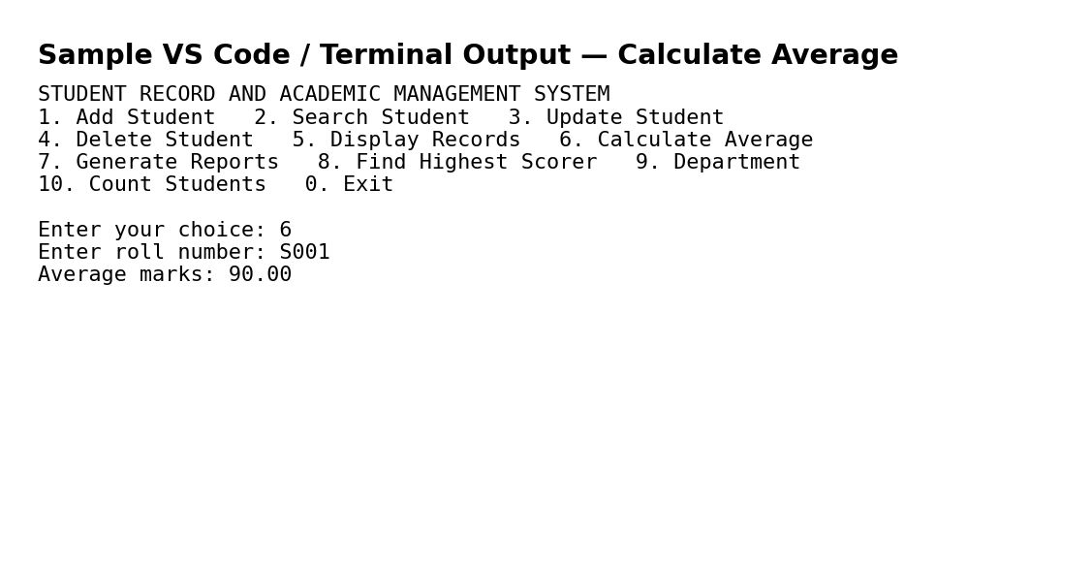
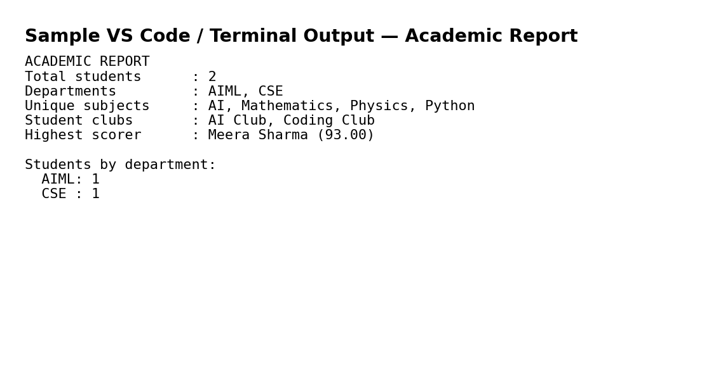

16. README
Project: Student Record and Academic Management System – Data Organization using Python
Purpose: Store, organize, update and retrieve student academic information using Python's built-in data structures.
HOW TO RUN
1. Install Python 3.
2. Open the project folder in VS Code.
3. Open Terminal.
4. Run:
python student_record_management_system.py
5. Use the numbered menu to test each operation.
The program starts with two demonstration records so that the main operations
can be tested immediately.

17. Student Deliverables Checklist
☐ Problem Analysis Report
☐ Data Structure Selection Report
☐ Algorithm Design Document
☐ Flowchart Collection
☐ Pseudocode Document
☐ String Programming Exercises
☐ List Management Programs
☐ Tuple-Based Programs
☐ Set Operations Programs
☐ Dictionary-Based Student Record Management System
☐ Integrated Student Record Management Application
☐ Testing Report
☐ Project Documentation
☐ Updated GitHub Repository

