Manual
Welcome to the manual for the rous Level Editor (RLE) v1.0. In the development of games for the NES, sometimes compromises have to be made. However, I've resolved to only make the necessary ones, and that means that you – the level designer – will have to make some slight concessions to ensure that your level will fit in the allowed amount of space. I've tried to make these concessions as aligned with one's natural thought process as possible, but only time will tell whether this actually worked. Good luck!
The level editor has the following features:
- Drawing of 8x8 pixel tiles using the NES color palette
- Combining them into larger 16x16 tiles and arbitrary size entity objects, which will be backed by sprites
- Creation of patterns, formed with commands that build them up out of 16x16
- Combination of those patterns into a full level, 32 (8x4) screens in size
It's still heavily under development (not even near completion as I'm writing this), so if you get a crash or bug of some sort… thanks for being part of the debugging process? Even minor improvements (a keystroke or two that don't exist yet) are welcome.
Color Palette Editor
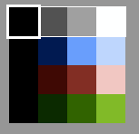

Up to four palettes are supported at once to draw your tiles, which is the amount that the hardware supports. Each large tile (16x16) can only have one palette throughout its entirety, something that the level editor does not enforce. Each palette has a single background color, which is shared between all four, and three colors of its own. Using the scroll wheel on any color in the palette will change it. The window indicates which color and palette you have selected. Also, if you hold Tab, an overlay will appear showing the numerical values for each color. Left click on any color to select it and its palette. Any tiles you are viewing will be displayed in the palette that was used when they were most recently changed.

Tile Editor
The tile editor allows for the direct editing of small tiles – 8x8 pixels – using your currently selected palette. Left clicking and dragging will draw on the tile using that color. Middle-clicking will fill the connected region with your chosen color. Below the tile editor is a grid of all the available tiles; there are 512. But take care! There are some important subdivisions here:
- The top half can only be used by background tiles, and the bottom only for sprites. The level editor doesn't enforce this, but the hardware certainly does.
- This part is still under development, but a cheap animation could be done by switching between sections of this table. Stay tuned for more updates.
You might find that 8x8 pixels is a bit small for your level elements. Fear not! These are not what are directly going into your levels. Instead, look to the:

Tile Builder

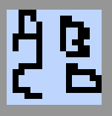
Here four 8x8 pixel small tile are arranged into a 16x16 large tile (called "metatiles" in the business) which you'll then more directly put in your levels. This has two effects:
- Smaller sizes, since you only need to store the number of the larger tile and not four numbers of each small tile
- Color granularity: the NES can only change its color palette on a basis of tiles of this size – hence the requirement for the same palette throughout this whole large tile
Left click and your selected small tile will be put in whichever corner you clicked. The table below, similar to before, stores all the available large tiles. Left click one to select it. There are 64 here, and you can use them wherever you see fit in your level, so long as you only have four palettes among all of them. This is a hardware hard restriction.
Level Editor
Press 'e'. The whole upper part of the screen will switch to the level editor (it toggles, so just press it again to go back).
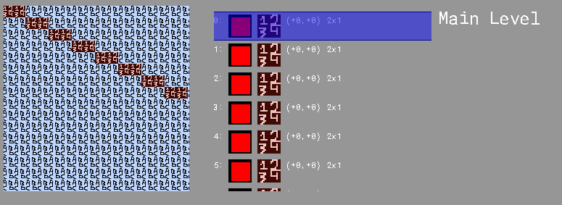
There's a lot of information here. At the far left is the scrolling level window. Arrow keys move it back and forth, and [] keys move it by larger increments. Your level will be shown here, or whichever pattern you're currently editing.
In the middle is the command list. In the RLE, levels are built up from commands: instead of specifying what tiles compose each level, you're giving instructions to the level engine on how to build it. Each line is a command, and there are five types of commands, each with its own icon:
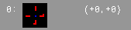
- Point commands. These place enemies and other objects of that nature, but are currently in development. Stay tuned!
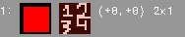
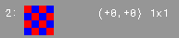
- Rectangle commands. These make a rectangle of tiles of the same type – this can even be 1x1 if you want to place a single tile. Next to their icon, they display the tile they're currently set to.
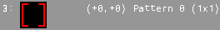
- Data block commands. These make a rectangle like the above – but they can specify each individual tile that compose them. The downside, of course, is that they take up a bit more space.
- Reference commands. These drop a copy of a pattern into your level, so if you find yourself using the same sequences over and over again, make a pattern out of it. Both you and the NES will thank you.
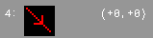
- Movement commands. The movement system is complicated and is discussed later, but these let you move by more than a short offset.
The movement system is probably the most unorthodox thing here. As the level engine draws the level out and reads in your commands, it keeps track of the current position. It takes more space to describe a position anywhere in the level than to describe a position relative to where you currently are, so that's what we did. The part in parentheses is the offset that that command causes before it draws itself. (+0, +0) means that it draws at the current position, for instance. And then, to make chaining them easier, each command moves the current position somewhere else. The rectangle commands, for instance, move the position to the bottom right of the rectangle, plus one in each direction. So if you had a bunch of rectangle command next to each other, with (+0, +0) in each one:
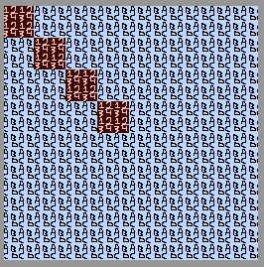

They would form a diagonal chain going downwards. And the movement commands? Well, the maximum range of that offset is -8 to 7, so if you want to have two consecutive commands that are farther than that away? You can use one of these movement commands move in increments of 8 in any direction and have a bit farther range: -32 to 24 in this case. They're cheap, so use them. Of course, you're not expected to keep track of all of this yourself. Pressing CTRL toggles clipping mode. This makes all commands past the one you're selecting disappear, so you can see the level where you're currently at in the command list, not just after all of them.
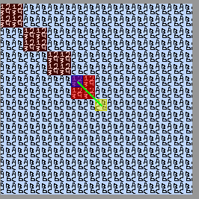
Pressing SHIFT toggles the overlay. The blue square is where your command started in terms of position, the red squares are tiles that your command changed, and the yellow square, connected with the green line is where the position ends up after it.
There are a number of hotkeys for navigating the command list. Scrolling scrolls the list up and down, and the arrow keys or left click change the selected command. Right click moves the selected command to where you clicked in the list. Backspace or delete deletes the current command, and enter adds a new command where you are – it defaults to a rectangle. To change that, hit space, which cycles the type of command you're working with. You can use WASD to change the offset value, and numpad 8426 to resize the command for those that support it. For the rectangle command and data block command, you need a way to change which tile(s) are selected – left click in the level area on part of the command's region to change it to the tile that you have selected right now. For the reference commands on the other hand, use scroll wheel on that area to change which pattern it selects. Speaking of patterns:
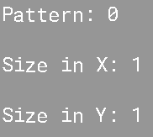
Patterns are independent lists of commands that can be "dropped in" at any point – similar to a function/subroutine in programming. The reference command is how you do this, and there are a maximum of 256 of them – a lot, but you don't need to use all of them. Scroll wheel is the way to go for manipulating patterns: scroll on the "Main Level" or "Pattern: #" text to change what you're editing, and on the sizes to resize the pattern. Patterns are edited just like the main level, because they're sequences of commands all the same. Each pattern can have a maximum of 128 commands in it, and the main level can have up to 256 – this might be too restrictive, but can be changed if need be (we'll see). Groundwork is in place for a "loop" option letting you draw several copies of a pattern in a grid with a single command – this will be in the final version.
Bytes
There are three things that are certain in life: death, taxes, off-by-one errors and having to economize bytes. Hopefully the third (second? fourth?) one is my problem and my problem alone, but the last one is something that the level designer will undeniably have to at least think about. I don't think that anyone has any illusions about how much 32 kilobytes is, or how much it isn't. And I still need half of that for my code, so use your space wisely. Everything that you do has a byte cost:
- There's a constant amount of overhead for your data which changes based on formats and such. Right now, it's probably around 2 or 3 bytes or so.
- Rectangle and reference commands cost 3 bytes.
- Data block commands cost 3 bytes plus the number of tiles they contain.
- Movement commands cost 1 byte. (+0, +0) movement commands are ignored, and so "cost" zero bytes.
- Point commands cost 2 bytes.
- Each unique pattern that gets used adds 4 bytes on, but only once per pattern – this is to store the size of the pattern and things like that.
- Each unique 16x16 tile costs 5 extra bytes!
- Each unique 8x8 tile costs… nothing?? Those are stored in graphics ROM, so they don't count against this total.

Current Status
This is, in every sense of the word, a first draft. Although most of these features will probably be there by the time you even get a copy of the level editor, here's what isn't in place right now:
- Saving and loading to files
- Sprites and objects to form enemies and things like that
- A byte counter
- Animation and better organization with the tile grids
- The "loop" option for reference commands
- Probably a handful of hotkeys
- Bugfixes that I don't even know about, and a large number of other things

