SUPERVISED LEARNING / CLASSIFICATION

Customer Churn
Classification
Project Report | Model comparison, cross-validation and test-set evaluation

Executive summary
This project compares three supervised classifiers for predicting whether a customer will churn. The provided CSV contains 5,880 customers, with churn represented in 49.29% of rows. Random Forest is the strongest candidate by mean five-fold cross-validation ROC-AUC (0.5031), but its held-out test ROC-AUC is 0.4982. This is essentially random ranking, so the current model is not suitable for deployment and the data should be investigated before making business decisions.

Dataset profile
Item | Observed value
Rows | 5,880 customer records
Original columns | 21, including customerID and Churn
Model input features | 19 after removing the identifier and target
Feature types | 15 categorical and 4 numerical
Target distribution | 2,898 churned (49.29%); 2,982 not churned (50.71%)
Missing cells in supplied CSV | 0 observed before preprocessing

Method
- Remove customerID and encode the target as 1 = Yes (churn), 0 = No (no churn).
- Use a stratified 80/20 train/test split (random_state=42).
- Within pipelines, impute missing values if present, one-hot encode categorical fields, and standardize numerical fields.
- Compare Logistic Regression, Random Forest, and Gradient Boosting using five-fold stratified cross-validation on the training data.
- Report Accuracy, Precision, Recall, F1-score, and ROC-AUC on the untouched test split; include a majority-class baseline for context.

Evaluation results
Held-out test-set performance. Values are rounded to four decimal places; “churn” is the positive class.
Model | Accuracy | Precision | Recall | F1-score | ROC-AUC
Logistic Regression | 0.5009 | 0.4926 | 0.4000 | 0.4415 | 0.4748
Random Forest | 0.5119 | 0.5054 | 0.4810 | 0.4929 | 0.4982
Gradient Boosting | 0.4804 | 0.4721 | 0.4517 | 0.4617 | 0.4628
Majority-class baseline | 0.5068 | 0.0000 | 0.0000 | 0.0000 | 0.5000
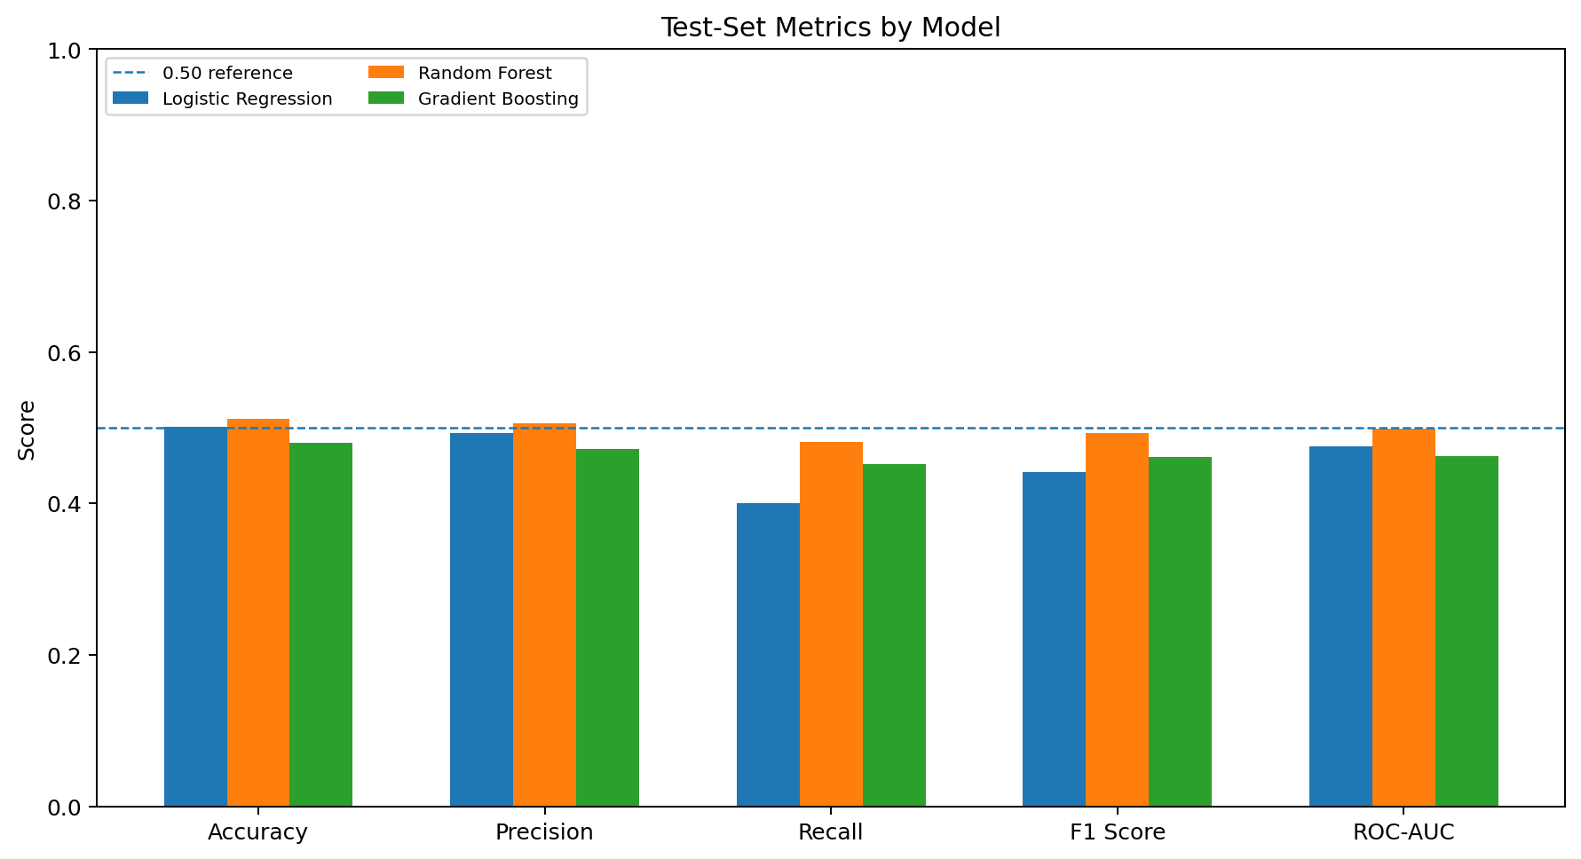
Figure 1. Comparison of test-set classification metrics for the three trained models.

Cross-validation results
Mean five-fold ROC-AUC on training data was 0.4869 for Logistic Regression, 0.5031 for Random Forest, and 0.4982 for Gradient Boosting. Random Forest ranks first among the three by this criterion, but the score is only marginally above 0.50 and its test ROC-AUC falls slightly below 0.50.

ROC analysis and interpretation
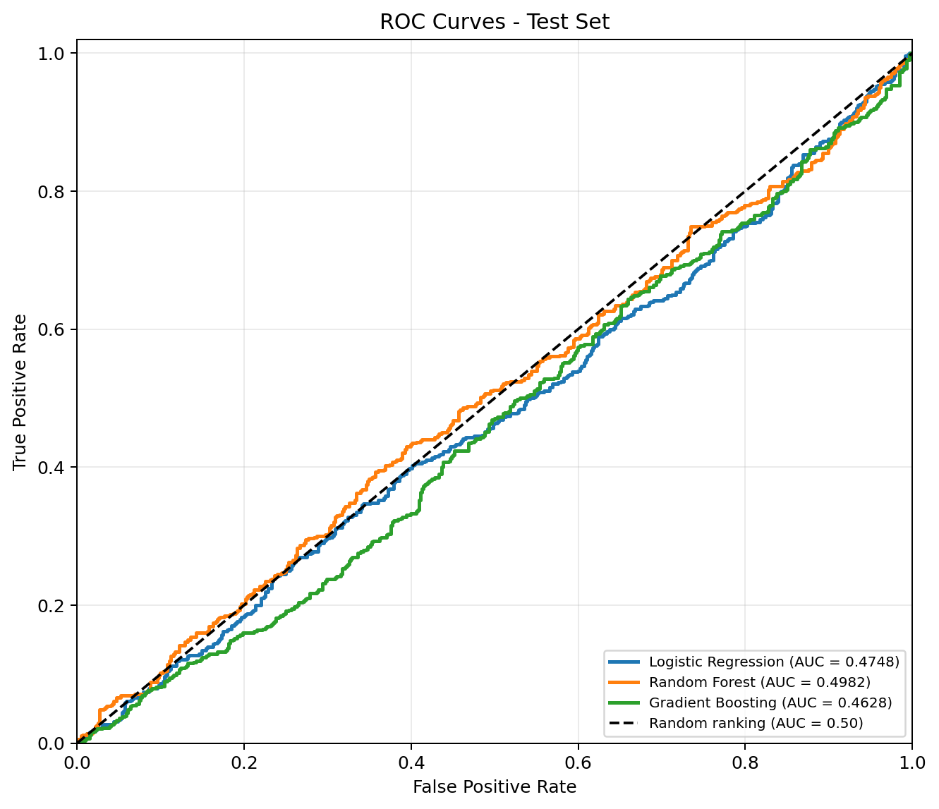
Figure 2. Test-set ROC curves. The dashed diagonal represents random ranking (ROC-AUC = 0.50).

What the results mean
The model curves lie close to the random-ranking diagonal. Random Forest reaches 51.19% accuracy, only about 0.51 percentage points above the majority-class baseline (50.68%), while its ROC-AUC is 0.4982. The other two models are below the 0.50 ROC-AUC reference on the test set. These metrics do not establish that the supplied features predict churn reliably.

Limitations and recommended next checks
- Verify the dataset source and the meaning of the target; check that churn labels are correct and aligned with each customer row.
- Review feature definitions, collection timing, and potential data-generation or label-shuffling issues. The supplied files do not state the dataset provenance.
- Explore more informative features and tune model settings only after data validity has been checked. Keep model selection inside cross-validation.
- Do not treat feature importance as causal evidence or deploy this candidate until performance improves on independent data.

Reproducibility and project files
From the project directory, create and activate a virtual environment, install requirements, then run the notebook or script.
Setup and run commands
- py -m venv .venv
- .\.venv\Scripts\Activate.ps1 (Windows PowerShell) | source .venv/bin/activate (macOS/Linux)
- python -m pip install -r requirements.txt
- jupyter notebook -> open Customer_Churn_Classification.ipynb and run all cells
- python run_analysis.py (regenerates metrics and plots in artifacts/)

Included code and supporting files
Resource | File / folder
Full notebook, code, outputs and plots | Customer_Churn_Classification.ipynb
Command-line reproducible analysis | run_analysis.py
Input dataset | customer_churn_data.csv
Metrics, ROC, confusion matrices and charts | artifacts/
Setup commands and repository instructions | README.md
Expanded project notes | project_documentation.md

Metric guide
Metric | What it measures
Accuracy | Share of all predictions that are correct.
Precision | Share of predicted churn cases that actually churned.
Recall | Share of actual churn cases correctly identified.
F1-score | Harmonic mean of precision and recall.
ROC-AUC | Ability to rank churn cases above non-churn cases across thresholds; 0.50 is chance-level ranking.
GitHub status: The package has not been pushed to GitHub; no repository was available through the connected account during preparation. Create an empty repository, follow the Git commands in README.md, and add the actual repository URL after pushing.

