Manual Deployment Workflow
Meta Clinic | How to push code without changing the live website
This guide explains the separation between saving code in GitHub and intentionally publishing a new version to the hosted application. The normal workflow is: edit, verify, commit, push, and leave the live site unchanged. Publishing is a separate, deliberate GitHub Actions step.
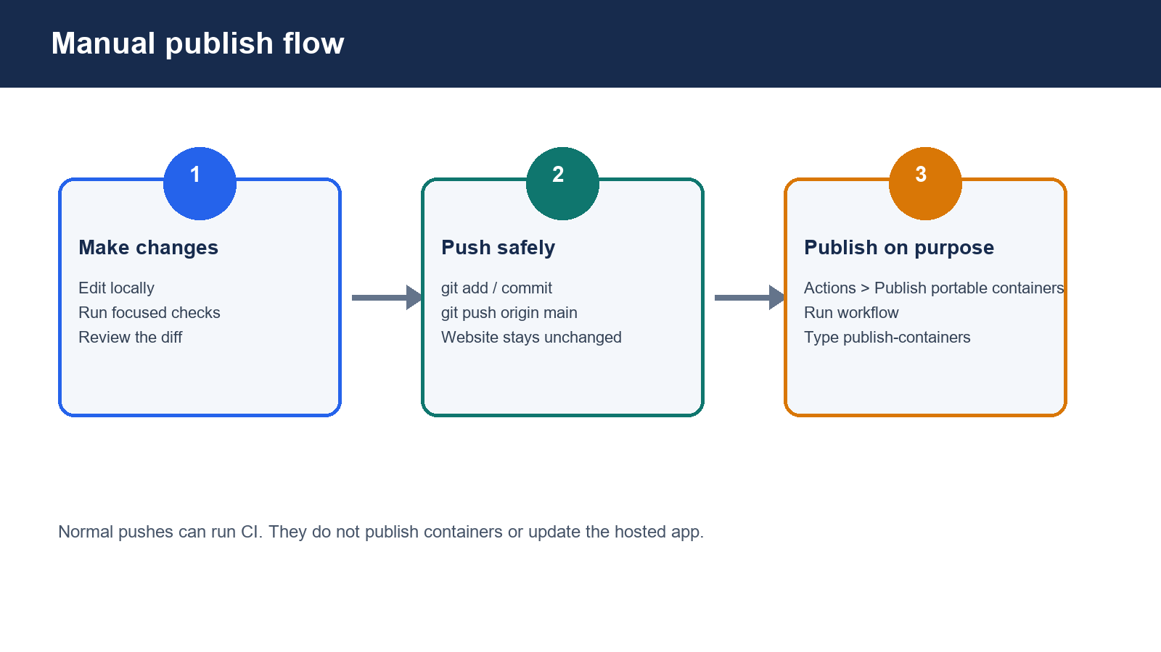
Figure 1. The intended separation between source control and publishing.

The short version
- Push code whenever you need a backup or collaboration point. A push to main may start CI checks, but it should not publish the website.
- Only publish when you have reviewed the exact commit and want the hosted containers rebuilt.
- Publishing is done from GitHub Actions with the Publish portable containers workflow and the confirmation phrase publish-containers.

Before you begin
You need | Why | Where to check
GitHub access | You must be able to push and run workflows. | Repository Settings and Actions tab
A reviewed commit | The publisher builds from one exact main commit. | Your local git log and GitHub commit page
Passing checks | CI evidence reduces the chance of publishing a broken build. | Actions tab; local checks; browser smoke test
Owner-controlled deployment access | The host must be updated intentionally and recoverably. | ops/portable/README.md and the deployment host

Workflow A Push code without updating the website
Use this for ordinary development, backups, collaboration, and review.
1. Check what will be included. git status --short
2. Run the focused checks for your change. Use the commands documented in docs/development/README.md and the nearest AGENTS.md.
3. Review the diff. git diff --check
git diff --stat
4. Commit the reviewed change. git add <specific-files>
git commit -m "Describe the change"
5. Push to GitHub. git push origin main
Expected result: GitHub may show a CI run for the push. The website should remain on its current deployed version because the publishing workflow is manual-only.

Workflow B Publish a new hosted version
Use this only after deciding that the live hosted application should change.
- Open the repository on GitHub: github.com/joshrice171723-creator/meta_clinic.
- Select the Actions tab.
- In the left workflow list, select Publish portable containers.
- Select Run workflow.
- Confirm the branch is main.
- In the confirmation field, type exactly: publish-containers
- Select Run workflow and wait for the run to finish.
- Record the commit SHA shown by the run. The API and web images are tagged with that same SHA.
- Update the owner-controlled deployment host using the matched API and web image tags. Follow ops/portable/README.md or the approved host runbook.
- Open the hosted URL and verify login, protected-route denial, the changed behavior, and service health. Keep the previous image identities for recovery.
Important: publishing the containers and updating the running host are separate actions. The GitHub workflow creates images in GHCR; it does not itself grant the server access or replace the running containers.
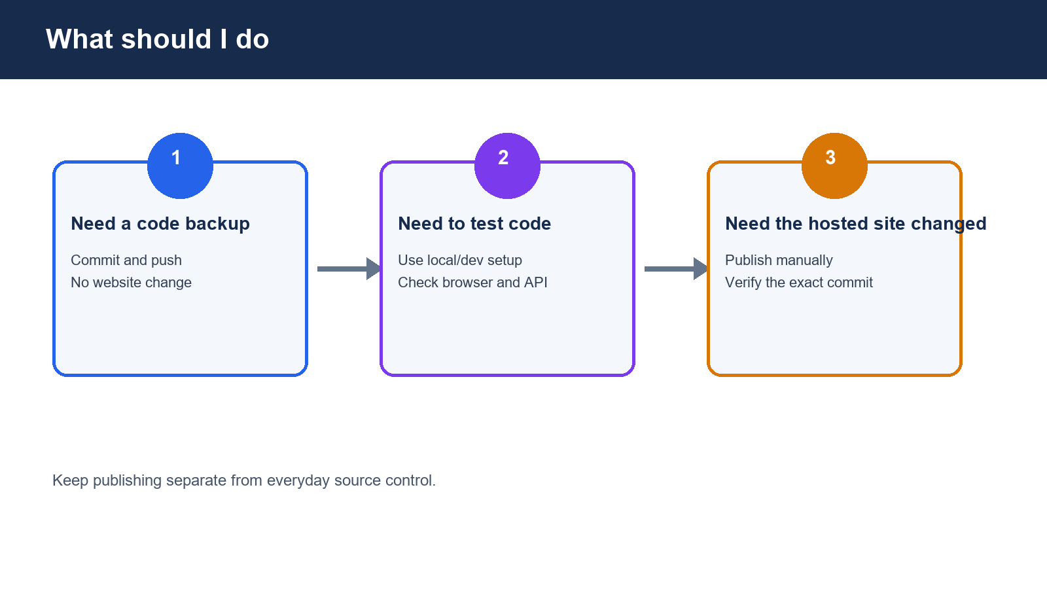
Figure 2. Choose the smallest workflow that matches your goal.

Useful links
- Repository
- GitHub Actions workflow file
- GitHub Actions manual workflow documentation
- GitHub Actions monitoring documentation
- Portable deployment runbook in this repository
- GitHub Container Registry documentation

Common mistakes and recovery
Symptom | What to do
The site changed after a push | Check the hosting provider, not only GitHub Actions. Look for a provider-side Git integration, webhook, or connected branch. Disable automatic deploys there or change the deploy branch to a protected release branch.
The workflow is missing | Confirm you are viewing the main branch and that .github/workflows/publish-containers.yml exists there.
The workflow refuses to run | The job requires the main branch and the exact confirmation phrase publish-containers.
Only one service was updated | Do not mix API and web images. Use the two image tags from the same workflow run and commit SHA.
A deployment is unhealthy | Keep the previous image tags, stop promotion, inspect logs and health checks, and follow the recovery runbook. Do not delete the database volume or regenerate encryption keys.

Final checklist
☐ I know whether I am only pushing code or intentionally publishing.
☐ The commit is reviewed and the relevant checks passed.
☐ The deployed API and web images come from the same commit.
☐ I kept the previous image identities for recovery.
☐ I verified the hosted site after a deliberate deployment.
☐ No secrets, patient information, or confidential data were committed.

