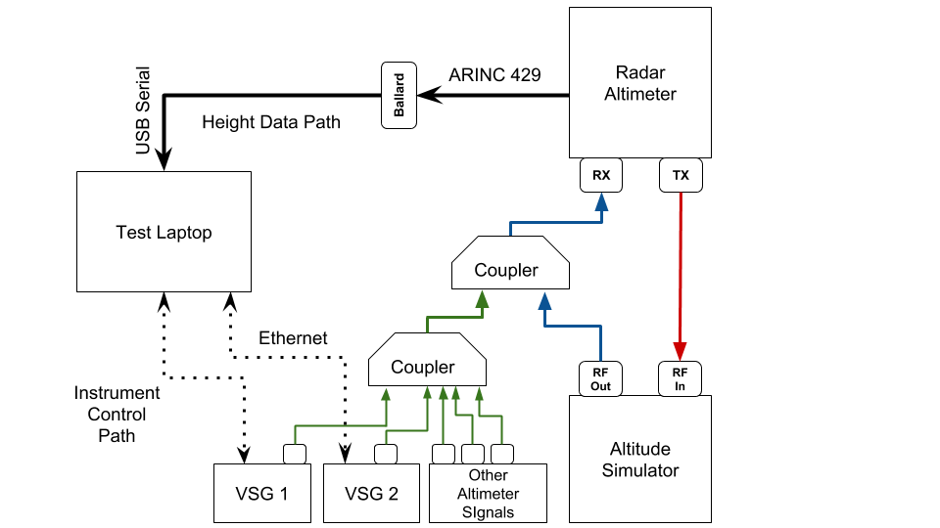

Figure 2.9: Expanded Test Bench For Wideband and Altimeter Interference.

## 2.4.2 Simulating Altimeter Interference

The other major modification shown in Figure 2.9 was the addition of other altimeter signals to the interference already being tested. This addition intended to move the setup closer to the reallife worst case scenario for the interference an altimeter might be subjected to. The test bed was configured to replicate an approach for landing scenario used in earlier compatability investigations. A series of VCOs were calibrated and driven by function generators to generate the external altimeter signals, and programmable and fixed attenuators configured the distance of each altimeter signal from the receiver. The VSG setup was configured to simulate the interference of the full 4.2 to 4.4 GHz band filled with WAIC signals from other aircraft, with a goal of determining what WAIC radiated power limitations were necessary to protect altimeters. Finally, all of these signals were coupled together with the VSG signals to send toward the interference injection point.

### 2.4.2.1 Determining the Worst-Case Scenario Geometry

A worst-case scenario for the interference experienced by a victim altimeter from other aircraft was developed in the 2014 compatibility studies submitted to the ITU [12]. The authors determined that the altimeter data was most important to the safety of a flight during the landing phase of operation. When aircraft line up for approach, they typically maintain a distance of around 5 km, which makes interfernce from WAIC signals or other altimeters aboard these neighbors negligible. On the other hand, aircraft taxiing or in holding adjacent to a runway can achieve distances less than 300 m to the victim RA. These aircraft could present a significant hazard to nearby altimeter receivers if WAIC power limitations are not developed in the context of this scenario.

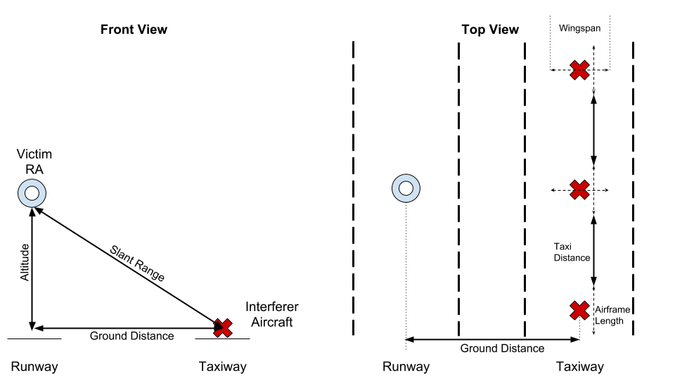

Figure 2.12: Geometry Used in [12] for Interference During Landing Scenario

Figure 2.12 shows the geometry from [12] which was also used for the this compatibility study. The markers represent the center of the airframe for each aircraft. Three parameters specify the distance of aircraft to one another in this scenario. The *ground distance* between the runway and adjacent taxiway, the *altitude* of the victim aircraft during descent, and the *taxi distance* from nose to tail of aircraft in the queue for takeoff. A *slant range* between the victim RA and an interferer can be determined using these parameters. Additionally, the *wingspan* and *airframe length* of each plane plays a role in the location of potential interferers.

The path losses from simulated WAIC signals were calculated in the context of this geometry.

Altimeter transmitters and receivers were located at the center of the airframe, directly underneath each aircraft. Interferers modeling WAIC devices for applications internal to the aircraft were grouped together at the center-point inside of each airframe. For applications external to the aircraft, Interferers were grouped together at the wing tip closest to the victim altimeter. This model provides a worst case scenario for WAIC interference, because in reality WAIC devices would be distributed throughout an airframe according to the need of an application, rather than grouped together at the point closest to an external aircraft’s receiver.

In addition to specifying the path loss experienced by WAIC interferers located at a minimum slant range, this geometry also served to model the interference subjected to the victim RA by other altimeters. While most altimeters are designed to handle external altimeter signals, the *combination* of these signals with WAIC interference leads to more stress on the victim receiver. This geometry models the locations of external altimeters along with WAIC signals to simulate this effect. Path losses assigned to each simulated altimeter are specified by the location in this geometry.

### 2.4.2.2 Simulating Individual Altimeter Signals

Several approaches were considered to simulate altimeter signals for the approach scenario. While software defined radios were appealing for the convenience the offered in modifying the test bed, they were in the end rejected in favor of a series of Voltage Controlled Oscillators (VCOs) controlled by function generators. The major advantage seen in the VCO approach was the simplicity of explaining the test scenario to regulators, as opposed to having to present another piece of software.

Eight two channel function generators and 16 VCOs were ordered for this purpose. The function generators were configured to output a triangle voltage wave to drive the VCOs in the FMCW pattern seen in Figure 1.1. The min and max voltage on the triangle wave correspond to the VCO setting for the min and max frequency of the simulated altimeter waveform. The frequency of the voltage waveforms was varied between different VCOs to simulate the varying pulse frequencies exhibited by different altimeters as well as to provide randomness to the simulation. It was considered critical that the different simulated altimeter signals were asynchronous to provide a realistic scenario.

### 2.4.2.3 Calibrating The VCOs

The VCOs ordered for this purpose could go beyond the 4.2-4.4 GHz range, but a control voltage did not necessarily map to the same frequency across different VCOs. This meant that each of the 16 VCOs needed to be calibrated. First, each VCO was connected to a 5V power supply, and the control pin was connected to a separate power supply. The RF output of each VCO was connected to the spectrum analyzer for observation. The frequency output by a VCO under constant voltage had a bit of a ‘wobble’ to it, so the spectrum analyzer was configured to display a *Max Hold* instead of a real time measurement. After a VCO was left on a control voltage for several seconds, a marker was used to locate the frequency of the maximum output at that setting.

The first calibration sweep went from 0 to 5 V in 1 V increments. The goal of this broad sweep was to get an approximation for where the 4.2 and 4.4 GHz voltages were for each VCO. The VCO output was observed on the spectrum analyzer to determine the operating frequency at that control voltage. The search found that a majority of the 4.2-4.4 GHz band lied in the 2-5V range for these VCOs. The initial sweep was not fine enough to capture the desired minimum and maximum frequencies for each VCO.

A second calibration was attempted to fix this. The goal was to get the simulated FMCW waveforms centered at 4.3 GHz, with a span of ±65 MHz. Using 100 mV increments, the previous calibration procedure was repeated, this time explicitly searching for the control voltages corresponding to the frequencies closest to 4235 MHz and 4365 MHz. These were achieved with a ±3 MHz precision. The 100 mV increments from the calibration process were chosen due to the precision available to the function generators. It was this limitation that lead to the 3 MHz frequency precision. The full calibration results are shown in Table 2.6.

Once the lower and upper voltages were determined, a simple calculation found the center voltage and amplitude necessary to feed into the function generators. In addition to the amplitude and offset settings available to the function generator, the control voltage wave had a frequency

Lower

Upper

Function Generator Setting

VCO

Freq [GHz]

Voltage

Freq [GHz]

Voltage

Freq [Hz]

Amplitude

Center

1

2.2

4.237

4.362

4.0

1.8

143

3.1

2

1.6

4.236

4.367

3.5

143

2.6

1.9

3

4.232

2.2

4.1

4.365

1.9

3.2

143

4

2.0

4.233

4.364

3.9

3.0

111

1.9

5

4.233

1.8

4.364

3.7

133

2.8

1.9

6

2.0

4.238

4.362

3.8

2.9

133

1.8

7

4.233

1.8

4.365

3.7

1.9

133

2.8

8

4.233

1.7

4.368

3.6

118

1.9

2.7

9

4.235

2.0

4.367

3.9

118

1.9

3.0

10

4.233

2.0

3.9

4.365

118

3.0

1.9

11

2.0

4.238

4.362

3.8

1.8

2.9

111

12

2.1

4.236

4.366

3.8

1.7

3.0

129

13

4.235

1.8

3.7

4.364

2.8

129

1.9

14

2.0

4.235

4.366

3.7

1.7

2.9

129

15

4.237

2.1

4.368

3.8

1.7

3.0

143

16

4.233

2.3

4.365

4.2

1.9

3.3

143

Table 2.6: VCO Calibration Results and Corresponding Function Generator Settings

parameter. These were chosen in part with enough variance so that there was no synchronization between the different simulated altimeter signals. Random crossover of the simulated altimeter signals was desired to closely match the real world interference scenario. Function generator parameters are also shown in Table 2.6.

### 2.4.2.4 VCO Protection Circuit

While the VCO’s were designed to operate with a control voltage between 0 and 5V, they were later verified to tolerate a maximum 6.5V signal before a catastrophic failure. Because the Function Generators were capable of a 20V peak to peak signal, they could damage a VCO with an accidental twist of a knob, and a protection circuit was needed.

Initially, the protective circuit seemed even more urgent. The voltage setting on the function generator starts at 10V upon power up, but does not clearly mark whether this is a peak to peak voltage or ±10 V. Compounding this ambiguity, when the output of the function generators was measured with an oscilloscope, the multiplier setting was set to 2X. This made it appear to be a ±10 V signal on startup which would fry the VCO if the function generator was accidentally power cycled. This error was only noticed after the protective circuit was designed and built.

After some searching, a limiter or ‘clipper’ circuit was decided on to protect the VCOs. Clippers consist of a resistor and one or two diodes. Various designs of clipper circuits and the tradeoffs between them are discussed in [13]. Based on this discussion, a double clipper was decided on because it would limit both the positive and negative extremes of the control waveform. The clipper circuit was modeled in a spice program so that different diode cutoff voltages could be tried.

Simulations narrowed this down to a 6 (?)V Zener (?) diode. The diagram is shown in Figure ??

## 2.4.3 Testing Lower Altitudes

A final major modification from the initial test regimen involved adding different altitude simulator configurations to the rotation to achieve lower altitudes. These were touched on briefly in Section 2.2.2.

2.4.4 Dual-VSG In Band Testing

## 2.4.5 Dual-VSG Out Of Band

REFERENCES

1. D. Redman, “WAIC Overview and Application Examples,” 2011.
2. H. Canaday, “War on wiring,” *Aerospace America*, May 2017.
3. Ferrell, “Feasibility of Intra-Aircraft Wireless Sensors,” Final Report AFE 56, Aerospace

Vehicle Systems Institute (AVSI), May 2007.

1. A. Tewfik, M. Heimdahl, N. Hopper, and K. Yongdae, “University of Minnesota Final Report,” AFE 56s1 Final Report, University of Minnesota, Minneapolis, Minnesota, Mar. 2009.
2. “Consideration of regulatory actions, including allocations, to support Wireless Avionics

Intra-Communications,” Resolution 423, World Radio Conference, Geneva, Switzerland, 2012.

1. “Consideration of the Aeronautical Mobile (route), Aeronotical Mobile, and Aeronautical Radionavigation Services Allocations to Accommodate Wireless Avionics IntraCommunication,” ITU Reccomendation ITU-R M.2318-0, International Telecommunication Union, Geneva, Switzerland, Nov. 2014.
2. “Final Acts of the World Radiocommunication Conference,” Final Acts WRC-15, International Telecommunication Union, Geneva, Switzerland, 2015.
3. “Operational And Technical Characteristics and Protection Criteria of Radio Altimeters Utilizing the Band 4 200 - 4 400 MHz,” ITU Recommendation ITU-R M.2059-0, International Telecommunication Union, Geneva, Switzerland, Feb. 2014.
4. “Minimum Performance Standards Airborne Low-Range Radar Altimeters,” Industry Standard DO-155, Radio Technical Commission for Aeronautics, Washington, D.C., Nov. 1974.
5. J. G. Proakis and M. Salehi, *Communication Systems Engineering*. Upper Saddle River, New

Jersey: Prentice Hall, second ed., 2002.

1. “Overview of IRIG-B Time Code Standard,” Technical Note IRIG Standard 200-04, Cyber

Sciences, Murfreesboro, TN, Sept. 2017.

1. “Compatibility Analysis Between Wireless Avionics Intra-Communication Systems and Systems in the Existing Services in the Frequency Band 4 200-4 400 MHz,” ITU Reccomendation ITU-R M.2319-0, International Telecommunication Union, Geneva, Switzerland, Nov. 2014.
2. A. S. Sedra and K. C. Smith, *Microelectronic Circuits*. Oxford: Oxford University Press, seventh edition ed., 2015.