*Investigating the state space of the hair bundle*

*in an exploration of tuned criticality within the inner ear*

Joshua D. Salvi, Tri-Institutional MD-PhD Program

Laboratory of Sensory Neuroscience, A.J. Hudspeth

September 2012

**Motivation and Specific Aims**

Human hearing is an engineering masterpiece. Trained musicians can distinguish frequencies differing by only 0.1% (1). Further, sound pressure stimuli ranging over six orders of magnitude (or 120 dB) can be tolerated (2), with a hearing threshold corresponding to energy near that of thermal fluctuations (3). Such traits imply a system that adds work through multiple mechanisms that serve to enhance signal detection. All of these components can be found in the cochlea, where they are together defined as the “active process” that augments incoming signals. Collectively, the active process enhances audition through amplification of small stimuli, sharp frequency tuning, and nonlinearity that compresses a vast range of stimulus magnitudes into a reasonable gamut of cochlear responses (4, 5). In addition, narrowband signals can be detected as emissions from the ear, epiphenomena of active biomechanical processes (6).

Nearly 30 million Americans are afflicted by hearing impairment, with approximately half of these cases due to exposure to loud noise (7). Noise-induced, drug-induced, and congenital hearing loss manifest themselves in damage to the receptors of the inner ear, hair cells (8). A grasp of this pathophysiology necessitates thorough knowledge of hair cells and their mechanical antennae, hair bundles. Here, I propose to exert control over hair-bundle mechanics to reveal the qualities that grant humans such exquisite auditory perception.

Astrophysicist and polymath Thomas Gold previously noted an active process in audition. In his two-part treatise of 1948, Gold predicted that the resonant quality of the basilar membrane could not be accomplished by a passive system, simply due to challenges in overcoming viscous damping. He extended this with a “regeneration hypothesis,” whereby an oscillator of “negative resistance” would permit high-quality resonance in the cochlea. His predictions mirrored observations in radio engineering, in which an oscillator whose amplificatory gain is too great will begin to self-oscillate (9). Years later, his hypotheses were reimagined with the emergence of a bifurcation theory for hair bundles. A bifurcation is a large qualitative change of a general dynamical system. This is exemplified in radio systems that can begin to self-oscillate – a dramatic behavioral change – after an increase in gain, a quantitative parameter. Indeed, hair bundles (*see Figure 1a,b for an illustration*) of multiple organisms spontaneously oscillate (10, 11). As described later, the transition at a Hopf bifurcation occurs at the critical value of some control parameter (12). Near the critical point bordering monostability of the hair bundle and spontaneous oscillations, convenient characteristics emerge. In particular, amplification of small stimuli, compressive nonlinearity, and frequency tuning develop as the hair bundle approaches criticality (13, 14). Upon crossing the bifurcation, the hair bundle produces spontaneous limit cycle oscillations. This phenomenon may provide a mechanism for generation of spontaneous otoacoustic emissions in amphibians (10) and lizards (15, 16). Taken together, the four components of the active process can be explained as the behavior of a dynamical system acting near a Hopf bifurcation.

This study seeks to scrutinize the state space of the hair bundle’s dynamics in order to unveil its sensory amplificatory properties. Recently, Ó Maoiléidigh et al. proposed a theoretical hair bundle state space based upon multiple models of bundle biomechanics (17). This dynamical system can be readily explored by manipulation of control parameters of offset force and stiffness. In doing so, I shall coerce the hair bundle to cross its critical point, demonstrating for the first time the presence of a Hopf bifurcation embedded in hair-bundle mechanics. This will then provide a tool for further investigation of phenomena characteristic of the active process. Thus, by controlling mechanical properties, I shall elucidate the functions of hair bundles that endow humans with keen auditory sensation.

*Specific aims*

**Aim 1: *Develop a modified displacement clamp for independent control of force and stiffness.*** I shall modify the feedback in a displacement clamp to control the total stiffness applied to hair bundles. This system will provide independent control of the offset force applied to hair bundles (*See Supplementary Material for detailed analyses.*). By holding offset force constant in each trial and modulating the gain, I shall develop calibration curves, depicting a displacement-stiffness relationship predicted by Hookean elasticity. I intend to prepare a systematic protocol stepping through a two-dimensional state space, allowing for versatility in both the exploration of the hair bundle state space and delivery of stimuli.

**Aim 2: *Map the two-dimensional state space for hair bundles of the saccular macula.*** Using the modified displacement clamp, I shall poise the hair bundle at different locales within a force-stiffness state space. As the space is traversed, regimes of monostability, spontaneous oscillations of differing amplitude and frequency, and bistability will be noted. I shall deliver stimuli of white noise to bundles in the monostable regime to determine the bundle’s operating-point trajectory relative to its state-space landscape. The primitive character of the state space will emerge with knowledge of the hair bundle dynamics occurring at various locations in the state space. Upon mapping, I shall revisit and improve upon previous models, developing them as the information is gleaned from experiment.

**Aim 3: *Determine whether approaching criticality generates phenomena associated with the active process.*** After mapping of its state space, I plan to experimentally poise a hair bundle near a supercritical Hopf bifurcation by adjusting its operating point. While adjusting the operating point to poise the bundle at relative distances from this instability, I shall deliver discrete frequency sweeps to the bundle. These data will provide frequency selectivity, nonlinearity, and amplification curves at different operating points, recapitulating those predicted near a Hopf bifurcation. This will reveal causality between criticality and active-process phenomena.

**Aim 4: *Explore bundle phenomena, including self-tuned criticality, bursting behavior, and longer timescales of adaptation.*** Armed with the maps and models of the hair bundle described by this state space, I plan to explore additional phenomena. I shall employ a model of Ca2+ flux to scrutinize self-tuned criticality, whereby an artificial reduction in Ca2+ concentration induces spontaneous oscillations until the hair bundle reaches a steady state of self-tuned critical oscillations. I intend to explore longer timescales of adaptation. I hypothesize that the hair bundle tunes itself near a Hopf bifurcation, that bursting behavior will be explained by a higher order bifurcation, and that longer timescales of adaptation will emerge as I coax the bundle through its state space at different velocities.

**Background**

Sound waves that impinge upon the tympanum are coupled to the middle ear, which transmit these signals to the inner-ear structures that perform mechanoelectrical transduction. The amphibian inner ear possesses eight end organs: three semicircular canals, the lagena, utricle, sacculus, amphibian papilla, and basilar papilla. Of these, the sacculus, amphibian papilla, and basilar papilla respond to auditory stimuli (18). Hair cells, named after the bundles of hair-like microvilli on their apical surfaces, are the sensory receptors of these organs (*Figure 1a,b*). These hair bundles are coupled to an overlying gelatinous matrix, the otolithic membrane. Stimulation due to linear acceleration or low-frequency seismic or auditory stimuli deflects the otolithic membrane. This in turn deflects coupled hair bundles, resulting in depolarization of the hair cells. Molecular and structural attributes of the hair bundle provide the foundation for this transduction.

Each stereocilium is connected to its taller neighbor by a proteinaceous filament known as the tip link (19). Composed of protocadherin-15 and cadherin-23 (20), this link is in series with one or two mechanoelectrical transduction (MET) channels (21, 22) that pass current at the stereociliary tip (23). Such current comprises a flux of Ca2+ and K+, the former controlling myosin motor activity. At rest, tension in the tip links equals the 12-21 pN stalling force of approximately 12-24 active myosin-1c motors in series with this complex (24). This maintains an open probability of 0.15 in physiological conditions (25-27). Positive deflection of the hair bundles results in a shearing force between stereocilia, increasing the open probability of the MET channels as tip-link tension rises. As the stalling force of the myosin motor complex is overcome, the motor slips with a time constant of 5-50 ms. Negative deflections slacken the tip link and allow the motors to climb the stereocilium, restoring tension, thus increasing open channel probability. This mechanism of slow adaptation requires ATP hydrolysis for myosin motor activity and is thus an active process (28).

If a series of steps is delivered to the hair bundle under displacement-clamp conditions (*Figure 1c*), the ensuing plot of force versus displacement reveals a region of negative stiffness. As each channel opens with positive deflection, slackening tip links, and cooperativity in channel opening begets negative stiffness (29, 30). Upon digestion and removal of the otolithic membrane, healthy hair bundles spontaneously oscillate at frequencies of 5-50 Hz and with an amplitude of ~25 nm. Furthermore, attaching a stimulus fiber and clamping the bundle’s position with increasing feedback strength reduces these oscillations’ amplitude and increases their frequency (31). Increasing the extracellular concentration Ca2+ provides a similar trend in frequency and amplitude of oscillations (16).

The observations of slow adaptation, negative stiffness, and spontaneous oscillations can be coalesced into a single model of hair-bundle motility. After deflecting the hair bundle for ~100 ms, slow adaptation was shown to shift the force-displacement curve in order to maintain the open probability of MET channels at their resting state. If one considers a force-displacement relation migrating as adaptation proceeds, a model for spontaneous oscillations emerges. The negative region in the force-displacement curve indicates bistability. Thus, as the bundle continues to adapt and move the force-displacement curve in the direction of the bundle’s deflection, it will eventually reach an instability with MET channels either mostly closed or mostly open. Instability results in rapid adjustment in the opposite direction, followed by slow adaptation in that same direction. Stability is lost once again with saturation of the MET channels, and the cycle repeats. This cycle of fast and slow components underlies the relaxation oscillations observed (30). Soon after the proposal of this model, a protocol that clamped hair bundles at different points along their oscillatory trajectory and measured a force-displacement relation demonstrated such an adaptive shift throughout the cycle (32).

The aforementioned active process of the inner ear with can be described by a system poised near a Hopf bifurcation. The truncated normal form of a supercritical Hopf bifurcation (*Figure 3a-c*) is given by:

*with*

The real part of the complex variable *z* could in this scenario be considered hair bundle position. If one considers only the first component, , then the system displays exponential growth or decay depending upon the sign of the control parameter, . The imaginary component, , corresponds to sinusoidal oscillation at a characteristic frequency . With a negative value for , the first two terms would result in exponential decay to a stable equilibrium (33). If instead is positive, this would result in an exponentially growing sine wave. If the third component’s coefficient *a* is negative, however, this constrains the wave’s amplitude and yields a limit cycle. If the coefficient *a* becomes positive, the system passes a Bautin bifurcation, birthing a subcritical Hopf bifurcation (*Figure 3d-f*), with its limit cycle described by the fifth-order component (not shown) (12, 34).

Evidence that the hair bundle may be described as such a dynamical system has grown in recent years. First consider nonlinearity. When the system is poised near a Hopf bifurcation (), the relationship between the phase-locked response and stimulus magnitude should follow a 1/3-power law. By extension, sensitivity then follows a -2/3-power law with respect to stimulus magnitude. Such nonlinearity underlies compression expected from the active process. Indeed, when hair bundles were stimulated with different amplitudes of an oscillatory stimulus, a phase-locked response in bundle movement emerged with a 1/3-power law in displacement and -2/3-power law in sensitivity (35). Such nonlinearities are predictive of the distortion products first noted by the violinist Giuseppe Tartini in the 18th century and later employed in both the control of the intonation of double-stop intervals (36) and in musical composition (37). The magnitude of cubic distortion products ( and ) should dominate over other combination tones in an active cochlea near a Hopf bifurcation. When an active bundle was provided a two-tone stimulation, the bundle alone displayed these combination tones, providing additional evidence that the hair bundles are critical oscillators (38).

Taking into account such evidence for a Hopf bifurcation, how can one best demonstrate its existence? If previous psychophysical and micromechanical data have been the footprints of the Hopf bifurcation, we wish to observe the animal itself. The most apparent method is to first propose a state diagram of the hair bundle in which each operating point is determined by one or more control parameters. The landscape of the state space at any given position would predict the system’s behavior. In 2012, Ó Maoiléidigh et al. developed a two-parameter state space for the hair bundle (*Figure 2*). Control parameters of offset force (FC) and stiffness (k) poise the bundle at different operating points. Oscillatory, monostable, and bistable regimes, reached through subcritical Hopf, supercritical Hopf, and fold bifurcations, are predicted for hair bundle dynamics. Control of applied mass and external damping further alter the landscape of this space (17). This state space is the foundation of the present work.

Recent studies have propagated evidence supporting the relevance of a Hopf bifurcation to understanding hair-bundle activity. Stimulation of oscillating bundles had previously demonstrated amplification (39), a hallmark of the active process. If a ramp stimulus was applied to mechanically deflect the bundle, oscillations became arrested, and a return to zero offset elicited long-timescale hysteresis (40). Further, numerical analyses of hair-bundle dynamics predicted reduced amplitude and increased frequency of oscillation with a stiff external load. Simulated bundles also displayed multimode oscillations, similar to the bursting behavior of a higher-order bifurcation. Taken together, these data support the presence of a Hopf bifurcation and imply effectors of slow adaptation with much longer timescales than those noted previously (40). When stimulus fibers of varying compliance were applied to oscillating bundles, oscillations declined in amplitude until arrested. Stimulation of bundles with a frequency sweep of sinusoids revealed what appeared to be an Arnold tongue, for which the required stimulus amplitude necessary for phase-locking is lowest at a characteristic frequency (41).

Phenomena present near an oscillatory instability include, but are not limited to, all components of the active process. Is this a coincidence, or does the hair bundle poise itself at such an operating point? Over a decade ago, the group of Jacque Prost conceived the concept of “self-tuned criticality” whereby a hair bundle may actively maintain its operating point in the state space near a Hopf bifurcation. The model claimed that motors had the propensity to oscillate at a characteristic frequency. These oscillations, controlled by hair bundle’s elastic properties, were dependent upon Ca2+ flux. If intracellular ion concentration drops below steady state, the bundle will begin to oscillate until the inward flux of Ca2+ through the MET channels again poises the bundle at a region of self-tuned critical oscillation (42). Experimental data later demonstrated that the extracellular Ca2+ concentration alone was enough to control the amplitude and frequency of motion (16).

Taken together, published data provide significant evidence in support of the proposed hair bundle criticality. They also document unusual behavior and components of slow adaptation on longer timescales. These coalesce into the present work, whereby I propose to formulate a map of such behavior, to recapitulate with living tissue previously simulated data of hair bundle dynamics approaching a Hopf bifurcation, and to explore the concept of self-tuned criticality. My overarching goal is to provide a unified description of hair bundle dynamics.

**Research Plan**

I shall prepare the sacculus of the American bullfrog (*Rana catesbeiana, Figure 1a*) using a method devised in this laboratory. Tissues are dissected into oxygenated N-methyl-D-glucamine (NMDG) endolymph (2 mM Na+, 3 mM K+, 114.5 mM NMDG+,0.25 mM Ca2+, 118 mM Cl-, 5 mM HEPES, and 3 mM D-glucose; 230 mmol‑kg-1), in which K+ is replaced with NMDG+ to reduce hair cell depolarization. Proteinase type XXIV is added to allow removal of the otolithic membrane. Each preparation is mounted with n-butyl cyanoacrylate over an aperture in a plastic disc. The disc is then sealed with vacuum grease, separating a lower compartment with artificial perilymph (114 mM Na+, 2 mM K+, 2 mM Ca2+, 118 mM Cl-, 5 mM HEPES, and 3 mM D-glucose; 230 mmol‑kg-1) from an upper compartment with artificial endolymph (2 mM Na+, 117.5 mM K+, 0.25 mM Ca2+, 118 mM Cl-, 5 mM HEPES, and 3 mM D-glucose; 230 mmol‑kg-1). I manually replace these solutions every 15-20 minutes. I shall visualize oscillations with differential-interference-contrast optics passed to a charge-coupled-device camera. Output sent to a video image processor allows real-time background subtraction to find oscillating bundles.

To fabricate fibers for mechanical stimulation of hair bundles, borosilicate capillaries of 1.2 mm diameter are pulled with a Sutter P2000, followed by a finer solenoid pull perpendicular to the first. Fibers are sputter coated with gold-palladium to enhance optical contrast. Thermal fluctuations of the fiber submerged in water are recorded to determine the fiber’s stiffness and drag coefficients.. A typical fiber has a stiffness of 50-400 and drag coefficient of 40-250 . Fibers are attached to kinociliary bulbs of oscillating bundles. Light from a light-emitting diode is passed through the sample, allowing the fiber’s shadow to be projected onto a photodiode for measurement.

*Programmatic control of force and stiffness*

In a typical displacement clamp, we can control feedback to command the hair bundle to a desired position (*Figure 1c*). However, this system should also allow us to deliver additional stimuli, including force and stiffness. This is useful in that the proposed state space (*Figure 2*) features these components as control parameters. We can control the delivery of an offset force by increasing the system’s feedback gain and command displacement both of which will increase the applied force. However, increased gain should also raise the stimulus fiber’s apparent stiffness. If true, increasing gain in a classical displacement clamp will increase both applied force and apparent stiffness.

To explore the state space, the stiffness component must be isolated from force. This is accomplished by compensating for increases in gain with a reduction in command displacement to hold the offset force constant. A vertically-oriented stimulus fiber serves as a simulacrum of a hair bundle. I shall couple a stimulus fiber to this mounted fiber and deliver a series of steps at different values of gain. With force held constant, I predict that control of stiffness through changes in gain will reveal an inverse relationship on a plot of displacement versus gain. I shall develop a series of such calibration curves in order to demonstrate this change in apparent stiffness (*See Supplementary Material*).

Investigation of the state space requires discrete steps through values of constant offset force and stiffness. We will design a systematic protocol in LabVIEW to control these two parameters with changes in command displacement and gain by:

Thus, gain (G) is dependent upon the stiffness of the stimulus fiber (κSF), two calibration factors (, *Figure 1c*), and the desired apparent stiffness (). Command displacement (XC) is controlled not only by the desired stiffness, but also by the desired offset force (FC). The program will also allow delivery of various displacement protocols, including ramps, white noise, and frequency sweeps, to the hair bundle while it is held at a particular operating point.

*Exploration and mapping of the hair bundle’s state space*

Using the described clamp and tissue preparation, I shall explore the hair bundle’s state space. Starting with an oscillating hair bundle comprising 60 or more stereocilia (*Figure 1b*), I shall first couple a stimulus fiber to the kinociliary bulb. I shall step through the two-dimensional state space by control of offset force and stiffness. I shall note hair-bundle dynamics at each operating point. Oscillations are predicted to decline in amplitude and increase in frequency as the bundle approaches a supercritical Hopf bifurcation. Since the shape of the landscape is unknown, this will provide a first clue to the location of this bifurcation. Eventually, oscillations will be arrested as the bundle reaches monostability. I shall deliver white-noise stimuli in conjunction with the above while the bundle’s operating point lies in the monostable regime. An active bundle is expected to amplify a characteristic frequency, and this amplification is predicted to be the strongest near a Hopf bifurcation. Thus, changes in this amplification and tuning will correspond to the proximity to a Hopf bifurcation, providing an indicator of the trajectory the bundle is following relative to its state-space landscape. By noting the bundle motion, calculating each trace’s power spectral density, and delivering stimuli while in a monostable regime, I shall develop a crude map of the hair bundle’s state space.

We will return to theory at this point in order to adjust the state-space model. Landscapes will presumably be different between bundles and slight variations in experimental conditions. The crude map will provide a reference for finer mapping of the state space. In doing so, we will measure the full map of the state space.

Thermal fluctuations in the system will further mask the location of bifurcations. Noise will mask the small-amplitude oscillations near a supercritical Hopf bifurcation, and it may spur a limit cycle even within the monostable regime of a subcritical Hopf bifurcation (*Figure 3*). These effects will further confound the analysis, placing an upper limit on the resolution of this map. Nonetheless, we will for the first time rigorously explore a hair bundle traversing its state space.

*Analysis of hair-bundle dynamics at various operating points*

Once a map is formulated, and in conjunction with the mapping, I shall explore the bundle’s approach to criticality. Previous studies noted that hair bundles would exhibit compressive nonlinearity (35), amplification of small stimuli, and frequency tuning (13, 33). How do these phenomena change as a bundle’s operating point departs from criticality? At various operating points approaching criticality, discrete frequency sweeps (e.g. 5 to 150 Hz) at different bundle displacements (e.g. XC to XC  300 nm) will be delivered to plot these components. Gain should be increased at its characteristic frequency, the range of compression should be increased, and the tuning should demonstrate curves with increased quality. We can represent these data as a plot of the phase-locked response at each stimulus frequency and amplitude in what may reveal a collection of Arnold tongues. A series of these curves across different operating points will show for the first time the relationship between active-process phenomena and proximity to a Hopf bifurcation.

*Revealing hair bundle phenomena near a Hopf bifurcation*

Longer timescales of slow adaptation provide hysteresis in hair bundle motility over the course of seconds. We can regulate myosin machinery by introducing 8-bromoadenosine-3’,5’-cyclic monophosphate (8-Br-cAMP), an upregulator cAMP-dependent protein kinase A (PKA) activity, and cAMP phosphodiesterase, a downregulator of the PKA activity. PKA may phosphorylate the myosin-1c, shifting the displacement-response curve to the right (43). This will presumably control the rate of adaptation. Specific inhibition of myosin-1c can elucidate the role of this protein in the slow adaptation process.

I plan to explore the bursting behavior of active bundles. This activity follows a pattern that switches between periods of quiescence and rapid oscillations. Bursting can arise from a multimodal regime (40), possibly from a higher-order bifurcation (34). This would imply switching between limit-cycle oscillations and monostability. Dynamics between spikes, including their periodicity, will elucidate whether these hair-bundle bursts are due to such a bifurcation or are due to thermal fluctuations, which would foster irregular spike train intervals.

Finally, I plan to explore the hypothesis of self-tuned criticality. If there exists a Hopf bifurcation, we hypothesize that the bundle will operate near criticality. After mapping a hair bundle’s state space, I shall set the bundle to an operating point near a Hopf bifurcation. Presumably, the bundle will exhibit critical oscillations at this point. To initially examine whether dynamics change qualitatively, I shall perform iontophoresis of a very low concentration of 1,2-bis(o-aminophenoxy)ethane-N-N-N’-N’-tetraacetate (BAPTA), a Ca2+ chelator. This runs the risk of rupturing tip links; thus, I propose the use of a low concentration of BAPTA to reduce the local Ca2+ concentration. Conversely, I shall iontophorese Ca2+ ions to increase this concentration. Iontophoresis will be used initially to target only one bundle per trial to establish a baseline. If the dynamics changes, either to a more stable regime with BAPTA or to an oscillatory regime with Ca2+, I predict that it will soon return to a pre-iontophoresis state. It is not known whether this is due to self-tuning of the Ca2+ concentration or diffusion of the iontophoresed material. Thus, I plan to perform follow-up experiments with a flow of BAPTA or elevated Ca2+ over the tissue preparation, calibrated based upon the effective concentrations from iontophoresis results.

**Preliminary Results**

*Calibration of the displacement clamp for independent control of stiffness*

In order to demonstrate robust control of stiffness with the displacement clamp, I delivered offsets with a stimulus fiber (kSF ~ 150 μN-m-1) to a vertically mounted stimulus fiber acting as a model hair bundle (k­HB ~ 250 μN-m-1). As described previously, compensations in the command displacement held the force constant. Plots of displacements in hair bundle position (X) revealed an inverse relationship with gain at a constant force of 60 pN (*Figure 4a*). Increased positive values of gain reduced the displacement, and more negative values of gain increased the displacement. The same was true for a plot movement of the fiber’s base, which is predicted to follow the same trend (not shown). When fit to a general model (*f*(x)=a/(1+b*x)), *a*, corresponding to the offset force divided by the total stiffness, was 1.56x10-7 N-m, which yielded an offset force of 62.4 pN. The coefficient *b*, corresponding to , was 2.1x10-7 m-V-1. With a value of equal to 5.2x10-7 m-V-1, this yielded a stiffness ratio 0.40, not far off from the calculated ratio of 0.38. By plotting , I predicted that this ratio should remain constant for all changes in gain (*Figure 4b*). The plot generally followed that trend, though stability appeared to be lost near a gain of zero.

These curves follow curves expected of a Hookean elastic material when force is held constant (*see also Supplementary Material*). A plot of displacement versus stiffness at constant force would follow a trend inverted from that shown here. In order to fully prepare the calibration data, however, it is beneficial to provide curves with additional offset forces using the same fiber. This should provide a series of iso-force lines and thus provide a minimum achievable resolution in scanning the state space.

Future work will include the aforementioned systematic control of the state space sweep and additional loads of damping and mass by clamping to the first and second time derivatives of bundle motion, respectively. The latter will prove challenging due to instabilities already noted in the clamp circuit, but an extension into these dimensions will allow control of the state-space landscape (*Figure 3e,f*). In doing so, I can more systematically predict variability in the state-space landscape.

*Oscillatory hair-bundle dynamics with changes in gain*

Using the calibrated displacement-clamp system and coupling a stimulus fiber to a kinocilium, I tracked bundle motion as I controlled gain (*Figure 5*). Additionally, I measured bundle motion without a fiber and with an applied offset force (not shown). As the gain was increased, the calculated apparent stiffness increased from 300 to 480 μN-m-1 (G = 0 to G = +1.0, = 0.6). With this change, the peak-to-peak amplitude was reduced by 25% (28 nm to 21 nm) and the frequency more than doubled (23 Hz to 47 Hz). If gain was switched to output negative values, and thus reduced the apparent stiffness from 300 to 246 μN-m-1 (G = 0 to G = -0.3, = 0.6)., the amplitude increased by about 20% (28 nm to 34 nm) yet the frequency showed no change (*Figure 5a*). These data are consistent with the hair bundle’s operating point progressing as the stiffness increased toward a supercritical Hopf bifurcation, at which oscillation amplitude is predicted to decrease and frequency is predicted to increase. The absence of reduced frequency with a reduction in stiffness is an unexpected result, and further investigation is required.

**Conclusion**

The auditory system is an engineering marvel of the natural world. The processing of sounds is realized by active mechanisms within the ear, all of which are found in tufts of microvilli less than ten microns in diameter. Functionally important attributes of this system emerge when a hair bundle operates in the vicinity of dynamic instabilities, which serve as a unifying tool to explain active hair-bundle motility. Evidence from recent decades provides support for criticality in the inner ear, but the relevant bifurcation has yet to be systematically mapped. The present study aims to provide such a tool, while using it to explain active phenomena at the level of the hair bundle.

Bibliography

1. Spiegel MF & Watson CS (1984) Performance on Frequency-Discrimination Tasks by Musicians and Nonmusicians. *J Acoust Soc Am* 76(6):1690-1695.

2. Knudsen VO (1923) The sensibility of the ear to small differences of intensity and frequency. *Phys Rev* 21(1):84-102.

3. Green DM, Huanping Dai (1991) Is human hearing limited by Brownian motion? *J Acoust Soc Am* 89(4B):1889.

4. Manley GA (2001) Evidence for an active process and a cochlear amplifier in nonmammals. *Journal of neurophysiology* 86(2):541-549.

5. Hudspeth AJ, Julicher F, & Martin P (2010) A Critique of the Critical Cochlea: Hopf-a Bifurcation-Is Better Than None. *Journal of neurophysiology* 104(3):1219-1229.

6. Zurek PM (1981) Spontaneous Narrowband Acoustic-Signals Emitted by Human Ears. *J Acoust Soc Am* 69(2):514-523.

7. Daniel E (2007) Noise and Hearing Loss: A Review. *Journal of School Health* 77(5):225-231.

8. Shim K (2006) The auditory sensory epithelium: The instrument of sound perception. *The International Journal of Biochemistry and Cell Biology* 38(11):1827-1833.

9. Gold T (1948) Hearting. II. The physical basis of the action of the cochlea. *Proceedings of the Royal Society of London Series B, Biological Sciences* 135(881):1-8.

10. Martin P, Bozovic D, Choe Y, & Hudspeth AJ (2003) Spontaneous oscillation by hair bundles of the bullfrog's sacculus. *The Journal of neuroscience : the official journal of the Society for Neuroscience* 23(11):4533-4548.

11. Tinevez JY, Julicher F, & Martin P (2007) Unifying the various incarnations of active hair-bundle motility by the vertebrate hair cell. *Biophysical journal* 93(11):4053-4067.

12. Strogatz S (1994) *Nonlinear Dynamics and Chaos* (Addison-Wesley, Reading, MA).

13. Eguíluz VM, Ospeck M, Choe Y, Hudspeth AJ, & Magnasco MO (2000) Essential nonlinearities in hearing. *Physical review letters* 84(22):5232-5235.

14. Hudspeth AJ, Julicher F, & Martin P (2010) A critique of the critical cochlea: Hopf--a bifurcation--is better than none. *Journal of neurophysiology* 104(3):1219-1229.

15. Gelfand M, Piro O, Magnasco MO, & Hudspeth AJ (2010) Interactions between Hair Cells Shape Spontaneous Otoacoustic Emissions in a Model of the Tokay Gecko's Cochlea. *PloS one* 5(6).

16. Manley GA, Sienknecht U, & Koppl C (2004) Ca2+ modulates the frequency and amplitude of spontaneous otoacoustic emissions in the bobtail skink. *Journal of neurophysiology* 92(5):2685-2693.

17. Ó Maoiléidigh D, Nicola EM, & Hudspeth AJ (2012) The diverse effects of mechanical loading on active hair bundles. *Proceedings of the National Academy of Sciences of the United States of America* 109(6):1943-1948.

18. Simmons DD, Meenderink, S. & Vassilakis, P. N. (2006) Anatomy, Physiology, and Function of Auditory End-Organs in the Frog Inner Ear. *Auditory End-Organs*).

19. Pickles JO, Comis SD, & Osborne MP (1984) Cross-Links between Stereocilia in the Guinea-Pig Organ of Corti, and Their Possible Relation to Sensory Transduction. *Hearing research* 15(2):103-112.

20. Kazmierczak P*, et al.* (2007) Cadherin 23 and protocadherin 15 interact to form tip-link filaments in sensory hair cells. *Nature* 449(7158):87-U59.

21. Sul B & Iwasa KH (2010) Gating of Two Mechanoelectrical Transducer Channels Associated with a Single Tip Link. *Biophysical journal* 99(4):1027-1033.

22. Vollrath MA, Kwan KY, & Corey DP (2007) The micromachinery of mechanotransduction in hair cells. *Annu Rev Neurosci* 30:339-365.

23. Hudspeth AJ (1982) Extracellular Current Flow and the Site of Transduction by Vertebrate Hair-Cells. *Journal of Neuroscience* 2(1):1-10.

24. Jaramillo F & Hudspeth AJ (1993) Displacement-Clamp Measurement of the Forces Exerted by Gating Springs in the Hair Bundle. *Proceedings of the National Academy of Sciences of the United States of America* 90(4):1330-1334.

25. Walker RG & Hudspeth AJ (1996) Calmodulin controls adaptation of mechanoelectrical transduction by hair cells of the bullfrog's sacculus. *Proceedings of the National Academy of Sciences of the United States of America* 93(5):2203-2207.

26. Howard J & Hudspeth AJ (1987) Mechanical Relaxation of the Hair Bundle Mediates Adaptation in Mechanoelectrical Transduction by the Bullfrogs Saccular Hair Cell. *Proceedings of the National Academy of Sciences of the United States of America* 84(9):3064-3068.

27. Alharazneh A*, et al.* (2011) Functional Hair Cell Mechanotransducer Channels Are Required for Aminoglycoside Ototoxicity. *PloS one* 6(7).

28. Gillespie PG & Hudspeth AJ (1993) Adenine Nucleoside Diphosphates Block Adaptation of Mechanoelectrical Transduction in Hair-Cells. *Proceedings of the National Academy of Sciences of the United States of America* 90(7):2710-2714.

29. Iwasa KH & Ehrenstein G (2002) Cooperative interaction as the physical basis of the negative stiffness in hair cell stereocilia. *J Acoust Soc Am* 111(5):2208-2212.

30. Martin P, Mehta AD, & Hudspeth AJ (2000) Negative hair-bundle stiffness betrays a mechanism for mechanical amplification by the hair cell. *Proceedings of the National Academy of Sciences of the United States of America* 97(22):12026-12031.

31. Martin P, Bozovic D, Choe Y, & Hudspeth AJ (2003) Spontaneous oscillation by hair bundles of the bullfrog's sacculus. *The Journal of neuroscience : the official journal of the Society for Neuroscience* 23(11):4533-4548.

32. Le Goff L, Bozovic D, & Hudspeth AJ (2005) Adaptive shift in the domain of negative stiffness during spontaneous oscillation by hair bundles from the internal ear. *Proceedings of the National Academy of Sciences of the United States of America* 102(47):16996-17001.

33. Hudspeth AJ (2008) Making an effort to listen: mechanical amplification in the ear. *Neuron* 59(4):530-545.

34. Izhikevich EM (2007) *Dynamical Systems in Neuroscience* (The MIT Press, Cambridge, Massachusetts).

35. Martin P & Hudspeth AJ (2001) Compressive nonlinearity in the hair bundle's active response to mechanical stimulation. *Proceedings of the National Academy of Sciences of the United States of America* 98(25):14386-14391.

36. Plomp RRR (1999) The Perception of Musical Tones. *The Psychology of Music,* Academic Press Series in Cognition and Perception, ed Deutsch D (Elsevier), 2nd Ed.

37. Campbell M GC (2002) *The Musician’s Guide to Acoustics.* (: Oxford Univ. Press,, Oxford, UK).

38. Barral J & Martin P (2012) Phantom tones and suppressive masking by active nonlinear oscillation of the hair-cell bundle. *Proceedings of the National Academy of Sciences of the United States of America* 109(21):E1344-1351.

39. Martin P & Hudspeth AJ (1999) Active hair-bundle movements can amplify a hair cell's response to oscillatory mechanical stimuli. *Proceedings of the National Academy of Sciences of the United States of America* 96(25):14306-14311.

40. Fredrickson-Hemsing L, Strimbu CE, Roongthumskul Y, & Bozovic D (2012) Dynamics of Freely Oscillating and Coupled Hair Cell Bundles under Mechanical Deflection. *Biophysical journal* 102(8):1785-1792.

41. Strimbu CE, Fredrickson-Hemsing L, & Bozovic D (2012) Coupling and elastic loading affect the active response by the inner ear hair cell bundles. *PloS one* 7(3):e33862.

42. Camalet S, Duke T, Jülicher F, & Prost J (2000) Auditory sensitivity provided by self-tuned critical oscillations of hair cells. *Proceedings of the National Academy of Sciences of the United States of America* 97(7):3183-3188.

43. Gillespie PG & Cyr JL (2004) Myosin-1c, the hair cell's adaptation motor. *Annual review of physiology* 66:521-545.

44. Eatock RA, Corey DP, & Hudspeth AJ (1987) Adaptation of mechanoelectrical transduction in hair cells of the bullfrog's sacculus. *The Journal of neuroscience : the official journal of the Society for Neuroscience* 7(9):2821-2836.

45. Chabbert CH (1997) Heterogeneity of hair cells in the bullfrog sacculus. *Pflugers Archiv : European journal of physiology* 435(1):82-90.

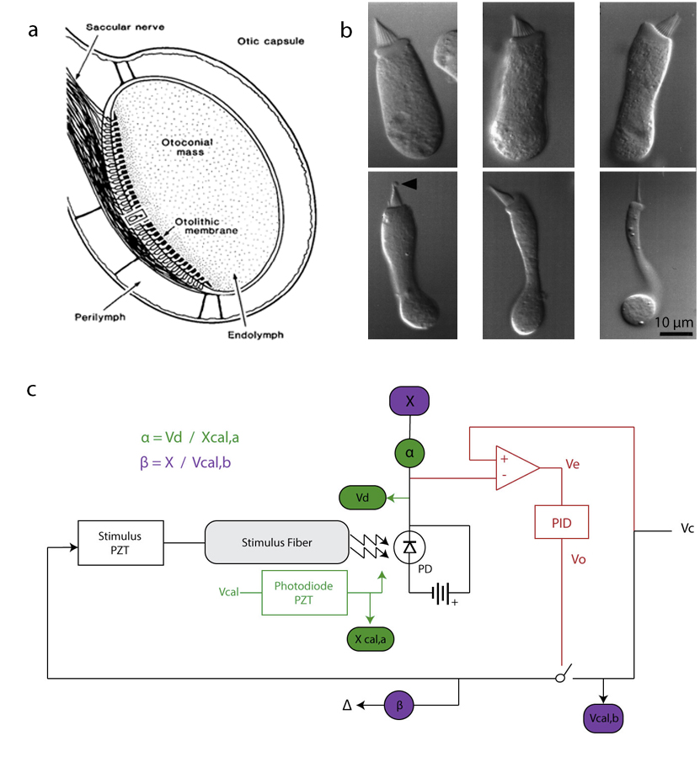

**Figure 1. The Bullfrog Saccular Preparation and the Displacement-Clamp System.** (*a*) The sacculus is one of eight end organs of the amphibian inner ear. Afferent and efferent nerve fibers from the eighth cranial nerve pass to each of the end organs. These innervate hair cells, the sensory receptors in the sensory epithelia. Sitting atop the macula is a gelatinous viscoelastic structure, the otolithic membrane, upon which lies an otoconial mass of calcium carbonate particles. Above and below the saccular macula are two compartments, containing high K+ endolymph above and high sodium perilymph below. The sacculus responds to both linear acceleration and low-frequency auditory stimuli. As seismic or pressure waves, ranging from 10 to 150 Hz, are transmitted from the tympanum and opercular system, vibrations of otoconia deflect the otolithic membrane. Hair cells are coupled to the membrane, and this deflection results in depolarization of sensory cells (44). (*b*) Sitting atop hair cells are their mechanical antennae, the hair bundles. Each bundles is composed of numerous enlarged microvilli, termed stereocilia, and one true cilium, the kinocilium. Deflection of the bundle toward the kinocilium results in influx of potassium and Ca2+ ions, depolarizing the hair cell, and thus transducing auditory stimuli. It should be noted that the hair cells of the sacculus are heterogeneous in both structure and function. They can be divided into larger, cylindrical cells and smaller, flask-shaped cells (45). (*c*) Shown here is a schematic of the displacement-clamp circuit. In order to deliver mechanical stimuli, a stimulus fiber of 50-1000 N-m-1 is coupled to the kinociliary bulb of a hair bundle. (*black*)The fiber’s base is displaced by a piezoelectric transducer receiving a command voltage (VC). Bundle motion is tracked as the shadow of the fiber on a photodiode. Voltage output from the photodiode (VD) corresponds to the bundle’s position (X). (*green*) To relate VD to X, the fiber’s shadow is independently translated by a calibrated piezoelectric transducer coupled to a mirror (Vcal, Xcal). Knowing the motion of this mirror and plotting its movement versus VD provides the calibration factor, . (*purple*) Using this factor, a series of steps in command voltage (Vcal,b) resulting in changes in X will provide the second calibration factor, , relating command voltage to stimulus fiber displacement**.** (*red*) When the displacement clamp is turned on, an error signal between VC and VD is calculated (VE), passed through a proportional-integral-derivative (PID) controller, and returned to the stimulus fiber (VO). Such feedback allows one to command the hair bundle to a desired position, XC (*See Supplementary Material for further application of these parameters.*). ***(Figure (a) from (******44******) (b) from (******45******))***

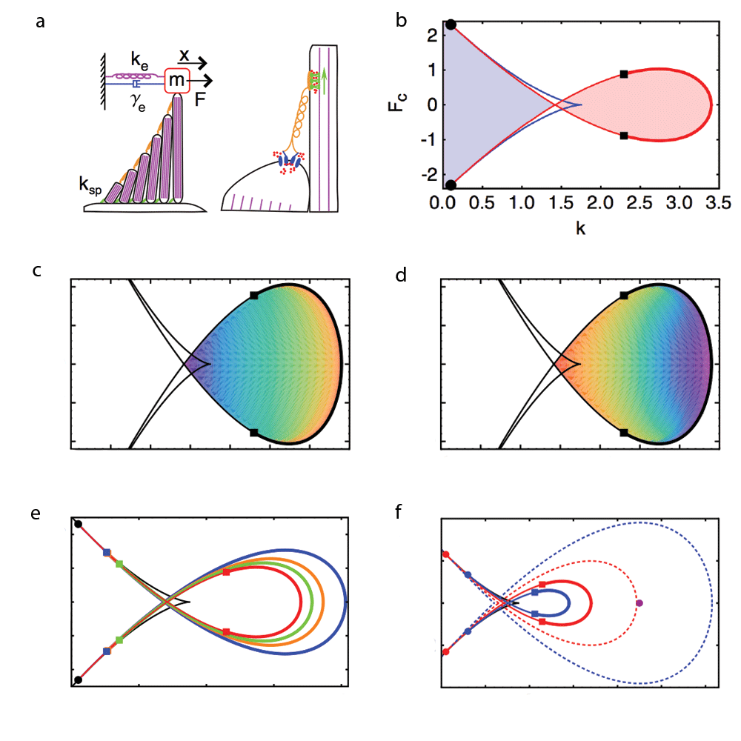

**Figure 2. Proposed State Diagram of the Hair Bundle.** (*a*) Hair bundles may be mechanically loaded with an offset force (F) that will displace the tip of the bundle some distance (x). In this particular model, bundles were loaded with some external stiffness (ke), mass (m), and damping (γe). ksp corresponds to the stiffness in the stereociliary pivots. Connecting stereocilia to their tallest neighbor is a tip link (*orange*) composed of cadherin-23 and protocadherin-15. In series with the link are one or two mechanoelectrical transduction channels (*blue*) and a myosin-1c motor complex (*green*). Deflection of the hair bundle results in shearing of stereocilia, increasing the tension in tip links and opening transduction channels. Myosin motors maintain the open probability of the channels such that tip-link tension is equal to the complex’s stalling force. (*b*) Emerging from numerous models of hair bundle mechanics is a state diagram composed of a loop of supercritical Hopf bifurcations (*red line, thick*), a series of subcritical Hopf bifurcations (*red line, thin*), and a series of fold bifurcations (*blue line*). Bautin points (*squares*) and Bogdanov-Takens points (*circles*) are codimension-two bifurcations connecting supercritical Hopf with subcritical Hopf bifurcations and subcritical Hopf with fold bifurcations, respectively. The white region outside the loop of bifurcations corresponds to a monostable regime. Upon crossing various bifurcations the bundle may spontaneous oscillate (*red region*) or become bistable (*blue region*). This two-dimensional state space allows one to explore hair-bundle mechanics through independent control of constant offset force (FC) and stiffness (k). (*c,d*) Within the limit-cycle regime, motion will change in its amplitude (*c*) and frequency (*d*) as parameters change, such that an approach in the direction of the loop of supercritical Hopf bifurcations would result in reduced amplitude and increased frequency (*red: high amplitude/frequency; purple: low amplitude/frequency*). (*e,f*) Both mass (e) and damping (*f*) change the shape of the loop of bifurcations. As mass is increased from m = 0 (*red*) to m = 4 (*blue*), the region of Hopf bifurcations increases in size. With damping increased from γe = 0 (*red*) to γe = 5 (*blue*), this region declines in size. Thus, while force and stiffness poise the hair bundle in different locations within the state space depicted, mass and damping act to alter the character of this space ***(Figure from (******17******))***.

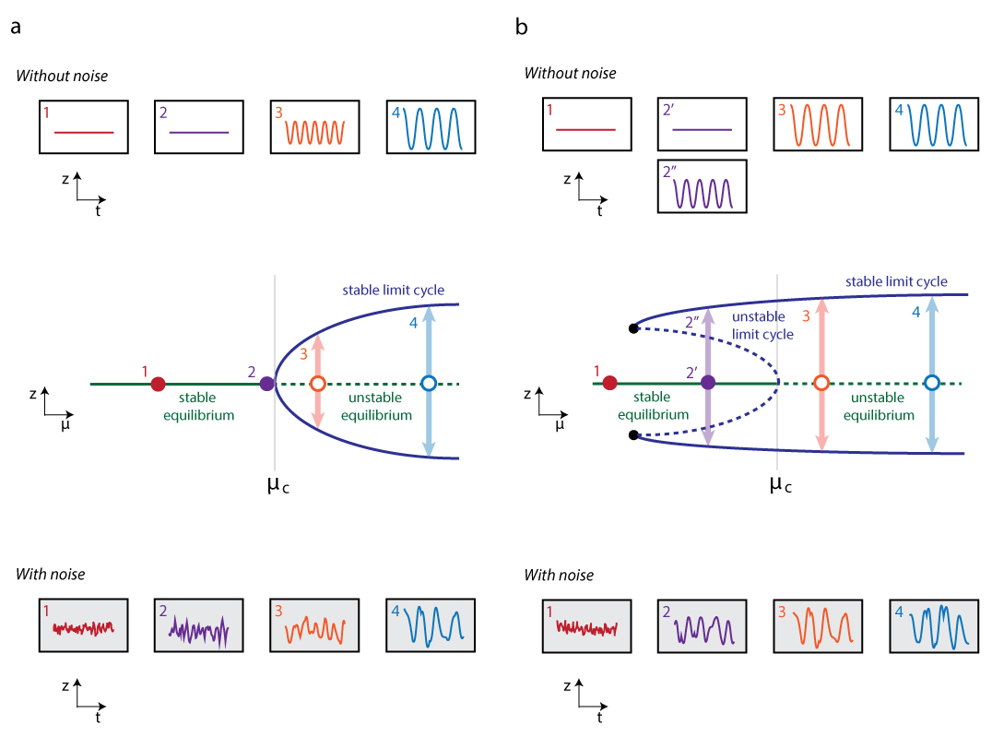

**Figure 3.** **Dynamics Near the Supercritical and Subcritical Hopf Bifurcations.** In order to better illustrate hair-bundle dynamics at or near criticality (μC), the supercritical (*a*) and subcritical (*b*) Hopf bifurcations are depicted. Illustrations in the middle row are plots of dynamics in *z* as some control parameter (μ) is changed. A Hopf bifurcation occurs at μC. (*a*) The state diagram of a supercritical Hopf bifurcation depicts a stable equilibrium (*green*) that becomes unstable at the critical value of the control parameter, at which a stable limit cycle (*blue*) is simultaneously birthed. (*a.1-a.4*) Hair-bundle dynamics are illustrated at different operating points. In a case without noise (*top*), the bundle remains at its stable equilibrium when μ< μC (*a.1, a.2; top*)but yields limit-cycle oscillations when μ> μC (*a.3, a.4; top*). Near the bifurcation (*a.2; top*), critical oscillations emerge. In a case with high-amplitude noise, the critical transition is less apparent (*a.2 versus a.3; bottom*). (*b*) The state diagram of a subcritical Hopf bifurcation depicts an unstable limit cycle (*blue*) that decays into a stable equilibrium (*green*), birthing an unstable equilibrium when the two meet at μC. Note also the presence of a fifth-order stable limit cycle that will obliterate upon colliding with the unstable limit cycle at a saddle-node bifurcation of periodic orbits (*black dots*). Due to the presence of a stable equilibrium within a stable limit cycle, different dynamics result based upon the direction of approach through μC. Starting with μ< μC on the stable point, one will remain on this point until it becomes unstable at μC (*b.2’; top*). However, approaching from μ> μC, the system will follow limit-cycle oscillations until the stable limit cycle is obliterated (*b.2”; top*). This memory at a subcritical Hopf bifurcation underlies the phenomenon of hysteresis. In a case without noise, a brief ring will decay to its stable equilibrium when μ< μC (*b.1, b.2; top)*. After surpassing its critical value, the hair bundle passes into a regime of limit-cycle oscillations (*b.3, b.4; top*). With added noise, noise overcoming the unstable limit cycle may unmask the higher-order stable limit cycle when μ< μC (*b.2; bottom*) (12, 34).

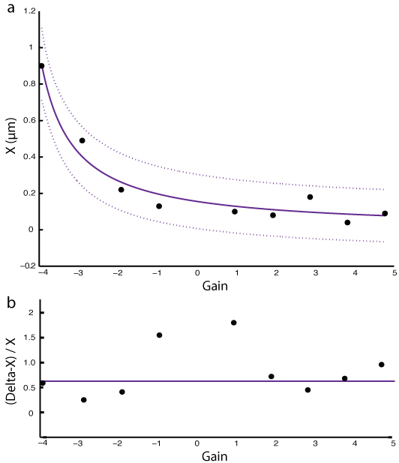

**Figure 4. Stiffness Control in a Displacement Clamp with Constant Offset Force.** Calibration data were acquired by imposing offsets with a stimulus fiber (kSF ~ 150 μN-m-1) onto a vertically mounted stimulus fiber acting as a Hookean model hair bundle (k­HB ~ 250 μN-m-1). For each value of both positive and negative gain, offset force was held constant by compensating with inverse changes in offset force. Hair-bundle position (X) was monitored by tracking the stimulus fiber’s shadow on a photodiode, and the base displacement of the fiber (Delta) was calibrated in the stimulus piezoelectric transducer. (*a*) Plotting displacement in X versus normalized gain at constant force, yields an inverse relationship is seen. Increases in gain result in a reduction in X. Data were fit to a general model (*purple*; f(x) = a/(1+b*x), a = 0.156, b = 0.21, R2 = 0.96), with the dotted line denoting 95% confidence intervals. (*b*) Subtracting displacements in X from the base displacements and dividing by X is predicted to follow a constant relationship, . The *purple* line depicts the predicted value from this relationship and is not a fitted curve.

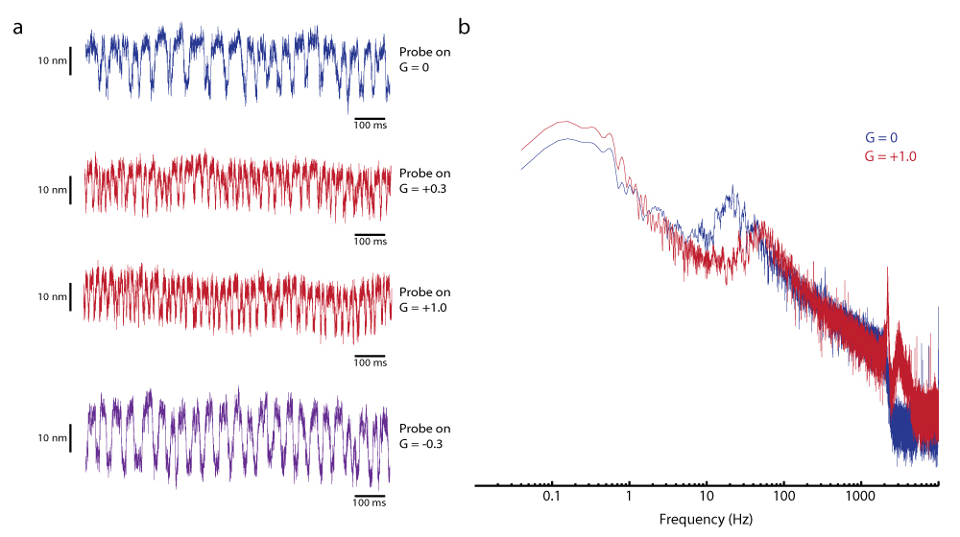

­­­­­­

**Figure 5. Hair Bundle Oscillatory Dynamics with Changes in Gain.** A stimulus fiber (kSF ~ 300 μN-m-1) was coupled to an oscillating hair bundle, and the offset was commanded to zero (FC = 0). (*a*) Feedback in the displacement clamp was changed to different values, and time traces of the hair bundle were recorded. When the gain was zero (*blue*), the bundle was oscillating at slightly over 20 Hz with a peak-to-peak amplitude greater than 20 nm. Increasing the gain to +0.3 and +1.0 (*red*), the amplitude was reduced and the frequency was increased. Finally, a switch to a gain of -0.3 (*purple*) resulted in a slight increase in amplitude but no apparent change in frequency relative to the zero-gain condition. The table below summarizes these results; the apparent stiffness is calculated by . (*b*) A power spectrum of the case where gain is zero (*blue*) and gain is +1.0 (*red*) reveals a shift in the power spectrum. When gain is zero, the spectrum peaks at a frequency slightly over 20 Hz. As the gain is increased to +1.0, we see the frequency more than double and the total power diminish. *( = 0.6)*

|  |  |  |  |
| --- | --- | --- | --- |
| *Gain* | *Apparent Stiffness (μN-m-1)* | *Peak-to-Peak Amplitude (nm)* | *Frequency (Hz)* |
| -0.3 | 246 | 34 | 23 |
| **0** | **300** | **28** | **23** |
| +0.3 | 354 | 22 | 42 |
| +1.0 | 480 | 21 | 47 |

Supplementary Material

*Engaging a displacement clamp for independent control of force and stiffness*

What follows is a brief description of an experimental system whereby mechanical stimuli are delivered to hair bundles. Using this system, an experimenter may clamp a hair bundle to a particular offset position and deliver mechanical stimuli. In addition, one may independently control offset force delivered to and the apparent stiffness of the coupled fiber-bundle system.

In the case of a displacement clamp with a proportional-integral-derivative (PID) controller (*Figure 1c*), an increase in the proportional gain (henceforth, G) results in an increase in the magnitude of force delivered by the stimulus fiber onto the hair bundle. This increased force reduces the difference between the commanded displacement (XC) and the hair bundle’s position in time (X). If one were to consider an imaginary clamp with zero error between XC and X, the system would behave as if the compliance were also zero. However, this case does not follow reality, where PID feedback provides an opportunity to reduce such error. By extension, an increase in G (and thus, feedback) should also reduce the apparent compliance of the coupled fiber-bundle system.

First, consider the steady state behavior of a hair bundle. The force exerted by the stimulus fiber (FSF) is equal and opposite to the reaction force exerted by the hair bundle (FHB).

This equation can be expanded to include hair bundle position (X), displace of the stimulus fiber (Δ), stiffness of the hair bundle (κHB), and stiffness of the stimulus fiber (κSF).

The above relationship defines a relationship between the terms that will be used in calibration of the displacement clamp. In the clamp circuit, a photodiode acts as the displacement monitor, and the output voltage (VD) is related to hair bundle shadow position by a coefficient, α. The piezoelectric transducer controlling the position of the stimulus fiber receives some command voltage (VO) and displaces the base of the stimulus fiber. This command voltage can be related to the proportional gain (G) of the PID controller and the error signal between XC and X.

An immediate observation is the existence of two components of force. The first is some offset force (FC) that should not change as XC and G remain constant. In order to hold force constant, as was done in the calibration of this clamp, one must compensate for changes in G with changes in XC. FC will be employed as one of the control parameters of the hair bundle’s state space using this relation.

One can further combine the relationships between these terms in order to predict the behavior of X and Δ as various parameters are varied. Note that the term in the numerator corresponds to the offset force, while the denominator corresponds to the total stiffness of the coupled fiber-bundle system. **This allows independent control of two parameters, force (**) **and stiffness ().**

Emerging from the equation for X is an expanded Hooke’s law of elasticity, where displacement and stiffness would have an inverse relationship with constant force. The same is true, though immediately less apparent, in Δ. The first component (ΔC) corresponds to the commanded value of Δ, which should not change if the force remains constant. The second term, a negative one, would directly follow changes in G, to a point. When the denominator reaches zero (such that κHB = ­– κSF), the system becomes unstable. Thus, both X and Δ are predicted to follow this inverse relationship between displacement and stiffness with constant offset force. These relationships have been employed in the calibration of the displacement clamp.

What can be seen in the denominator is the presence of G. Changing the value of G thus alters the apparent stiffness of the stimulus fiber.

This relationship can be used to manipulate the total stiffness of the fiber-bundle system.

In summary, a displacement clamp would be predicted to provide both independent control of offset force and total stiffness of the system. This can be calibrated with the relationships above in X and Δ. Employing the clamp in an exploration of the two-dimensional hair bundle state space will be accomplished by engaging the relationships for FC and κSF,apparent, the control parameters of import.