**Name**: Josh Seymour

**Homework:** VBA Scripting - Screenshots of Results

2016

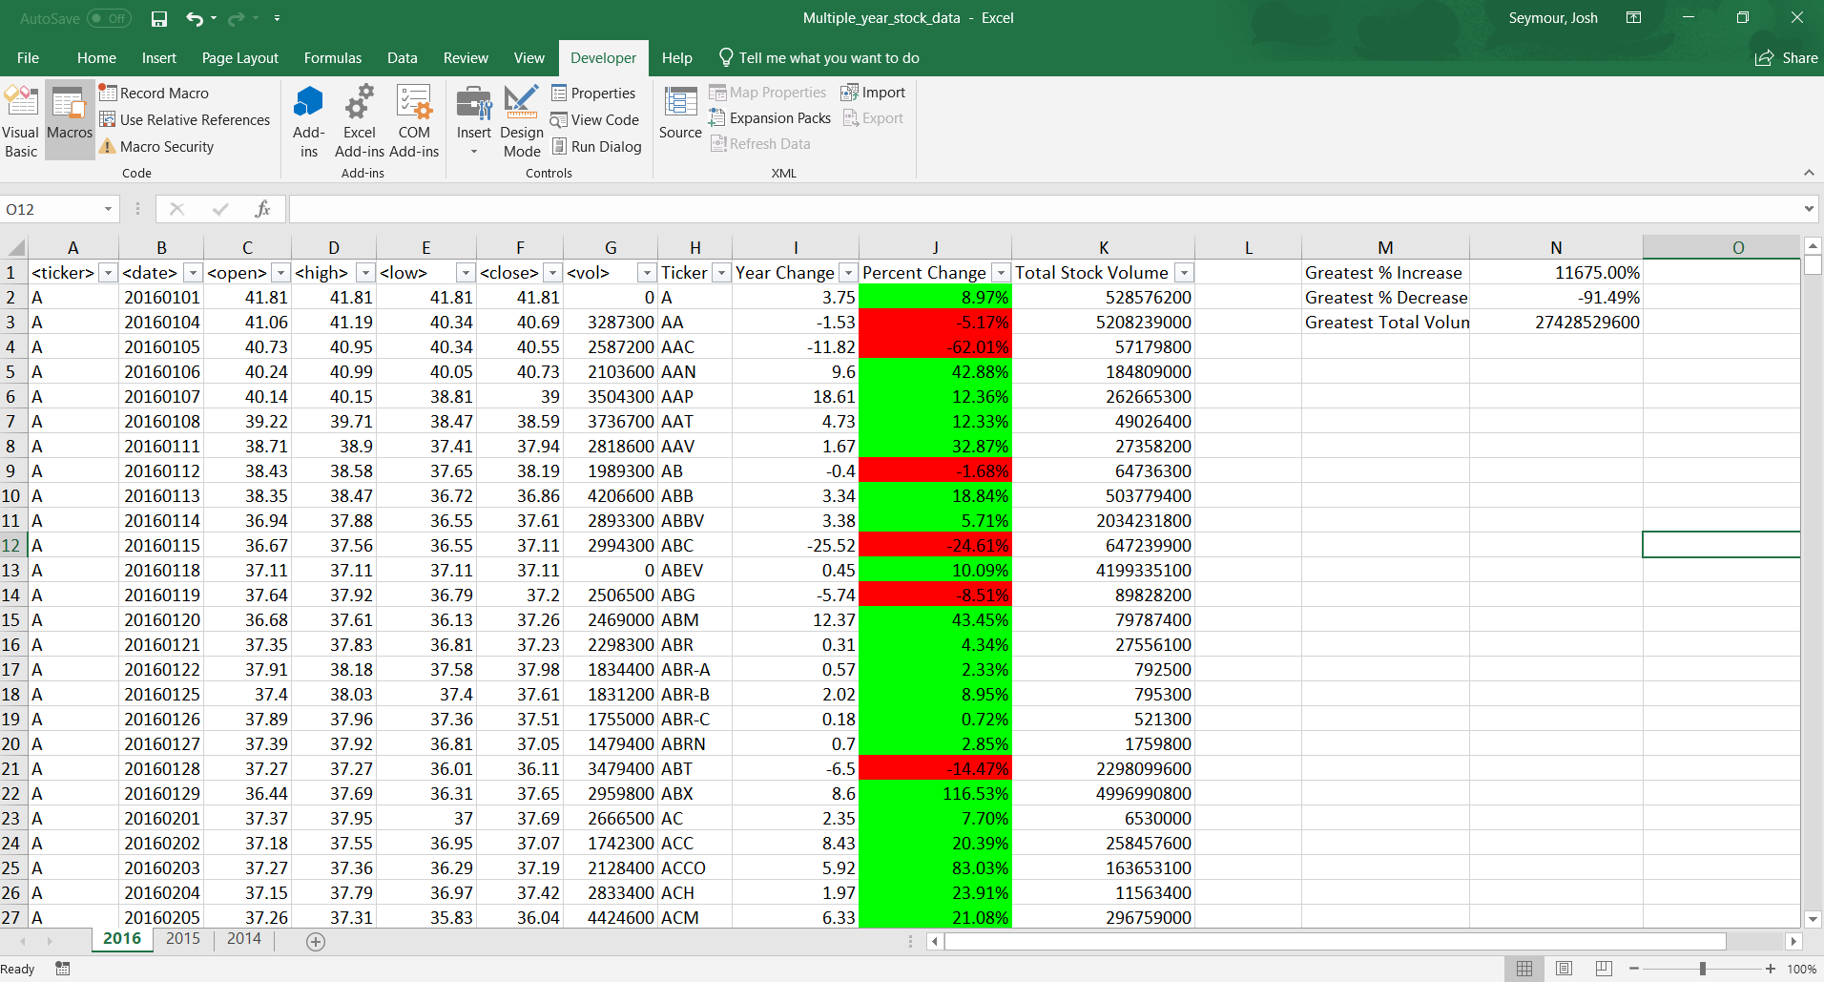

2015

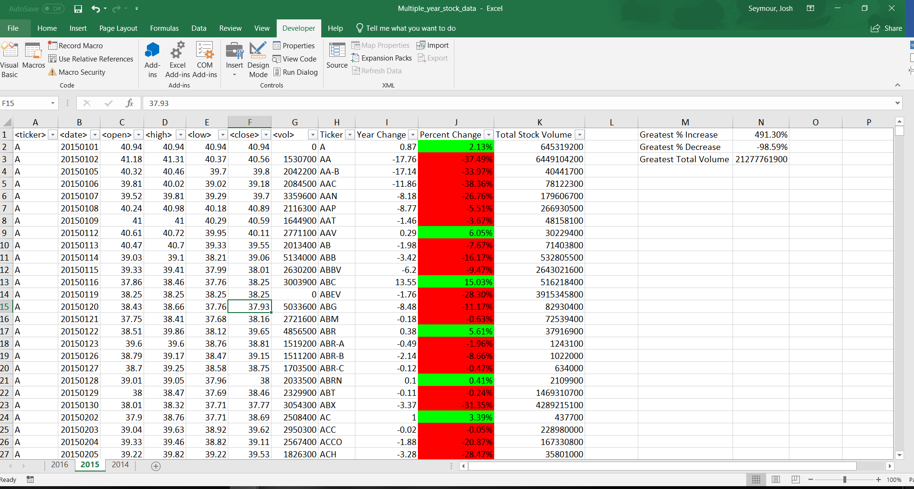

2014

