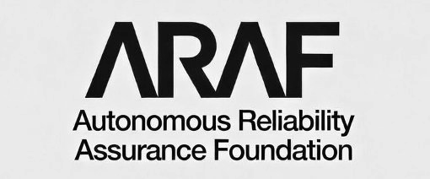

AUTONOMOUS RELIABILITY ASSURANCE FOUNDATION

ARA Standard v1.0
Trademark and Certification Mark
Usage Policy

ARAF-ARA-TMK-2026-001

Version 1.0 | January 2026
Classification: Public

Document Control

Document ID | ARAF-ARA-TMK-2026-001
Title | Trademark and Certification Mark Usage Policy
Version | 1.0
Status | Published
Classification | Public
Date Published | January 2026
Approved By | ARAF Board of Directors
Parent Document | ARAF-ARA-STD-2026-001 (ARA Standard v1.0)
Related Documents | ARAF-ARA-AVB-2026-001 (AVB Authorization Guide)

Revision History

Version | Date | Author | Description
1.0 | January 2026 | ARAF Legal and Standards Office | Initial publication

Table of Contents

Article 1: Purpose and Scope 4
Article 2: ARAF Trademark Portfolio 5
Article 3: ARA Certification Mark Specifications 7
Article 4: Authorized Usage by Certification Level 9
Article 5: Placement and Display Requirements 11
Article 6: Digital Usage, Registry Badge, and Tokenized Badge 13
Article 7: Prohibited Uses 17
Article 8: Mark Display with Conditions and Limitations 19
Article 9: Sublicensing, Transfers, and Third-Party Use 20
Article 10: Monitoring, Enforcement, and Violations 21
Article 11: Mark Revocation and Transition 23
Appendix A: Certification Mark Visual Reference and Artwork 25
Appendix B: Usage Compliance Checklist 28
Appendix C: Glossary of Terms 30

Foreword
The ARA Certification Mark is the public-facing symbol of the Autonomous Reliability Assurance Standard. It communicates to customers, partners, regulators, and the public that an autonomous system has been evaluated against rigorous reliability criteria and meets the requirements of its certified level.
The value of the ARA Certification Mark depends entirely on the integrity of its use. When the mark is displayed accurately and consistently, it builds trust in the certification ecosystem. When it is misused, misrepresented, or displayed without authorization, it undermines the credibility of every organization that has invested in earning legitimate certification.
This Trademark and Certification Mark Usage Policy establishes binding rules governing the display, reproduction, and management of ARAF trademarks and the ARA Certification Mark. It applies to all certified organizations, Authorized Validation Bodies (AVBs), ARAF partners, and any party that references ARAF or ARA certification in products, marketing, or communications.
Compliance with this policy is a condition of maintaining ARA certification. Violations may result in enforcement actions up to and including certification revocation.
The ARAF Legal and Standards Office maintains this policy and welcomes questions regarding mark usage. Inquiries may be directed to the trademark team through the ARAF website.

Article 1: Purpose and Scope

1.1 Purpose
This policy defines the authorized uses, visual standards, placement requirements, and enforcement procedures for the ARAF trademark portfolio and the ARA Certification Mark. Its objectives are to: preserve the integrity and recognition value of the ARA Certification Mark; ensure that all representations of ARA certification are accurate and verifiable; protect certified organizations from confusion caused by unauthorized mark use; provide clear guidance for all parties on what constitutes authorized versus unauthorized use; and establish proportionate enforcement procedures for policy violations.

1.2 Scope of Applicability
This policy applies to all uses of ARAF trademarks and the ARA Certification Mark in any medium, including but not limited to:
Physical media: Product packaging, printed marketing materials, trade show displays, signage, business cards, letterhead, and physical product labeling.
Digital media: Websites, mobile applications, software interfaces, digital advertising, social media, email communications, API documentation, and developer portals.
Documentation: Technical documentation, compliance reports, audit reports, RFP responses, sales proposals, and investor materials.
Press and media: Press releases, news articles, analyst reports, blog posts, podcasts, and video content.
Contractual references: Service agreements, partnership agreements, vendor contracts, and procurement documents.

1.3 Binding Authority
This policy is incorporated by reference into every ARA Certification Agreement, AVB Authorization Agreement, and ARAF Partner Agreement. By obtaining or maintaining ARA certification, organizations agree to comply with this policy as amended from time to time. Non-compliance constitutes a breach of the Certification Agreement and may trigger enforcement actions under Article 10 of this policy.

1.4 Policy Amendments
ARAF reserves the right to amend this policy at any time. Material amendments will be communicated to all certified organizations and AVBs with a minimum 90-day implementation period. Certified organizations are responsible for updating their mark usage to comply with amendments within the implementation period. Continued use of marks after the implementation period constitutes acceptance of the amended policy.

Article 2: ARAF Trademark Portfolio

2.1 Protected Marks
The following marks are registered trademarks of the Autonomous Reliability Assurance Foundation. All rights are reserved.
Mark | Type | Registration Status | Primary Authorized Users
ARAF | Word mark | Registered | ARAF, AVBs, press/media (editorial)
ARAF Logo (stylized wordmark with tagline) | Design mark | Registered | ARAF only (limited AVB exception)
ARA | Word mark | Registered | ARAF, AVBs, certified organizations
ARA Certification Mark (circular badge) | Certification mark | Registered | Certified organizations, ARAF, AVBs
Autonomous Reliability Assurance | Word mark | Registered | ARAF, AVBs, certified organizations (descriptive)
“ARA Certified” | Word mark | Registered | Certified organizations only (current certification)
Continuous Assurance Platform / CAP | Word mark | Pending | ARAF, licensed platform users

2.2 ARAF Organizational Logo
The ARAF organizational logo (the stylized “ARAF” wordmark with “Autonomous Reliability Assurance Foundation” tagline) is reserved for use by ARAF in its own communications, publications, and platforms. Limited exceptions apply:
Authorized Validation Bodies: AVBs may display the ARAF logo on their “Authorized by ARAF” credential page, sized no larger than 1.5 inches (38 mm) wide, with the required “Authorized Validation Body” designation displayed adjacent to the logo.
Certified organizations: Certified organizations SHALL NOT display the ARAF organizational logo. Certified organizations use the ARA Certification Mark (Article 3) to indicate certification status.
Press and media: Journalists and publications may reproduce the ARAF logo for editorial purposes without modification, at a resolution sufficient to preserve legibility, with attribution to ARAF.

2.3 Trademark Notice Requirements
All documents, web pages, and marketing materials displaying any ARAF mark SHALL use the appropriate trademark symbol on first use and include the attribution statement:
Mark | First Use on Page or Document | Subsequent Uses on Same Page
ARAF | ARAF® | ARAF (no symbol)
ARA | ARA® | ARA (no symbol)
ARA Certification Mark (badge) | ™ adjacent to first display of badge | No symbol required
“ARA Certified” | ARA Certified® | ARA Certified (no symbol)

Required attribution statement: “ARAF, ARA, and the ARA Certification Mark are registered trademarks of the Autonomous Reliability Assurance Foundation. Used under license.”
This statement SHALL appear in a legible font size (minimum 6pt print, 10px digital) at the bottom of the page, document, or in a legal notices section of the website.

Article 3: ARA Certification Mark Specifications

3.1 Mark Anatomy
The ARA Certification Mark is a circular badge containing the following required components. All components must be present for a valid mark display.
Component | Description | Required
Outer ring text | “AUTONOMOUS RELIABILITY ASSURANCE” in uppercase, arranged in a semicircular arc from the left side, over the top, to the right side of the mark | Yes
Lower ring text | “CERTIFIED” in uppercase, arranged in a circular arc at the lower portion of the mark | Yes
Central wordmark | “ARA” in the proprietary ARAF geometric logotype with distinctive angled letterform cuts, centered within the mark | Yes
Certification level | “LEVEL 1”, “LEVEL 2”, or “LEVEL 3” displayed beneath the ARA wordmark, corresponding to the organization’s certified level | Yes
Certification ID | “Certification ID: ARA-YYYY-NNNNN” in small text at the bottom interior of the mark, corresponding to the organization’s unique certification ID from the ARAF registry | Yes
Circular border | Two concentric circular borders forming a text band that contains the ring text, enclosing all elements | Yes
Removal, alteration, or obscuring of any required component renders the mark display invalid and constitutes a violation of this policy.

3.2 Authorized Color Variations
The ARA Certification Mark is available in four authorized color variations. No other color treatments are permitted.
Variation | Use Case | Background Requirement
Standard (dark on light) | Primary use on white or light-colored backgrounds | Background #F0F0F0 or lighter
Reverse (light on dark) | Use on dark backgrounds, dark-themed interfaces | Background #404040 or darker
Monochrome black | Single-color printing (black ink only) | White or light background
Monochrome white | Single-color reversed printing | Dark or black background
The mark SHALL NOT be rendered in the certified organization’s brand colors, in gradient fills, with drop shadows, with transparency or opacity effects, with embossing or 3D effects, or in any color combination not specified above.

3.3 Minimum Size Requirements
Medium | Minimum Diameter | Rationale
Print (300+ DPI) | 0.75 inches (19 mm) | Ensures Certification ID text remains legible
Digital display (screen) | 80 pixels diameter | Ensures legibility at standard screen densities
High-DPI / Retina display | 80 CSS pixels (160+ device pixels) | Maintains visual consistency on high-density screens
Favicon / app icon | Not permitted | Mark cannot maintain required component legibility at favicon size

3.4 Clear Space
A minimum clear space equal to 15% of the mark’s diameter SHALL be maintained on all sides of the mark. No text, graphics, logos, rules, borders, or other visual elements may enter the clear space zone. The clear space is measured from the outermost edge of the circular border to the nearest adjacent element.

3.5 Color Specifications
The following color values define the official ARA Certification Mark palette:
Element | Standard (Dark on Light) | Reverse (Light on Dark)
Circular borders | #000000 (Black) | #FFFFFF (White)
Ring text | #000000 (Black) | #FFFFFF (White)
ARA central wordmark | #000000 (Black) | #FFFFFF (White)
LEVEL text | #000000 (Black) | #FFFFFF (White)
Certification ID text | #555555 (Dark Gray) | #AAAAAA (Light Gray)

3.6 Typography
The ARA Certification Mark uses the following typography: the “ARA” central wordmark is rendered in the proprietary ARAF geometric logotype, a custom-designed letterform with distinctive angled cuts matching the ARAF organizational wordmark. This logotype is not a standard typeface and SHALL NOT be recreated from any font. The “CERTIFIED” and “LEVEL” text use a bold sans-serif typeface. The “AUTONOMOUS RELIABILITY ASSURANCE” ring text uses a regular-weight sans-serif. The Certification ID uses a light-weight sans-serif. Certified organizations SHALL NOT recreate the mark from component elements. They SHALL use only the official vector artwork files (.SVG, .EPS, .AI) or approved raster files (.PNG at 300+ DPI) provided through the ARAF Certification Portal.

Article 4: Authorized Usage by Certification Level

4.1 Usage Rights Matrix
Certified organizations receive mark usage rights corresponding to their certification level. Higher levels receive broader rights reflecting the greater evaluation scope.
Usage Right | Level 1 | Level 2 | Level 3
Display mark on certified system documentation | Yes | Yes | Yes
Display mark on company website (certification page) | Yes | Yes | Yes
Reference certification in API documentation | Yes | Yes | Yes
Display mark on product packaging or labeling | No | Yes | Yes
Display mark in product UI or system interface | No | Yes | Yes
Reference certification in press releases | ARAF pre-approval required | Yes | Yes
Display mark in advertising or marketing materials | No | Scope-limited (see 4.3) | Yes
Display mark in sales proposals or RFP responses | No | Yes | Yes
Use “ARA Certified” in product naming or branding | No | No | ARAF pre-approval required
Display mark at trade shows or conferences | Own booth only | Yes | Yes
Include mark in investor or board materials | Yes | Yes | Yes

4.2 Scope Limitation Requirement
Regardless of certification level, the ARA Certification Mark SHALL only be displayed in connection with the specific system or systems that have been evaluated and certified. The mark SHALL NOT be used to imply certification of systems, products, or services that were not included in the evaluation scope. The Certification ID embedded in the mark is the definitive identifier linking the mark to a specific certified system.
If a certified organization operates multiple systems and only some are certified, all mark usage must clearly indicate which system or systems hold certification. Blanket statements such as “Our products are ARA Certified” are prohibited unless all products of the referenced type are certified.

4.3 Level 2 Marketing Usage Restrictions
Level 2 certified organizations may use the mark in marketing materials subject to the following restrictions: the marketing material must identify the specific certified system by name or product identifier; the material must not imply that certification extends to uncertified systems or to the organization as a whole; the Certification ID must be legible in the mark display or referenced in adjacent text; and the material must include the required attribution statement (Article 2, Section 2.3).

4.4 Level 3 Product Naming Approval Process
Level 3 certified organizations seeking to incorporate “ARA Certified” into product naming (e.g., “ProductName ARA Certified Edition”) must submit a written request to the ARAF Legal and Standards Office including: the proposed product name with ARA reference; the Certification ID of the certified system; the intended markets and channels for the named product; and sample packaging and marketing mockups. ARAF will respond within 30 business days. Approval, if granted, is specific to the named product and non-transferable.

Article 5: Placement and Display Requirements

5.1 General Placement Principles
The ARA Certification Mark SHALL be displayed in a manner that is: clearly associated with the certified system (not ambiguously placed near uncertified systems or services); legible at the displayed size (all required components readable without magnification in print or zoom in digital); visually distinct from the certified organization’s own logos and branding (the mark must not appear to be part of the organization’s logo); and consistent with the clear space requirements defined in Article 3, Section 3.4.

5.2 Product Packaging
For Level 2 and Level 3 certified organizations authorized to display the mark on packaging:
Placement: The mark shall appear on the rear or side panel of the package, not on the primary display panel (front of package), unless ARAF provides written approval for front-panel placement.
Size: Minimum 0.75 inches (19 mm) diameter; maximum 2.0 inches (51 mm) diameter unless the package size necessitates a larger display.
Proximity: The mark shall be placed within 2 inches (51 mm) of the product name or model number to which certification applies.
Attribution: The required trademark attribution statement (Article 2, Section 2.3) shall appear on the same panel as the mark or on the package’s legal/regulatory information panel.

5.3 Website Display
Certified organizations displaying the mark on their website SHALL comply with the following requirements:
Dedicated certification page: The mark shall appear on a dedicated certification or compliance page that identifies the certified system, certification level, Certification ID, certification date, and next reassessment date. A hyperlink to the ARAF Public Certification Registry entry for the certified system is required.
Homepage or product page: The mark may appear on the homepage or product pages only if it links directly to the dedicated certification page described above. The mark shall not be larger than 120 pixels diameter on homepage or product page placement.
Footer badge: A small certification badge (80 pixels diameter) may appear in the website footer if it links to the dedicated certification page and the organization’s homepage clearly identifies which system is certified.

5.4 Software and System Interface
For Level 2 and Level 3 certified organizations displaying the mark within a software product or system interface:
Settings or About screen: The mark may appear on a Settings, About, or Compliance information screen within the certified system’s interface.
Login or splash screen: The mark may appear on the login or splash screen of the certified system only, not on login screens for uncertified systems from the same organization.
Interactive link: When displayed in a digital interface, the mark should function as a clickable element that opens the ARAF Public Registry entry for the certified system, or navigates to the organization’s dedicated certification page.
Documentation: The mark may appear on the cover page or header of technical documentation for the certified system.

5.5 Print Advertising and Marketing Materials
For Level 2 (with scope limitations) and Level 3 certified organizations:
Size: The mark shall appear at no less than the minimum size (0.75 inches diameter) and no more than 15% of the total advertisement area.
Certified system identification: The advertisement must clearly identify the certified system. The mark shall not appear in advertisements that do not reference the certified system.
Disclaimers: If the advertisement features both certified and uncertified products, a clear disclaimer shall state: “ARA certification applies to [certified system name] only. Other products shown are not ARA certified.”

Article 6: Digital Usage, Registry Badge, and Tokenized Badge

6.1 ARAF Public Certification Registry
ARAF maintains a publicly accessible Certification Registry at registry.araf.org that lists all currently certified systems with their certification details. Each certified system has a unique registry entry containing: the certified organization name; the certified system name and version; the certification level; the Certification ID; the certification date and expiration date; the evaluation scope summary; the most recent reassessment date; and the current certification status (Active, Suspended, Expired, or Revoked).
The registry is the authoritative source for certification verification. Any party may query the registry to verify a claimed certification. The registry entry URL follows the format: registry.araf.org/verify/ARA-YYYY-NNNNN

6.2 Registry Verification Badge
In addition to the static ARA Certification Mark, ARAF provides a dynamic Registry Verification Badge for digital placements. The badge is an embeddable HTML/JavaScript component that:
Displays the ARA Certification Mark in the authorized digital format. Connects to the ARAF registry API to verify current certification status in real-time. Displays a green verification indicator when certification is Active. Displays a yellow indicator when certification is within 30 days of expiration. Displays a red indicator and disables the mark display when certification is Expired, Suspended, or Revoked. Links to the certified system’s registry entry when clicked.

6.3 Badge Implementation
Certified organizations are encouraged to use the Registry Verification Badge instead of static mark images for all website and digital application placements. The badge ensures that mark display automatically reflects current certification status, eliminating the risk of displaying the mark after certification expires or is revoked.
Embed code: The badge embed code is available through the ARAF Certification Portal after login. The embed code is specific to each Certification ID and cannot be reused for other systems.
Customization: The badge supports light and dark theme variants matching the authorized color variations in Article 3. No other customization is permitted.
Fallback: If the badge cannot connect to the ARAF registry (network error, API downtime), it shall display the static mark with a “Verification unavailable” tooltip rather than hiding or removing the mark.

6.4 Social Media Usage
Certified organizations may reference ARA certification on social media platforms subject to the following rules:
Text references: Organizations may state “Our [system name] has achieved ARA Level [N] certification” or equivalent factual statements. The Certification ID should be included where character limits permit.
Mark image: The ARA Certification Mark may be included in social media posts as an image, provided it meets the minimum size requirement for the platform and is not cropped, filtered, or overlaid with other graphics.
Profile images: The ARA Certification Mark SHALL NOT be used as a social media profile picture, avatar, or header image. It is not a substitute for the organization’s own branding.
Hashtags: Organizations may use #ARACertified and #ARALevel[N] hashtags in conjunction with certification announcements.

6.5 Email Signatures
Certified organizations may include a small ARA Certification Mark in email signatures for personnel directly associated with the certified system (product managers, engineering leads, sales engineers). The mark in email signatures must meet the minimum digital size requirement (80 pixels), link to the registry entry or dedicated certification page, and include the Certification ID in adjacent text or alt text. The mark SHALL NOT appear in email signatures of personnel unrelated to the certified system.

6.6 Tokenized Certification Badge
ARAF issues a unique, cryptographically tokenized certification badge to each certified system upon successful completion of the ARA evaluation process. The tokenized badge is the authoritative digital artifact linking the visual ARA Certification Mark to a verified, tamper-evident certification record.

6.6.1 Token Architecture
Each tokenized badge is generated by the ARAF Certification Platform and contains: a cryptographic signature binding the badge to the specific Certification ID, certified system identity, certification level, and certification validity period; a unique token identifier that is non-transferable and non-reproducible; an embedded verification URL that resolves to the ARAF Public Certification Registry entry for the certified system; a machine-readable payload (JSON Web Token format) containing structured certification metadata for automated verification by third-party systems; and a visual rendering of the ARA Certification Mark with the correct level and Certification ID pre-embedded.

6.6.2 Issuance and Lifecycle
Tokenized badges are issued automatically by the ARAF platform upon certification grant. Each badge has a lifecycle that mirrors the certification itself: the token is activated upon certification issuance; the token is automatically refreshed upon successful reassessment; the token is suspended if certification is suspended (visual rendering displays suspension status); the token is revoked and permanently invalidated if certification is revoked; and the token expires when the certification period ends without renewal. Expired or revoked tokens cannot be reactivated. A new token is issued upon recertification.

6.6.3 Physical Asset Usage
Certified organizations may use the tokenized badge on physical assets associated with the certified system. For physical deployment, the tokenized badge is rendered as a QR code or NFC-readable tag that links to the verification URL. Physical badge applications include: product labels and packaging (Level 2 and Level 3); hardware enclosures and chassis plates for certified physical autonomous systems; safety compliance placards in deployment environments; and equipment identification tags for field-deployed systems. The QR code or NFC tag SHALL resolve to the live ARAF registry entry, providing real-time verification of certification status to any party scanning the code. Static images of the badge without a machine-readable verification link are permitted but the tokenized version with live verification is strongly recommended for physical assets.

6.6.4 Digital Asset Usage
For digital deployment, the tokenized badge provides enhanced verification capabilities beyond the static mark or the Registry Verification Badge (Section 6.2). Digital applications include: API response headers where certified systems can include the token in HTTP headers (X-ARA-Certification-Token) enabling automated verification by consuming systems; agent-to-agent handshake where autonomous agents can present their tokenized badge during multi-agent interactions to establish certified status with peer systems; continuous assurance integration where the token is linked to the Continuous Assurance Platform (CAP) telemetry, enabling real-time compliance status to be cryptographically attested; developer portal and marketplace listings where the tokenized badge is embeddable as a verified credential that third-party platforms can independently validate against the ARAF registry; and digital procurement and RFP responses where the token provides machine-verifiable certification evidence.

6.6.5 Verification Protocol
Any party may verify a tokenized badge through the following methods: scan the QR code or NFC tag (physical assets) which redirects to the ARAF registry entry; submit the token identifier to the ARAF Verification API (GET https://api.araf.org/v1/verify/{token-id}) which returns the current certification status and metadata as a signed JSON response; validate the cryptographic signature offline using the ARAF public key (published at https://araf.org/.well-known/ara-signing-key) for environments requiring air-gapped verification; or use the ARAF SDK verification method which handles token validation, signature checking, and status confirmation in a single function call.

6.6.6 Token Security
Tokenized badges incorporate the following security measures: asymmetric cryptographic signatures (RSA-4096 or Ed25519) preventing forgery; token binding to the certified system identity preventing transfer to uncertified systems; short-lived verification tokens (24-hour validity) for API-based verification requiring periodic re-validation; revocation checking via Certificate Revocation List (CRL) and Online Certificate Status Protocol (OCSP) endpoints; and tamper detection where any modification to the token payload invalidates the cryptographic signature. Attempting to forge, duplicate, or tamper with a tokenized badge constitutes a violation under Article 7 (Prohibited Uses) and Article 10 (Enforcement) of this policy, and may additionally constitute fraud under applicable law.

Article 7: Prohibited Uses

7.1 Absolute Prohibitions
The following uses of the ARA Certification Mark and ARAF trademarks are prohibited under all circumstances, regardless of certification level:

7.1.1 Mark Modification
The mark SHALL NOT be altered, redrawn, distorted, rotated, animated, fragmented, or modified in any way. This includes changing colors beyond authorized variations, changing fonts or typefaces within the mark, stretching or compressing the mark non-proportionally, adding visual effects (shadows, glows, bevels, gradients, outlines), overlaying other graphics or text onto the mark, removing any required component (ring text, level, certification ID), cropping the mark to show only a portion, and animating, spinning, pulsing, or applying motion effects to the mark.

7.1.2 False or Misleading Certification Claims
No party SHALL display the ARA Certification Mark or claim ARA certification for any system that has not been evaluated and certified through the official ARA certification process. This includes: displaying the mark for a system that was never submitted for evaluation; displaying a Level 2 or Level 3 mark when only Level 1 certification was achieved; displaying the mark for a system version that differs materially from the evaluated version; using a fictitious Certification ID; and displaying the mark after certification has expired, been suspended, or been revoked without acknowledging the current status.

7.1.3 Implied Endorsement
The ARA Certification Mark SHALL NOT be used in any manner that implies ARAF endorses, recommends, sponsors, or guarantees the certified organization’s products, services, or business practices beyond the specific scope of ARA certification. Prohibited phrasings include: “Recommended by ARAF,” “ARAF-approved,” “ARAF partner” (unless a formal partnership exists), and “Guaranteed by ARA certification.”

7.1.4 Competitive Disparagement
The ARA Certification Mark SHALL NOT be used to disparage competitors or to imply that uncertified systems are unsafe, unreliable, or inferior. Factual comparisons stating that a system holds ARA certification while competitors do not are permitted only if: the comparison is factually accurate and verifiable; the comparison does not characterize uncertified systems as deficient; and the comparison does not suggest that ARA certification is the only valid certification standard.

7.2 Context-Specific Prohibitions

7.2.1 Co-Branding
The ARA Certification Mark SHALL NOT be combined with any other certification mark, quality seal, trust badge, or endorsement symbol into a composite graphic. The mark must always stand alone within its clear space. Adjacent placement of multiple certification marks is permitted provided each mark maintains its own clear space.

7.2.2 Domain Names and URLs
Certified organizations SHALL NOT register or use domain names containing “ARAF,” “ARA Certified,” or confusingly similar terms (e.g., aracertified-[company].com, araf-verified.com). References to ARA certification in URL paths (e.g., company.com/ara-certified) are permitted.

7.2.3 Product Names and Service Names
Except as authorized under Article 4, Section 4.4 (Level 3 naming approval), no organization SHALL incorporate ARAF trademarks into product names, service names, feature names, or trade names without written ARAF approval.

7.2.4 NFTs, Tokens, and Blockchain
The ARA Certification Mark SHALL NOT be minted as a non-fungible token (NFT), used as a digital token symbol, or placed on blockchain-based digital assets without explicit written authorization from ARAF. ARAF may issue official digital certification credentials through its own platforms in the future.

Article 8: Mark Display with Conditions and Limitations

8.1 Conditional Certification Display
When an ARA certification includes conditions or limitations (e.g., remediation timelines for Conditional ACR failures, scope restrictions, or operational constraints), the mark display must reflect these conditions in specific circumstances.

8.2 Active Remediation Status
If a certified system is operating under an active remediation plan for Conditional ACR deficiencies, the organization may continue to display the ARA Certification Mark provided: the remediation timeline has not expired; the certification status in the ARAF registry is “Active — Remediation in Progress”; the organization does not represent the certification as unconditional in any context where the remediation status is material (e.g., regulatory submissions, procurement responses that ask about compliance status); and the Registry Verification Badge (Article 6) is used for digital placements, as it will automatically reflect the remediation status.

8.3 Scope-Limited Certification
When certification is limited to specific operational modes, deployment environments, or use cases, the mark display must include a scope limitation statement whenever the mark is displayed in a context where the limitation is material. The scope limitation statement shall be placed adjacent to the mark in legible text.
Example: “ARA Level 2 Certified for warehouse automation environments. Certification does not extend to outdoor or public-space deployment.”

8.4 Domain 13 Physical Systems Notation
For systems certified with Domain 13 (Physical Actuation Integrity) evaluation, the standard ARA Certification Mark is used without modification. However, when the mark is displayed in documentation or marketing materials that describe the system’s physical capabilities, the organization is encouraged (but not required) to include a supplementary statement: “Including physical actuation integrity evaluation per ARA Domain 13.”

8.5 Multi-Level Certification
If an organization has systems certified at different levels, each system’s mark SHALL display the correct level for that specific system. Displaying a Level 3 mark for a Level 2 certified system (or any other level mismatch) is a prohibited use under Article 7, regardless of whether the organization holds a Level 3 certification for a different system.

Article 9: Sublicensing, Transfers, and Third-Party Use

9.1 No Sublicensing
The right to display the ARA Certification Mark is granted exclusively to the certified organization identified in the Certification Agreement. This right may not be sublicensed, assigned, or transferred to any third party without written approval from ARAF. This includes: resellers, distributors, or channel partners of the certified organization; OEM customers or white-label partners; parent companies, subsidiaries, or affiliates (each entity must hold its own certification); and marketing agencies or contractors acting on behalf of the certified organization.

9.2 Reseller and Partner References
Resellers and partners of a certified organization may make factual references to ARA certification in their sales materials using text statements only (e.g., “[Product] by [Certified Organization] holds ARA Level 2 Certification, ID: ARA-2026-XXXXX”). Resellers and partners SHALL NOT display the ARA Certification Mark graphic in their own materials. Only the certified organization may display the mark.

9.3 Mergers and Acquisitions
In the event of a merger, acquisition, or corporate restructuring affecting a certified organization: the acquiring entity must notify ARAF within 30 days of the transaction closing; ARAF will review whether the certification remains valid under the new organizational structure; the acquiring entity may continue to display the mark for the certified system during the review period (not to exceed 90 days); ARAF may require a reassessment if the organizational change materially affects the certified system’s governance, operations, or technical architecture; and if reassessment is required and not completed within 180 days, the certification will be suspended and the mark must be removed.

9.4 White-Label and OEM Scenarios
When a certified system is deployed under a white-label or OEM arrangement where the end customer’s brand replaces the certified organization’s brand, the ARA Certification Mark SHALL NOT be displayed on the white-labeled product unless the end customer has obtained its own ARA certification for the deployed configuration. The underlying certified organization may reference its ARA certification in technical documentation provided to the OEM/white-label customer.

Article 10: Monitoring, Enforcement, and Violations

10.1 Monitoring
ARAF actively monitors the use of its trademarks and the ARA Certification Mark through: automated web monitoring for unauthorized mark usage; review of certified organization websites and marketing materials during annual compliance reviews; AVB reporting of mark usage observed during evaluations; industry and community reporting (any party may report suspected misuse to trademarks@araf.org); and social media and marketplace monitoring.

10.2 Violation Categories
Trademark and mark usage violations are classified into three severity tiers:
Tier | Category | Examples | Initial Response
Tier 1 | Minor / Inadvertent | Incorrect color variation, missing attribution statement, mark slightly below minimum size, outdated trademark symbol | Written notice with 30-day correction period
Tier 2 | Substantive | Mark displayed for uncertified system, missing Certification ID, mark displayed after expiration, unauthorized marketing usage (Level 1 in advertising), mark modification | Written demand with 14-day correction period; certification review initiated
Tier 3 | Willful / Fraudulent | Fabricated Certification ID, forged certification mark, deliberate misrepresentation of certification level, continued violation after Tier 2 demand, unauthorized party displaying mark | Immediate cease-and-desist; certification suspension; legal action

10.3 Enforcement Escalation

10.3.1 Tier 1 Process
ARAF issues a written notice identifying the specific violation and the required correction. The certified organization has 30 calendar days to correct the violation and confirm correction to ARAF. If corrected within 30 days, no further action is taken. If not corrected within 30 days, the violation escalates to Tier 2.

10.3.2 Tier 2 Process
ARAF issues a formal written demand identifying the violation, the required correction, and the consequences of non-compliance. The certified organization has 14 calendar days to correct the violation. ARAF initiates a certification review to determine whether the violation reflects broader compliance issues. If corrected within 14 days and the certification review identifies no systemic issues, the matter is closed with a formal warning recorded. If not corrected within 14 days, certification may be suspended. Two Tier 2 violations within a 12-month period automatically trigger Tier 3 escalation.

10.3.3 Tier 3 Process
ARAF issues an immediate cease-and-desist demand. Certification is suspended pending investigation. If the investigation confirms willful or fraudulent misuse, certification is revoked. ARAF reserves the right to pursue legal action for trademark infringement. ARAF may publish a notice on the registry indicating that certification has been revoked due to mark misuse.

10.4 Unauthorized Third-Party Enforcement
When ARAF identifies unauthorized mark usage by a party that has never held ARA certification, ARAF will issue a cease-and-desist demand. If the unauthorized party does not comply within 14 days, ARAF will pursue legal action for trademark infringement. ARAF will notify relevant industry bodies and regulatory authorities if the unauthorized use creates a public safety concern.

10.5 Appeals
Certified organizations subject to enforcement action may appeal to the ARAF Board of Directors within 30 days of the enforcement action. Appeals must be submitted in writing with supporting evidence. The Board will convene a review panel and issue a decision within 60 days. Board decisions on trademark enforcement are final.

Article 11: Mark Revocation and Transition

11.1 Events Triggering Mark Removal
The certified organization must remove all displays of the ARA Certification Mark within the specified timeframes when any of the following events occur:
Event | Mark Removal Deadline | Additional Requirements
Certification expires (not renewed) | 30 days after expiration date | Organization may state “Previously ARA Certified” with certification dates
Certification suspended | 7 days after suspension notice | Mark must be removed from all public-facing displays; internal documentation may retain with “SUSPENDED” overlay
Certification revoked | Immediately upon revocation notice | All displays must be removed; no “previously certified” reference permitted for 12 months
Certified system decommissioned | 30 days after decommissioning | Organization may retain historical references with past-tense language
Voluntary certification withdrawal | 30 days after withdrawal confirmation | Organization may state “Previously ARA Certified” with certification dates

11.2 Transition Period for Expiration
When certification approaches expiration and the organization has initiated the reassessment process, ARAF may grant a grace period of up to 60 days beyond the expiration date during which the mark may continue to be displayed. The grace period is not automatic; it must be requested and granted in writing by ARAF. During the grace period, the Registry Verification Badge will display the “Pending reassessment” status.

11.3 Mark Removal Verification
Following any event requiring mark removal, ARAF will verify removal through web monitoring and direct review. If the mark has not been removed within the required timeframe, ARAF will issue an enforcement demand under Article 10 (Tier 2 for expired certifications, Tier 3 for revoked certifications). For digital placements using the Registry Verification Badge, mark display is automatically disabled when certification status changes, requiring no manual removal by the organization.

11.4 Recertification After Revocation
An organization whose certification was revoked due to mark misuse may apply for recertification after a minimum waiting period of 12 months from the revocation date. The recertification application must include evidence that the mark usage violations have been fully remediated, a compliance plan for future mark usage, and acknowledgment of the revocation history. ARAF reserves the right to impose additional conditions on recertified organizations with prior revocation history, including enhanced monitoring and restricted mark usage rights.

11.5 Legacy References
After certification expiration or voluntary withdrawal (but not revocation), the organization may make historical references to its prior ARA certification using past-tense language only: “[System name] held ARA Level [N] certification from [date] to [date], Certification ID: ARA-YYYY-NNNNN.” Historical references SHALL NOT include display of the ARA Certification Mark graphic. Text-only references are permitted.

Appendix A: Certification Mark Visual Reference
This appendix provides the official artwork reference for the ARAF organizational identity and the ARA Certification Mark. Official high-resolution artwork files are available exclusively through the ARAF Certification Portal.

A.1 ARAF Organizational Wordmark
The ARAF organizational wordmark consists of the stylized “ARAF” logotype in the proprietary geometric typeface with the “Autonomous Reliability Assurance Foundation” tagline. This wordmark is reserved for ARAF use only (see Article 2, Section 2.2). Both standard and reverse variants are shown below.


Figure A.1a — ARAF Organizational Wordmark, Standard (black on light/transparent)

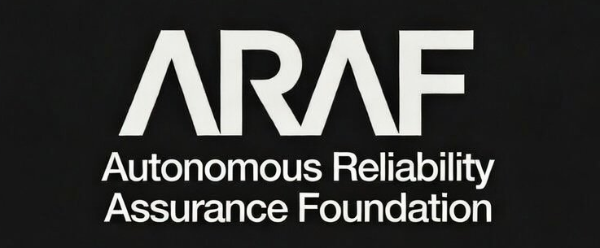
Figure A.1b — ARAF Organizational Wordmark, Reverse (white on dark)

A.2 ARA Certification Mark — Standard Variation (Dark on Light)
The standard variation is the primary mark for use on white and light-colored backgrounds. All mark components are rendered in black (#000000) with the Certification ID in dark gray (#555555).

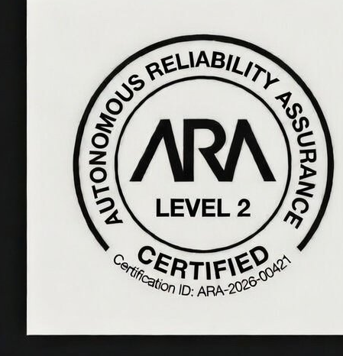
Figure A.2 — ARA Certification Mark, Standard Variation (dark on light)

A.3 ARA Certification Mark — Reverse Variation (Light on Dark)
The reverse variation is used on dark backgrounds and dark-themed interfaces. All mark components are rendered in white (#FFFFFF) with the Certification ID in light gray (#AAAAAA).

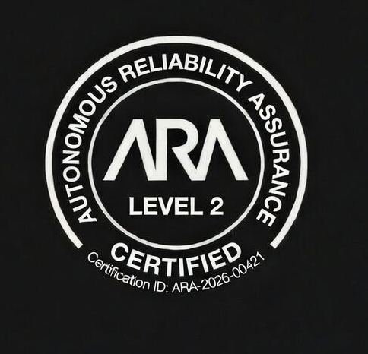
Figure A.3 — ARA Certification Mark, Reverse Variation (light on dark)

A.4 Complete Brand Identity Reference
The following composite image shows the ARAF organizational wordmark alongside both authorized certification mark variations for reference.

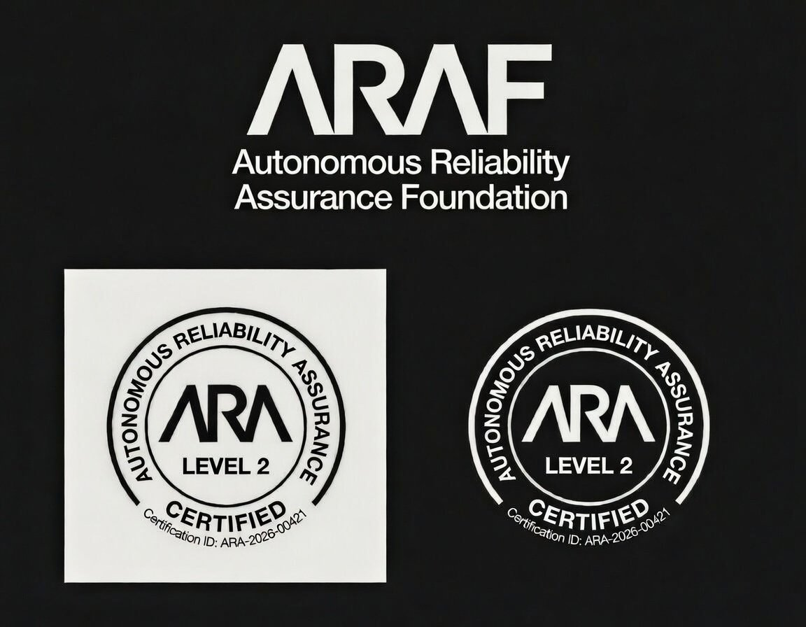
Figure A.4 — ARAF Brand Identity: Organizational Wordmark and Certification Mark Variations
Note: The certification marks shown above display “Level 2” and Certification ID “ARA-2026-00421” as reference examples. Each certified system receives a unique mark with the appropriate level and Certification ID. The mark artwork shown is representative; certified organizations receive their system-specific artwork through the ARAF Certification Portal.

A.5 Mark Component Reference
Component | Specification
Shape | Circular badge with two concentric borders forming a text band
Outer ring text | “AUTONOMOUS RELIABILITY ASSURANCE” (uppercase, semicircular arc from left over top to right)
Lower ring text | “CERTIFIED” (uppercase, circular arc, bottom)
Central wordmark | “ARA” (proprietary geometric logotype, centered)
Level text | “LEVEL 1” / “LEVEL 2” / “LEVEL 3” (below ARA wordmark)
Certification ID | “Certification ID: ARA-YYYY-NNNNN” (small, bottom interior)
Primary typeface | Proprietary ARAF geometric logotype (ARA wordmark); sans-serif family (ring and supporting text)
Minimum size (print) | 0.75 inches (19 mm) diameter
Minimum size (digital) | 80 pixels diameter
Clear space | 15% of diameter on all sides

A.6 Color Reference
Variation | Borders/Ring Text | ARA Wordmark | Level Text | Cert ID
Standard (dark on light) | #000000 | #000000 | #000000 | #555555
Reverse (light on dark) | #FFFFFF | #FFFFFF | #FFFFFF | #AAAAAA
Monochrome black | #000000 | #000000 | #000000 | #333333
Monochrome white | #FFFFFF | #FFFFFF | #FFFFFF | #CCCCCC

A.7 File Formats Available
Format | Use Case | Provided Sizes
SVG (vector) | Web display, scalable digital applications | Scalable (no fixed size)
EPS (vector) | Professional print production | Scalable (no fixed size)
AI (vector) | Adobe Illustrator source file for print design | Scalable (no fixed size)
PNG (raster, transparent background) | Web, email, presentations, documents | 80px, 120px, 240px, 480px, 960px diameter
PNG (raster, white background) | Print, documents, white backgrounds | 300 DPI at 0.75in, 1.0in, 1.5in, 2.0in diameter
JPG (raster) | Not provided | JPG not provided due to compression artifacts; use PNG
Tokenized badge (QR) | Physical assets, equipment labeling | System-specific; generated via Certification Portal
Tokenized badge (embeddable) | Digital integration, API, agent-to-agent | System-specific; JWT token via Certification Portal

Appendix B: Usage Compliance Checklist
Certified organizations should use this checklist to verify compliance with this policy before publishing or distributing any material containing the ARA Certification Mark or ARAF trademarks.

B.1 Pre-Publication Checklist
Check Item | Policy Reference | Status
Mark uses official artwork file (not recreated) | Article 3, Section 3.6
Mark is an authorized color variation | Article 3, Section 3.2
Mark meets minimum size requirement | Article 3, Section 3.3
Clear space maintained (15% of diameter) | Article 3, Section 3.4
All required mark components present and unmodified | Article 3, Section 3.1
Certification ID in mark matches actual certification | Article 3, Section 3.1
Level in mark matches actual certification level | Article 3, Section 3.1
Usage authorized for organization’s certification level | Article 4, Section 4.1
Mark associated only with the certified system | Article 4, Section 4.2
Trademark symbol (® or ™) on first use | Article 2, Section 2.3
Attribution statement included | Article 2, Section 2.3
No prohibited modifications applied | Article 7, Section 7.1.1
No implied endorsement language | Article 7, Section 7.1.3
No co-branding with other certification marks | Article 7, Section 7.2.1
Certification is currently Active (not expired/suspended) | Article 11
Tokenized badge used for physical/digital assets where applicable | Article 6, Section 6.6

B.2 Website-Specific Checklist
Check Item | Policy Reference | Status
Dedicated certification page exists with required information | Article 5, Section 5.3
Registry link to registry.araf.org included | Article 5, Section 5.3
Homepage/product page mark links to certification page | Article 5, Section 5.3
Registry Verification Badge used where possible | Article 6, Section 6.3
Social media usage follows text/image rules | Article 6, Section 6.4
Mark not used as favicon or profile image | Article 3, Section 3.3 / Article 6, Section 6.4
Email signature usage limited to relevant personnel | Article 6, Section 6.5
Tokenized badge QR code resolves to live registry entry | Article 6, Section 6.6.3
API integration uses X-ARA-Certification-Token header where applicable | Article 6, Section 6.6.4

B.3 Annual Compliance Review
Certified organizations are required to conduct an internal review of all ARA Certification Mark usage at least annually, coinciding with the certification reassessment cycle. The review should confirm that: all mark displays reflect the current certification level and Certification ID; no mark displays exist for systems that are no longer certified; all digital placements use current artwork files; the attribution statement is present on all materials; and any new placements since the last review comply with this policy.

Appendix C: Glossary of Terms
The following terms are used throughout this document with the specific meanings defined below.

Term | Definition
ARA | Autonomous Reliability Assurance. The certification standard published by ARAF.
ARA Certification Mark | The circular badge displaying “AUTONOMOUS RELIABILITY ASSURANCE / ARA / LEVEL [N] / CERTIFIED / Certification ID” that certified organizations are authorized to display.
ARAF | Autonomous Reliability Assurance Foundation. The independent standards body that publishes and governs the ARA Standard.
Attribution Statement | The required legal notice: “ARAF, ARA, and the ARA Certification Mark are registered trademarks of the Autonomous Reliability Assurance Foundation. Used under license.”
AVB | Authorized Validation Body. A third-party organization authorized by ARAF to conduct ARA evaluations.
Certification Agreement | The legal agreement between ARAF and a certified organization governing certification terms including mark usage rights.
Certification ID | A unique alphanumeric identifier (format: ARA-YYYY-NNNNN) assigned to each certified system, embedded in the mark and recorded in the registry.
Certification Portal | The ARAF-operated web platform where certified organizations access official mark artwork files, embed codes, and certification management tools.
Clear Space | The minimum unoccupied area surrounding the mark (15% of diameter) where no other visual elements may appear.
Design Mark | A trademark consisting of a specific visual design or logo, as distinguished from a word mark.
Public Certification Registry | The publicly accessible database at registry.araf.org listing all currently and historically certified systems.
Registry Verification Badge | A dynamic HTML/JavaScript embeddable component that displays the ARA Certification Mark with real-time certification status verification.
Scope Limitation | A restriction on the operational modes, deployment environments, or use cases covered by a certification.
Tokenized Badge | A cryptographically signed digital artifact issued by the ARAF platform for each certified system, containing embedded certification metadata, a verification URL, and a machine-readable JWT payload. Used for tamper-evident verification on physical and digital assets.
Token Identifier | A unique, non-transferable alphanumeric string assigned to each tokenized badge, used to query the ARAF Verification API for real-time certification status.
TSB | Technical Standards Board. The ARAF committee responsible for standard development and technical governance.
Word Mark | A trademark consisting of text/words without specific design treatment, protecting the name itself regardless of visual presentation.

