**E-commerce (Golang Product APIs only)**

**Product API**

1. **Get All Product by limit and page number API**

**Route** : /products?limit=2&page=3

Limit means number of products to be displayed in one page, default is 5. In the given example limit is 2.

page means the page number you currently wanna see , it is optional with default as 1. In the given example below we are seeing page number 3.

total_pages = ceil((number of records) / limit)

**Method** : Get

**Request Header** :

Accept : application/vnd.e-commerce.v1

**Response Json-**

{

"products": [

{

"id": 5,

"product_title": "Sony DSC W830 Cyber-Shot 20.1 MP ",

"description": " stores or generates electricity",

"product_price": 1500,

"discount": 50,

"tax": 8,

"stock": 15,

"category_id": 2,

"category": "Electronics",

"brand": "Samsung",

"color": "Blue",

"size": “”,

"image_urls": [

"assets/productImages/SonyDSC1.jpeg",

"assets/productImages/SonyDSC2.jpeg",

"assets/productImages/SonyDSC3.jpeg"

]

},

{

"id": 6,

"product_title": "Charger",

"description": " stores or generates electricity",

"product_price": 500,

"discount": 5,

"tax": 21,

"stock": 4,

"category_id": 2,

"category": "Electronics",

"brand": "One Plus",

"color": "White",

"size": “”,

"image_urls": [

"assets/productImages/Charger1.jpeg",

"assets/productImages/Charger2.jpeg"

]

}

],

"total_pages": 8

}

**Response Status Codes** -

200 Ok - If user record is fetched successfully according to the ID

400 BadRequest - If the Id is not supplied/ not valid URLs data

500 Internal Server Error - If any unexpected error occurred

1. **Get Specific Product By its Id API**

**Route** : /product/12

Here 12 is the id of the product

**Method** : Get

**Request Header** :

Accept : application/vnd.e-commerce.v1

Json Response

{

"id": 12,

"product_title": "Sonata Watch",

"description": "A watch is a portable timepiece intended ",

"product_price": 3010,

"discount": 20,

"tax": 5,

"stock": 12,

"category_id": 4,

"category": "Watch",

"brand": "Sonata",

"color": "Golden",

"size": “”,

"image_urls": [

"assets/productImages/SonataWatch1.jpeg",

"assets/productImages/SonataWatch2.jpeg",

"assets/productImages/SonataWatch3.jpeg"

]

}

**Response Status Codes** -

200 Ok - If user record is fetched successfully according to the ID

400 BadRequest - If the Id is not supplied/ not valid URLs data

500 Internal Server Error - If any unexpected error occurred

1. **Update Stock API:**

**Route** : /product/stock?product_id=3&stock=2

product_id : Id of the product whose available_quantity is to be updated

stock : Quantity which is to be decremented/incremented from available_quantity(Do not confuse this stock with the one sent as a json Response. That stock means available_quantity)

**Method** : Put

**Request Header** :

Accept : application/vnd.e-commerce.v1

Previous Json Response:

{

"data": {

"id": 3,

"product_title": "Dragon Jacket",

"description": "Made from the skin of one of the dragons",

"product_price": 700,

"discount": 40,

“tax”: 10,

"stock": 3,

"category_id": 1,

"category": "Clothes",

"brand": "Veteran",

"color": "Black",

"size": "Extra Large",

"image_urls": [

"assets/productImages/DragonJacket1.jpeg",

"assets/productImages/DragonJacket2.jpeg",

"assets/productImages/DragonJacket3.jpeg"

]

}

}

After Json Response:

{

"data": {

"id": 3,

"product_title": "Dragon Jacket",

"description": "Made from the skin of one of the dragons",

"product_price": 700,

"discount": 40,

“tax”: 10,

"stock": 1,

"category_id": 1,

"category": "Clothes",

"brand": "Veteran",

"color": "Black",

"size": "Extra Large",

"image_urls": [

"assets/productImages/DragonJacket1.jpeg",

"assets/productImages/DragonJacket2.jpeg",

"assets/productImages/DragonJacket3.jpeg"

]

}

}

* **Response Status Codes** -

200 Ok - If Product Id existed in db

404 page not found - Bad request

- If Product does not exist

- If id is missing in route

- If stocks in database are less than stocks asked to decrement

- If any product with that id is not present in database

500 Internal Server Error - If any unexpected error occurred

1. **Product Deletion API (Only for admin)**

**Route** : /product/16

Here, 16 is the id of the product we wanna delete along with its image data.

**Method** : Delete

**Request Header** :

Accept : application/vnd.e-commerce.v1

**Json Response:**

{

"data": "Product Deleted Successfully!"

}

* **Response Status Codes** -

200 Ok - If Product Id existed in db

400 Bad Request

- If token is invalid

404 page not found

- Bad request

- If id is missing in route

- If User does not exist

500 Internal Server Error - If any unexpected error occurred

1. **Product Filters API**

**Route** : /products/filters?category_id=3&brand=Apple&price=asc

category_id is a Parameter, its value here is 3.

brand is a Parameter, Apple its value .

price is a Parameter, “asc” or “desc” can be its value. In given example “asc” is its value which means sort by ascending order

color is also a Parameter, it could be used in addition to above Parameters.

size is also a Parameter, it could be used in addition to above Parameters.

limit and page Parameters provide same functionality as in **Get All Product by limit and page number API**

**Note** : All Parameters are case-sensitive so apple != Apple. All parameters are optional. That is if no parameter is provided to the above route, it will behave the same as **Get All Product by limit and page number API** .

**Method** : Get

**Request Header** :

Accept : application/vnd.e-commerce.v1

**Json Response:**

{

"products": [

{

"id": 9,

"product_title": "Apple iPhone XR (64GB)",

"description": "The mobile phone can be used to communicate ",

"product_price": 50000,

"discount": 6,

"tax": 15,

"stock": 20,

"category_id": 3,

"category": "Mobile",

"brand": "Apple",

"color": "Grey",

"size": "",

"image_urls": [

"assets/productImages/AndroidLEDTV1.jpeg",

"assets/productImages/AndroidLEDTV2.jpeg",

"assets/productImages/AndroidLEDTV3.jpeg"

]

},

{

"id": 7,

"product_title": "Apple iPhone 11 Pro (64GB)",

"description": "The mobile phone can be used to communicate ",

"product_price": 60000,

"discount": 5,

"tax": 15,

"stock": 10,

"category_id": 3,

"category": "Mobile",

"brand": "Apple",

"color": "Golden",

"size": "",

"image_urls": [

"assets/productImages/AndroidLEDTV1.jpeg",

"assets/productImages/AndroidLEDTV2.jpeg",

"assets/productImages/AndroidLEDTV3.jpeg"

]

},

{

"id": 8,

"product_title": "Apple iPhone 11 Pro (64GB) Max",

"description": "The mobile phone can be used to communicate ",

"product_price": 700000,

"discount": 4,

"tax": 15,

"stock": 30,

"category_id": 3,

"category": "Mobile",

"brand": "Apple",

"color": "Black",

"size":"",

"image_urls": [

"assets/productImages/AndroidLEDTV1.jpeg",

"assets/productImages/AndroidLEDTV2.jpeg",

"assets/productImages/AndroidLEDTV3.jpeg"

]

}

],

"total_pages": 1

}

**Response Status Codes** -

200 Ok - If Product Id existed in db

404 page not found - Bad request , If id is missing in route

500 Internal Server Error - If any unexpected error occurred

1. **Product Search by text API**

**Route** : /products/search?text=xr

text is a Parameter, its value here is xr. This text is currently searched in only Product’s name, Product’s brand and Category names.

limit and page Parameters provide same functionality as in **Get All Product by limit and page number API**

**Note** : All parameters case-insensitive so apple = Apple. All parameters are optional thus if no parameter is provided to the above route, it will behave the same as **Get All Product by limit and page number API** .

**Method** : Get

**Request Header** :

Accept : application/vnd.e-commerce.v1

**Json Response:**

{

"products": [

{

"id": 9,

"product_title": "Apple iPhone XR (64GB)",

"description": "The mobile phone can be used to communicate ",

"product_price": 50000,

"discount": 6,

"tax": 15,

"stock": 20,

"category_id": 3,

"category": "Mobile",

"brand": "Apple",

"color": "Grey",

"size": "",

"image_urls": [

"assets/productImages/AndroidLEDTV1.jpeg",

"assets/productImages/AndroidLEDTV2.jpeg",

"assets/productImages/AndroidLEDTV3.jpeg"

]

}

],

"total_pages": 1

}

**Response Status Codes** -

200 Ok - If Product text existed in db

404 page not found - Bad request , If id is missing in route

500 Internal Server Error - If any unexpected error occurred

1. **Create Product API (Only for admin)**

**Route** : /createProduct

**Method** : Post

**Request Header** :

Accept : application/vnd.e-commerce.v1

Content-Type:multipart/form-data

**Request Body:**

**Post Form Request:**

product_title:VolleyBall

description:Some

product_price:200

discount:40

tax:5

stock:4

category_id:6

category:Sports

brand:Cosco

images:(Upload Images here)

**Post** **Form Request Sample in Postman**:

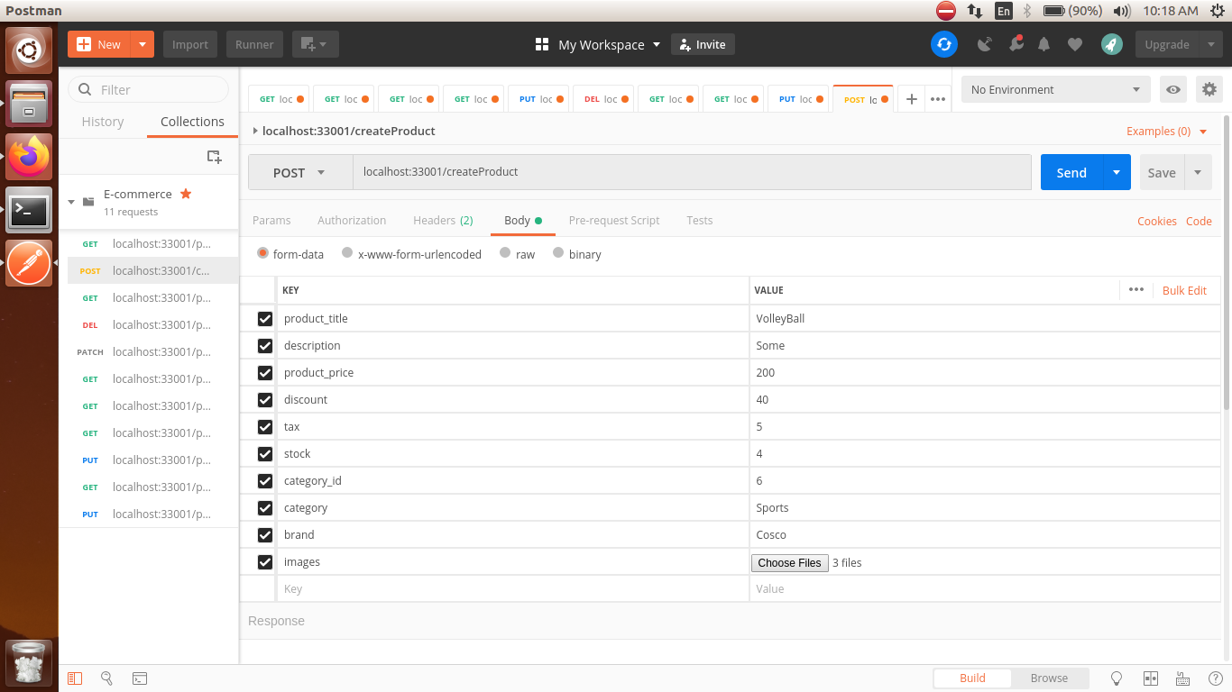

**Json Response:**

{

"id": 20,

"product_title": "VolleyBall",

"description": "Shoes are for regular comfort wear",

"product_price": 200,

"discount": 40,

"tax": 5,

"stock": 4,

"category_id": 6,

"category": "Sports",

"brand": "Cosco",

"color": "",

"size": "",

"image_urls": [

"assets/productImages/VolleyBall-848868461.png",

"assets/productImages/VolleyBall-152944872.png",

"assets/productImages/VolleyBall-519967527.png"

]

}

**Response Status Codes** -

200 Ok - If Product was created successfully.

400 Bad Request

- If token is invalid

404 page not found

- If User does not exist

- Bad request

- If Product fields are not legal

500 Internal Server Error - If any unexpected error occurred

1. **Update Product API (Only for admin)**

**Route** : /product/20

Here /product/20 means product with product_id as 20 is to be updated.

Note: In the Form request only the fields that need to be updated should be mentioned. In case of empty strings or null values the behaviour is different for each field. What that means is you ought to avoid inserting the fields in the update request that you don’t wanna update. Product Images also get updated,but it’s optional like any other product fields.

For seeing the previous contents of the updated Product given in this API, see **Json Response for product with id 20** in createProduct API.

**Method** : Put

**Request Header** :

Accept : application/vnd.e-commerce.v1

Content-Type:multipart/form-data

**Request Body:**

**Post Form Request for Updation:**

color:Cyan

images:(Upload images here)

**Post Form Sample Request for Updation in PostMan:**

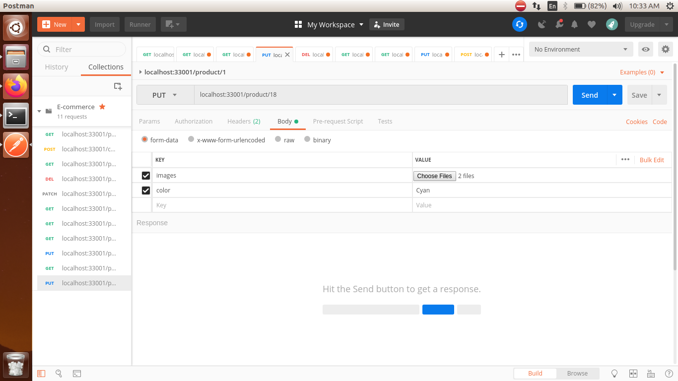

**Json Response:**

{

"data": {

"id": 20,

"product_title": "VolleyBall",

"description": "Shoes are for regular comfort wear",

"product_price": 200,

"discount": 40,

"tax": 5,

"stock": 4,

"category_id": 6,

"category": "Sports",

"brand": "Cosco",

"color": "Cyan",

"size": "",

"image_urls": [

"assets/productImages/VolleyBall-652675395.png",

"assets/productImages/VolleyBall-562613190.png"

]

}

}

**Response Status Codes** -

200 Ok - If Product was updated successfully.

400 Bad Request

- If token is invalid

404 page not found - Bad request , if Product fields are not legal

409 Conflict - If database Constraints are violated.

500 Internal Server Error - If any unexpected error occurred