# Social Hierarchy and Survival Likelihood on the Titanic

Joshua Tice

## Introduction

The objective of this project was to create an explanatory data visualization using Tableau to convey an insight into the Titanic dataset. I wanted to show evidence that social hierarchy and social norms had a strong influence on which passengers survived the sinking of the doomed vessel. In particular, traveling in first class, being a woman, or being a child greatly increased one's chances of survival. Additionally, the social status of the passenger could offset influences from the other two features (*i.e.*, age or sex).

## Design

Initially, when I began designing the visualization, I was only going to focus on survival likelihood as a function of sex and class. Specifically, I wanted to convey the message that being female or being in first class correlated strongly with greater survivorship. My thought was to display the number of passengers in each segment with bar charts. Then, I was going to apply color to indicate which fraction of each segment survived. My initial sketch is shown below.

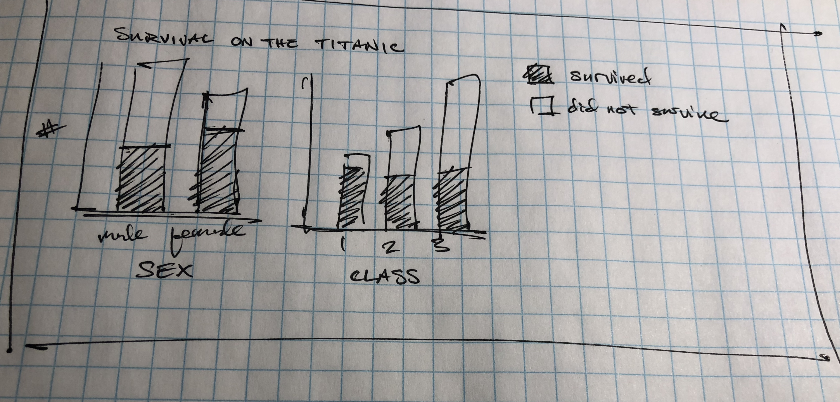

I translated the sketch into a Tableau dashboard, but I thought that the initial concept was too simple. I added several additional features to convey extra information. First, I added a tooltip that would display the exact number of passengers in each segment. Second, I added an action to the dashboard that would filter the data when the tooltip hovered over a specific segment. For example, if I hovered the tooltip over the bar for “Class 1”, the data in the chart for “Sex” would be filtered to show only Class 1 data. The user could use this filter to show that Class could partially offset the disadvantage of being male, for example. Finally, I added an additional chart that showed a histogram of the Fare data, which I thought would reinforce the message conveyed by the Class chart.

Link: [Visualization – Dashboard 1.0](https://public.tableau.com/profile/joshua.tice#!/vizhome/Udacityproject-TitanicData/Dash1_0)

At this point in the design, I requested feedback from a colleague. Without telling her the exact message I wanted to convey, I asked her to think out loud as she tried to decipher the main take-away of the visualization. Immediately, I saw that the interactive filter was a major distraction rather than an aid. My coworker spent several minutes trying to figure out what the filter did, and I eventually had to explain its purpose. After the clarification, she spent another several minutes trying to pick apart complex relationships between Sex, Class, and Fare rather than focusing on the simple high-level message. The Fare chart was particularly distracting. After finally mentioning the take-away I was looing for, my colleague asked if any correlation was seen between survival and age. I initially did not include age information because I thought the data would be too messy displayed as a histogram. (Admittedly, I added an unnecessary histogram in its place – the Fare data). After digesting all this feedback, I came to the conclusion that I had designed the visualization to be more of an exploratory data analysis tool for myself rather than a clear communication tool for a second party.

I also observed that she intuitively talked about the data in terms of “fractions” rather than absolute numbers. Having the fraction of passengers listed in the tooltip rather than the number of passengers would have been far more useful.