Relax Challenge Report

Joshua Ogden-Davis, March 31, 2024

Overall user adoption rate is 13.8%. Of the original features, none seemed to exert a strong or defining influence on user adoption, as described below.

The effects of the mailing list and marketing drip were visible, but influenced overall adoption by a maximum of just under 1 percentage point (and that’s if the user is both on the mailing list and enabled for marketing drip). In cases where the user has not opted into the mailing list, the marketing drip seemed to hurt adoption rates (though the sample size of that group is small).

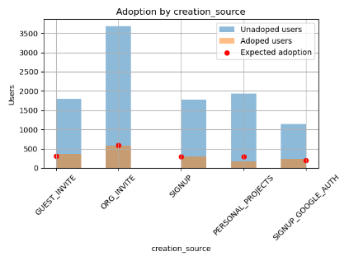

Comparing expected adoption rates of creation_source revealed little of interest as well, except that users for personal_projects had slightly low adoption.

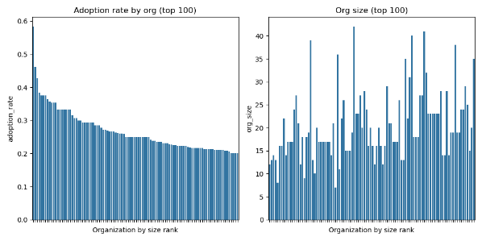

Some orgs had higher adoption rates than others. There is a weak inverse correlation between org size (by number of users) and adoption rates of invitees, ie, invites from smaller companies tend to result in slightly higher adoption rates.

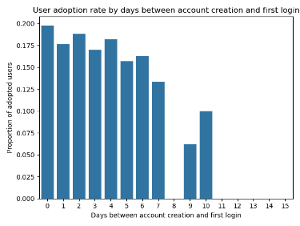

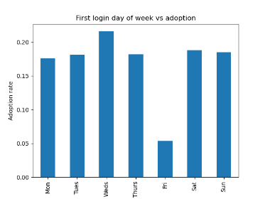Though not an original feature, the most reliable predictor of adoption is the user’s behavior within the first 10 days after account creation. No user whose first login was more than 10 days after account creation became an adopted member. Oddly, users who first logged in on a Friday substantially less adoption than any other subset of users.