Humans & Biometrics:
Human-Computer Interaction (HCI) Trends & User Acceptance

Joshua Gregory
CS4712 W01 UIE
Kennesaw State University

Contents
I. Abstract 3
II. Introduction 4
III. Biometrics HCI & User Acceptance 6
IV. End-User Acceptance: Survey Data Analysis 8
V. Remarks on Data Analyses 14
VI. Conclusion 15
VII. References 16

Abstract
This paper conducts a literature review to examine human-computer interaction (HCI) trends in current and emerging biometric systems and how biometric HCI may impact user acceptance of systems that collect and authenticate biometric characteristics (biometrics). End-user perspectives are examined via analyses of raw data from a peer-reviewed study survey.
Analyses revealed significant trends. Fingerprint recognition, the most experienced modality by overall mean, was consistently the most accepted by overall mean acceptance and within demographic groupings. DNA was consistently the least accepted. Other modalities examined (voice recognition, facial recognition, iris/retina scanning, and palm geometry) held similar relative positions across experience and acceptance.
Grouping modality acceptance by each demographic variable revealed that the modality type typically influenced acceptance more than a demographic. Large internal variance between categories was discovered in racial or ethnic identities, gender identities, and education levels, likely due to small sub-sample sizes. This resulted in deviations from observed patterns, especially within the gender grouping. This highlighted important considerations regarding minority communities for designing and training biometric systems. Overall trends remained stable, however.
The relationship observed betweenled to hypothesizing that experience with a biometric modality was correlated with user acceptance of the modality. Spearman testing found that positive correlation was statistically significant, though weak, between user experience and acceptance of a modality. Correlation between acceptance and concern over privacy infringement was also tested, though found to be negligible.
Ultimately, it was determined that ensuring a system is experienceable will likely improve user acceptance. Following a user-centered design process may also improve acceptance. Finally, future research needed was identified for discovering other correlative factors, for understanding how UI/UX impacts how users experience biometrics, and for defining traits that make a technology experienceable.
Keywords: Biometric, Recognition, Authentication, Human-Computer Interaction, HCI, User Acceptance, UA, User Experience.

Introduction
People are increasingly interacting with biometric technologies during everyday life. Biometric systems are designed to collect one or more physical or behavioral characteristic for the purpose of authenticating identity, knowingly or otherwise. Biometric trait-based authentication has been overtaking authentication schemes, like knowledge-based authentication (KBA) and possession-based authentication (PBA), offering promises of no more forgotten PINs or lost keys. This implies increased reliability and security, though practical implementation is nuanced and a topic of continued debate due to technical concerns and societal perceptions.
Inarguably, biometrics have had a profound impact on identity management, user authentication, and general HCI. Despite an impressive breadth of applications, the field is relatively young, with applications and capabilities rapidly expanding. Society is closer today than ever before to managing and authenticating real-world identities via fully-automated systems integrated into environments, requiring no user input. Particular consideration will increasingly be required when comparing benefits promised by ubiquitous, no-input identity management against ethical and social concerns. Successful implementation depends not only on meeting technical benchmarks but, more importantly, on identifying the factors that influence how users experience and ultimately accept biometric systems.

III. Apparatus & Methodology
3.1 Apparatus
This research project primarily utilizes two resources:
- Peer-reviewed academic literature
  - Accessed via Google Scholar and Kennesaw State University library resources.
- Raw dataset from peer-reviewed survey results
  - Raw survey dataset is publicly available from its host

3.2 Methods
Methodology used by this research project includes:
- Literature review
  - Reviewed to identify consensus findings, trends, and perspectives on biometrics, HCI, and user acceptance.
  - Sources referenced throughout document with full entries provided at the end of document.
- Data analyses
  - Conducted to quantify and evaluate user acceptance across qualitative variables for biometric type and demographic data and quantitative variables for respondent acceptance level.
  - Prepared, analyzed, and visualized in Python with NumPy, SciPy, and Matplotlib libraries using Google Colab notebook.
- Analyses Methodology
  - The initial dataset was formatted in tab-separated values (TSV). The file was obtained from publicly accessible host site and uploaded to a Google Drive, mounted programmatically. The TSV was read into a Pandas dataframe from which subsequent dataframes were generated.
  - Columns deemed relevant to present research were extracted. These included: response ID, each demographic variable, experience across six modalities; comfort ranking across modalities; and general concern over privacy infringement.
  - Column headers were stored as the full text from each survey question. These were renamed to usable variables. Qualitative responses were converted to ordinal integers to facilitate mean calculation (e.g., “Acceptable”, “Not sure”, “Unacceptable” 3, 2, 1). Unanswered questions (stored as cells with string “No Answer”) were converted to Pandas NA objects for automatic bypassing during iterative calculations.
  - State of residence was converted to regional maps to account for certain states having very small sub-sample sizes (n < 10). The regional map was based on state divisions used by the U.S. Census Bureau: Northeast, Midwest, South, and West. Only US states were mapped with District of Columbia, Guam, and Puerto Rico excluded.
  - Comfort per modality was used a proxy for acceptability and is described as “acceptance per modality” in code and hereafter. This question was the only to store responses as integers: 6 – 1 such that 6 = least comfortable and 1 = most comfortable. For consistency, this was reversed to 1 – 6 such that 1 = least comfortable and 6 = most comfortable.
  - Spearman tests were used to determine the statistical strength of correlation between experience with each modality and acceptance of the modality and to determine the same between general privacy concern and acceptance of each modality.
  - Means were calculated for each variable and for acceptance per modality grouped-by each demographic variable. Visualizations were generated for each mean and for the distribution of privacy responses. Spearman test results were tabulated.

Biometrics Overview
4.1 Evolution of Biometrics
Authenticating identity is far from a new concern. Systems to record and prove identity date as far back as written records exist. Ancient Egypt recorded physical descriptions of trusted traders for secure access. Fingerprints of merchants have been found pressed into Babylonian clay tablets from as early as 500 BCE. Records from 14th-century China also store merchant fingerprints (Britannica, 2026). Signatures and wanted posters also have been used for millennia, evolving over time to incorporate new technologies with modern digital methods for production and analysis.
One foundational predigital scheme was signaletics, a semi-formal system developed by late 19th-century Parisian police. Informed by Enlightenment-era methodology, signaletics leveraged emerging technologies like photography and recordkeeping alongside metrics for physical and behavioral characteristics. Head and body measurements and shapes of facial features were measured alongside recording physical markers like tattoos or disfigurements and behavioral traits like personalities. Master records were warehoused in a secured centralized location then transferred to portable cards that could be carried and referenced by officers in the field. Elements of this system saw widespread adoption across western agencies. (Britannica, 2026). Signaletics was an analog precursor for concepts used by modern biometrics: centralized secure data storage; one-to-many distribution; on-demand retrieval; multi-modal traits; among others. This decade also saw the first formal attempt at fingerprint classification, adopted by police agencies through the early 20th-century. Other non-digital authentication systems emerged in the 20th-century, including handwriting, dental, magnetic voiceprint, blood type, and DNA. However, photography and fingerprint emerged as dominant modalities.
Through the 20th-century, digital computing revolutionized biometrics. The information age and rapid adoption of the internet gave rise to data warehousing, remote retrieval, and record digitization. Algorithms like advanced reward-based learning improved analyses, though fingerprint and photography continued to remain dominant. This gave way to fiber optics, big data, advanced A.I. chips, portable computing, and high-quality CCTV. Apple’s 2013 fingerprint sensor revolutionized consumer biometrics and HCI. Equally impactful was Apple’s 2017 facial recognition system. Over the last decade, applications of biometrics have rapidly expanded. Drones capture gait for real-time authentication. Mobile phones track gaze. Vehicles track head and eye position. Personal assistants analyze and recognize voice. Deep-learning models continue to refine authentication with ever-increasing amounts of data like photos, medical records, and keystroke. A clear trend in biometric HCI has emerged: continuous collection of physical and behavioral characteristics for fully-automated authentication amid decreasing user awareness.

4.2. Biometric HCI Trends
4.2.1 Current Biometric HCI.
4.2.2 Emerging Biometric HCI.

End-User Acceptance: Survey Data Analysis
5.1 Dataset Overview
5.1.1 Dataset Information.
The initial dataset was compiled as a component for a research paper titled, A survey of U.S. public perspectives on facial recognition technology and facial imaging data practices in health and research contexts (Katsanis et al., 2021). The research was peer-reviewed and published at PLOS ONE, focusing primarily on medical facial imaging and recognition. A Qualtrics Panels survey was conducted as a research component. It was comprehensive, recording a wide range of demographic and experimental variables including experience, acceptability, trust, and privacy concern. This facilitated opportunities for analyses outside of its original design. Responses were compiled into a TSV-formatted dataset and hosted publicly at Synopsis.
The survey population of all adults residing in the U.S. respondents was quota sampled across four dimensions: age, gender, race, and U.S. state, district, or territory of residence. This yielded a sample size of n = 2010. Methodology yielded 80% statistical power at alpha = 0.05 for subgroups as small as n = 50 (Katsanis et al., 2021).

5.1.2 Methods Applied.
See section III, Apparatus & Methodology, for a full description of tools and technologies, analysis steps and assumptions, and statistical methodology applied to present research.

5.2 Overall Mean Experience per Modality
The mean of each respondent’s experience level across modalities unsurprisingly significantly skewed toward fingerprint collection and analysis. Prevalent digital and pre-digital applications with clear purpose and understandable HCI likely contributes to this.
Notably, digital fingerprinting HCI requires obvious interactions between user and computer. With the exception of obvious applications in law enforcement, fingerprint collection offers a sense of agency with implied consent, typically with the option to not consent and rely on conventional KBA, e.g., password or PIN.
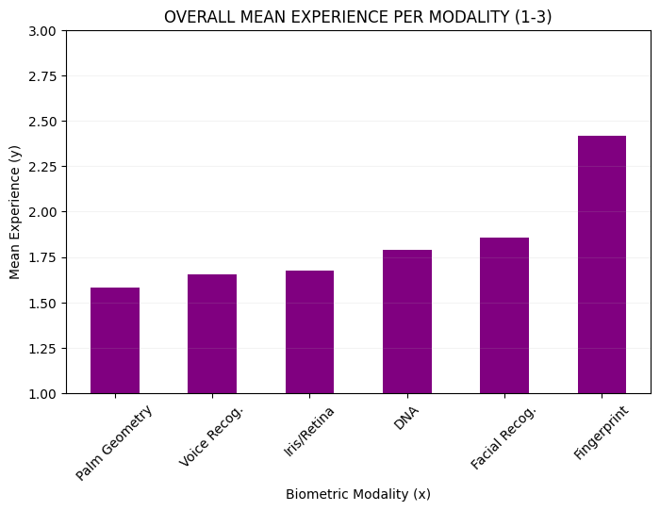
Figure 1: mean of all experience ratings per modality. Survey responses, “Unacceptable”, “Not Sure”, “Acceptable”, were converted to integers with values 1, 2, and 3, respectively.

5.3 Overall Mean Acceptance per Modality
Overall mean acceptance per modality demonstrated that fingerprint analysis was ranked as the most acceptable biometric by the average respondent (originally reported as comfort). Notably, as seen above, it is also the most experienced modality. Lesser-experienced modalities like DNA and iris/retina scanning follow the inverse pattern. This implies that experience with a modality may positively influence a user’s perception of acceptability for the modality.
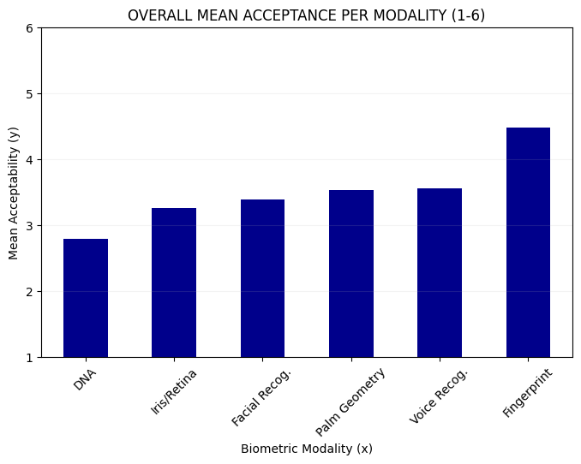
Figure 2: mean of all acceptance ratings per modality, The survey’s use of “comfort”, was used as a proxy for acceptability. Ratings were recorded as integers, 1 – 6.

5.4 General Privacy Concern Across Respondents
The mean privacy concern across all respondents was calculated at 4.194.
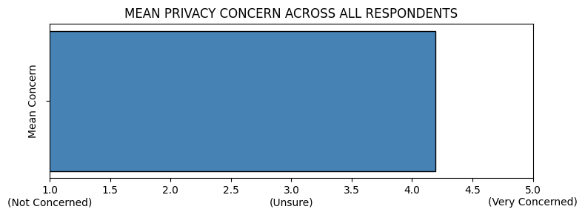
Figure 3: mean privacy concern across respondents. Qualitative responses were converted to integers 1 – 5, where 1 reflected no concern and 5 reflected very concerned.
The distribution of responses to this question highlighted how important the concern over privacy infringement was to a typical respondent with nearly 1800 of 2010 or 90% of respondents reporting being moderately or very concerned. Due to this high percentage, correlation was tested between this variable and acceptance per modality.
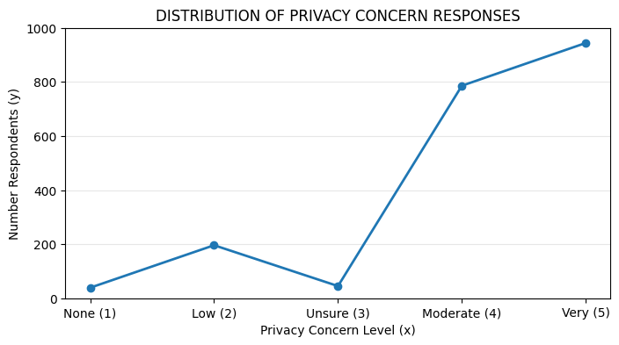
Figure 4: number of respondents per level of privacy concern (scale is the same as in Figure 3).
5.5 Mean Acceptance per Modality as Grouped-by Age Range
A clear trend emerged across age ranges. Fingerprint recognition was the most accepted biometric modality and DNA was the least. Voice recognition and palm geometry were next with very close acceptance. Facial and iris/retina scanning were next, also with very similar acceptance.
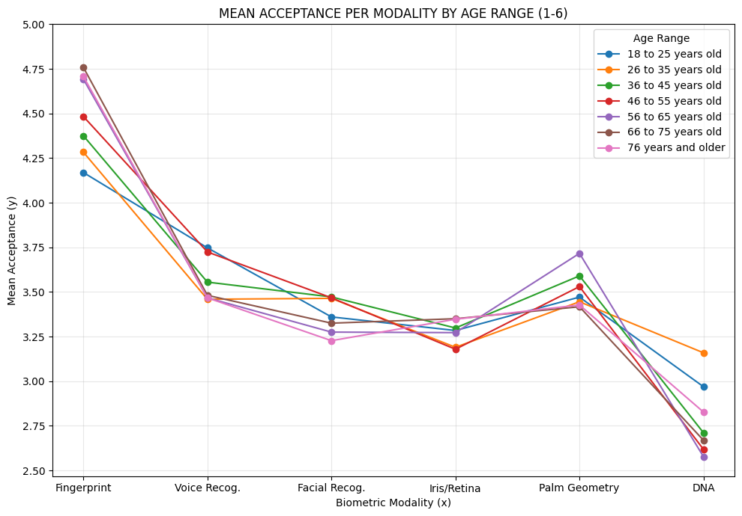
Figure 5: mean acceptance ratings per modality of each age range grouping.

5.6 Mean Acceptance per Modality as Grouped-by Political Affiliation
The same acceptance trend was observed as seen when grouped by age range, though with slightly more extreme boundaries. Fingerprint recognition was the most accepted, moreso than by age range. DNA was also least accepted at lower values across categories compared to age ranges. Voice recognition and palm geometry remained very similar. Facial recognition and iris/retina scanning remained very close as well.
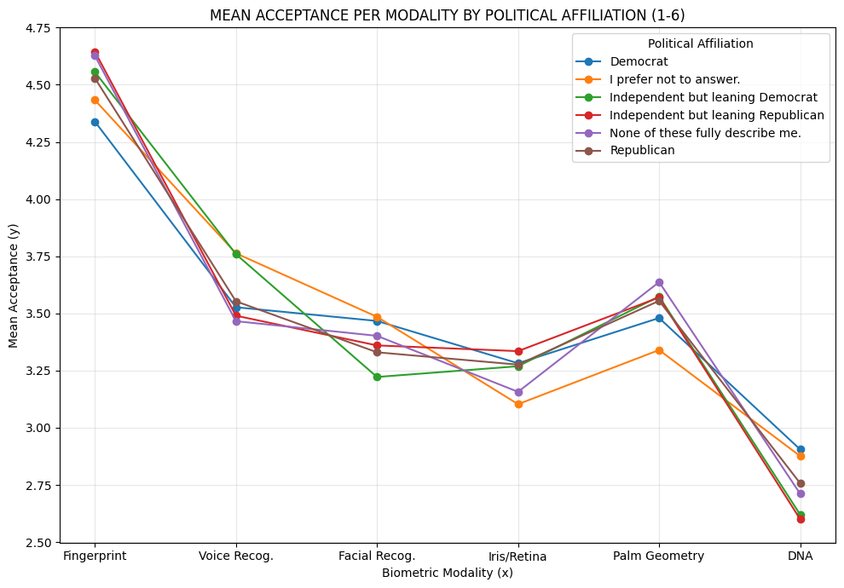
Figure 6: mean of all acceptance ratings per modality of each political affiliation grouping.

5.7 Mean Acceptance per Modality as Grouped-by Education Level
The trend across education levels was generally consistent with other demographic groupings. Though variance emerged between categories, the overall pattern was stable. As educational attainment increased, acceptance of fingerprinting increased while acceptance of DNA decreased. However, no clear monotonic relationship was observed, suggesting that education level is not a good candidate for predicting user acceptance of biometric systems. Significant variance was observed with lower education levels (Never attended, Primary, No Answer). These exhibitied atypical acceptance patterns relative to other categories and other demographics. However, such observations require further research due to small sample sizes within the dataset. Overall, the type of biometric had greater influence on acceptance than education.
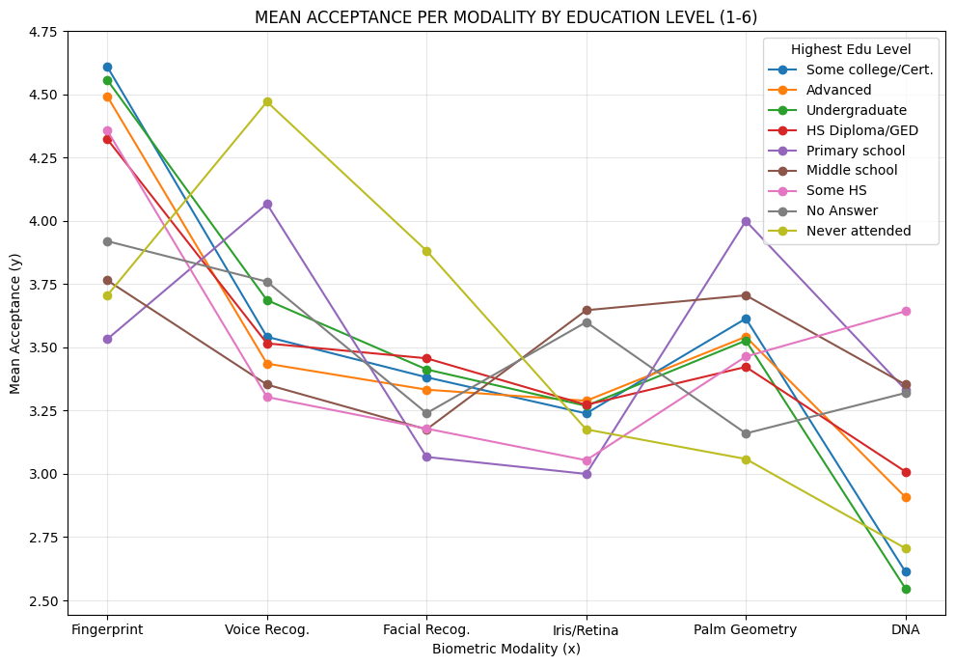Figure 7: mean of all acceptance ratings per modality by each highest education level grouping.

5.8 Mean Acceptance per Modality as Grouped-by Gender Identity
Grouping acceptance per modality by gender identity offers unique inferences. The survey permitted respondents to select multiple categories, resulting in unique identifiers. This led to considerable variance within the demographic due to underrepesentation of certain identities. The data show significant deviation from previously observed trends in other demographics. Though fingerprinting remains the most accepted, iris/retina and DNA are considered nearly as acceptable. This inverts observed trends for other demographic groupings. Likewise, facial recognition, previously observed as the second most accepted in other demoraphics, is least acceptable.
This leads to important inferences for biometric design and implementation. Users whose phsyical appearance may change over time may skew toward modalites that have the perception of being more permanent (i.e., less volatile) compared to characteristics like facial or voice recognition. This is a key finding with implications for biometric training. Training datasets often underrepesent user groups comprised of population minoritions. This is an acknowledged issue across ML applications that must be addressed to ensure reliable, convenient, and safe authentication for all users.
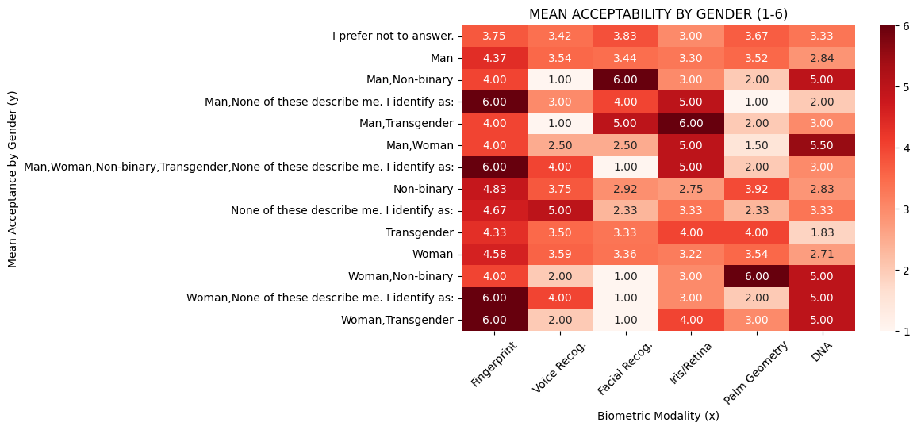
Figure 8: heatmap of mean acceptance ratings per modality by each gender identity grouping.

5.9 Mean Acceptance per Modality as Grouped-by Racial & Ethnic Identity
Visualizing mean acceptance per modality when grouped by racial or ethnic identity reveals substantially more internal variance than observed when grouping by gender identity. Similar to gender identity, the survey allowed users to select multiple categories, creating a number of identities with very small sub-sample sizes that resulted in underrepresentation of certain identities. Meaningful patterns in the data can be observed, regardless. Apart from outliers, fingerprint analysis shows overall darker hues while DNA analysis shows lighter hues with the highest concentration of white cells. Despite the issue with representation, the data appear to follow previously observed trends, unlike the inverted trends observed in the gender grouping.
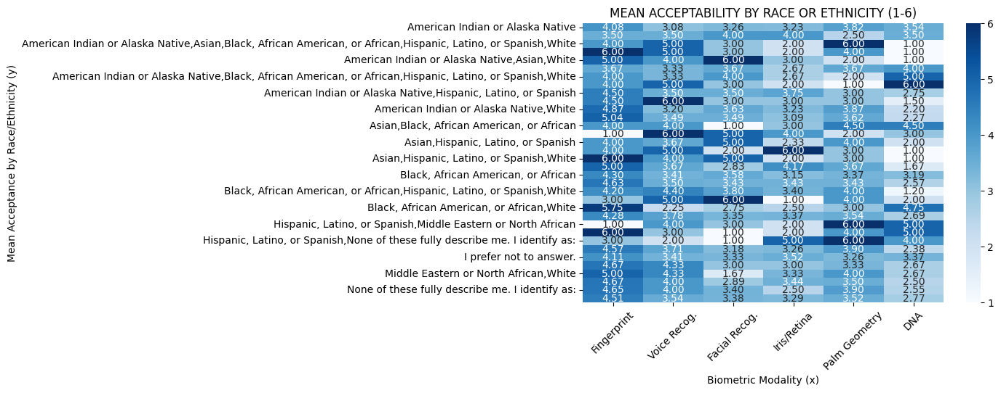
Figure 9: heatmap of mean acceptance ratings per modality by each racial or ethnic identity grouping.

5.10 Mean Acceptance per Modality as Grouped-by Geographic Region
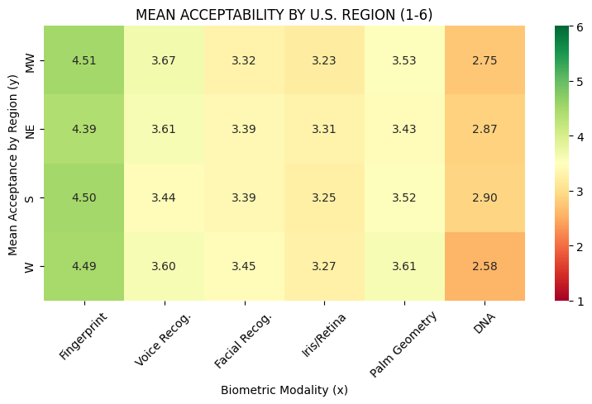
Figure 10: Shows heatmap of mean acceptance per modality by geographic region in which respondent resides.
To address issues with some states having very small sub-sample sizes (including n = 1), states were aggregated to U.S. Census Bureau divisions while districts and territories were excluded (as explained in Section III, Apparatus & Methodology). These regions exhibited the same broader patterns as observed in other demographic groupings. Fingerprint recognition was the most accepted biometric modality while DNA remained the least. Voice recognition and palm geometry were very similar and typically the next-most accepted. Iris/retina scanning and facial scanning followed these, also with very similar acceptance. Similar to age range, political affiliation, educational attainment, and race, geographic region appeared to have less influence over acceptance than did the modality itself.

5.11 Correlating Modality Acceptance
5.11.1 Experience vs. Acceptance.
The statistical strength of correlation between experience with a modality and acceptance of the modality was tested via Spearman. Experience with nearly every modality and acceptance of the modality exhibited statistically significant and positive correlation, though weakly associated.
The strength of DNA correlation was slightly stronger with weak-to-moderate association. This was notable due to being the least accepted modality overall and across most demographics, suggesting that DNA acceptance would experience a greater rate-of-change if experience changes.
Palm geometry emerged as an outlier with no statistically significant correlation between modality experience and acceptance.
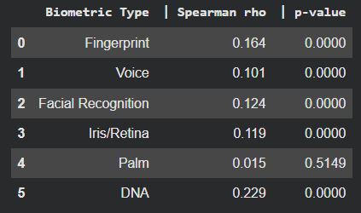
Figure 11: tabulated Spearman results showing RHO and P-value for experience and acceptance per modality.

5.11.2 Privacy Concern vs. Acceptance.
Negative correlation was tested between privacy infringement concern scores and acceptance per modality. Contrary to intuitively expected results, concern over privacy infringement did not meaningfully correlate with acceptance. The relationship was negligible.
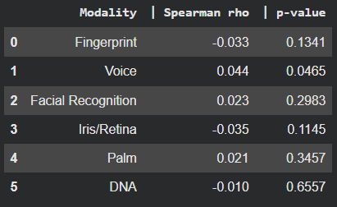
Figure 12: tabulated Spearman results showing RHO and P-value for privacy concern and acceptance per modality.

Remarks
6.1 Experience vs Acceptance Trends
Modality | Overall Mean Exp. | Overall Mean Acpt.
Fingerprint | 2.418 | 4.474 (1st)
Facial | 1.855 | 3.390 (4th)
DNA | 1.789 | 2.786 (6th)
Iris/Retina | 1.676 | 3.263 (5th)
Voice | 1.652 | 3.560 (2nd)
Palm Geometry | 1.579 | 3.527 (3rd)
6.2 Demographic Trends
Following demographic trends, fingerprint recognition was the most accepted across all demographics. The remaining acceptance means hold for all demographic groupings except for within gender identity (modality acceptance was nearly inverted) and education level (large variance relative to other demographics). Voice recognition and palm geometry appeared to be the next most accepted modalities across most demographics. Facial recognition and iris/retina scanning were considered the fourth- and fifth-most acceptable across most demographics. The least-most accepted modality across most demographics was DNA.
An exception to this trend was observed when grouping acceptance by gender identity. Though fingerprint recognition remained most acceptable, the remaining modalities were nearly inverted. Education level also revealed large internal variance. Inferences from these have been discussed.
6.2 Predicting Acceptance
Given fingerprint recognition was widely more experienced and accepted across both overall acceptance and demographic groupings, and the similar positions of other values, it was hypothesized that experience with a modality and user acceptance of the same was correlated with statistical significance. Spearman tests revealed statistically significant, though weak, positive correlations between experience and acceptance for most modalities. These findings supported the stated hypothesis without fully explaining acceptance patterns.
Privacy concern was also evaluated as a potential predictor of user acceptance. Spearman's tests revealed negligible relationships between one's level of concern about privacy infringement and user acceptance across modalities. While a statistically significant correlation was observed for voice recognition, it lacked meaningful significance. These findings suggested that respondents may evaluate privacy concerns and concerns regarding biometric acceptance independently as separate issues.

Conclusion
7.1 Improving Biometric User Acceptance
7.1.1 User-Centered Design Model.
Research by the National Institute of Standards and Technology (NIST) has shown that user interaction directly influences successful biometric implementation. Improved usability through ease-of-use, accessibility, interface design, performance, accuracy, robustness, and reduced complexity is critical for success (. Usable, effective, and understandable systems promote user experience and as shown in the previous section, modality experience positively correlates with acceptance. The user-centered design model replaces conventional SDLC with “a holistic approach in which users are a key component in the design of a biometric system … wherein users become our design partners and have an integral role … to have a measurable impact on a system’s ease of use” (NIST, 2008).
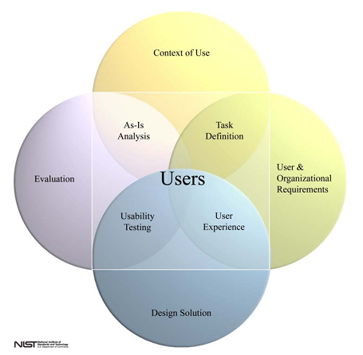
Figure 13: User-Centered Design Model process chart (NIST, 2008).

7.1.2 Implications from Analyses.
As trends in data showed, fingerprint recognition systems are a sufficient starting point for designing acceptable biometric systems. Collection and authentication of this characteristic is easy, understandable, and obvious in implementation (i.e., it is not a hidden, continuous process occurring in the environment). With the exception of obvious law enforcement applications, fingerprint collection is justifiable with implicit consent – each time a user unlocks their device by fingerprint, they do so willingly, especially when devices provide alternatives.
Furthermore, as Spearman testing showed, increasing user experience with a modality tends to improve user acceptance of the modality. Though the weak relationship suggested that user experience is not the sole correlative factor, it can be considered a known predictor (as compared to factors like concern over privacy infringement). Experience implies multiple requirements: explainable technology, understandable purpose, ease-of-use, and obvious implementation. I.e., collection or authentication of characteristics should not occur without the passive consent or active knowledge of users. Additionally, the link between experiencing biometric HCI and good UX design should not be neglected.
However, leveraging this correlation is undermined by current HCI trends toward no-input, background collection and automated, continuous authentication. Without appropriate user education, this will likely lead to reversing the shown correlation, with decreased user experience leading to decreased user acceptance. Ultimately, following a user-centered design model may improve acceptance of a biometric system. Prioritizing design that ensures a biometric system is experienceable will improve acceptance.

    - Future Research.
Further research is needed to define qualities that make technology experienceable and determine how such qualities impact biometric user acceptance. Research is also needed to better understand how UX design impacts the manner in which users experience biometric systems. Most critically, research is needed to discover other correlative factors for biometric acceptance such that a set of objective predictors are quantified, reducing the reliance on assumptions derived from other technologies.

References
Imaoka, H., Hashimoto, H., Takahashi, K., Ebihara, A. F., Liu, J., Hayasaka, A., Morishita, Y.,
Sakurai, K. (2021). The future of biometrics technology: from face recognition to related applications. APSIPA Transactions on Signal and Information Processing, 10(9). https://doi.org/10.1017/ATSIP.2021.8
Jain, A.K., Ross, A., & Prabhakar, S. (2004). An introduction to biometric recognition. IEEE
Transactions on Circuits and Systems for Video Technology, 14(1), 4-20, Jan. 2004.
https://doi.org/10.1109/TCSVT.2003.818349
Katsanis, S., Claes, P., Doerr, M., Cook-Deegan, R., Tenenbaum, J., Evans, B., Myoung, K.,
Anderton, J., Weinberg, S., Wagner, J. (2021). A survey of U.S. public perspectives on
facial recognition technology and facial imaging data practices in health and research
contexts. PLOS ONE 16(12): e0261738. https://doi.org/10.1371/journal.pone.0261738
National Institute of Standards and Technology. (2008). Usability & Biometrics.
www.nist.gov/system/files/usability_and_biometrics_final2.pdf
Wagner, J. (2021). Perspectives on facial images, DNA, and other biometrics [Dataset]. Synapse.
https://doi.org/10.7303/SYN25618565

