Humans & Biometrics:
Human-Computer Interaction (HCI) Trends & User Acceptance

Joshua Gregory
CS4712 W01 UIE
Kennesaw State University
October 18, 2026

Contents
I. Abstract 3
II. Introduction 4
III. Biometrics HCI & User Acceptance 6
IV. End-User Acceptance: Survey Data Analysis 8
V. Remarks on Data Analyses 14
VI. Conclusion 15
VII. References 16

Abstract
This paper conducts a literature review to examine how human-computer interaction (HCI) in systems for collection and recognition of biometric data for identity authentication (biometrics) influence user acceptance. An end-user perspective is examined by conducting secondary analyses of a raw dataset from a peer-reviewed study that surveyed over two thousand respondents to obtain acceptance and trust across biometric modality and application.
EXPLAIN FINDINGS
EXPLAIN CONCLUSION

NOTE: leveraging the weak positive correlation between modality familiarity and its acceptance is undermined by the trend toward no-input, background collection and fully-automated continuous authentication. Reversing the shown correlation shows that as familiarity decreases, acceptance will tend to decrease.
Keywords: Biometric, Recognition, Authentication, Human-Computer Interaction, HCI, User Acceptance, UA.

Introduction
People are increasingly interacting with biometric technologies during everyday life. Biometric systems are designed to collect one or more physical or behavioral characteristic for the purpose of authenticating identity, knowingly or otherwise. Biometric trait-based authentication has been overtaking authentication schemes, like knowledge-based authentication (KBA) and possession-based authentication (PBA), offering promises of no more forgotten PINs or lost keys. This implies increased reliability and security, though reality is nuanced and a topic of continued debate due to technical concerns and social perceptions. Inarguably, biometrics have had a profound impact on identity management, user authentication, and general HCI. Despite an impressive breadth of applications, the field is relatively young, with current and novel applications and capabilities rapidly expanding. Society is closer today than ever before to managing and authenticating real-world identities without user input. Biometrics requires particular consideration when comparing the benefits promised by ubiquitous and no-input identity authentication. Successful implementation depends not only on meeting technical benchmarks but, more importantly, on addressing social issues that are influenced by untrusted HCI and erode widespread acceptance.

III. Methodology
3.1. Apparatus
This research project primarily utilizes two resources:
- Peer-reviewed academic literature
  - Accessed via Google Scholar and Kennesaw State University library resources.
- Raw dataset from peer-reviewed survey results
  - Raw survey dataset is publicly available from its host

3.2. Methods
Methodology used by this research project includes:
- Literature review
  - Reviewed to identify consensus findings, trends, and perspectives on biometrics, HCI, and user acceptance.
  - Sources referenced throughout document with full entries provided at the end of document.
- Data analyses
  - Conducted to quantify and evaluate user acceptance across qualitative variables for biometric type and demographic data and quantitative variables for respondent acceptance level.
  - Prepared, analyzed, and visualized in Python with NumPy, SciPy, and Matplotlib libraries using Google Colab notebook.
- Analyses Methodology
  - The initial dataset was formatted in tab-separated values (TSV). The file was downloaded from its public host at Synopsis and uploaded to a Google Drive that was mounted via function call.
  - A stream was opened to the file’s location using Pandas read_csv() where file path and delimiter of \t were passed as parameters.
  - A subset table (i.e., Pandas dataframe) was compiled using relevant columns. response ID, age range, education level, racial or ethnic identity, gender identity, familiarity per modality, acceptance per modality, acceptance per application, trust rating for facial recognition per organization, trust rating for DNA analysis per organization.
  - The subset table was searched to ensure no response IDs appeared in duplicate.
  - The original dataset kept rows where respondents answered some but not all questions with unanswered cells marked with the string “No Answer”. This was maintained though the strings were converted to Pandas NA objects (for automatic bypassing during iterative calculations).
  - The initial dataset used full question text for column headers. These were replaced with descriptive variables.
  - Qualitative responses were converted to ordinal integers to facilitate quantification. (E.g., “No experience”, “Not sure”, “Experienced” 1, 2, 3.)
  - Comfort rankings per modality were originally recorded from 6 – 1, where 6 reflected least comfortable and 1 reflected most comfortable. For consistency with other responses, this order was reversed such that option 1 reflected least comfortable and option 6 reflected most comfortable.
  - Comfort level was used as a proxy for acceptability. This also provided consistency with acceptability per application.
  - Representing acceptance by state of residence was converted to regional maps to account for certain states having very small sub-samples (less than 10). Mapping states to regions was based on top-level divisions established by the U.S. Census Bureau: Northeast, Midwest, South, and West.
  - Guam and Puerto Rico were excluded from regional mapping due to each only having a sub-sample of 1 respondent.
  - A Spearman correlation test was applied to determine the statistical strength of correlation between experience with a modality (predictor) and acceptance of the modality (outcome).
- Variables:
  - Independent variables
    - Demographic data
    - Experience per modality
    - Trust in facial recognition per organization
    - General concern about privacy
  - Dependent variables
    - Acceptance (comfort) per modality
    - Acceptability per application

Biometrics Overview
4.1. A Brief History of Biometrics
Authenticating identity is far from a new concern. Systems to record and prove identity date as far back as written records exist. Ancient Egypt recorded descriptions of trusted traders for secure access. Fingerprints of merchants have been found in Babylonian tablets from as early as 500 BCE. Records from 14th-century China also store fingerprints of merchants (Britannica, 2026). Similarly, signatures were and remain a means of authentication, while wanted posters continue to serve as analog facial recognition for law enforcement.
One foundational predigital scheme was signaletics, a semi-formal system developed by late 19th-century Parisian police. Informed by Enlightenment-era methodology, signaletics leveraged emerging photography and recordkeeping technologies with metrics for physical and behavioral characteristics. Head and body measurements, facial feature shape, and others like tattoos or disfigurements were recorded alongside behavioral metrics like personality traits. Master records were warehoused in a secure central location then transferred portable cards that could be carried and referenced by officers in the field. The system saw widespread adoption across western agencies. (Britannica, 2026). Signaletics was an analog precursor of concepts in modern biometrics: centralized secure data storage, one-to-many distribution, on-demand retrieval, multi-modal collection, etc. This decade also saw the first fingerprint classification, adopted by police agencies through the early 20th-century. Other non-digital systems emerged in the 20th-century: handwriting, dental, magnetic voiceprint, blood type, and DNA, though photography and fingerprint remained dominant for ease-of-use and accessibility.
Through the mid 20th-century, digital computing revolutionized biometrics. The information age and rapid adoption of public internet gave rise to data warehousing, remote data retrieval, and incentives to digitize records. Algorithms like advanced reward-based learning improved analysis, though fingerprint and photography remained dominant. This era soon gave way to fiber optics, big data, advanced chips, portable computing, and high-quality yet cheap CCTV. Apple’s 2013 fingerprint sensor revolutionized biometric application and HCI. Arguably more impactful was their 2017 facial recognition system. Over the last decade, applications of biometrics have rapidly expanded. Drones capture gait for real-time authentication. Mobile phones track gaze. Vehicles track head and eye position. Personal assistants recognize voice. Deep-learning models continue to refine authentication with ever-increasing amounts of data like photos, medical records, and keystroke. A clear trend in biometric HCI has emerged: continuous collection of physical and behavioral characteristics for fully-automated authentication amid decreasing user awareness.

4.2. Emerging Biometric HCI Trends
4.2.1. Internet of Things (IoT) Integration.
4.2.2. Continuous Authentication.
4.2.3. Multi-Modal Systems.
4.2.4. Explainable A.I. (XAI).
4.3. User Acceptance
4.3.1. Cost vs. Benefit
4.2.2. Privacy, Trust, Security.
4.3.3. Technology Acceptance Model (TAM).

End-User Acceptance: Survey Data Analysis
5.1. Dataset Overview
5.1.1. Source Information.
The initial dataset was compiled as a component for a report titled, A survey of U.S. public perspectives on facial recognition technology and facial imaging data practices in health and research contexts. The research was peer-reviewed and published at PLOS ONE. Though it focused primarily on medical facial recognition, the survey was comprehensive, with multiple demographics and various acceptance metrics, offering multiple paths for analyses. The raw data, hosted at Synopsis in TSV, consisted of responses to a Qualtrics Panels survey. Using a population of all adults residing in the US, respondents were quota sampled using four dimensions: age, gender, race, and US state for accurate representation. This yielded a sample with size n=2010. The authors showed methodology with 80% statistical power at alpha = 0.05 for subgroups as small as n=50 (Katsanis et al., 2021).

5.1.2. Methods Applied.
See Apparatus & Methodology (section 3) for a full description of tools, steps, and statistical methodology applied.
Visualizations are found below.

5.2. Overall Mean Experience Level per Modality
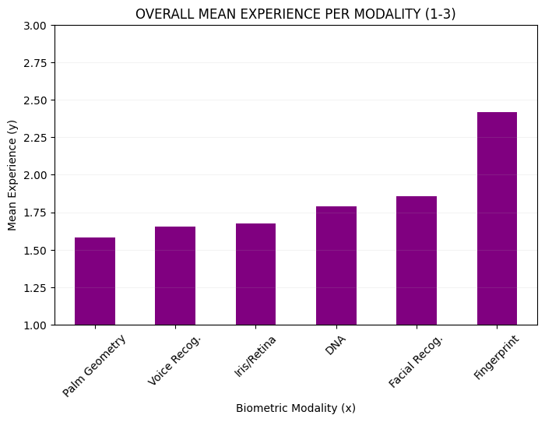
Figure 1: Shows mean of all experience ratings per modality. Survey responses, “Unacceptable”, “Not Sure”, “Acceptable”, were converted to integers with values 1, 2, and 3, respectively.
The mean of each respondent’s experience level across modalities skews significantly toward fingerprint collection and analysis. This finding is unsurprising given extensive pre-digital applications through the 20th-century, being fully digitized and widely adopted early, and implementation in consumer electronics.
Notably, digital fingerprinting HCI requires obvious interactions between user and computer. With the exception of obvious applications, fingerprint collection used for consumer device security offers agency and implicit consent, typically with the option to not consent and rely on conventional KBA, e.g., password or PIN.

5.3. Overall Mean Acceptance per Modality, per Application
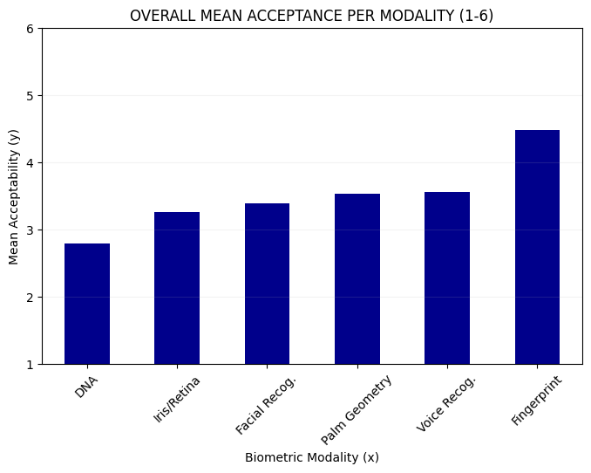
Figure 2: Shows mean of all acceptance ratings per modality, The survey’s use of “comfort”, was translated as an acceptability proxy for current purposes. Ratings were recorded as integers, 1 – 6.

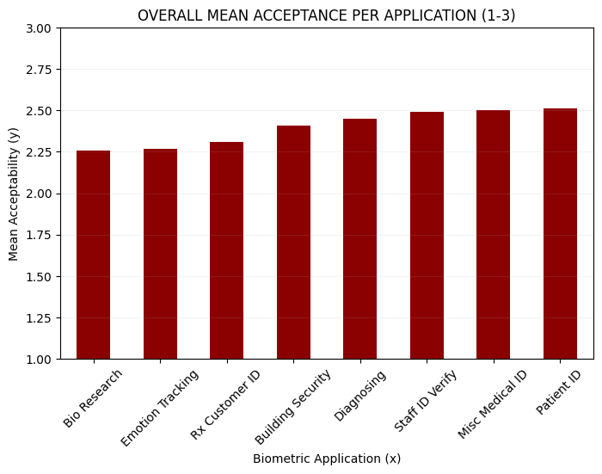
Figure 3: Shows mean of all acceptance ratings per application. Responses of “Unacceptable”, “Not sure”, “Acceptable” were converted to integers 1, 2, 3, respectively.
Overall mean acceptance per modality and per application demonstrate fingerprint analysis is reported as the most acceptable by the greatest number of respondents. Notably, it is also the most experienced modality (as seen above). Lesser-experienced modalities like DNA and iris/retina scanning follow the inverse pattern, appearing to imply that experience with a modality may impact acceptability of the modality. This pattern leads to the possibility of correlation between user experience and user acceptance.
Regarding overall mean application, notably the most acceptable applications center on patient care and safety, falling as an application moves away from these purposes.

5.4. Overall Mean Trust in Facial Recognition Usage per Organization
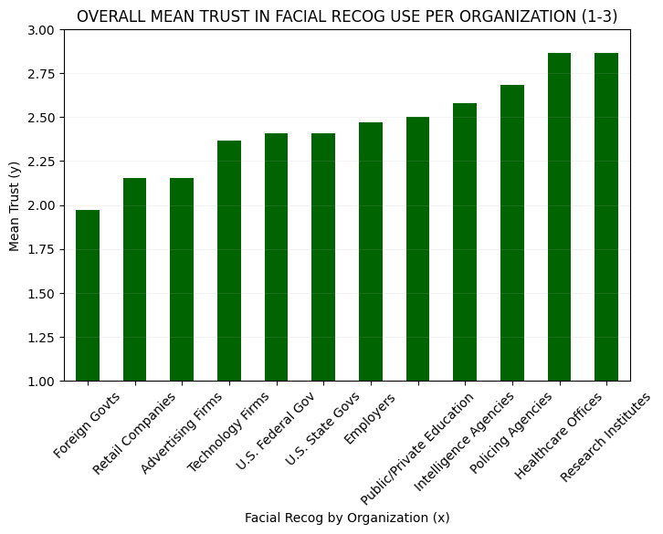
Figure 4: Shows overall mean trust in facial recognition usage per various organizations.
Overall mean trust in facial recognition across various organizations represents how users feel about a specific, commonly-encountered biometric with expanding usage by a variety of organizations. Notably, medical organizations are reported as most acceptable. Interestingly, these are followed by policing and intelligence agencies, which are reported as more acceptable than education, employers, technology firms, and retailers. Expectedly, foreign governments is consideered the least acceptable organization to use facial recognition of US citizens.

5.5. Mean Acceptance per Modality as Grouped by Age Range
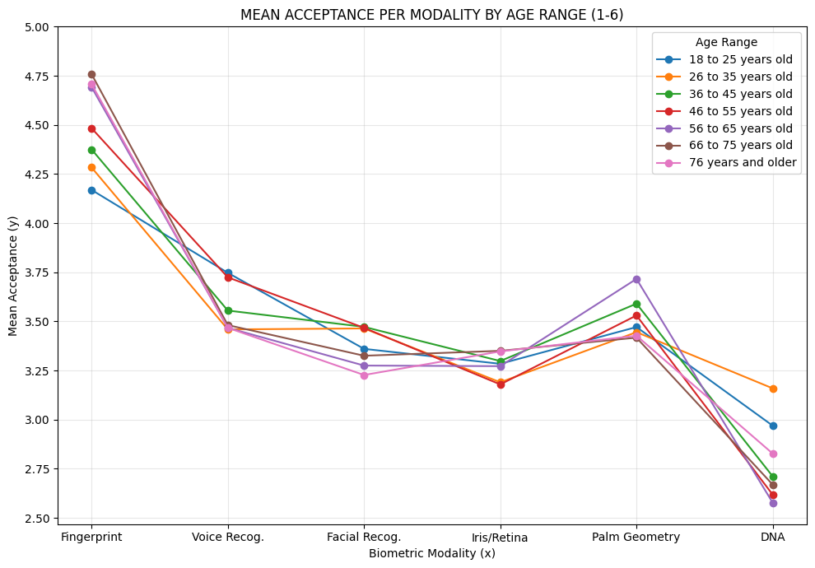
Figure 5: Shows mean acceptance ratings per modality of each age range grouping.
INFO ON AGE GROUPING

5.6. Mean Acceptance per Modality as Grouped by Political Affiliation
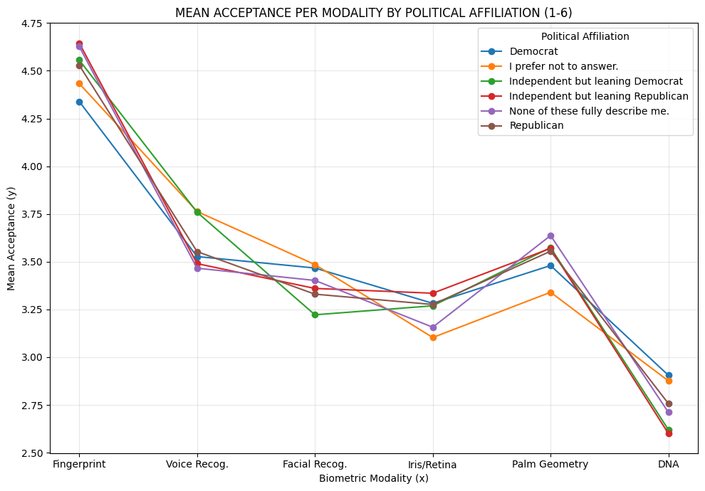
Figure 6: Shows mean of all acceptance ratings per modality of each political affiliation grouping.
INFO ON POLITICAL GROUPING

5.7. Mean Acceptance per Modality as Grouped by Education Level
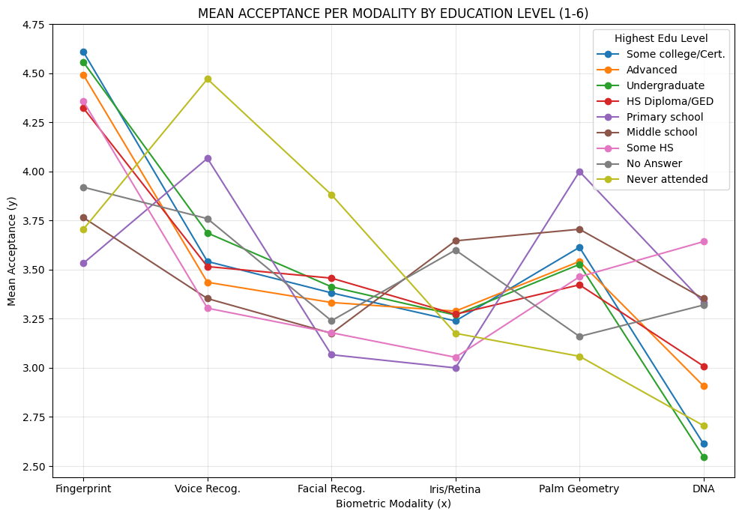Figure 7: Shows the mean of all acceptance ratings per modality by each highest education level grouping.
INFO ON EDU GROUPING

5.8. Mean Acceptance per Modality as Grouped by Gender Identity
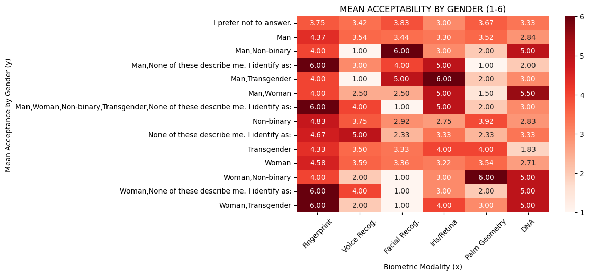
Figure 8: Shows heatmap of mean acceptance ratings per modality by each gender identity grouping.
Grouping acceptance per modality by gender identity offers unique inferences. The considerable variance within the demographic highlights possible underrepesentation in the sample of certain identities, possibly corroborated by a prevelance of evenly-rounded mean values. Regardless, it still offers insight. Significant deviation from trends is obsereved across all demographics. Fingerprinting remains the most accepted. However, iris/retina and DNA are reported nearly as acceptable, inverse to trends observed in other subgroupings. Likewise, facial recognition, previously observed as the second most accepted in other demoraphics, is least acceptable.
This reversal of trends leads to important inferences with critical implications for biometric design and implementation. Users whose phsyical appearance may change over time likely skew toward modalites that have the perception of being more permanent with less volatility over time compared to facial or voice recognition. This is a key finding that implicates ML training data for biometrics. Such datasets often underrepesent user groups comprised of population minoritions. This is an acknowledged issue in model training, not just for biometrics, that must be addressed to ensure reliable, convenient, and safe authentication of all users.

5.9. Mean Acceptance per Modality as Grouped by Racial & Ethnic Identity
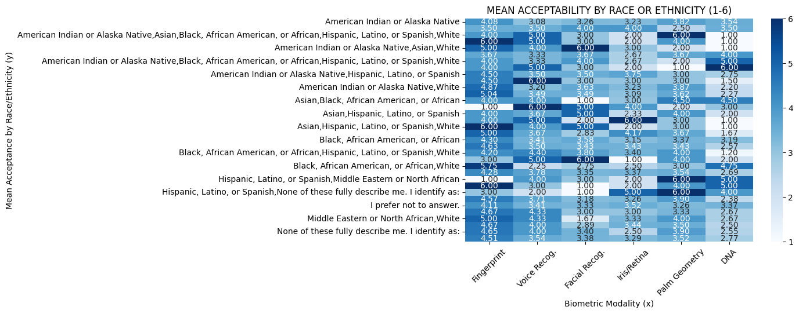
Figure 9: Shows heatmap of mean acceptance ratings per modality by each racial or ethnic identity grouping.
Visualizing mean acceptance per modality when grouped by racial or ethnic identity reveals substantially more internal variance, and perfectly-rounded means, than observed when grouping modality acceptance by gender identity. This is likely due to underrepresentation in the sample set of certain user-selected mixed-race or -ethnicity identities. Meaningful patterns in the data can be observed, regardless. Apart from outliers, fingerprint analysis shows overall darker hues while DNA analysis shows lighter blues with the highest concentration of white cells. Despite the issue with representation, the data appear to follow previously observed trends.

5.10. Mean Acceptance per Modality as Grouped by Geographic Region
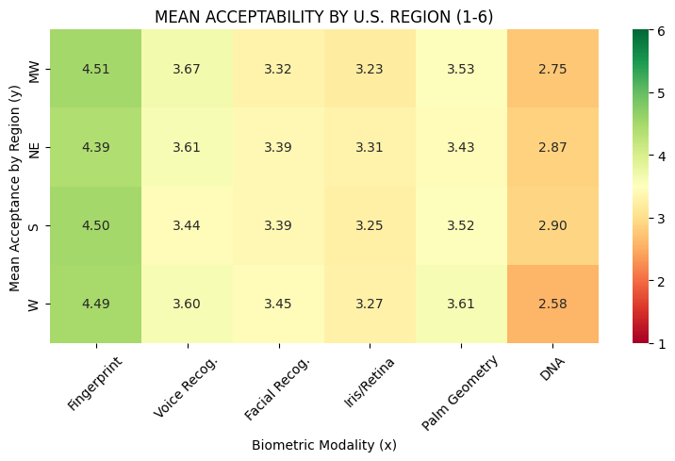
Figure 10: Shows heatmap of mean acceptance per modality by geographic region in which respondent resides.
INFO ON GEO GROUPING

5.11. Summary
Responses were quantified from 1 (least acceptable) to 6 (most acceptable).
Respondents across age groups and education levels appear to similarly find fingerprinting least acceptable and DNA analysis most acceptable.
Responses by race and ethnicity display substantial variance, complicating identification of patterns or meaningful inferences. Unlike other demographics, no clear trend lines emerge with analysis. Notably, a number of perfect ratings are shown for different modalities (e.g., a mean rating of exactly 1.00, 2.00, 3.00, 4.00, 5.00, or 6.00). These occur most frequently among mixed racial or ethnic identities. Reasonably, this implies that such identities occupy very small subgroup sizes, allowing a limited number of responses to have outsized influence over a subgroup’s mean rating. Thus, findings for these or other underrepresented subgroups necessitate caution to mitigate biased interpretation with these results most likely reflecting sampling variances, rather than responses that accurately represent corresponding population subgroups.

Remarks
6.1. Trends
6.2. Familiarity as Acceptance Predictor
After observing patterns above, the statistical strength of correlation was Spearman tested between experience with a modality and acceptance of the modality. This yielded:
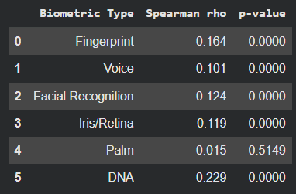
Figure 11: Tabulated results of Spearman test showing RHO and P values per modality experience and acceptance.

6.3. Demographic Implications

Conclusion
8.1.

References
Jain, A.K., Ross, A., & Prabhakar, S. (2004). An introduction to biometric recognition. IEEE
Transactions on Circuits and Systems for Video Technology, 14(1), 4-20, Jan. 2004.
https://doi.org/10.1109/TCSVT.2003.818349
Imaoka, H., Hashimoto, H., Takahashi, K., Ebihara, A. F., Liu, J., Hayasaka, A., Morishita, Y.,
Sakurai, K. (2021). The future of biometrics technology: from face recognition to related applications. APSIPA Transactions on Signal and Information Processing, 10(9). https://doi.org/10.1017/ATSIP.2021.8
Katsanis, S., Claes, P., Doerr, M., Cook-Deegan, R., Tenenbaum, J., Evans, B., Myoung, K.,
Anderton, J., Weinberg, S., Wagner, J. (2021). A survey of U.S. public perspectives on
facial recognition technology and facial imaging data practices in health and research
contexts. PLOS ONE 16(12): e0261738. https://doi.org/10.1371/journal.pone.0261738
Wagner, J. (2021). Perspectives on facial images, DNA, and other biometrics [Dataset]. Synapse.
https://doi.org/10.7303/SYN25618565

