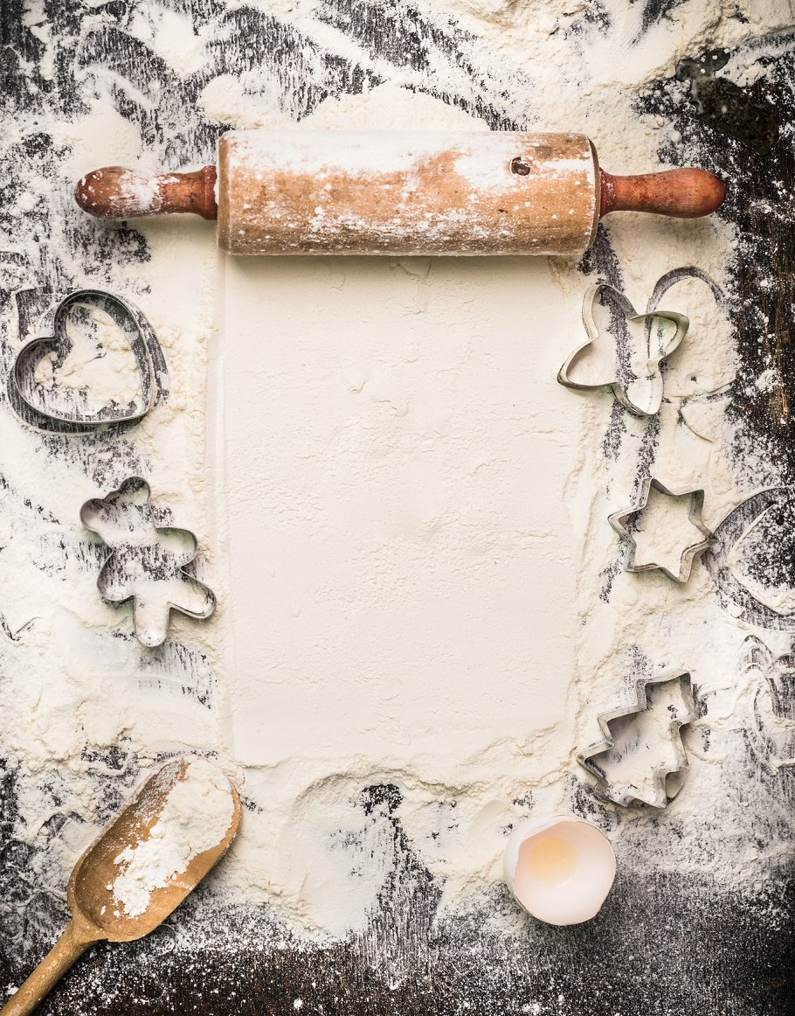

*PASTRIES MENU*

Cinnamon swirl quick……..price

Croissants……………………….price

Muffins……………………..…...price

Doughnuts……………………….price

Glazed Doughnuts…………..price

Chip Muffins......……………..price

NutMuffins……..……………...price

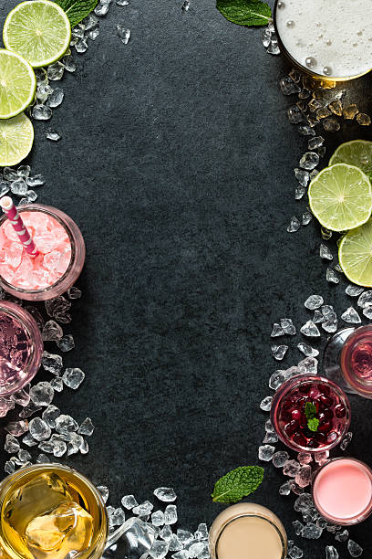

***DRINKS MENU***

*1. Old Fashioned*

*2. Negroni*

*3. Daiquiri*

*4. Dry Martini*

*5. Margarita*

*6. Espresso Martini*

*7. Whiskey Sour*

*8. Manhattan*

*9. Aperol Spritz*

*10. Mojito*

*11. Bloody Mary*

*12. Gimlet*

*13. Moscow Mule*

*14. Penicillin*

*15. Dark 'n Stormy*

*18. Boulevardier*

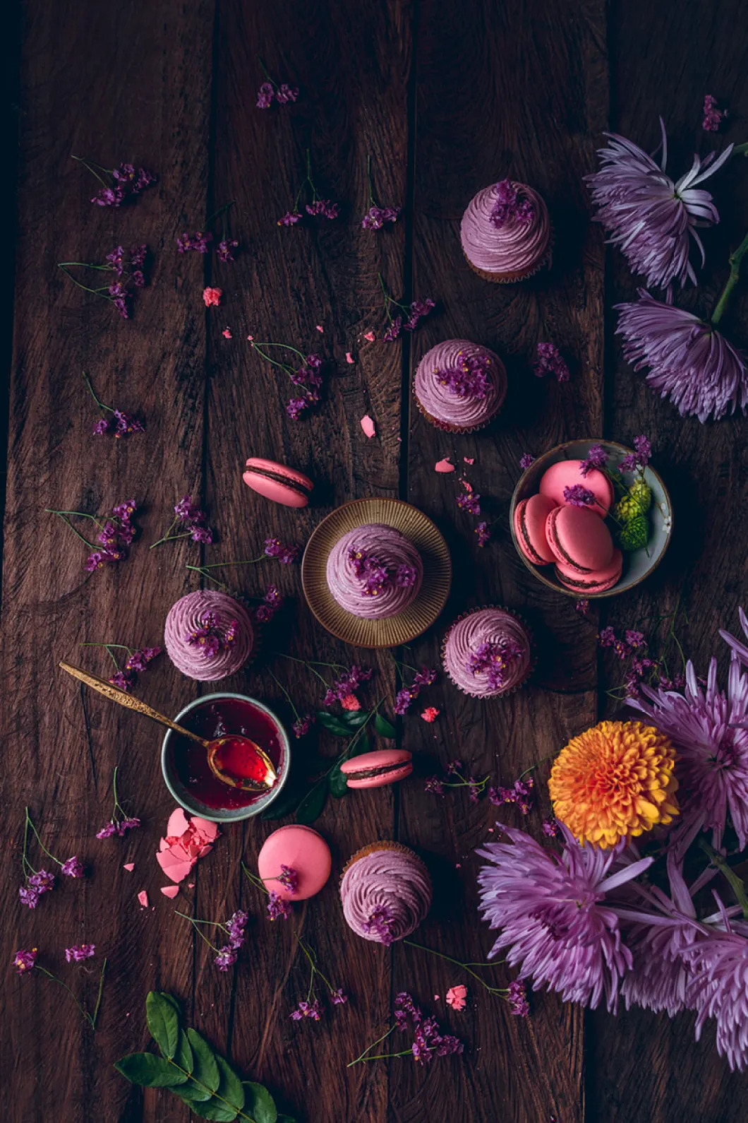

***DESSERTS***

Apple pie

Apple Strudel

Banana Bread

Banana Pudding

Blueberry Muffins

Blackberry Pie

Cake Pops

Cheesecake

Panna Cotta

Cherry Pie

Custard Tart

Cinnamon Rolls

Fudge

Gingersnaps

Ice cream

Ice cream sundae

Lemon Bar

Jelly Rolls

Macaroon