ACTIVE DIRECTORY SECURITY ASSESSMENT
Active Directory Privileged-Group Assessment
and Remediation
BloodHound privilege-path analysis in an authorized Active Directory lab
Item | Value
Domain | corp.local
Domain Controller | DC01.corp.local — 192.168.56.101
Affected groups | IT@CORP.LOCAL and DOMAIN ADMINS@CORP.LOCAL
User used for path analysis | ALICE@CORP.LOCAL
Tool | BloodHound Community Edition

1. Assessment Objective
This section documents the assessment of a privileged Active Directory group relationship identified through BloodHound, its security impact, remediation, and post-remediation verification.
The report focuses on the identified privileged-group relationship and the associated remediation and verification activities.

2. Assessment Finding — Privileged Group Membership
The assessment identified IT@CORP.LOCAL as a member of the highly privileged DOMAIN ADMINS@CORP.LOCAL group.
Get-ADGroupMember -Identity "Domain Admins"
The identified group relationship resulted in the following effective privilege path:
ALICE@CORP.LOCAL → IT@CORP.LOCAL → DOMAIN ADMINS@CORP.LOCAL
Because Alice is a member of IT, the relationship creates an indirect path from Alice to the Domain Admins group. This represents a privilege-management issue because access to a highly privileged group is inherited through a lower-level operational group.

3. BloodHound Analysis
BloodHound was used to analyze the collected Active Directory relationships and validate the effective privilege path. After collecting and ingesting the JSON BloodHound identified the expected shortest path:
Alice → IT → Domain Admins

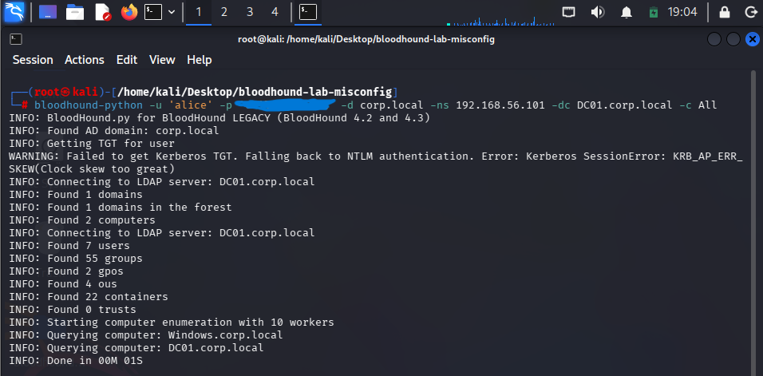
Figure 1. Using BloodHound-python to collect AD-data
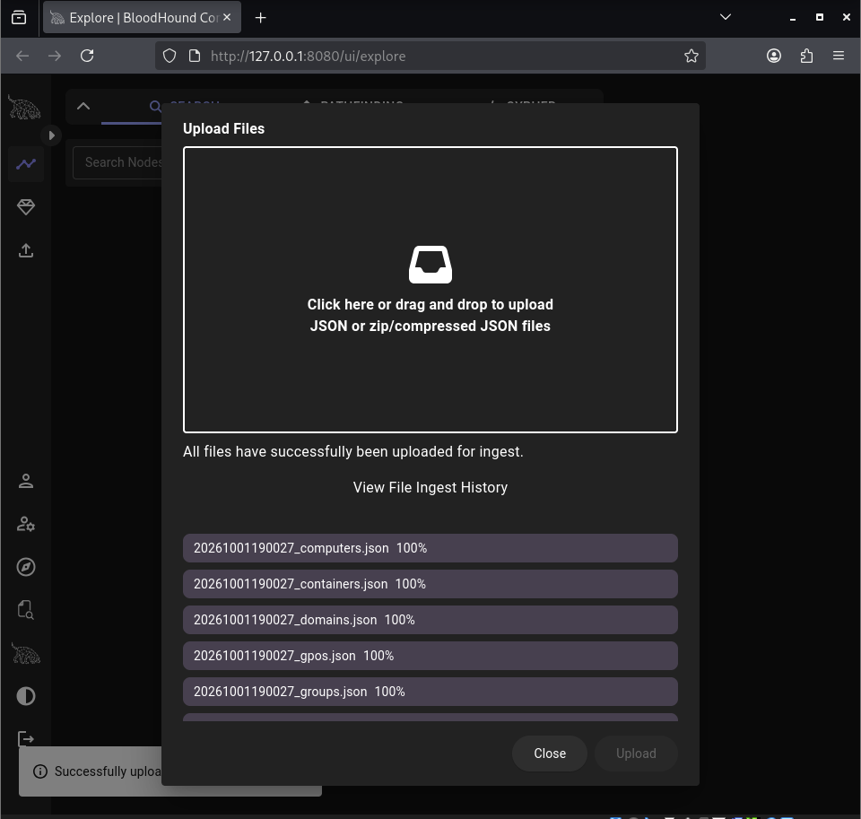
Figure 2. Importing the AD-data retrieved from the BloodHound collector

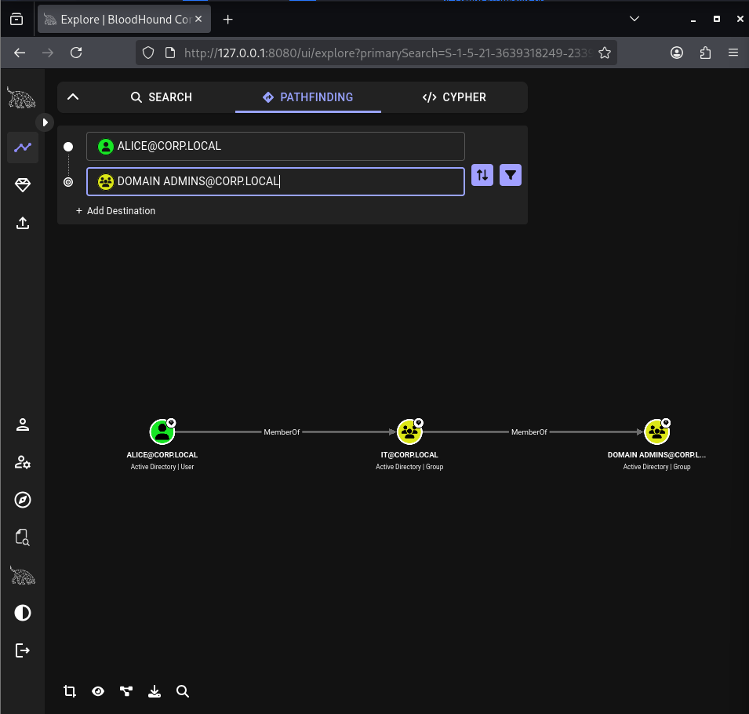
Figure 3. BloodHound detects the controlled privilege path: Alice → IT → Domain Admins.
The analysis shows that the privilege path is not based on Alice being directly assigned to Domain Admins. Instead, the path is inherited through her membership in IT.

4. Security Impact
The identified relationship creates an indirect path to Domain Admins for members of IT. In an enterprise environment, users inheriting membership through the lower-level group could therefore obtain the effective privileges associated with Domain Admins.
- Alice was not directly added to Domain Admins.
- The privilege path was created through group nesting.
- BloodHound made the indirect relationship visible as a shortest path.
- The assessment was performed within the authorized Active Directory laboratory.

5. Remediation
The identified IT → Domain Admins relationship was removed as a remediation measure:
Remove-ADGroupMember -Identity "Domain Admins" -Members "IT" -Confirm:$false
Domain Admins membership was then verified to confirm that IT was no longer a member and that the expected administrative membership remained.
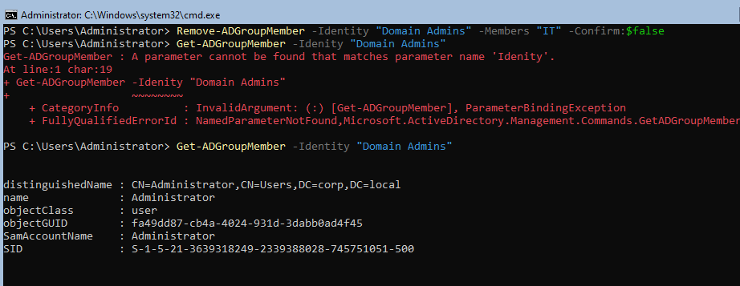
Figure 4. Remediation verification showing IT removed from Domain Admins.

6. Post-Remediation Verification
The previous BloodHound data was cleared before the post-remediation collection was imported to ensure that the verification reflected the current Active Directory state rather than a stale relationship.
A fresh collection was then imported and the same shortest-path query from ALICE@CORP.LOCAL to DOMAIN ADMINS@CORP.LOCAL was repeated.
The resulting query returned:
Path not found
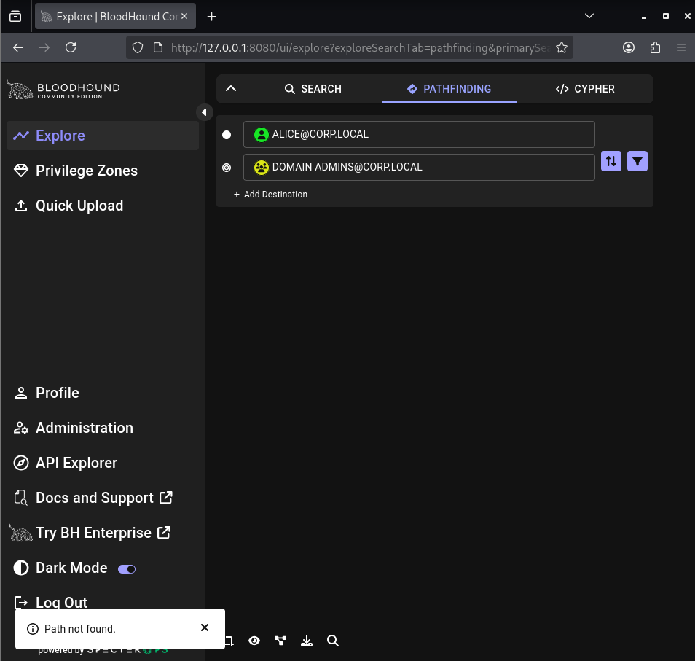
Figure 5. Post-remediation BloodHound retest: Alice → Domain Admins — path not found.
The retest confirms that the identified privilege path was removed after the IT → Domain Admins relationship was remediated.

7. Assessment Finding
ID | Finding | Status
AD-01 | IT is a member of Domain Admins, creating the BloodHound path Alice → IT → Domain Admins. | Remediated

8. Recommendations
- Do not add ordinary operational groups directly to highly privileged groups unless there is a documented administrative requirement.
- Review privileged-group membership regularly.
- Apply least privilege to Active Directory group design.
- Use BloodHound or equivalent directory-analysis tooling to identify unintended privilege paths.
- After remediation, perform a fresh collection and retest the affected path.

9. Conclusion
The assessment identified an indirect privilege path from Alice to Domain Admins through IT. BloodHound provided visibility into the relationship, and remediation removed the path. The post-remediation verification confirmed that the identified privilege path no longer exists.

Appendix — Assessment and Remediation Commands
Review identified group membership
Get-ADGroupMember -Identity "Domain Admins"
Verify Domain Admins
Get-ADGroupMember -Identity "Domain Admins"
Remediate group membership
Remove-ADGroupMember -Identity "Domain Admins" -Members "IT" -Confirm:$false

