SECURITY LAB REPORT
Active Directory GenericAll ACL Privilege Escalation
Author: Joshua Sanctus
Date: 08 October 2026
Environment: Active Directory lab / VirtualBox

1. Executive Summary
A controlled Active Directory ACL assessment was performed. CORP\bob had GenericAll permission over the IT group. Bob was able to add himself to IT. IT was a member of Domain Admins, and Bob's refreshed logon token contained CORP\Domain Admins. The permission and membership were removed, and the final BloodHound path check reported Path not found.

2. Scope and Lab Environment
Assessment / Lab | Active Directory Security Lab
Domain / Environment | corp.local
Target 1 | DC01 / 192.168.56.101 / Domain Controller
Target 2 | Windows 10 / Domain workstation
Attacker / Testing VM | Kali / 192.168.56.106
Network | 192.168.56.0/24 / VirtualBox Host-only
Accounts used | alice, bob, Administrator
Tools | BloodHound CE, bloodhound-python, PowerShell, dsacls
Scope: DC01, the Windows 10 workstation, the corp.local Active Directory domain, and the lab accounts used for the controlled assessment.
Out of scope: Production systems and third-party systems.

3. Objective
Identify and validate an excessive ACL permission affecting a privileged Active Directory group, demonstrate the resulting privilege path, and verify remediation.
Identify a GenericAll permission assigned to a standard user on the IT group.
Validate the resulting privilege path to Domain Admins.
Remove the excessive permission and confirm that the path is no longer present.

4. Methodology
The assessment followed a short sequence: BloodHound collection, relationship analysis, validation of the ACL and privilege path, evidence collection, remediation, and re-test.
1. Reconnaissance / Discovery: Collected current Active Directory data with bloodhound-python.
2. Enumeration: Reviewed BloodHound relationships involving Bob and the IT group.
3. Validation / Exploitation: Validated that Bob could add himself to IT and obtain Domain Admins in his refreshed logon token.
4. Evidence Collection: Captured screenshots of the relationship, privilege token, remediation, and final pathfinding result.
5. Remediation / Re-test: Removed Bob from IT, removed Bob's GenericAll ACL entry, and re-tested the path with BloodHound.

5. Technical Walkthrough

5.1 BloodHound Collection
Purpose: Collect current Active Directory data.
Command / Configuration: bloodhound-python -u 'alice' -p -d corp.local -ns 192.168.56.101 -dc DC01.corp.local -c All
Result: BloodHound found 1 domain, 2 computers, 7 users, 55 groups, 2 GPOs, 4 OUs, and 22 containers. Kerberos returned KRB_AP_ERR_SKEW and the collector fell back to NTLM.

5.2 GenericAll Relationship
Purpose: Identify the permission assigned to Bob on IT.
Command / Configuration: BloodHound relationship analysis.
Result: BOB@CORP.LOCAL -> GenericAll -> IT@CORP.LOCAL.

5.3 Privilege Validation
Purpose: Validate the impact of the ACL.
Command / Configuration: Bob was added to IT and his Windows logon session was refreshed.
Result: IT contained Alice and Bob. Bob's refreshed token contained CORP\IT and CORP\Domain Admins.
Interpretation: Bob obtained Domain Admin group membership through the IT group.

5.4 Remediation and Re-test
Purpose: Remove the excessive permission and verify the result.
Command / Configuration: Bob was removed from IT and the CORP\bob ACL entry was removed from IT. BloodHound was re-collected.
Result: IT contained only Alice, Bob's refreshed token no longer contained Domain Admins, and BloodHound reported Path not found.
Interpretation: The tested privilege path was removed.

6. Evidence

6.1 GenericAll Relationship
BloodHound screenshot showing BOB@CORP.LOCAL -> GenericAll -> IT@CORP.LOCAL.
Figure 1 — Bob has GenericAll over the IT group.
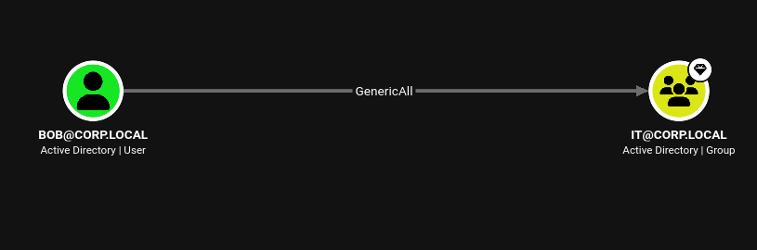

6.2 Privilege Validation
Windows screenshot showing CORP\IT and CORP\Domain Admins in Bob's refreshed token.
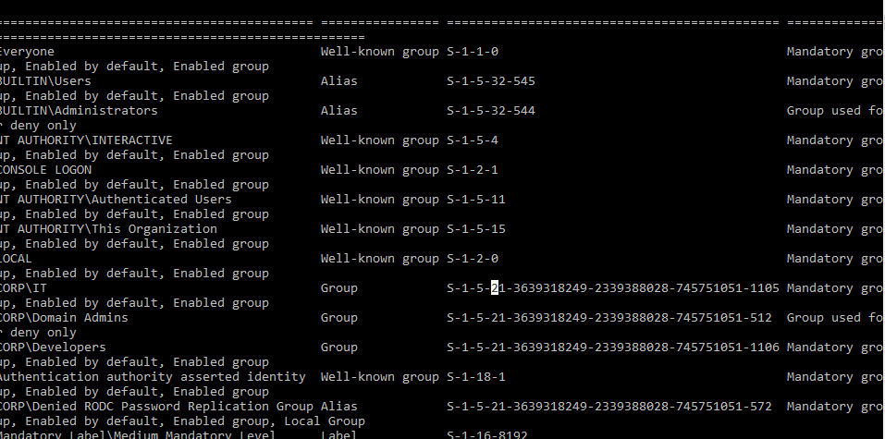
Figure 2 — Bob's token contains Domain Admins after the group change.

6.3 Final Re-test
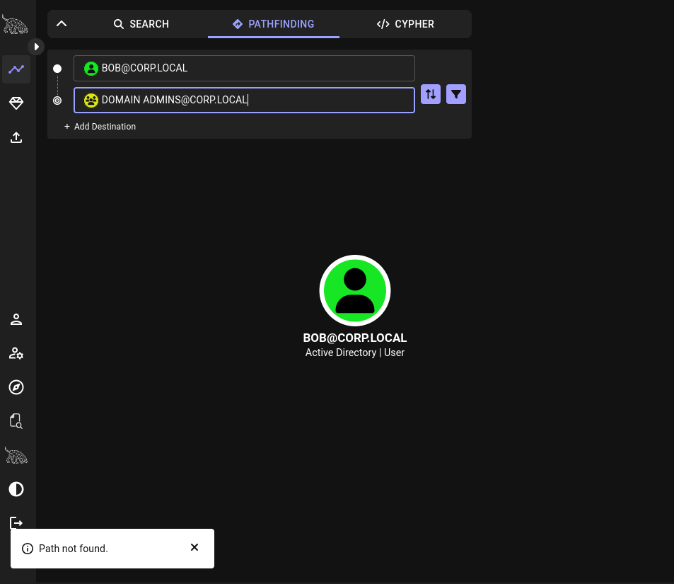
BloodHound screenshot showing Path not found from Bob to Domain Admins.
Figure 3 — The privilege path is no longer present after remediation.

7. Findings
One finding was identified and validated.

Finding 1 — Excessive GenericAll Permission on IT Group
Observation: CORP\bob had GenericAll permission over the IT group.
Evidence: BloodHound showed BOB@CORP.LOCAL -> GenericAll -> IT@CORP.LOCAL.
Impact: Bob was able to add himself to IT. IT was a member of Domain Admins, and Bob's refreshed token contained CORP\Domain Admins.
Root Cause / Contributing Factors: Full control was assigned to a standard user on a privileged group.
Severity / Priority: High
Affected Assets: corp.local Active Directory; IT group; Bob account; Domain Admins group.

8. Attack / Event Chain
The sequence below shows the demonstrated privilege path and remediation.
1. Bob had GenericAll permission over IT.
2. Bob added himself to IT.
3. IT was a member of Domain Admins.
4. Bob's refreshed logon token contained CORP\Domain Admins.
5. Bob was removed from IT and his GenericAll ACL entry was removed.
6. BloodHound re-test reported Path not found.

9. Remediation and Hardening
The following actions were performed or are recommended for this lab finding.
- • Remove unnecessary GenericAll permissions from privileged groups.
- • Use least privilege for Active Directory group ACLs.
- • Review permissions on privileged groups regularly.
- • Avoid assigning standard users control over privileged groups.

10. Recommended Re-Test
Repeat the same BloodHound path query after removing the ACL and group membership.
Pre-remediation result: Bob had GenericAll over IT and a path to Domain Admins.
Remediation performed: Bob was removed from IT and his GenericAll ACL entry was removed from IT.
Re-test procedure: Re-collect BloodHound data and run pathfinding from BOB@CORP.LOCAL to DOMAIN ADMINS@CORP.LOCAL.
Expected / observed post-remediation result: Path not found.

11. Key Learning Outcomes
- • GenericAll on a privileged group can allow group membership changes.
- • Group nesting can create indirect privilege escalation paths.
- • Windows logon tokens must be refreshed after group membership changes.
- • BloodHound can identify and re-test Active Directory attack paths.
- • ACL remediation should be followed by fresh collection and verification.

12. Evidence Handling
Evidence was stored as screenshots from the isolated lab. The BloodHound collector screenshot was redacted before sharing because the original command contained a password. No password was included in the report.

13. Conclusion
The lab demonstrated a privilege escalation path caused by excessive GenericAll permission on the IT group. The path was validated and then removed. The final BloodHound test reported Path not found.

Appendix A — Commands / Configuration
Cleaned commands used in the lab. Credentials are omitted.
bloodhound-python -u 'alice' -p -d corp.local -ns 192.168.56.101 -dc DC01.corp.local -c All
Add-ADGroupMember -Identity "IT" -Members "bob"
Get-ADGroupMember -Identity "IT"
Remove-ADGroupMember -Identity "IT" -Members "bob" -Confirm:$false
dsacls "CN=IT,OU=Groups,DC=corp,DC=local" /R "CORP\bob"

Appendix B — References
BloodHound CE — Active Directory relationship analysis.
bloodhound-python — Active Directory data collection.
Microsoft Active Directory PowerShell module — group management.
dsacls — Windows Active Directory ACL management.

