ACTIVE DIRECTORY SECURITY LAB
Kerberoasting Assessment & Offline Password Audit
Authorized isolated laboratory assessment
Domain: CORP.LOCAL | Focus: Kerberos / SPN abuse

1. Executive Summary
This lab exercise demonstrated a complete Kerberoasting workflow against a deliberately configured Active Directory service account. A normal domain user (CORP\alice) was used to enumerate service principal names (SPNs), identify the lab service account sqlservice, request a Kerberos service ticket for its SPN, and perform offline password auditing against the captured TGS-derived material.
The captured ticket used Kerberos encryption type 23 (RC4-HMAC), and the offline dictionary audit recovered the deliberately weak lab password using the RockYou wordlist. The exercise therefore demonstrated both the attack path and the security impact of weak service-account credentials.

2. Scope and Lab Environment
Domain | CORP.LOCAL
Domain Controller | DC01 — 192.168.56.101
Windows 10 workstation | 192.168.56.10 — CORP\alice
Kali Linux | 192.168.56.106
Service account | CORP\sqlservice
SPN | MSSQLSvc/db01.corp.local:1433
Network | VirtualBox Host-Only — 192.168.56.0/24
Primary tools | Impacket GetUserSPNs, Hashcat, RockYou wordlist
All activity described in this report was performed against the user's isolated lab environment. The sqlservice account and its SPN were deliberately created for the exercise.

3. Objective
- Understand how Active Directory SPNs identify services associated with accounts.
- Demonstrate that a normal authenticated domain user can enumerate user-backed SPNs.
- Request a Kerberos service ticket for an identified SPN.
- Perform offline password auditing against the captured TGS-derived material.
- Document the security implications and appropriate remediation.

4. Methodology
1. SPN discovery: Authenticated to Active Directory as CORP\alice and enumerated service principal names.
2. Service identification: Identified MSSQLSvc/db01.corp.local:1433 mapped to the sqlservice account.
3. TGS request: Requested a Kerberos service ticket for the identified SPN using Impacket GetUserSPNs.
4. Offline extraction: Captured the TGS-derived $krb5tgs$ representation for local analysis.
5. Password audit: Used Hashcat mode 13100 with the RockYou wordlist to perform an offline dictionary audit.
6. Validation: Confirmed the audit recovered the deliberately weak sqlservice password.

5. Evidence
The following screenshots are included as evidence. Credential and ticket material has been redacted from the report so the document is safe to share publicly.

5.1 SPN Enumeration
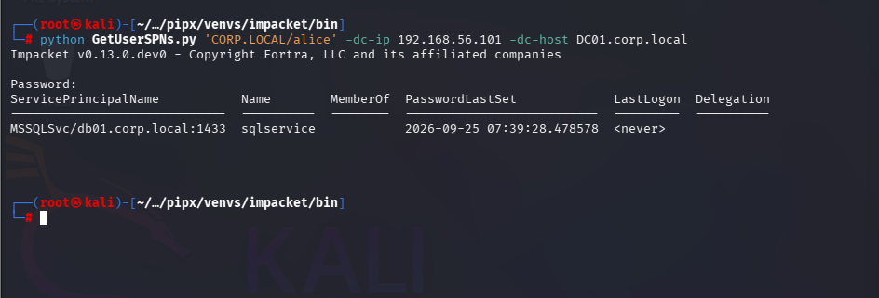
Figure 1 — GetUserSPNs enumeration identified sqlservice and its MSSQL service SPN.

5.2 TGS Request
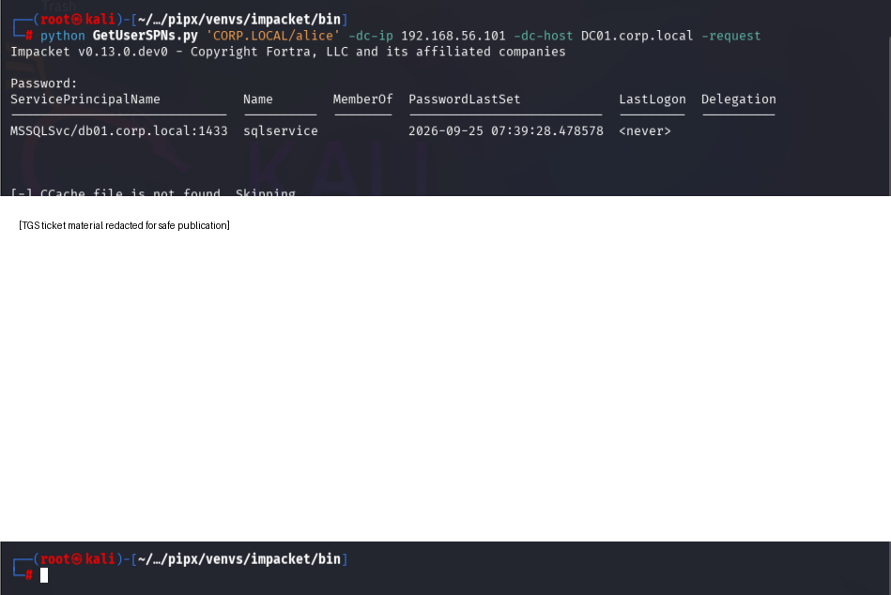
Figure 2 — A Kerberos TGS was successfully requested for the identified service SPN; ticket material is redacted.

5.3 Offline Password Audit
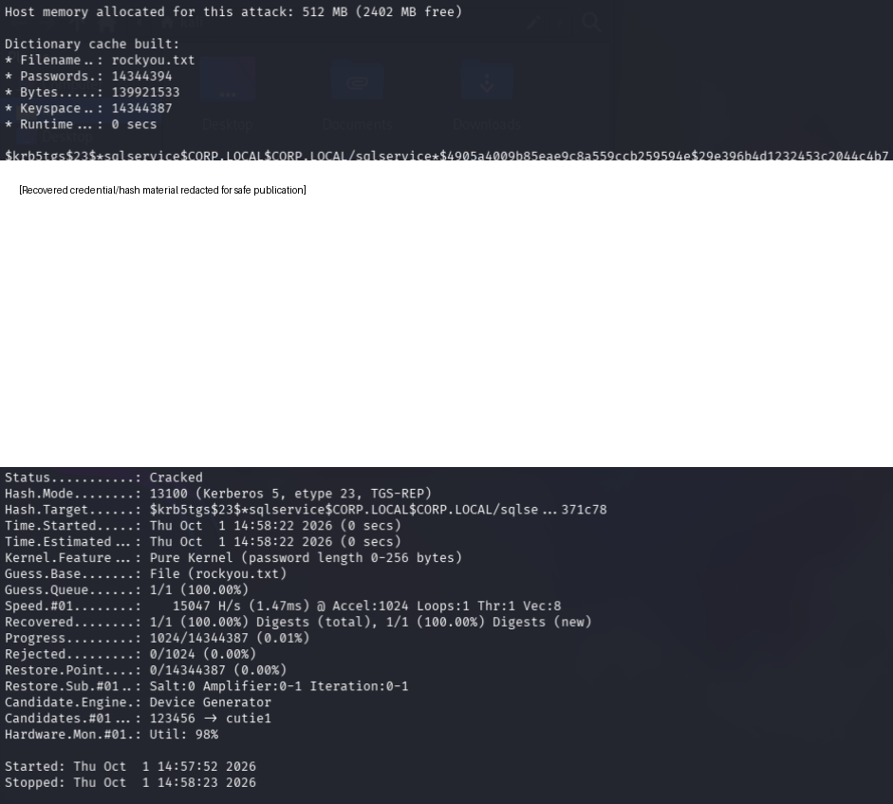
Figure 3 — Hashcat reports the Kerberos TGS audit as Cracked, with 1/1 target recovered.

6. Findings

Finding 1 — Weak Service Account Credential Exposed to Offline Auditing
Observation: The sqlservice account had a user-backed SPN and a password that could be recovered from the captured TGS-derived material using a common dictionary.
Impact: An attacker with a normal domain account could potentially obtain crackable service-ticket material and perform password guessing offline without repeatedly authenticating against the domain controller. If the recovered account has meaningful privileges or access to sensitive resources, compromise of the service account could increase the attacker's access.
Evidence: GetUserSPNs identified MSSQLSvc/db01.corp.local:1433 as belonging to sqlservice; the requested ticket was represented as $krb5tgs$23$...; Hashcat mode 13100 reported Status: Cracked and Recovered: 1/1.

Finding 2 — RC4-HMAC Service Ticket Observed
Observation: The captured service ticket used Kerberos encryption type 23 (RC4-HMAC), as reflected in the Hashcat mode and the earlier Windows ticket inspection performed during the lab.
Security relevance: Modern Active Directory environments should prefer AES-based Kerberos encryption where supported and avoid unnecessary dependence on legacy RC4 for service accounts.

7. Attack Chain
The demonstrated chain can be summarized as:
- Authenticated domain user
- → SPN enumeration
- → user-backed service account identified
- → TGS requested
- → TGS-derived crackable material captured
- → offline dictionary attack
- → service-account credential recovered
The attacker does not need to wait for the service account to authenticate. The important property of Kerberoasting is that a domain user can request a service ticket for an SPN and then perform password guessing against the resulting ticket material offline.

8. Remediation and Hardening
- Use long, random, unique passwords for service accounts. Avoid human-memorable passwords.
- Prefer Group Managed Service Accounts (gMSA) where the application/service supports them, allowing Active Directory to manage strong credentials.
- Prefer AES-based Kerberos encryption and reduce reliance on RC4 where compatibility permits.
- Review user-backed SPNs periodically and remove stale or unnecessary SPNs.
- Apply least privilege to service accounts. A service account should have only the permissions required by its service.
- Monitor unusual service-ticket request patterns and investigate anomalous Kerberos activity in appropriate security telemetry.
- Treat captured TGS material and recovered credentials as sensitive secrets; never commit them to public repositories.

9. Recommended Re-Test
After remediation, repeat the same controlled workflow using a newly generated strong password for sqlservice. The expected result is that the same common dictionary does not recover the new credential. This provides a clear before/after validation for the lab report.

10. Key Learning Outcomes
- SPNs connect Kerberos services to identities in Active Directory.
- Kerberoasting does not require the attacker to know the service-account password beforehand.
- The TGS is requested through the domain controller, but password guessing can be performed offline.
- Weak service-account passwords are a major factor in practical Kerberoasting risk.
- Encryption type, account privilege, service-account hygiene, and password strength all affect impact.
- A strong security assessment should include discovery, exploitation, evidence, remediation, and re-testing.

11. Evidence Handling
The original terminal captures contain sensitive ticket and credential material. The versions embedded in this report have been redacted for publication. The original files should be stored only in a private lab/evidence location and must not be uploaded to a public GitHub repository.

12. Conclusion
This exercise successfully demonstrated a complete Kerberoasting attack in an isolated Active Directory lab: SPN discovery, service-ticket acquisition, extraction of TGS-derived material, and offline password auditing. The lab also demonstrates why service-account credential hygiene and appropriate Kerberos configuration are important defensive controls.

