SECURITY LAB REPORT
Active Directory GPO Permissions Assessment
Group Policy Object (GPO) Permission Validation and Remediation
Authorized isolated laboratory assessment
Author | [Name]
Date | 28 October 2026
Environment | VirtualBox isolated lab (adlab.test)
Classification | Lab exercise – review screenshots before external sharing

1. Executive Summary
This assessment tested a deliberately introduced GPO permissions issue in the adlab.test domain. The group GPO-Editors, which contains the user alice, was granted GpoEdit on LAB-GPO-Permissions-Test.
From Kali Linux, Alice authenticated to LDAP and SYSVOL and her group membership was confirmed. A harmless temporary file was uploaded to the test GPO’s SYSVOL directory and then deleted. A benign computer-side registry marker was also applied to the Windows 10 workstation through the test GPO.
After the group’s explicit GPO permission was removed, the repeated SYSVOL upload attempt returned NT_STATUS_ACCESS_DENIED. The objective of demonstrating and remediating the tested write-access path was achieved.
Scope note: The retest confirms the SYSVOL write attempt was blocked. It does not independently decode every effective AD and SYSVOL ACL.

Key result | Outcome
Group membership | alice confirmed as a member of GPO-Editors
Pre-remediation write | Temporary file upload to the test GPO’s SYSVOL directory succeeded
Policy application | Benign computer-side registry marker applied to the workstation
Post-remediation write | Upload denied with NT_STATUS_ACCESS_DENIED

2. Scope and Lab Environment
Assessment / Lab | Active Directory GPO Permissions Assessment
Domain / Environment | adlab.test (VirtualBox isolated lab)
Target 1 | DC01 – domain controller – 192.168.56.10
Target 2 | Windows 10 workstation – 192.168.56.20
Attacker / Testing VM | Kali Linux – 192.168.56.40
Network | VirtualBox host-only network (192.168.56.0/24)
Accounts used | alice (test account); GPO-Editors (security group)
Tools | ldapsearch, smbclient, Get-GPPermission, Set-GPPermission, gpupdate

In scope: DC01 (192.168.56.10), the adlab.test domain, the test account alice, the GPO-Editors group, LAB-GPO-Permissions-Test, Kali Linux, and the Windows 10 workstation (192.168.56.20).
Out of scope: Default Domain Policy, Default Domain Controllers Policy, systems outside the isolated lab, credential theft, persistence, and deployment of executable payloads.

3. Objective
Assess whether membership in a group granted GpoEdit on a dedicated test GPO, combined with SYSVOL write access, permits a file-write operation; then remove the permission and repeat the test.

4. Methodology
The workflow proceeded from discovery and identity enumeration to permission validation, harmless policy application, remediation, and retesting.
# | Phase | Activity
1 | Reconnaissance / Discovery | Confirmed the domain controller and located the dedicated GPO in SYSVOL.
2 | Enumeration | Queried Alice’s LDAP attributes and confirmed memberOf included GPO-Editors; queried the GPO metadata and path.
3 | Validation | Authenticated to SYSVOL as ADLAB\alice and tested a temporary-file upload in the test GPO directory.
4 | Evidence Collection | Captured LDAP output, initial SYSVOL write success, the permission-removal command and ACL output, and the denied retest.
5 | Remediation / Re-test | Removed GPO-Editors’ explicit GPO permission with Set-GPPermission and repeated the upload attempt.

5. Technical Walkthrough
The following steps record the observed configuration and results. Passwords are not included.

5.1 Identity and Group Membership
Purpose: Establish which domain account was used and whether it belonged to the group receiving GPO editing rights.
Command:
ldapsearch -x -H ldap://192.168.56.10 -D 'alice@adlab.test' -W \
-b 'DC=adlab,DC=test' \
'(&(objectCategory=person)(objectClass=user)(sAMAccountName=alice))' \
sAMAccountName memberOf

Result: LDAP returned sAMAccountName: alice and memberOf: CN=GPO-Editors,OU=Lab-Groups,DC=adlab,DC=test.
Interpretation: Alice’s membership in GPO-Editors was confirmed. The GPO permission was separately checked on DC01 using Get-GPPermission.

5.2 GPO Discovery and Initial SYSVOL Access
Purpose: Confirm the GPO path and determine whether Alice could read and write in its SYSVOL directory.
GPO name | LAB-GPO-Permissions-Test
GUID | {3B657C51-4664-4965-B891-8594D9109EA6}
SYSVOL path | \\adlab.test\SysVol\adlab.test\Policies\{3B657C51-4664-4965-B891-8594D9109EA6}

Result: Alice read the GPO directory and its GPT.INI, Machine, and User entries. The initial test command succeeded and the file was deleted:
put /etc/hostname kali-write-test.txt

Interpretation: The initial test demonstrated read access and write access to the test GPO’s SYSVOL directory. This was a harmless file-write validation, not execution of a policy payload.

5.3 Harmless Policy Application
Purpose: Confirm that the dedicated test GPO was linked within the workstation’s computer policy scope and could apply a benign setting.
Setting type | Computer Configuration registry preference
Key | HKLM\Software\ADLab\GPOTest
Value | LabComputerMarker (REG_SZ)
Data | GPO-Test-Applied

Result: gpupdate /target:computer /force completed, LAB-GPO-Permissions-Test appeared in the applied computer GPO list, and the registry query reported the marker was set.
Interpretation: The computer-side policy marker applied successfully. The earlier user-side marker was not applied because the user and computer policy scopes did not align; the test was adjusted to the computer-side scope.

5.4 Permission Remediation and Retest
Purpose: Remove the group’s explicit permission on the test GPO and repeat the same SYSVOL write check.
Command:
Set-GPPermission -Name 'LAB-GPO-Permissions-Test' `
-TargetName 'GPO-Editors' -TargetType Group -PermissionLevel None

Result: After remediation, the repeated upload returned NT_STATUS_ACCESS_DENIED.
Interpretation: The previously successful SYSVOL write attempt was blocked after the permission change. A final ACL review should be retained to document the post-remediation effective permissions.

6. Evidence
Screenshots below document identity enumeration, initial write access, remediation, and the denied retest. Review images for any sensitive information before sharing.

6.1 Alice’s LDAP Identity and Group Membership
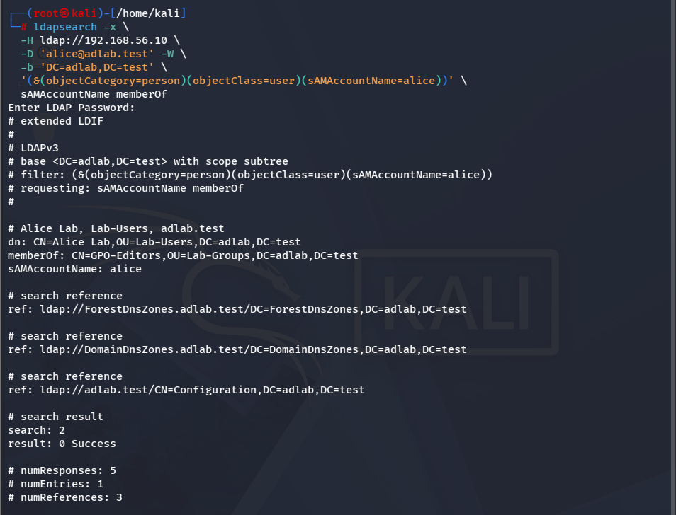
Figure 1 – LDAP output confirms Alice is a member of GPO-Editors.

6.2 Initial SYSVOL Write Test
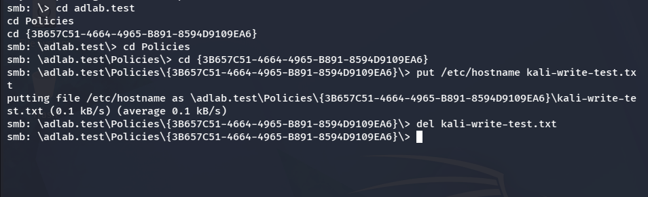
Figure 2 – The temporary file upload succeeded before remediation and was deleted.

6.3 Permission Remediation on DC01
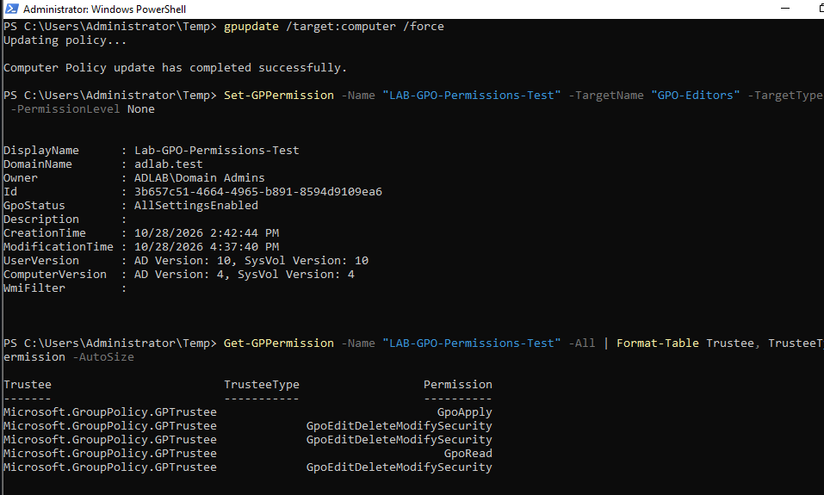
Figure 3 – The GPO permission was removed and the permission listing was reviewed.

6.4 Post-Remediation Retest
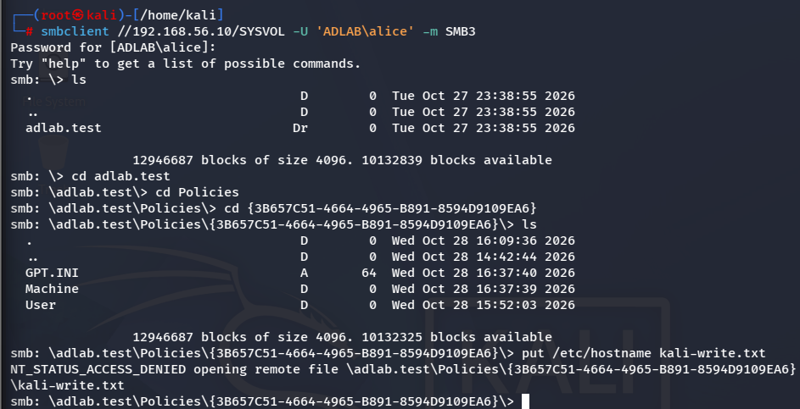
Figure 4 – The repeated upload attempt returned NT_STATUS_ACCESS_DENIED.

7. Findings
Findings are limited to what the lab outputs demonstrate; no broader domain compromise is claimed.
ID | Finding | Severity (lab)
F-01 | Excessive GPO editing permission | Medium
F-02 | SYSVOL write access before remediation | Medium
F-03 | Write attempt blocked after remediation | Validation result

Finding 1 – Excessive GPO Editing Permission
Observation | GPO-Editors, which contained Alice, had GpoEdit on LAB-GPO-Permissions-Test before remediation.
Evidence | LDAP memberOf output and the Get-GPPermission output from DC01.
Impact | Members of the group could edit the dedicated GPO, potentially affecting computers in its scope.
Root cause | GPO editing rights were granted to the test group for the deliberate lab scenario.
Severity / Priority | Medium in this isolated lab; assess production severity according to GPO scope and group membership.
Affected assets | LAB-GPO-Permissions-Test and the GPO-Editors group.

Finding 2 – SYSVOL Write Access Before Remediation
Observation | Alice could upload a harmless temporary file to the test GPO’s SYSVOL directory before remediation.
Evidence | Initial smbclient put succeeded; the file was subsequently deleted.
Impact | Write access to GPO files can undermine policy integrity if unauthorized changes are made.
Root cause | The test group’s GPO permission and corresponding SYSVOL access allowed the initial write test.
Severity / Priority | Medium for this lab; prioritize review where writable GPOs affect sensitive systems.
Affected assets | The SYSVOL directory for the test GPO.

Finding 3 – Write Attempt Blocked After Remediation
Observation | The repeated upload attempt failed with NT_STATUS_ACCESS_DENIED after the group’s GPO permission was removed.
Evidence | Post-remediation Kali screenshot and Set-GPPermission command output.
Impact | The previously available file-write operation was blocked.
Root cause | The explicit GPO permission assigned to GPO-Editors was removed.
Severity / Priority | Remediation validation result; continue reviewing effective permissions for alternate grants.
Affected assets | LAB-GPO-Permissions-Test and its SYSVOL directory.

8. Attack / Event Chain
Sequence of observed events:
- Alice’s LDAP identity and membership in GPO-Editors were confirmed.
- The group’s GpoEdit permission on the dedicated test GPO was confirmed on DC01.
- Alice authenticated to SYSVOL and read the test GPO files.
- Initial harmless file upload succeeded and the temporary file was deleted.
- The group’s explicit GPO permission was removed on DC01.
- The repeated upload attempt was denied with NT_STATUS_ACCESS_DENIED.

9. Remediation and Hardening
Recommended actions based on the findings:
- Least privilege: grant GPO editing rights only to authorized administrators.
- Regular review: check direct and group-derived GPO permissions periodically.
- Both layers: audit Active Directory GPO ACLs and SYSVOL file-system permissions.
- Backups: maintain and periodically test GPO backups before security-sensitive changes.
- Auditing: enable appropriate auditing for GPO changes and SYSVOL modifications.
- Separation: keep test policies separate from Default Domain Policy and Default Domain Controllers Policy.

10. Key Learning Outcomes
- GPO access must be evaluated across both the Active Directory permission and SYSVOL file-system layers.
- Group membership can confer permissions granted to a security group.
- LDAP enumeration can confirm identity, group membership, and GPO metadata.
- Policy scope matters: computer settings should be tested against the computer’s applied GPO list.
- A harmless temporary file can validate write access without executing code.
- Retesting is essential to verify whether a remediation blocks the previously observed operation.

11. Evidence Handling
Evidence consisted of screenshots supplied for the lab: LDAP group membership, initial SYSVOL access and write, remediation output, and the post-remediation denied upload. No passwords were intentionally included in the report. Review screenshots before external publication.

Appendix A – Commands / Configuration
Commands below are cleaned examples; enter passwords interactively and do not store them in scripts.
1. LDAP identity query
ldapsearch -x -H ldap://192.168.56.10 -D 'alice@adlab.test' -W \
-b 'DC=adlab,DC=test' \
'(&(objectCategory=person)(objectClass=user)(sAMAccountName=alice))' \
sAMAccountName memberOf

2. SYSVOL connection
smbclient //192.168.56.10/SYSVOL -U 'ADLAB\alice' -m SMB3

3. Pre-remediation write test (inside the test GPO directory)
put /etc/hostname kali-write-test.txt

4. Remediation (on DC01)
Set-GPPermission -Name 'LAB-GPO-Permissions-Test' `
-TargetName 'GPO-Editors' -TargetType Group -PermissionLevel None

5. Post-remediation write test (same command; returned NT_STATUS_ACCESS_DENIED)
put /etc/hostname kali-write-test.txt

References
- Microsoft Group Policy PowerShell cmdlets: Get-GPPermission and Set-GPPermission.
- Samba client tools: smbclient and ldapsearch command-line documentation.
- Lab evidence: screenshots captured during the authorized VirtualBox assessment.
- Assessment scope: isolated adlab.test lab; no external systems tested.

