ACTIVE DIRECTORY LAB — BEGINNER WRITE-UP
LDAP Enumeration and SMB Enumeration

Lab item | Value
Domain | corp.local
Domain Controller | DC01 — 192.168.56.101
Attacker | Kali Linux
Domain user | CORP\alice
Main tools | ldapsearch, smbclient, smbmap, rpcclient
This write-up records what was learned and observed during the beginner Active Directory lab. It focuses on understanding the commands and results rather than advanced exploitation.

1. What We Were Trying to Learn
The goal was to learn how a normal domain user can discover basic information about an Active Directory environment.
- Find the domain structure using LDAP.
- Find users, groups and computers.
- Understand Alice's group membership.
- Find Group Policy information in AD and SYSVOL.
- See which SMB shares Alice can access.
- Understand what information is useful during a VAPT assessment.

2. LDAP Enumeration
LDAP is one of the main ways to query Active Directory. We used ldapsearch from Kali.

2.1 Find the domain naming context
ldapsearch -x -H ldap://192.168.56.101 -s base -b "" namingContexts
The query showed DC=corp,DC=local along with the Configuration, Schema and DNS-related partitions. This gave us the base DN used for later queries.
Evidence — Initial AD service discovery
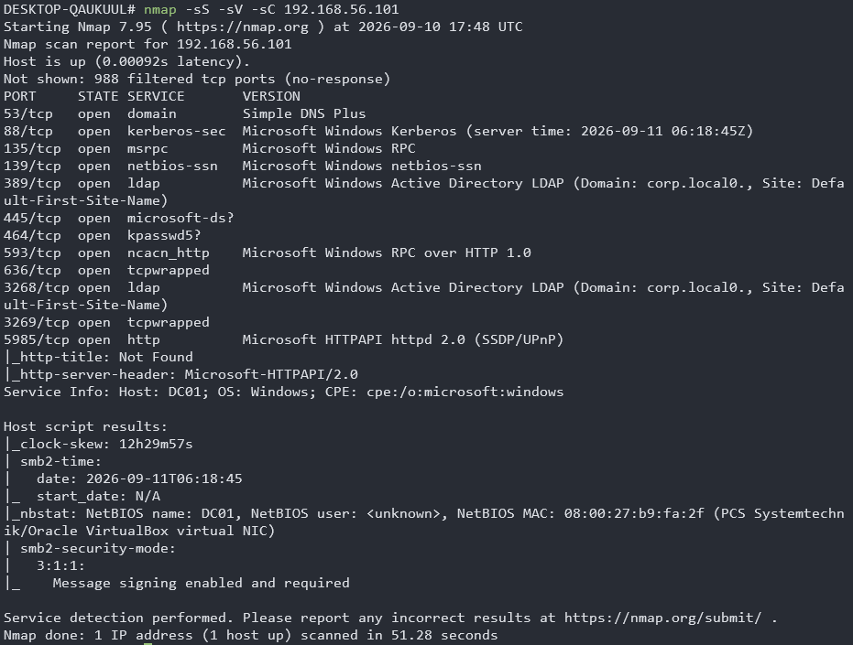
Evidence — LDAP naming contexts
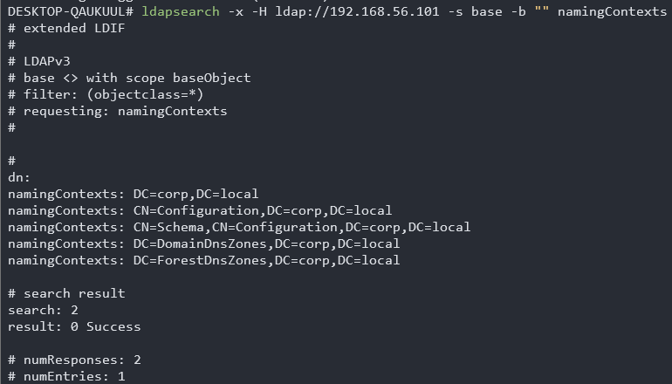

2.2 Find domain users
ldapsearch -x -H ldap://192.168.56.101 -D "alice@corp.local" -W -b "DC=corp,DC=local" -s subtree "(objectClass=user)" sAMAccountName
We found Administrator, Guest, krbtgt, Alice, Bob and computer accounts such as DC01$ and WINDOWS$. The $ at the end is a useful clue that the object is a computer account.
Evidence — LDAP user enumeration
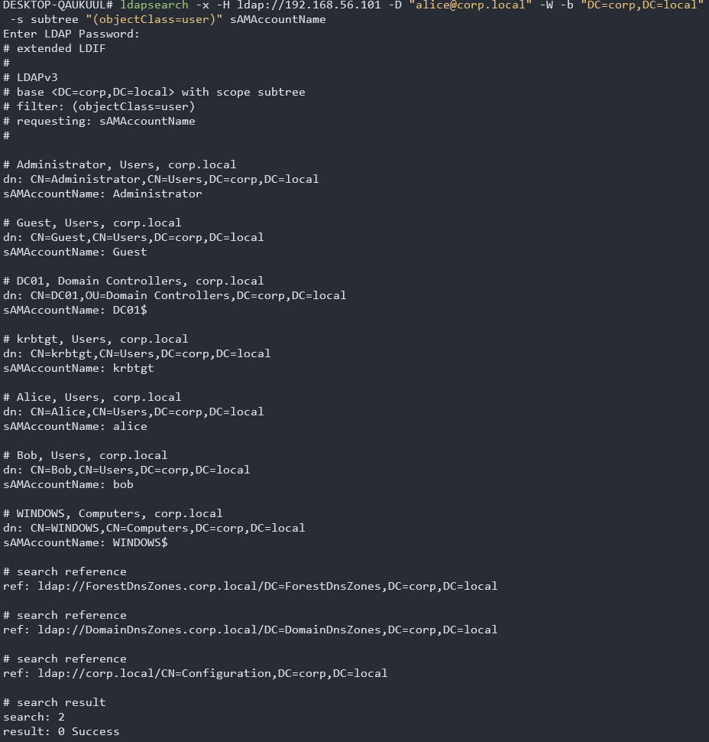

2.3 Find groups
ldapsearch -x -H ldap://192.168.56.101 -D "alice@corp.local" -W -b "DC=corp,DC=local" -s subtree "(objectClass=group)" sAMAccountName member
The lab contains standard AD groups and the custom groups IT, Developers and HR. Alice is in IT and Bob is in Developers.
Evidence — LDAP group enumeration
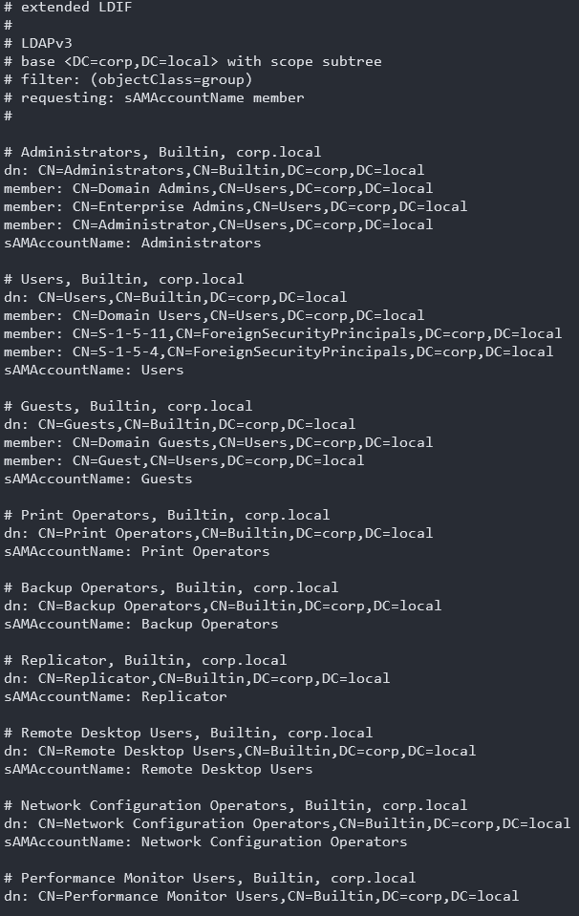

2.4 Look at Alice's account
ldapsearch -x -H ldap://192.168.56.101 -D "alice@corp.local" -W -b "CN=Alice,CN=Users,DC=corp,DC=local" -s base "(objectClass=*)" "*"
Attribute | What we saw
sAMAccountName | alice
userPrincipalName | alice@corp.local
memberOf | IT
userAccountControl | 512
primaryGroupID | 513
For this lab, Alice is a normal enabled user and is a member of IT. The primary group ID corresponds to Domain Users.
Evidence — Alice LDAP attributes
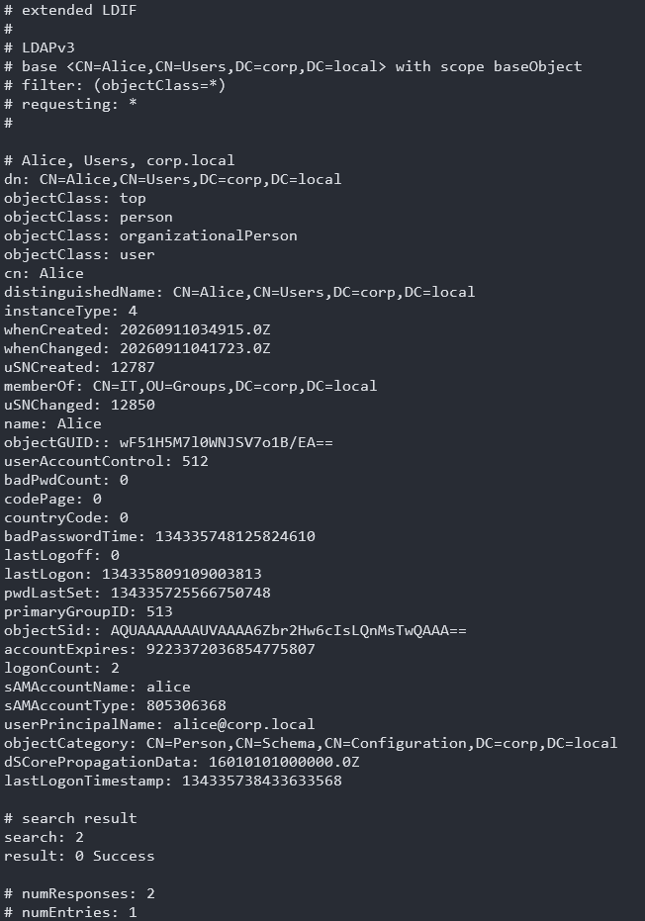

3. SMB Enumeration
SMB is used by Windows for file and network resource sharing. In an AD environment, SYSVOL and NETLOGON are especially important shares.
smbclient -L //192.168.56.101 -U "CORP/alice"
Share | Alice's access
ADMIN$ | No access
C$ | No access
IPC$ | Read only
NETLOGON | Read only
SYSVOL | Read only
This tells us Alice does not have administrative access to the DC's ADMIN$ or C$ shares. She can read SYSVOL and NETLOGON, which is normal for domain users.
Evidence — SMB share enumeration
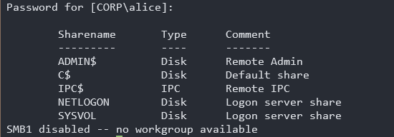
Evidence — SYSVOL access
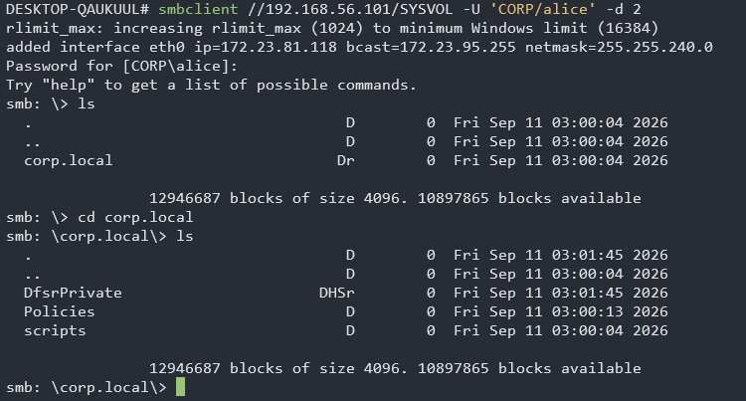

4. SMBMap
We also used smbmap to quickly check share permissions from Alice's perspective.
smbmap -H 192.168.56.101 -u alice -p [Alice password] -d CORP
SMBMap confirmed the same basic permission picture: SYSVOL and NETLOGON are read-only, while ADMIN$ and C$ are not accessible.
The password visible in the original screenshot is intentionally not reproduced here.
Evidence — SMBMap (credential redacted)
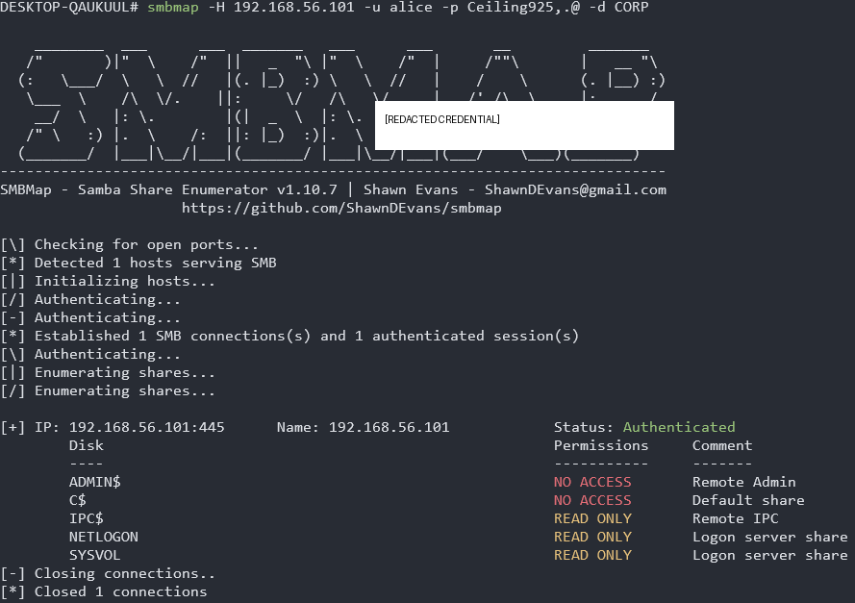

5. GPO / SYSVOL — What We Learned
We followed the SYSVOL Policies directory and found two standard GPOs:
GPO | GUID
Default Domain Policy | {31B2F340-016D-11D2-945F-00C04FB984F9}
Default Domain Controllers Policy | {6AC1786C-016D-11D2-945F-00C04fB984F9}
LDAP showed the GPO objects, while SYSVOL contained folders with the same GUIDs. This helped us understand that AD stores GPO information and SYSVOL stores the related policy files.
The Default Domain Policy contained password and account-lockout settings. In our captured policy, the minimum password length was 7 and LockoutBadCount was 0. These are security weaknesses worth noting in the lab.
The Domain Controllers Policy showed LDAP signing, Netlogon signing/sealing and SMB signing enabled/required. These are positive security settings.
Evidence — GPO enumeration
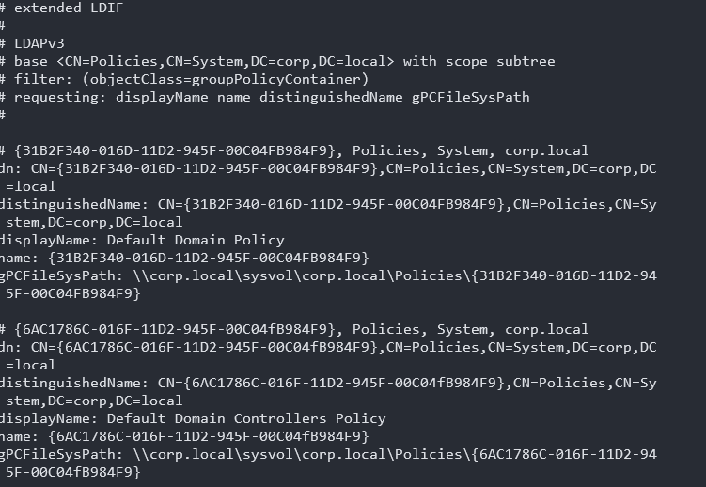
Evidence — Domain GPO link
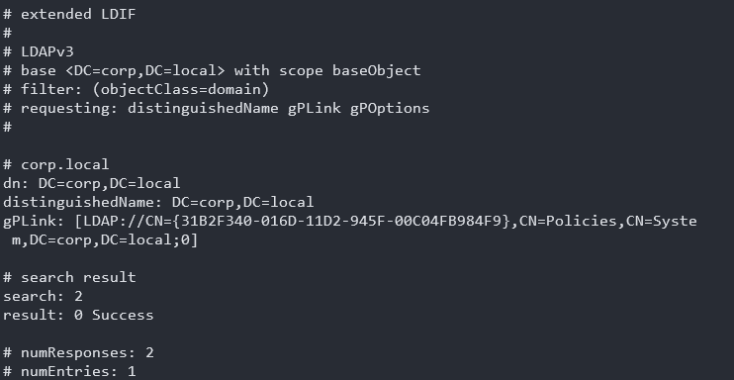
Evidence — SPN enumeration result
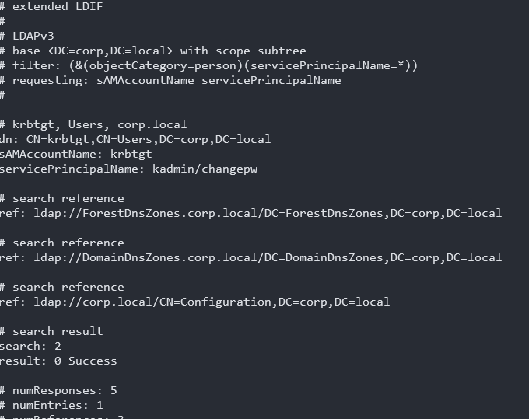

6. RPC Enumeration
rpcclient gave us another way to enumerate domain users and groups. Alice's RID was 0x44f, and her group query showed Domain Users and IT.
rpcclient -U 'CORP/alice' 192.168.56.101
enumdomusers
enumdomgroups
queryuser alice
queryusergroups 0x44f
Evidence — RPC enumeration
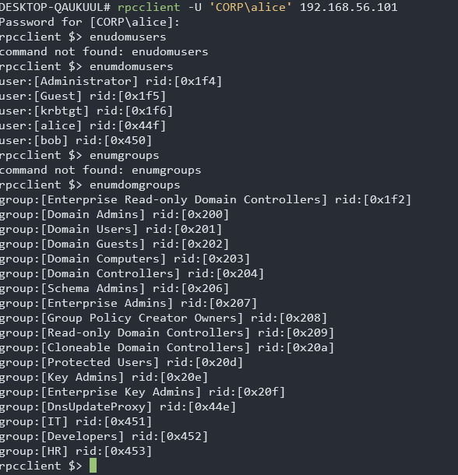

7. What We Can Say From This Lab
Area | Result
Domain | corp.local
DC | DC01 / 192.168.56.101
Alice | Normal domain user; IT member
Users/computers | Successfully enumerated
Groups | Successfully enumerated
SMB | Shares and permissions identified
SYSVOL | Read-only access confirmed
Admin shares | No access for Alice
SPNs | No normal user-backed service account identified
No successful privilege escalation or domain compromise was demonstrated in this part of the lab. The purpose was enumeration and understanding the AD environment.

8. Beginner Takeaways
- LDAP lets us ask Active Directory structured questions about users, groups, computers and policies.
- SMB lets us discover and access Windows shares according to our permissions.
- SYSVOL is important because it contains Group Policy files.
- RPC can provide another view of users, groups and RIDs.
- Different tools can be used to cross-check the same information.
- Enumeration comes before exploitation: first understand the environment, then identify possible attack paths.

9. Next Step in the Lab
The next stage is Kerberos. We have already observed Alice's TGT and CIFS service ticket with klist. The next controlled exercise will be to create a lab service account with an SPN and understand Kerberoasting safely, step by step.

