Penetration Test Report
Mr-Robot: 1 — Vulnerable Virtual Machine Assessment

Environment: Kali Linux and target VM in VirtualBox
Tools used: Nmap, WordPress enumeration, Hydra, hash analysis Result: Full compromise — root access and all three flags obtained

Executive Summary

This report documents an assessment of the intentionally vulnerable Mr-Robot: 1 virtual machine. The supplied evidence shows discovery of exposed web content, identification of WordPress-related endpoints, successful credential testing against the WordPress login, access to the WordPress administration interface, modification of PHP through the theme editor, subsequent shell activity, local enumeration, and a final root identity check. Three flag-related screenshots were supplied as milestone evidence.
The main security themes demonstrated are information disclosure, weak or guessable authentication, over-privileged access to executable theme files, and a local privilege-escalation path. Severity ratings are not assigned as definitive production ratings because this is a deliberately vulnerable training image, and the supplied screenshots alone do not establish impact in a real deployment.

Scope and Methodology

Scope | The Mr-Robot: 1 VM supplied for a local training exercise. No external systems are in scope.
Methodology | Web discovery → authentication behavior review → credential validation → authenticated WordPress review → PHP / theme editor activity → shell and local enumeration → privilege-escalation validation → flag / root evidence.

Evidence limitation: based on supplied screenshots, not an independent re-scan. Target IP, exact Nmap command/output, tool versions, and precise privilege-escalation root cause should be added only if verified from original logs.

Assessment Findings

F-01 — Exposed Web Content and Application Information

Observation: The first flag screenshot and WordPress path-enumeration screenshot show that public-facing content and application paths disclosed useful information.
Recommended remediation: Review public files and directories; remove unintended sensitive artifacts; restrict backups and diagnostic files; periodically audit web-root contents.

F-02 — Weak or Guessable WordPress Authentication

Observation: A successful credential-testing screenshot follows a captured failed-login response and WordPress endpoint enumeration. The exact credential is intentionally omitted.
Recommended remediation: Use unique high-entropy passwords and MFA; rate-limit authentication; monitor failures; prevent password reuse; disable unused accounts.

F-03 — Privileged Ability to Modify Executable PHP

Observation: The WordPress Users page and theme-editor screenshot document authenticated administrative access and PHP code editing. If such changes are saved and executed, server-side code may run with the web server's privileges.
Recommended remediation: Disable the built-in theme/plugin editor in production; limit
administrator accounts; protect privileged sessions with MFA; deploy code through reviewed version control; monitor theme-file changes.

F-04 — Local Privilege-Escalation Path

Observation: Later screenshots document local permission/configuration investigation and a final root identity check. The exact root cause should be tied to the specific misconfiguration shown in the original terminal output before publication.
Recommended remediation: Apply supported OS and application updates; audit SUID/capabilities, writable paths, scheduled tasks, sudo rules and service configurations; remove unnecessary privileges; retest after remediation.

Attack Path Summary

  - Discover public web content and retrieve the first flag milestone.
  - Enumerate WordPress-related paths and observe authentication failure behavior.
  - Perform credential testing against the WordPress login; a successful result is evidenced.
  - Access the WordPress administration interface.
  - Use the theme editor to modify PHP; the screenshot records the code-editing stage.
  - Continue with shell handling and local enumeration; examine account/permission and misconfiguration evidence.
  - Validate the final privilege level with root identity output and capture the final flag milestone.

Evidence Screenshots (Chronological)

The screenshots are arranged by the timestamps in the supplied archive. Captions are limited to what the evidence supports. Review and redact any real credentials, tokens, or unrelated personal information before publication.
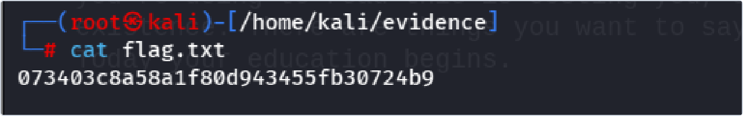
Figure 1 — Initial flag discovery. The first flag was retrieved from the target's exposed web content. This establishes early information disclosure; the report intentionally does not reproduce flag values.
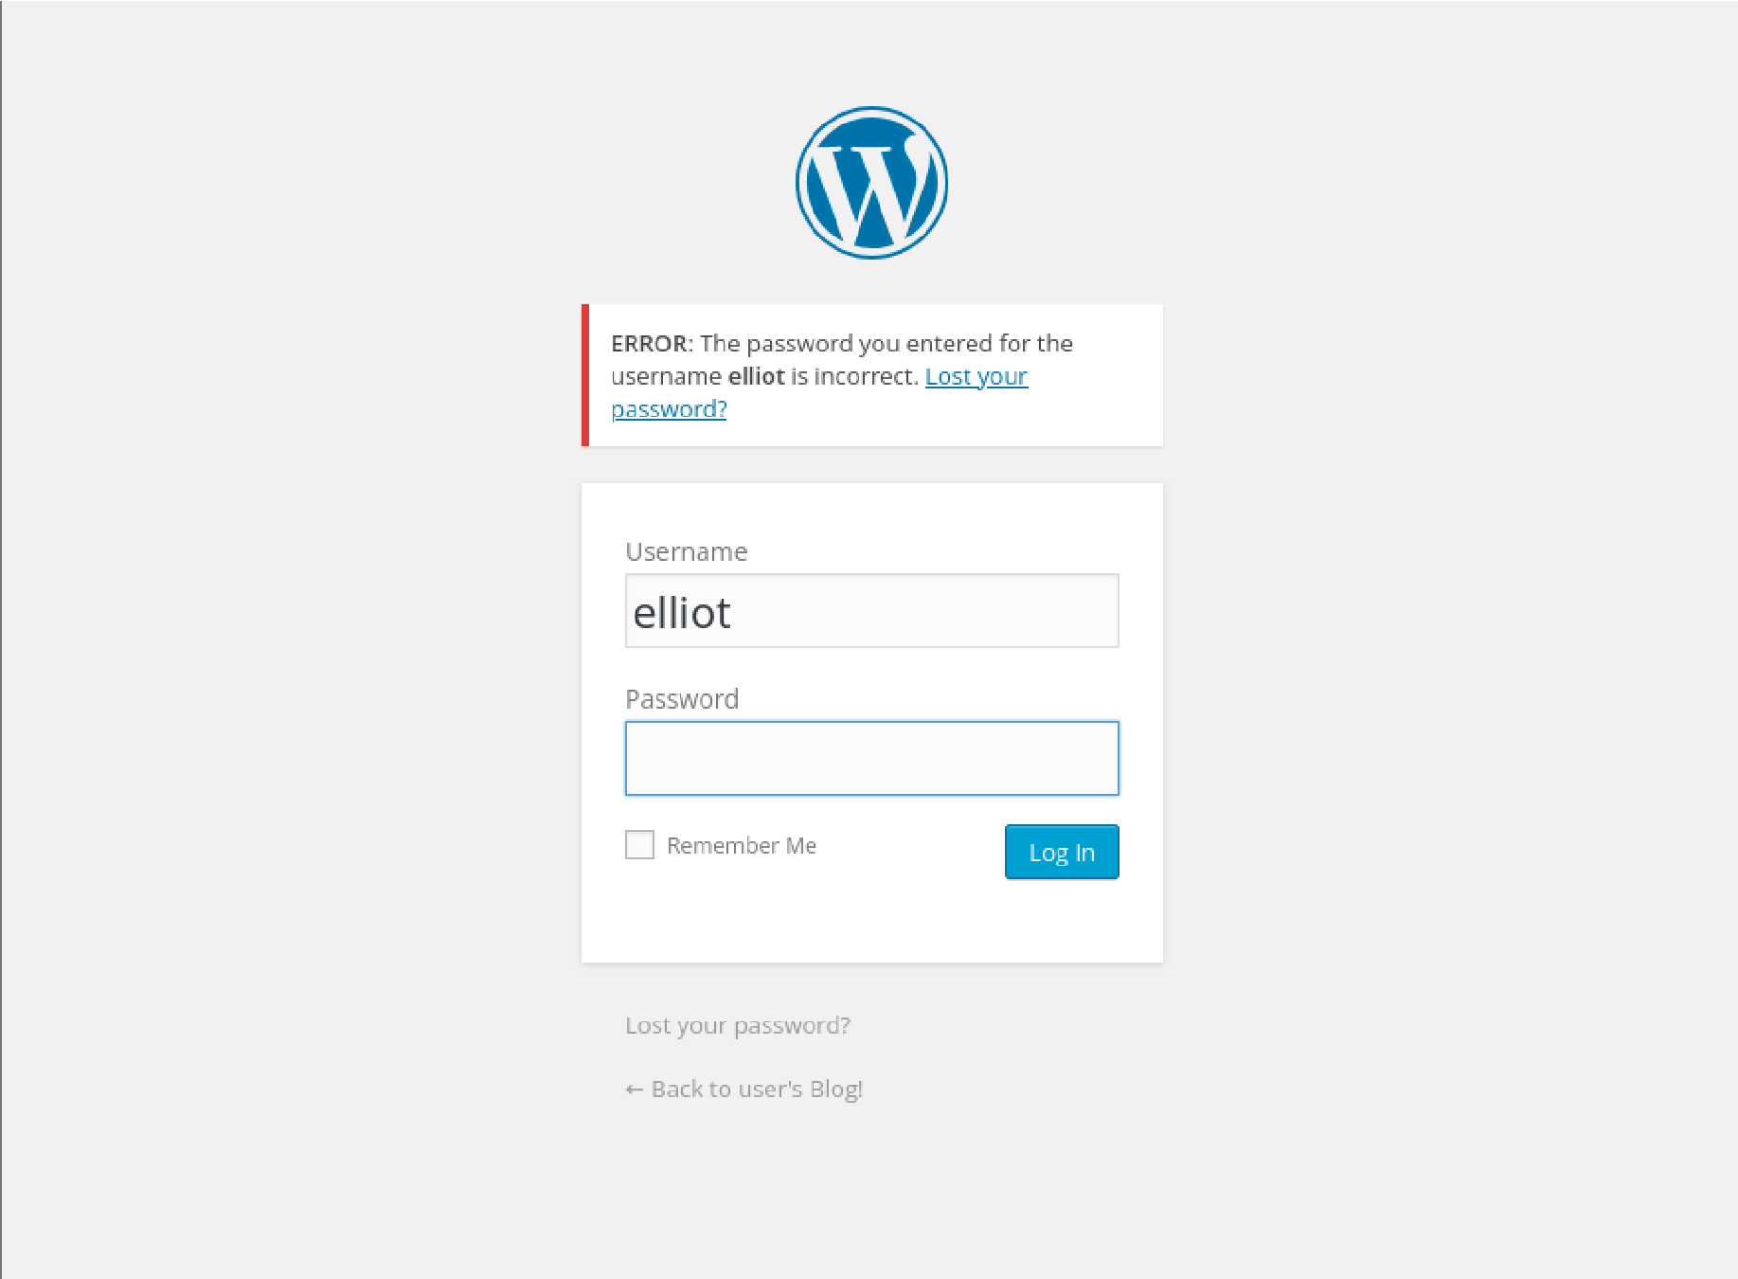

Figure 2 — WordPress authentication response. A failed login response was captured to establish the behavior of the authentication endpoint before credential testing.
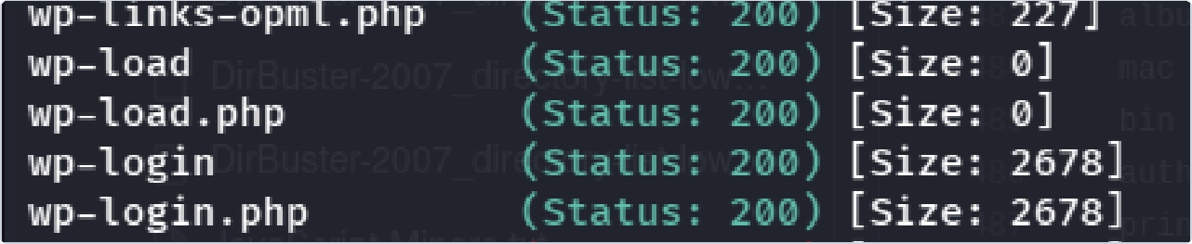
Figure 3 — WordPress endpoint enumeration. Enumeration results identify WordPress-related paths, including the login endpoint, supporting the decision to investigate the WordPress application.
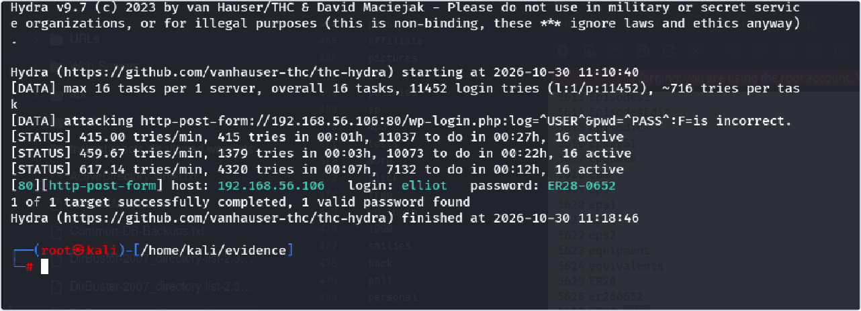
Figure 4 — Credential testing result. The screenshot records a successful credential test against the lab WordPress login. Credentials are not repeated in this report.
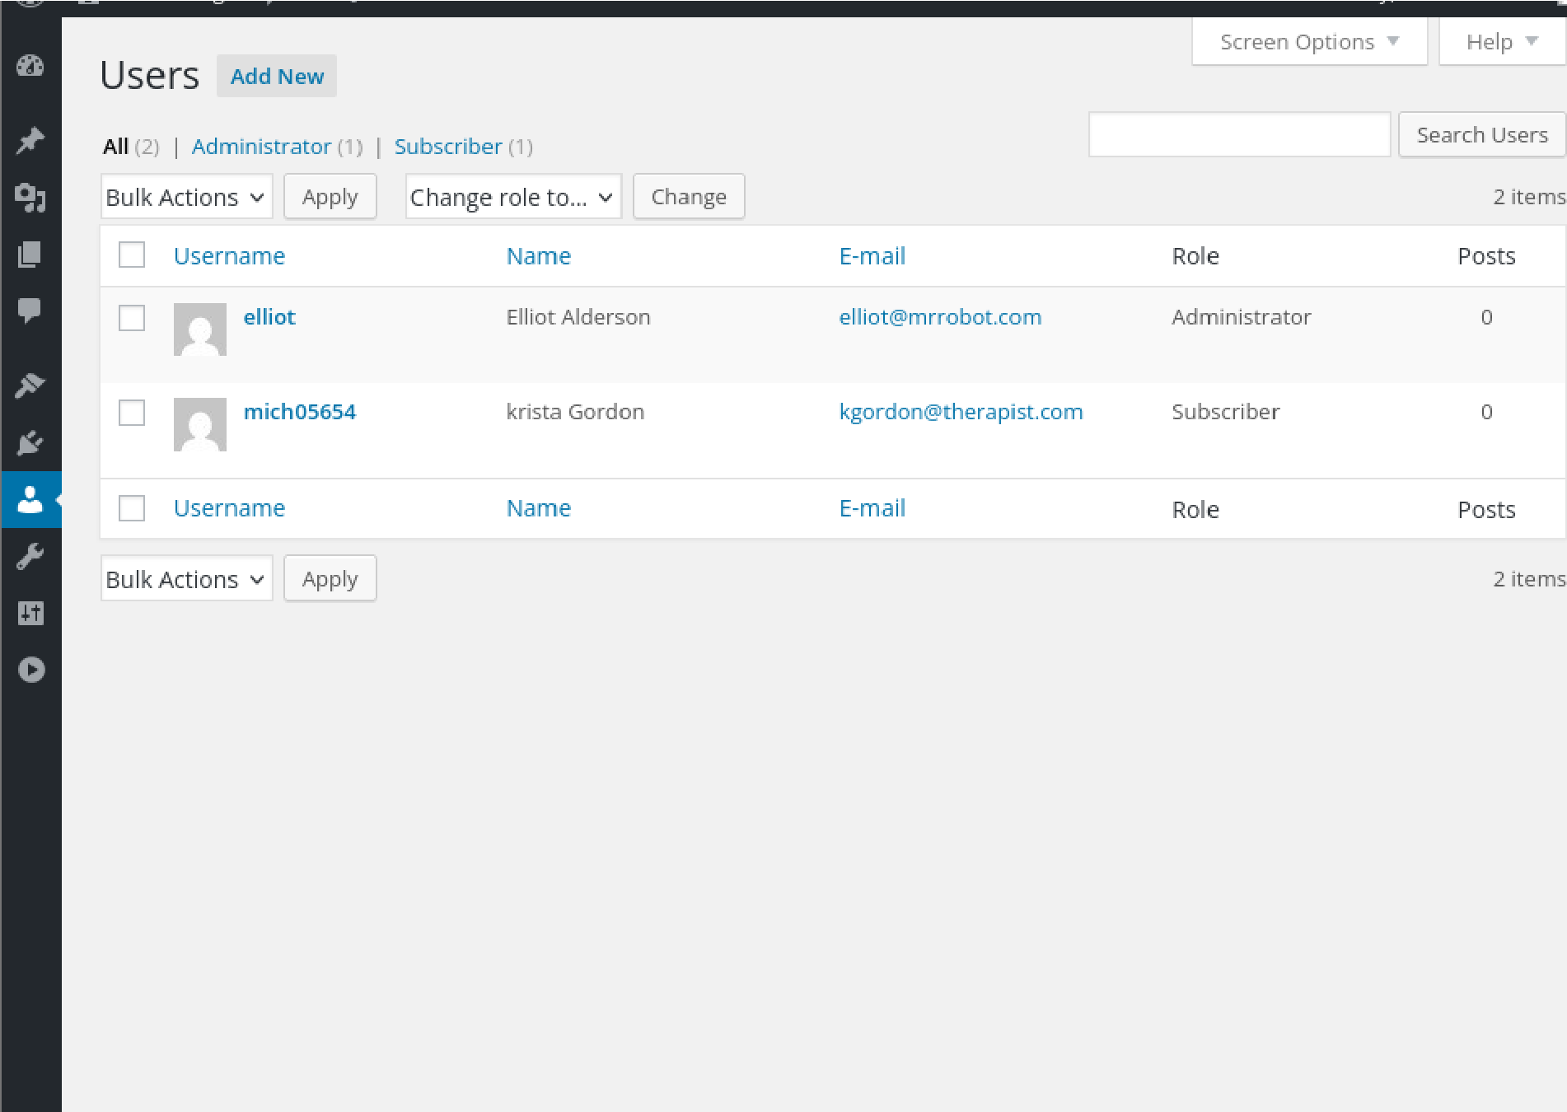

Figure 5 — Authenticated WordPress administration. The WordPress Users page shows access to the administrative interface and the available user accounts.
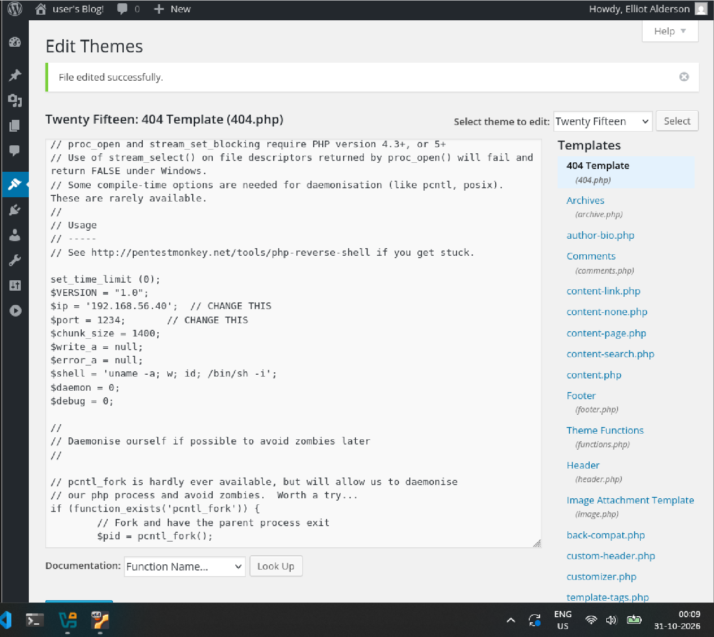

Figure 6 — Theme editor inspection. The screenshot documents PHP code entered through the WordPress theme editor, demonstrating the risk of permitting privileged users to modify executable server-side code.
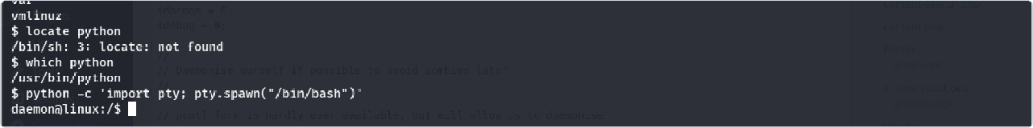
Figure 7 — Shell stabilization. Terminal evidence records follow-up work after initial access. The exact privileges should be confirmed from the command output before making claims beyond the screenshot.
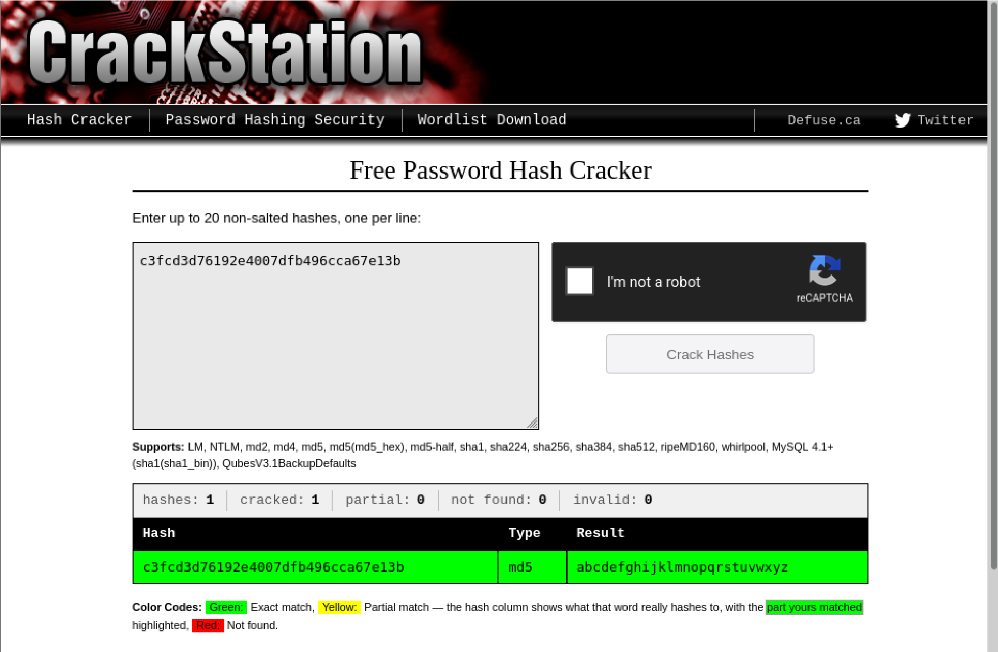

Figure 8 — Password-hash analysis. A password-hash cracking result is shown. The report does not reproduce recovered secrets.
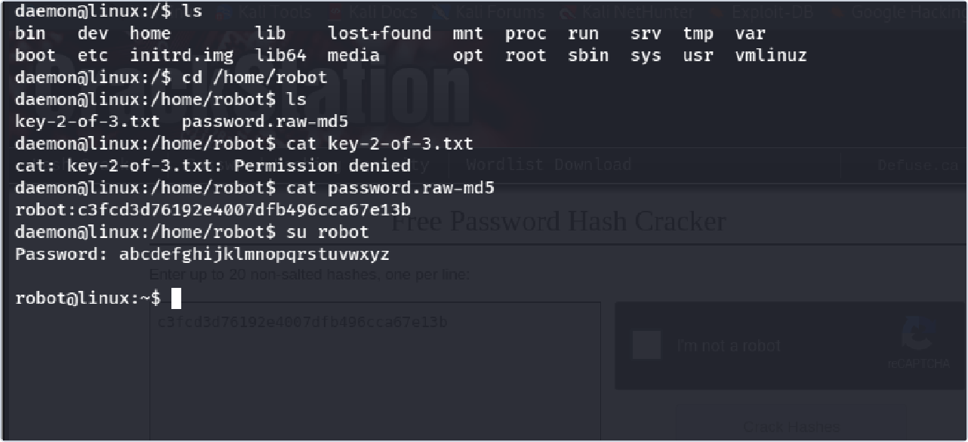
Figure 9 — Local permission and account investigation. Filesystem and account-related investigation was performed to identify the next privilege-escalation path.
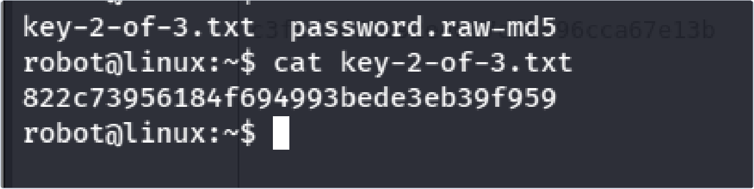
Figure 10 — Second flag evidence. The screenshot shows the second flag file being read in the lab environment.
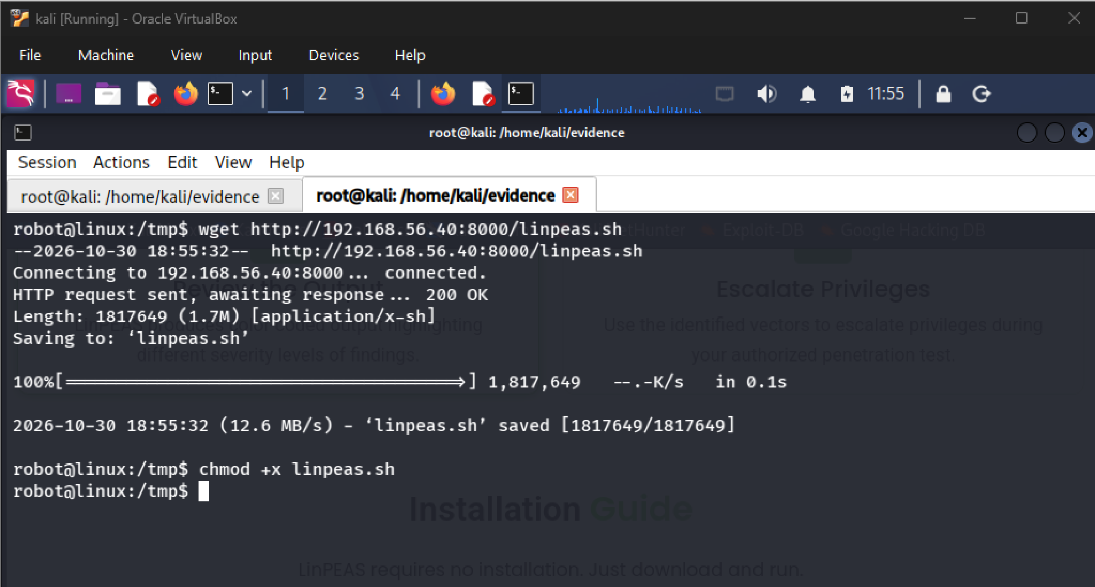

Figure 11 — Privilege-escalation enumeration preparation. The screenshot records transfer of a local enumeration script to the target for authorized lab analysis.
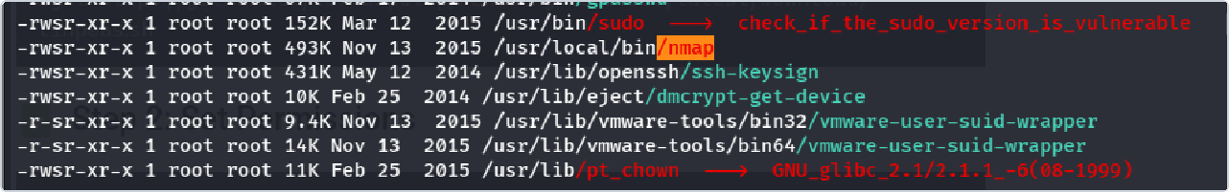
Figure 12 — Local service and configuration investigation. The screenshot shows investigation of local files and configuration relevant to the escalation path.
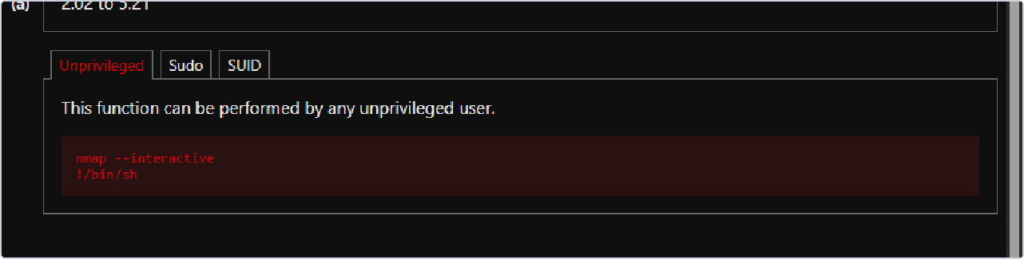
Figure 13 — Misconfiguration validation. The screenshot records a permission or configuration check. The finding should be described narrowly to match the visible evidence.
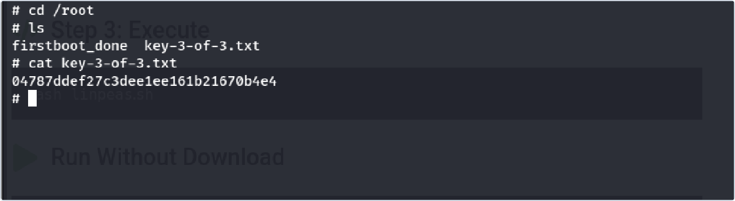
Figure 14 — Final flag evidence. The screenshot shows the final flag file being read from the target.
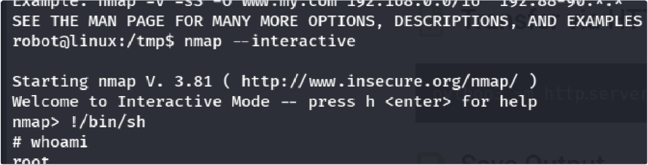
Figure 15 — Root access verification. The terminal screenshot shows the session identity as root, documenting successful privilege escalation in the lab.

Remediation Priorities
Priority Action

Immediate Remove any test shell or assessment artifacts and restore the VM snapshot if needed.

High Strengthen WordPress authentication with unique passwords, MFA, and rate limiting.

High Disable server-side PHP editing from the WordPress dashboard in production and restrict administrator roles.

High Investigate and remediate the exact local privilege-escalation misconfiguration demonstrated by the terminal evidence.

Ongoing Update the operating system, web server, WordPress core, themes, and plugins to supported versions.

Validation Repeat relevant checks after remediation and confirm the attack path no longer succeeds.

Conclusion and Limitations

The supplied evidence supports a progression from web reconnaissance and credential discovery to authenticated WordPress administration, server-side PHP editing, local investigation, and root-level access in the lab. This report does not claim a specific CVE or definitive privilege-escalation mechanism unless the evidence directly establishes it. Before external publication, confirm the target IP, add exact Nmap output and commands from original logs, and ensure no reusable secrets appear in screenshots.

Appendix A — Evidence Index

Figure | Source File | Description
Figure 1 | flag1.png | Initial flag discovery
Figure 2 | checkingerror_response.png | WordPress authentication response
Figure 3 | wordpress_confirmation.png | WordPress endpoint enumeration
Figure 4 | bruteforce_success.png | Credential testing result
Figure 5 | elliot_admin.png | Authenticated WordPress administration
Figure 6 | reverse_shell_code_in_404php.png | Theme editor inspection
Figure 7 | stablise_shell.png | Shell stabilization
Figure 8 | cracked_hash.png | Password-hash analysis
Figure 9 | permission_for_robot.png | Local permission and account investigation
Figure 10 | flag2.png | Second flag evidence
Figure 11 | linpeas_transfer.png | Privilege-escalation enumeration preparation
Figure 12 | nmap_investigation.png | Local service and configuration investigation
Figure 13 | investigation_of_misconfig.png | Misconfiguration validation
Figure 14 | flag3.png | Final flag evidence
Figure 15 | root_yay.png | Root access verification

