PENETRATION TEST REPORT
CONFIDENTIAL | TRAINING ASSESSMENT
Stapler: 1
Vulnerable Linux Lab Assessment

TARGET | 192.168.56.105 (host name observed: RED)
ASSESSMENT DATES | 28–29 October 2026
ASSESSMENT TYPE | Authorized, isolated virtual lab
ENVIRONMENT | VirtualBox host-only network
OVERALL RISK | CRITICAL
CLASSIFICATION | Confidential training report
Contents
1. Executive Summary 3
2. Scope and Methodology 3
3. Nmap Service Discovery 4
4. Findings 5
5. Attack Path Summary 8
6. Evidence Screenshots 9
7. Remediation Priority 13
8. Conclusion 13
Appendix A. Nmap Output Notes 14

1. Executive Summary
An assessment of the intentionally vulnerable Stapler: 1 virtual machine identified multiple exposed services and several paths that led to local access and privilege escalation. The tester observed anonymous FTP access, guest-accessible SMB content, a WordPress installation with database exposure, reusable credentials, and a PHP reverse-shell callback running as the web-service account.
A local user, peter, held unrestricted sudo rights, shown as (ALL : ALL) ALL. This allowed escalation to root and retrieval of the lab flag.
OVERALL RISK: CRITICAL
In the context of a real deployment, the demonstrated chain reached root-level control. This rating is contextual to the lab and should not be read as a production-system rating without validating scope and business impact.

FINDINGS BY SEVERITY
2  CRITICAL | 3  HIGH | 1  MEDIUM | 6  TOTAL FINDINGS

2. Scope and Methodology

2.1 Scope
The single lab target 192.168.56.105 on the local VirtualBox host-only network.

2.2 Activities documented
- Service discovery with Nmap
- Review of FTP and SMB access
- Inspection of exposed WordPress and database artifacts
- Credential validation
- Controlled PHP reverse-shell execution
- Local enumeration and sudo privilege assessment
- Proof-of-impact collection

2.3 Limitations
- This report reflects the supplied Nmap output and screenshots.
- No independent re-scan or verification was performed while drafting the report.
- The Nmap scan did not establish an exact operating-system match.

3. Nmap Service Discovery
COMMAND RECORDED IN THE SCAN OUTPUT
nmap -sV -Pn -A -oN results.txt 192.168.56.105
The host was reachable with approximately 2.1 ms latency. Nmap reported 992 filtered TCP ports among the default scanned ports. Open services and observations are summarized below.

Port / Service | Observed version / result | Security significance
21/tcp — FTP | vsftpd 3.0.3; anonymous login allowed; directory listing denied by PASV response | Anonymous access was possible; file retrieval behavior should be constrained and reviewed.
22/tcp — SSH | OpenSSH 7.2p2 Ubuntu 4 | Remote login surface; a valid account credential was later identified in the lab.
53/tcp — DNS | dnsmasq 2.75 | Exposed DNS service; review whether it is required and restrict access.
80/tcp — HTTP | Nmap HTTP title: 404 Not Found; service fingerprint was generic (PHP CLI server 5.5 or later) | Web content and WordPress paths required manual validation; Nmap’s generic identification may not reflect the full web stack.
139/tcp — NetBIOS/SMB | Samba smbd 4.3.9-Ubuntu; WORKGROUP | Guest/unauthenticated SMB enumeration and share access were observed.
666/tcp — unknown (ZIP-like) | Nmap fingerprint began with ZIP archive bytes and referenced message2.jpg | Unusual service/port; investigate the listening process and restrict or disable if unnecessary.
3306/tcp — MySQL | MySQL 5.7.12-0ubuntu1 | Database service exposed on the network; database configuration and network access controls require review.

ADDITIONAL NMAP NOTES
- SMB signing was enabled but not required in the SMB2 script output, while the legacy SMB security script reported signing disabled. Treat these as script-specific observations and validate the effective configuration.
- Nmap identified the host as Linux with host name RED, but returned no exact OS match.

4. Findings
Six findings were identified. Severity ratings are contextual to the lab environment and are summarized below, followed by the evidence and recommendation for each.
ID | Finding | Severity | Affected service
F-01 | Anonymous FTP access | MEDIUM | 21/tcp (FTP)
F-02 | SMB guest access and information disclosure | HIGH | 139/tcp (SMB)
F-03 | Credential exposure and weak credential hygiene | HIGH | 21/tcp (FTP), 22/tcp (SSH)
F-04 | WordPress and database information exposure | HIGH | 80/tcp (HTTP), 3306/tcp (MySQL)
F-05 | PHP reverse shell execution as web-service account | CRITICAL | 80/tcp (WordPress uploads directory)
F-06 | Unrestricted sudo privileges enabling root escalation | CRITICAL | Local operating system (user peter)

F-01 Anonymous FTP access
SEVERITY  MEDIUM | AFFECTED SERVICE  21/tcp (FTP) | EVIDENCE  Figure 1
EVIDENCE
Nmap reported that anonymous FTP login was allowed. The tester connected as anonymous and retrieved a file named note, although directory listing was denied.
RECOMMENDATION
- Disable anonymous FTP unless explicitly required.
- Restrict read and write permissions for any anonymous access that remains.
- Use authenticated, encrypted file transfer where appropriate.
- Review the files accessible to anonymous users.

F-02 SMB guest access and information disclosure
SEVERITY  HIGH | AFFECTED SERVICE  139/tcp (SMB) | EVIDENCE  Figures 2–3
EVIDENCE
SMB enumeration identified Unix users and an accessible Kathy share. The tester retrieved todo-list.txt from the kathy_stuff directory.
RECOMMENDATION
- Disable guest access where it is not required.
- Restrict share permissions to named users and groups.
- Audit share contents for credentials, operational notes and other sensitive files.

F-03 Credential exposure and weak credential hygiene
SEVERITY  HIGH | AFFECTED SERVICE  21/tcp (FTP), 22/tcp (SSH) | EVIDENCE  Figures 4–5
EVIDENCE
A valid FTP credential for elly was identified as elly / ylle (Figure 4). A separate SSH credential test shows SHayslett / SHayslett accepted by the target (Figure 5). These results indicate weak or guessable credentials in the lab.
RECOMMENDATION
- Enforce unique, strong passwords and block common or reversed username patterns.
- Rate-limit authentication attempts and monitor failures.
- Use SSH keys or MFA where feasible.
- Avoid reusing credentials across services.

F-04 WordPress and database information exposure
SEVERITY  HIGH | AFFECTED SERVICE  80/tcp (HTTP), 3306/tcp (MySQL) | EVIDENCE  Figure 6
EVIDENCE
The tester accessed the WordPress database and displayed wp_users records containing user names, email addresses and password hashes. WordPress configuration material was also shown (Figure 6), including the database name wordpress, the database user root, and the database password.
RECOMMENDATION
- Do not expose MySQL to untrusted networks; restrict database access to localhost or required application hosts.
- Use a least-privilege database account rather than root.
- Protect wp-config.php and backups.
- Rotate exposed secrets.

F-05 PHP reverse shell execution as web-service account
SEVERITY  CRITICAL | AFFECTED SERVICE  80/tcp (WordPress uploads directory) | EVIDENCE  Figures 7, 8, 11
EVIDENCE
A PHP reverse-shell file was placed in the WordPress uploads directory and executed. The listener received a connection from 192.168.56.105, and the shell identified the process context as uid=33(www-data) gid=33(www-data).
RECOMMENDATION
- Prevent execution of PHP in upload directories.
- Store uploads outside the web root where possible and enforce server-side file validation.
- Remove the uploaded shell.
- Restrict outbound connections and harden PHP and web-server permissions.

F-06 Unrestricted sudo privileges enabling root escalation
SEVERITY  CRITICAL | AFFECTED SERVICE  Local operating system (user peter) | EVIDENCE  Figures 9–10
EVIDENCE
After switching to the local user peter, the tester ran sudo -l, which showed (ALL : ALL) ALL. Running sudo su resulted in root access, and the tester read the lab flag.
RECOMMENDATION
- Remove unrestricted sudo rights from ordinary users; grant only the specific commands required.
- Require authentication where appropriate.
- Review sudoers files and group membership.

5. Attack Path Summary
The compromise progressed through the following stages, from initial discovery to root-level access.

Step | Stage | Activity | Reference
1 | Service discovery | Identified FTP, SSH, DNS, HTTP, SMB, port 666 and MySQL. | Section 3
2 | Unauthenticated access | Anonymous FTP and SMB guest access provided access to files and user/account information. | F-01, F-02
3 | Credential access | Credential testing identified valid weak credentials for lab accounts. | F-03
4 | Information discovery | WordPress database/user information and configuration material were inspected. | F-04
5 | Code execution | A PHP reverse shell was executed from the uploads directory, yielding a shell as www-data. | F-05
6 | Account pivot | The tester obtained a shell as peter and found unrestricted sudo permission: (ALL : ALL) ALL. | F-06
7 | Privilege escalation | sudo su provided root-level access, and the lab flag was retrieved. | F-06

6. Evidence Screenshots
Screenshots supplied during the assessment are included below. Each caption describes the evidence visible in the image above it.
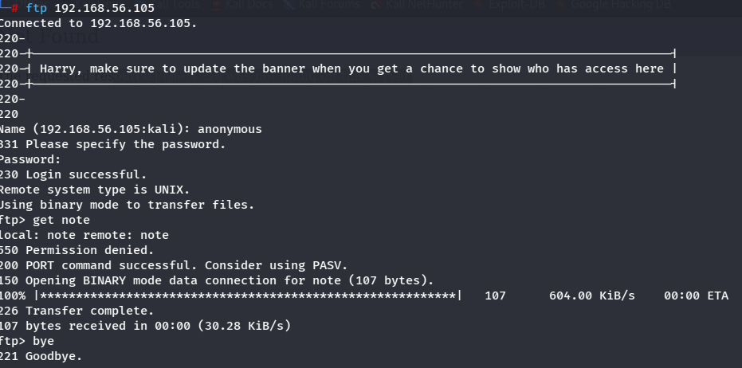
Figure 1. Anonymous FTP login and retrieval of the note file.
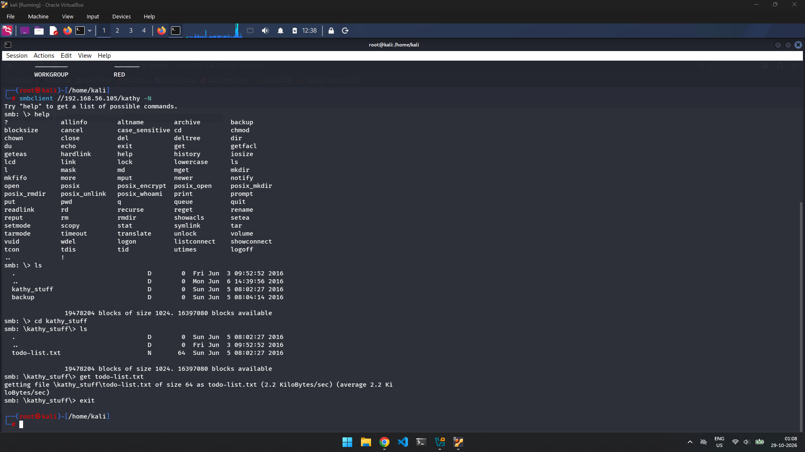
Figure 2. SMB guest access to the Kathy share and retrieval of todo-list.txt.
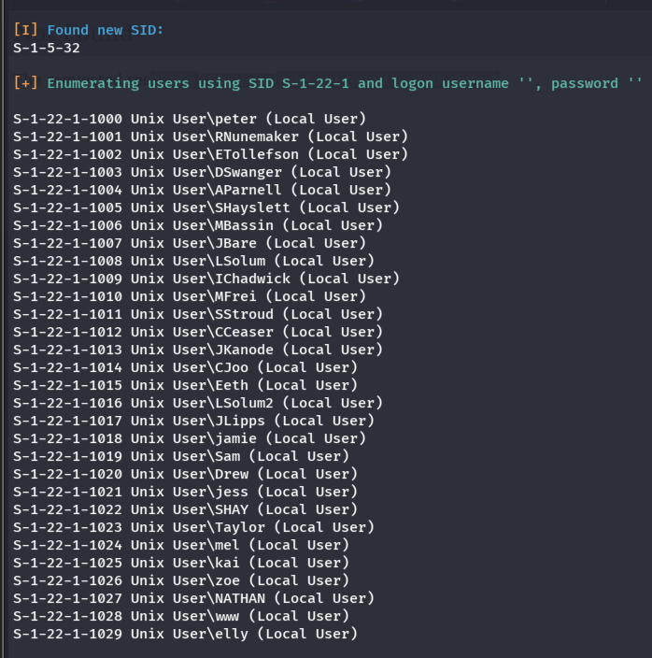
Figure 3. SMB/RPC user enumeration showing local Unix user accounts.
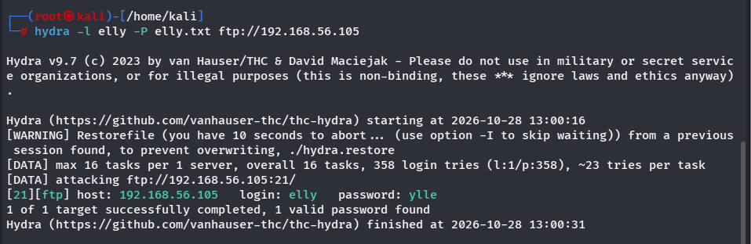
Figure 4. Hydra output identifying a valid FTP credential for the user elly.
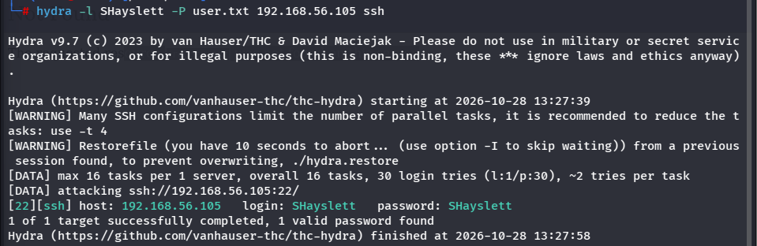
Figure 5. Hydra output identifying a valid SSH credential for the user SHayslett.
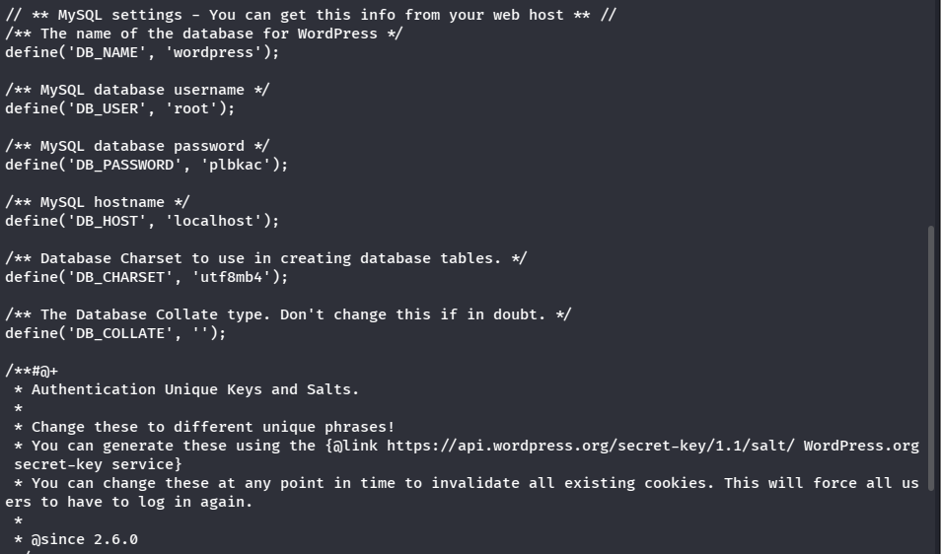
Figure 6. WordPress wp-config.php exposing the database name, database user (root) and database password.
Figure 7. PHP reverse-shell file (php-reverse-shell.php) present in the WordPress uploads directory.
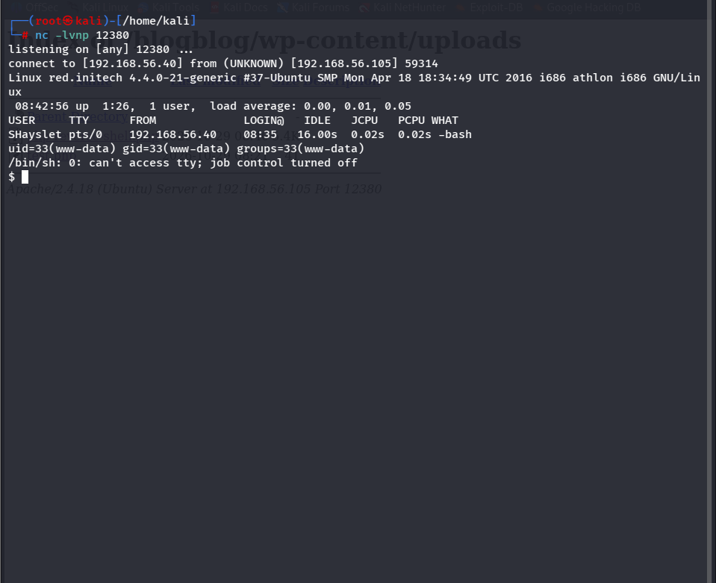
Figure 8. Reverse-shell callback received from the target; the shell runs as www-data.
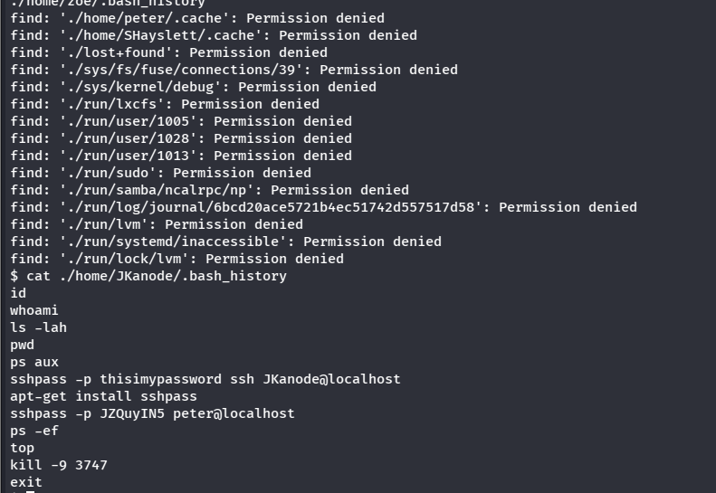
Figure 9. Shell history of the user JKanode containing plaintext sshpass commands, including credentials for the peter account.
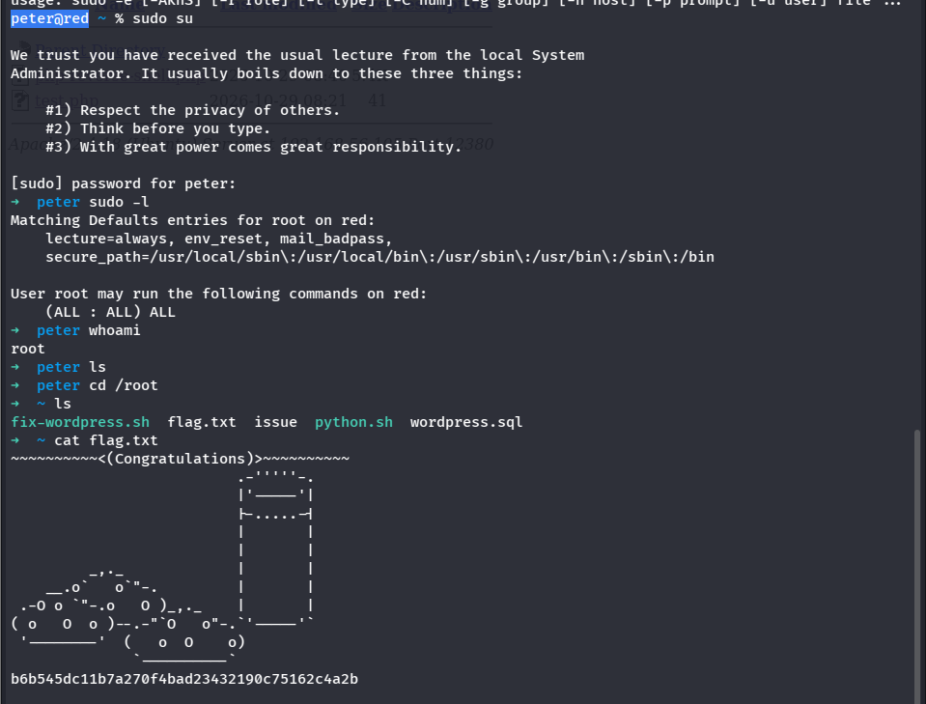
Figure 10. The user peter has unrestricted sudo (ALL : ALL) ALL; sudo su yields root and the lab flag is displayed.
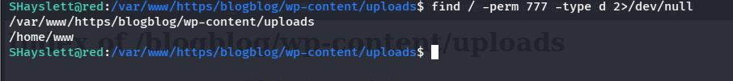
Figure 11. Filesystem permission enumeration: world-writable directories, including the WordPress uploads directory.

7. Remediation Priority
Actions are listed in the order in which they should be addressed.

Priority | Action | Related
IMMEDIATE | Remove PHP execution capability from the uploads directory and remove the reverse-shell artifact. | F-05
IMMEDIATE | Remove unrestricted sudo rights for peter and audit all sudoers rules. | F-06
HIGH | Rotate exposed database and user credentials; replace the database root account used by WordPress with a least-privilege account. | F-03, F-04
HIGH | Disable anonymous FTP and SMB guest access; review all exposed files and shares. | F-01, F-02
HIGH | Harden SSH authentication and enforce strong, unique passwords with rate limiting. | F-03
MEDIUM | Review the service bound to TCP/666, close unnecessary services, and restrict MySQL to required hosts. | Section 3, F-04
ONGOING | Patch the operating system, web stack, WordPress and plugins, Samba, OpenSSH, MySQL and the DNS service to supported versions. | General hardening

8. Conclusion
The lab assessment demonstrated a complete compromise path ending in root-level access. The most impactful issues were executable PHP uploads, weak and reused credentials, exposed database and configuration information, and unrestricted sudo privileges.
In a real environment, these weaknesses should be addressed in the priority order above, then retested to verify that the attack path is no longer viable.

Appendix A. Nmap Output Notes
Summary of the supplied Nmap scan output.

Scan started | 28 October 2026, 12:28:57
Scan completed | 28 October 2026, 12:29:57
Host | RED — Linux, one network hop away
Open TCP ports | 21, 22, 53, 80, 139, 666, 3306
Closed TCP ports | 20
Filtered TCP ports | 992 (default-scanned)
Operating-system match | No exact match
TCP/666 fingerprint | Included ZIP-file bytes and the string message2.jpg

