WEB APPLICATION PENETRATION TESTING
Authentication Assessment Report
Username Enumeration via Different Responses
Assessment type | Web application authentication testing (training lab)
Target | PortSwigger Web Security Academy lab: “Username enumeration via different responses”
Tooling | Burp Suite Community Edition (Proxy, Intruder)
Finding | Username enumeration through observable response differences, followed by password guessing
Classification | CWE-204; MITRE ATT&CK T1110.001 (password-guessing stage)
Risk rating | Not scored; see Section 7

1. Executive Summary
This assessment tested the PortSwigger Web Security Academy lab “Username enumeration via different responses.” The login endpoint returned distinguishable responses for valid and invalid usernames. Burp Suite Intruder was used to test candidate usernames and compare response characteristics. The candidate “archie” produced a different response length from invalid candidates. Password candidates were then tested against that username. One attempt returned HTTP/2 302 Found and redirected to the account page. The lab subsequently displayed its completion confirmation.

2. Scope and Objective
Scope: the intentionally vulnerable PortSwigger Web Security Academy lab environment used for this exercise.
Objective: determine whether login response differences disclose valid usernames, then test whether the identified account can be accessed through password guessing within the authorised lab.
This report documents the lab exercise only; it does not establish that a production application has the same behaviour.

3. Tools and Methodology
- Burp Suite Community Edition — intercepting and modifying the login request.
- Burp Intruder — testing candidate usernames and comparing response lengths, then testing password candidates against the identified username.
- Browser — verifying the authenticated account page and lab completion.

4. Technical Findings

4.1 Username Enumeration Through Response Differences
The login endpoint accepted a POST request to /login containing username and password parameters. An invalid username produced an “Invalid username” message. In the Intruder results, the candidate “archie” returned a response length of 3354 bytes, while several invalid candidates returned 3352 bytes. This observable difference provided a signal that “archie” was a valid username.
The supplied evidence supports response-length comparison as the enumeration indicator. In a real assessment, the behaviour should be repeated to rule out unrelated response variation.

4.2 Password Guessing Against the Identified Account
After identifying “archie”, password candidates were tested against that username. The successful attempt returned HTTP/2 302 Found with a Location header pointing to /my-account?id=archie. The browser then displayed the account page for archie, and the lab displayed its success confirmation.
This confirms authentication in the lab. The screenshots do not establish the application’s password policy, rate-limiting configuration, or behaviour outside the training environment.

5. Evidence
The following screenshots are arranged chronologically. Session-cookie values and the password value have been redacted in the report copies.
Figure 1 — Invalid username response
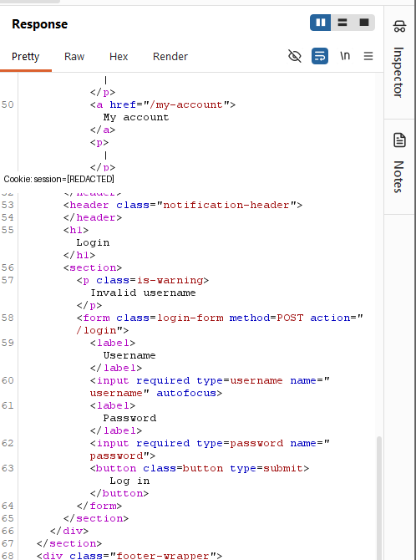
The response displays “Invalid username”, showing the error behaviour for an invalid candidate.
Figure 2 — Intruder username-enumeration setup
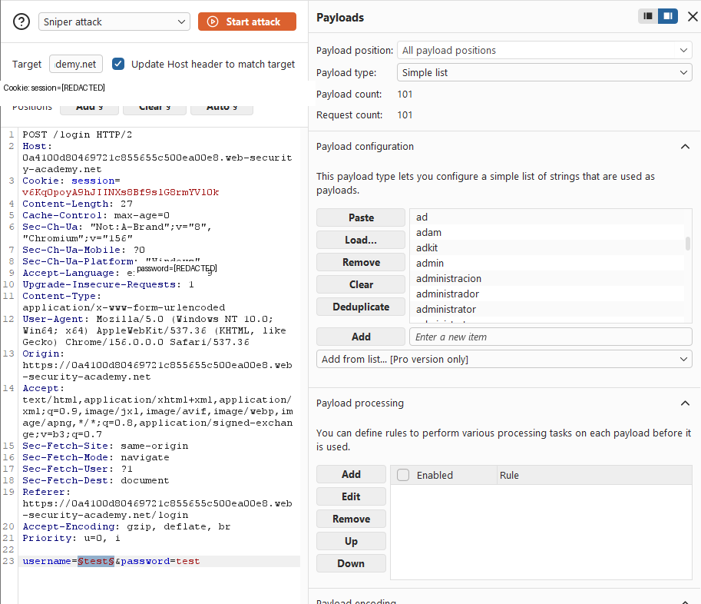
Burp Intruder is configured to submit a candidate list against the username parameter.
Figure 3 — Intruder response comparison
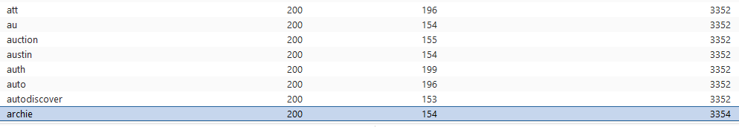
The results show differing response lengths; the archie candidate differs from invalid candidates.
Figure 4 — Authentication response
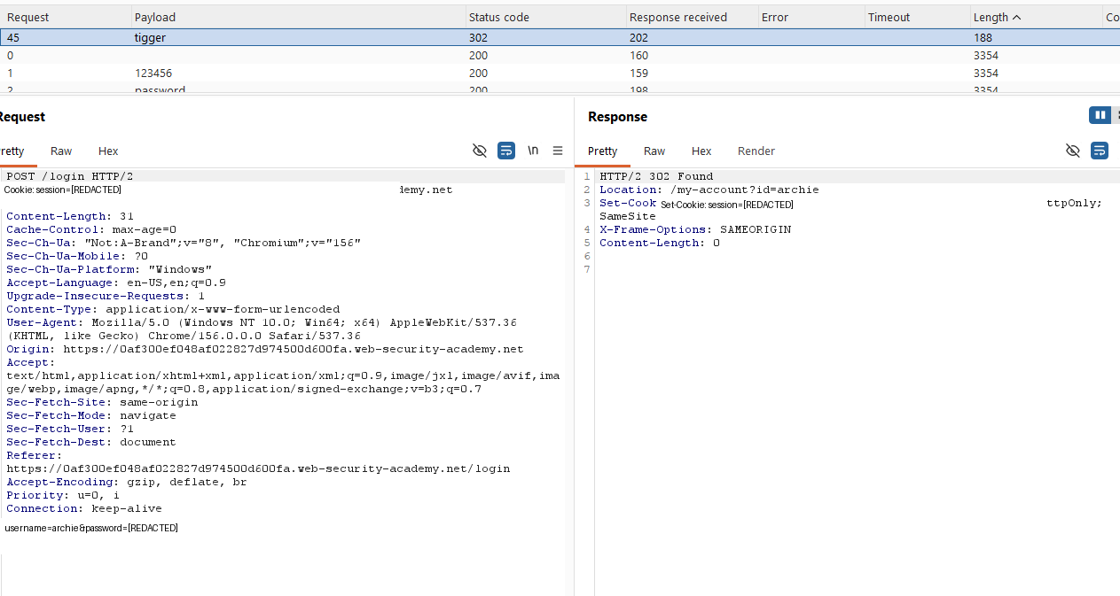
The tested request receives HTTP/2 302 Found and redirects to /my-account?id=archie.
Figure 5 — Lab completion
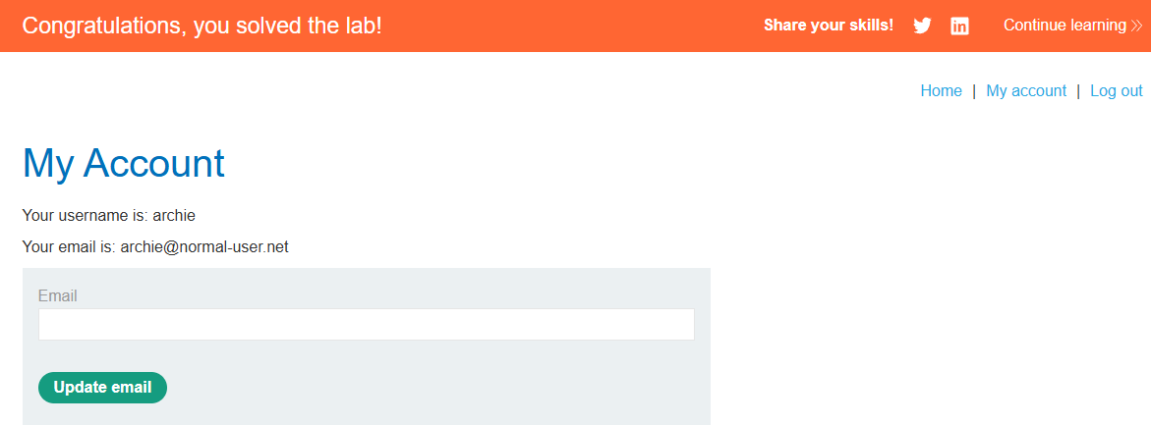
The account page and success banner confirm completion of the PortSwigger lab.

6. Impact
In an application with this weakness, an attacker may be able to distinguish valid usernames from invalid ones. This reduces uncertainty during subsequent password guessing or credential-stuffing attempts. If repeated attempts are not adequately restricted and a weak or reused password is accepted, account compromise may result. The demonstrated account access is limited to the intentionally vulnerable lab.

7. Risk and Classification
No numerical CVSS score is assigned. The evidence demonstrates username disclosure through response discrepancy and successful password guessing in the lab, but does not provide sufficient production-context information for a defensible real-world score.
- CWE-204 — Observable Response Discrepancy: externally observable differences in responses can disclose whether a supplied username is valid.
- MITRE ATT&CK T1110.001 — Password Guessing: relevant to the password-guessing stage. This is not a dedicated mapping for the username-enumeration behaviour.

8. Recommendations
- Return consistent login error messages for invalid usernames and incorrect passwords.
- Avoid response differences that disclose account validity, including differences in response body, status code, or timing where practical.
- Apply rate limiting and progressive delays to repeated authentication failures.
- Monitor and alert on high-volume login attempts and repeated attempts across many usernames.
- Implement multi-factor authentication to reduce the impact of compromised passwords.
- Encourage strong, unique passwords and screen against commonly used or compromised passwords.

9. Conclusion
The lab demonstrated that distinguishable login responses can be used to enumerate valid usernames. Once a valid username was identified, password guessing resulted in successful authentication to the lab account. Consistent authentication responses, rate limiting, monitoring, and multi-factor authentication are recommended to reduce the likelihood and impact of these attacks.

10. References
PortSwigger Web Security Academy — Username enumeration via different responses
https://portswigger.net/web-security/authentication/password-based/lab-username-enumeration-via-different-responses
MITRE ATT&CK T1110.001 — Password Guessing
https://attack.mitre.org/techniques/T1110/001/
CWE-204 — Observable Response Discrepancy
https://cwe.mitre.org/data/definitions/204.html
Disclaimer
This exercise was conducted in an intentionally vulnerable training environment provided by PortSwigger Web Security Academy. The techniques described must only be used on systems for which explicit authorisation has been obtained.

