Implementing A Central Linux Server for Medical Image File Sharing - Post Implementation Report
Joshua M. Dyer
Western Governors University

Table of Contents
Summary 4
A.2 IT Solution 4
A.3 Implementation Plan 5
Review of Other Work 7
Changes to the Project Environment 9
Methodology 10
Project Goals and Objectives 13
F1. Goals, Objectives, and Deliverables Table 15
Project Timeline 18
Unanticipated Scope Creep 22
Conclusions 23
References 24
Appendix A 25
Network Diagram 25
Appendix B 26
Code snippet of Bash backup script 26
Appendix C 27
Screenshot of shared directory 27

Summary
My company, [provider], provides medical imaging services to [client], a small medical clinic. Imaging services include ultrasound and x-ray studies. [Provider] also assists in small IT-related projects and services for small and home offices. Our company has three employees: one assisting in IT services, one with medical imaging and general medical assistance, and one who performs both functions. [Client] previously stored medical images on a single desktop computer in one of the physician’s offices. The imaging reports are available in the patient charts, but the images were inconvenient to access due to the storage method. This inconvenience and the hectic schedule typical to medical practices often lead to images not being reviewed as needed or within acceptable timeframes. [Client] requested a centralized way to store the medical images so they can be more easily accessed from each clinician’s laptop from anywhere inside the clinic. This facilitates imaging reviews as patients are seen, improving overall decision-making and patient care.

A.2 IT Solution
To solve [client]’s need for a centralized way to access images, [provider] proposed that a server computer could be set up with a network-shared directory. This allows access to any appropriately configured user to access the shared directory from anywhere within the clinic and from their device. This system has removed the need to go to a specific, central location to access the imaging data physically. This server is in the back storage room, which contains the clinic’s central modem, router, and wiring, as there is no need for direct access under regular use for viewing image data. A desktop computer was available that fit the hardware specifications that [provider] had on hand. To facilitate a platform-neutral network share and control cost, we utilized Linux as the operating system, specifically Ubuntu Server, as [provider]’s staff is most experienced with this software. Samba software was used to set up the network share and UFW (Uncomplicated Fire Wall) to protect sensitive data from intrusion attempts. An automated backup script was added to ensure the attached hard drive will keep an additional copy of any data. At the same time, the imaging systems continue to house the second data backup. Individual accounts were created for each user, and appropriate access was granted as needed. The old system, which currently houses the imaging data, was backed up with an external hard drive, and this backup was used to load the data onto the new system. [Provider] utilizes Seagate 2TB external hard drives for backups for our accounts, which was also used in this case for data transfer to the new system. The system was then connected to the network. Samba configurations were finalized. Connectivity to the shared directory was checked from each provider’s laptop to ensure proper configuration and accessibility. Finally, lunch-and-learn sessions were provided to teach each provider how to access the new imaging server to view images as needed from their device.

A.3 Implementation Plan
The plan was completed in four phases. All phases were completed by [provider]. [Client] assisted in creating the list of requirements in the first phase and fulfilled the trainee role during phase four. During the first phase, a list of [client]’s requirements and needs was compiled, and available hardware and software to meet those needs was created. The hardware was gathered and prepared in the second phase by loading all appropriate software, including the Ubuntu Server operating system, Samba for file sharing, and UFW for security. One of [provider]’s Seagate external hard drives took a fresh backup from the old desktop. This drive and backup loaded current data onto the new system. User accounts were created on the new system for all providers requiring imaging data access. Samba was installed, and the directory hosting the imaging data was set up to be shared. This ensured that other users could reliably find the server on the network. The firewall (UFW) was configured so internal network users could access the images, but traffic originating from the public internet was denied. This ensures data security for the private information associated with the images. A script was added to the new imaging server to automate the backup schedule and ensure reliable data integrity and availability. In the third phase, the server was connected to the network, and a reserved IP address was set up on the network. At this point, Samba was used to finalize the share settings for the final network location. We ensured each provider could access the network share from their laptops. The imaging data previously stored on the desktop from the previous storage solution was, at this point, removed. The external hard drive previously used for backups was left connected to the new imaging server to facilitate backups. Finally, in the fourth phase, we hosted lunch-and-learn sessions to ensure each provider could access images on the new system and documentation on their laptops.
The project’s first phase was carried out during a meeting at the clinic during one of the lunchtime breaks reserved for this purpose. The project’s second phase was carried out at [provider]’s office during regular business hours, as the construction and setup of the server did not interfere with the clinic’s business operation, and no network access was needed at this point. The third phase was completed over a weekend during non-business hours at the clinic, so business operations were unaffected. The final phase was conducted during the lunch breaks at the clinic to provide new users with easy access to [provider]’s IT staff for training and clarification.
This plan was appropriate as the previous solution was functional, if sub-optimal, and created minimal disruption of business activity. The building and preparation of the new server could be performed before connecting it to the network, which ensured no disruption during this phase. When the server was ready to connect to the network, we did so, and final configurations were made. It was then tested during non-business hours. If issues arose, the process could be rolled back and reassessed without further disrupting business activity. When phase three was completed successfully, phase four was scheduled conveniently for the staff, as lunchtime meetings are commonplace for the clinic and are regarded as an appropriate time for short training and informational sessions.

Review of Other Work
Review of work 1
Samba’s official Wiki page, SambaWiki (n.d.), offered several pieces of documentation we referenced to insert the final configurations for the Samba directory share. This article explained how we could add the user's home folders into a Group Policy Object (GPO) and assign it through an Organizational Unit. This would prevent the need to assign the home folders individually and ensure the appearance was more uniform. We decided that this would better facilitate the clinic users' ability to assist one another if their experience was as similar as we could make it. This was relevant to our project as we were setting up our Samba shared directory for remote image access on the system.
Review of work 2
Phoenix NAP’s article on UFW (Simic, 2024) offered additional details on configuring this utility compared to those we had previously identified. This article gave a walkthrough of the initial setup and many examples of additional commands and settings in UFW. We used these to check application profiles, specifically for Samba and ensured they were only active and accessible from the internal network. This was helpful to our project as we worked to ensure the security of the images, considering that they contained sensitive data and our solution needed to remain compliant with regulatory requirements.
Review of work 3
The GeeksforGeeks article on bash scripting specifically addressed our plans to create a simple, automated backup script (GeeksforGeeks, 2024). This article provides a step-by-step walkthrough of creating the bash script in Linux. The detailed guide explained how to reference the locations to be backed up properly. It also gave details on how to direct the location of where to store the files and how to name them to provide an audit trail through those file names. This article was specifically helpful as we wrote our backup script and set it up to store the files on the external hard drive. It also provides a walkthrough of how to use the backup to restore the data from the backup if needed. We used the directions found here to ensure data safety.

Changes to the Project Environment
At the time of the project proposal, the clinic was struggling to make good use of the trove of imaging data that was available but inconvenient to access. The providers were forced into a juggling act to balance the loss of time with their patients against the lack of utilization of the imaging data. The environment as it exists now has streamlined this process, improving imaging data availability and the time spent with patients. Through this increased time and availability of images, the patients' involvement has improved, increasing their awareness, understanding, and overall satisfaction. They are pleased to have their findings discussed and shown so they are more aware of what has been discovered and how it might be addressed.
A benefit was also discovered that we had not anticipated, as the providers can now access the old images to compare with the current studies for follow-up exams as the scans are taking place. This allows immediate and direct comparison to follow-up images to assess changes in any diagnosis the clinic may be tracking. It can also help us identify areas of the procedure that may need additional attention to detail or even alternative approaches.
The providers actively use the new system regularly and are pleased with the new tool. Patients also appreciate the direct discussion and readily available examples of their studies that we can now provide them during consultations. We assess that the overall culture of the clinic has warmed toward potential benefits of future technology solutions and how they might improve on the daily processes and focus their strategies of excellent patient care.

Methodology
Our project was well-defined, and our schedule was accommodated, so we used the Waterfall methodology. This method is best when a project is well-defined and unlikely to change. It is also helpful when a project must thoroughly verify each step's completion before moving forward to the next. Our steps were as follows:
Requirements: In this project phase, we discussed with the clinic what they would like the new system to accomplish. We assessed what general hardware and software components would be needed to meet these requirements. We also created a list of documentation that would help perform each step. The deliverables in this phase were a list of all requirements needed to fulfill the clinic's needs and a list of documentation related to each step of our project.
Design: In this project phase, we took the requirements list and created a list of specific hardware and software to fulfill these goals. We used the documentation from the previous step to identify components that would help us reach the system's desired state. This list of required components was the first deliverable from this phase. This list was then used to create a schedule of activities detailing the order in which each step would take place. We ordered all the steps that would be taken during phase two of our project next. This included any hardware adjustments that had to be made first, followed by installation of the operating system. We then ensured that all additional software was installed on the system. The configuration of software that could be done at that point was performed. This included setting up user and group accounts, accesses, and firewall rules. At this point, a backup of the current imaging data was placed into the shared directory. The system was tested to verify that all these steps were in order before moving to phase two. The plan in phase three was to deliver the system to the clinic on a weekend, during non-business hours. The system was connected to the network, and the remaining software settings were made. This included sharing the imaging data directory, finalizing firewall rules, and adjusting the providers’ laptops. The system was then tested to ensure functionality and access from each laptop. A backup script was added to the system to automate the backup process to ensure data safety. If any issues had been encountered with no solution found, the plan could have been rolled back at this point without harm or disruption to the clinic’s workflow, and the project could have been reassessed. The phase four plan would be detailed, listing any training the clinicians may need and creating a simple documentation file that we could leave on each laptop to ensure they would readily have a step-by-step guide.
Implementation: During this phase, the project was brought to life. We followed the lists and schedules made in the Design phase. As each step was taken, it was compared to the schedules to ensure all components were added or adjusted in the proper order. Phase two activities were completed, including making hardware adjustments and installing each software component needed. User accounts and groups were set for the system and imaging directory. Preliminary firewall settings were made. A backup of the current imaging data was added to the shared directory. A script was added to the system to automate the backup process. We confirmed completion before the scheduled weekend of delivery. On the planned delivery weekend, we followed the phase three schedule. We connected the system to the network. We made final adjustments to the firewall rules and set up the shared imaging data directory. Next, we added each laptop's new account settings and access to ensure functional access. We then ensured that the external hard drive used for the automated backup process was attached and labeled appropriately. Upon confirmation that all steps were completed, we made plans to move into phase four the following week. In phase four, we utilized a series of lunch-and-learn sessions to show the providers how to access the new shared imaging directory and where to find the documentation in case they have any issues. The deliverables at this phase of the Waterfall Methodology were the list of functionality needs and technology to be used, the pre-installation build-out of the system in phase two, the system delivery, final adjustments, and confirmation of necessary functionality in phase three, and verification that each provider was comfortable utilizing the new system and was aware of the provided documentation in phase four. A formal project report was also provided to [client] at the end of phase four.
Verification: In this phase, we ensured that all of [client]’s needs were met. We verified that they were pleased with the readily available imaging data access and had no issues using the system. If any problem had been identified with access, this could have been addressed with additional training or documentation. If any issues were found with the system's function, we would have been required to reassess, returning to step one of the Waterfall Method to begin again.
Maintenance: In this phase, we created a schedule for system health checks. We will verify that the backup system is running correctly and that no significant errors are noted on the systems logs as we visit the clinic each week. The external hard drive is also checked to ensure adequate space to continue its work. The system is currently being assessed for any obvious physical issues. We established a maintenance log that our technicians initial when this check occurs. [Provider] has ensured [client] had multiple ways to contact us if an error that needs immediate attention occurs.

Project Goals and Objectives
The goals for this project began with completing a list of [client] requirements. This was accomplished by completing the objective of discussing the needs with the client and confirming an understanding of how they would be met to create a list that assisted [provider] in determining what technologies would be needed. The deliverables for these objectives were an agreement of understanding regarding the needs of the new system and a list of those requirements. We completed this goal when we confirmed a thorough understanding of [client]’s needs and created a list of those needs confirmed by both [client] and [provider].
The next goal to be met was to create a list of hardware and software components necessary to fulfill [client]’s needs. This was done by reaching two objectives. First, we compared [client]'s needs to those of available technologies and compiled a list of actual hardware and software that could satisfy the needs. This objective produced the list of technologies implemented as its deliverable. The next was to research documentation that would support the implementation and use of all hardware and software involved in the project. The second objective produced two deliverables: a list of documentation that thoroughly explained how that technology will be implemented and used and a schedule of events that would most efficiently complete the system. This goal was met when we created two deliverables: A thorough and detailed list of all hardware and software components needed for the solution with all necessary documentation and a thorough schedule of activities to complete the solution's build.
The next goal was to build the system. The objective of gathering the necessary hardware and software components achieved this goal. The deliverable for this objective was the acquisition of all necessary system components. This objective was completed when we had the system and its components in place and all software downloaded and ready on an available USB drive. The next objective was to assemble the components and configure the system to its pre-installation state. This meant configuring the system to the extent it could be before delivery and installation into its final environment. Some settings, specifically the Samba share and network settings, needed access to their destination network before they could be completed. The deliverable for this objective was the completed system pre-configured for installation. We confirmed that this goal was met when all identified steps in the schedule of activities were completed and verified that a properly functioning system was ready to be installed.
The next goal was to install the technology solution that would fulfill [client]’s requirements. This was accomplished by reaching the objective of installing the system at the clinic and connecting it to [client]’s network. The deliverable of this step was a delivered and installed system that had been appropriately connected to the clinic network. The next objective to complete this goal was to make final system configuration and functionality testing adjustments. The deliverable was completed, and the objective was met when we had a functional technology solution in place at the clinic, confirmed functional with testing, and ready to use. Completing this deliverable and objective achieved the goal of having a verified system on-site and functioning as expected when tested.
The next goal was to verify that all users could access and use the system effectively. This goal was accomplished by reaching the objectives of completing user training and delivery of user-end documentation. The first objective was completed during the on-site training sessions, and the deliverable verified that users knew how to use the system. The second was also completed during these sessions, and the deliverable was to verify that users knew how to find the provided user documentation for their system. We completed this goal by verifying with each user that they could use the system and knew how to access the documentation.
The final goal was verification that all [client]’s needs for this system had been met. This was completed by accomplishing two objectives. Delivering the final project report was the first deliverable. The second was to discuss the project and have all stakeholders sign off to verify satisfaction with the delivered technology solution. This goal and its objectives were satisfied when a signed copy of the report was left with [client] and retained by [provider].

F1. Goals, Objectives, and Deliverables Table
 | Goal | Supporting objectives | Deliverables enabling the project objectives | Met / Not Met
1 | Gather [client]’s needs for the technology solution | 1.a. Discuss the needs of the system with the client | 1. a.i. Understanding and agreement of [client]’s needs for the technology solution | Met
1 | Gather [client]’s needs for the technology solution | 1.b. Create the list of those needs and confirm full understanding | 1. b.i. Physical listing of [client’s] needs for the technology solution | Met
2 | Create a list of necessary components and schedule of activities | 2.a. Compare client needs to available technology to determine what will be needed. | 2. a.i. Compiled list of the hardware and software required to build the solution | Met
2 |  | 2.b. Research and compile documentation for how to install and use the chosen technology | 2. b.i. Compilation of documentation for chosen technologies | Met
2 |  |  | 2.b.ii. Schedule of activities which best accomplishes the build of the system | Met
3 | Build System | 3.a. Gather necessary hardware and software components | 3. a.i. All necessary hardware and software components are available to build the system. | Met
3 | Build System | 3.b. Assemble and configure the system for pre-installation | 3. b.i. The completed system, which is configured for pre-installation | Met
4 | Delivery and Installation of the System | 4.a. Install the system at the clinic | 4. a.i. The system is located at the clinic and installed on [client]’s network | Met
4 | Delivery and Installation of the System | 4.b. Make final configuration settings | 4. b.i. The functional technology solution is confirmed to be working as expected | Met
5 | Properly trained users | 5. a. Training performed at the clinic | 5. a.i. Verification that users can access and use the system | Met
5 | Properly trained users | 5.b. Delivery of documentation | 5. b.i. Verify that users can access the documentation provided for their new system. | Met
6 | Verification of project satisfaction | 6.a. Deliver the final report | 6. a.i. The project's final report is to be reviewed and kept by [client]. | Met
6 | Verification of project satisfaction | 6.b. Discuss the project and collect signatures | 6. b.i. Verified, signed project report documentation confirming that [client] agrees that the system meets their proposed needs | Met

Project Timeline
Milestone or deliverable | Duration  (hours or days) | Projected start date | Projected end date | Actual start date | Actual end date
List of [client] needs and solution requirements | 2 hours | 4 Nov 2024, 11:30 am | 4 Nov 2024, 1:30 pm | 4 Nov 2024, 11:30 am | 4 Nov 2024, 1:30 pm
List of Hardware and software requirements to complete the system | 5 days | 5 Nov 2024 | 9 Nov 2024 | 4 Nov 2024 | 4 Nov 2024
Compiled list of documentation for chosen technologies | 2 days | 10 Nov 2024 | 11 Nov 2024 | 4 Nov 2024 | 5 Nov 2024
Schedule of activities for building the system | 2 days | 12 Nov 2024 | 13 Nov 2024 | 5 Nov 2024 | 5 Nov 2024
Gather all necessary hardware and software | 3 days | 14 Nov 2024 | 16 Nov 2024 | 5 Nov 2024 | 6 Nov 2024
Assemble and configure the system to its pre-installation state | 1 day | 17 Nov 2024 | 17 Nov 2024 | 6 Nov 2024 | 6 Nov 2024
Deliver and install the system at the clinic | 1 day | 23 Nov 2024 | 23 Nov 2024 | 9 Nov 2024 | 9 Nov 2024
Make final configurations to the on-site system | 1 day | 23 Nov 2024 | 23 Nov 2024 | 9 Nov 2024 | 10 Nov 2024
Train users, provide documentation, and confirm access | 1 hour | 25 Nov 2024, 11:30 am | 25 Nov 2024, 12:30 pm | 11 Nov 2024, 11:30 am | 11 Nov 2024, 12:30 am
Verification of project satisfaction | 1 hour | 29 Nov 2024,  4:30 pm | 29 Nov 2024,  5:30 pm | 15 Nov 2024, 4:30 pm | 15 Nov 2024, 5:30 pm

The project began with a lunchtime meeting as planned. As we had been discussing with the clinic before beginning this step, much of the information was quickly obtained. We thoroughly understood the tasks and were ready to begin creating our lists. The following steps took less time than we had allotted, as the requirements did fit a desktop system [provider] had on hand with minimal changes to be made. Upon reviewing documentation for Ubuntu Server, we did include adding a stick of RAM to the system, which we had not identified initially. We felt this addition would ensure the system would remain highly functional for an extended period. This RAM stick was also available from on-site supplies, and the entire list was compiled the following day. We continued gathering documentation for the system. After referencing it, we felt we understood the steps needed to build out the system and did not immediately anticipate any issues. Over the next two days, we gathered all necessary hardware and software components and had the system up and running. We made the adjustments needed to the configuration to bring the system to its pre-installation state. We realized we had allotted more time than necessary for several steps and could likely complete the project before the holiday arrived in late November. We decided to push forward and take advantage of this, knowing the clinic would prefer access to the system sooner. We checked to see if the following weekend was available as we were running ahead of schedule. The clinic confirmed this would be fine, and we planned to install the system on 9 November 2024.
We arrived at the clinic on 9 November 2024 and began work installing the system on the network. This went well with no issues. We identified the network address that would be reserved and set this on the router. This setting was then used to finalize the Samba-shared directory and add the final firewall rules. We confirmed that the data was loaded on the system and settings were in place but decided to return the next day for final testing on the provider’s laptops.
We returned on 10 November 2024 to begin testing each laptop. As anticipated, we had difficulty setting up the Windows 10 machine. We pulled the documentation we had saved for reference from the compiled lists and were then able to complete the access. The remaining Windows 11 laptops were set without issue. We loaded all documentation for the new system onto each laptop and placed a link on each system's desktop interface. We reviewed our checklists and confirmed all steps completed to this point and planned to continue with training on the following day. Our lists and schedules helped facilitate the efficient and timely completion of each step. They also served as checklists to ensure no step had been missed.
On 11 November 2024, we completed the lunch-and-learn session with the providers. They found the system quite agreeable overall. We spent a little extra time that seemed less confident, showing them how to search the directory and how they would be labeled. This gave them ample hands-on time, and we agreed to continue working with them throughout the week while we were scanning. [Provider]’s additional IT employee remained on-site with us this week to continue assisting with walk-throughs and to take notes on any changes that needed to be made. We adjusted the documentation slightly, separating the Windows 10 and Windows 11 sections to account for the slight difference in the appearance of each interface in the screen captures we included. This was a quick adjustment, taking only about an hour to acquire new screen captures, add them to the documentation, and update each to the new version. This was completed at the end of the clinic’s day on 13 November 2024 not to disrupt the use of the provider’s laptops as we made the update.
Finally, we confirmed that [client] was satisfied with the system and that all requirements had been met with a final meeting on 15 November 2024. We reviewed the project documentation together, confirming that each step was completed as planned with updated timelines. Both parties signed the document, leaving a copy with [client] for their records. We made our first maintenance check that day to confirm that the automated backups were functioning as planned and had dropped the new images onto the external hard drive. We completed the initial satisfaction survey to confirm our initial project success metric, which passed with unanimous user acceptance. We scheduled to complete the following satisfaction survey in approximately four weeks, on 16 December 2024. This survey was also completed successfully, with 100% satisfaction expressed by all users, confirming project success.

Unanticipated Scope Creep
The only addition to this project's scope involved the final training phase. [Provider] decided to retain our additional IT technician on-site to assist with any issues with the system during its first week of use. This was beneficial as one of the providers noted differences in the screen captures found in our documentation for his Windows 10 system and found it difficult to find his way to the system. We had only included screen captures from a Windows 11 system in the initial version of the documentation. Our technician added new screen captures to the documentation and split the sections between Windows 10 and Windows 11 systems for clarity. The user who had experienced trouble was then consulted, and the update was satisfactory. The user could again navigate to the shared directory and find the needed images with the updated documentation.

Conclusions
In conclusion, our project involved solving the issue [client] was having to access the images that were available to them but found them inconvenient and time-consuming to do so. They had valuable data that was not being utilized to its full extent. Our solution, providing a centralized server that allows remote access to the clinic’s providers' laptops from anywhere in the clinic, has solved this issue. The available data is now being utilized and accessed, and the inconvenience of its availability has been removed. The providers are pleased to be able to access the imaging data for comparisons and reviews more easily. They also enjoy conveniently accessing patient images to show and explain findings, improving patient care, understanding, and satisfaction.
We assessed the project for success on 15 November and 16 December 2024. The first assessment was performed after approximately one week of system use, and the second was performed after approximately one month. Our goal was 100% satisfaction from the providers, which was achieved at both checkpoints. Upon verifying this metric, we have concluded that the project was a success.

References

References
GeeksforGeeks. (2024, May 15). Linux shell script to backup files and directory. https://www.geeksforgeeks.org/linux-shell-script-to-backup-files-and-directory/
Simic, S. (2024, September 12). How to set up UFW firewall on ubuntu: Phoenixnap KB. Knowledge Base by phoenixNAP. https://phoenixnap.com/kb/configure-firewall-with-ufw-on-ubuntu
Windows User Home Folders. Windows User Home Folders - SambaWiki. (n.d.). https://wiki.samba.org/index.php/Windows_User_Home_Folders

Appendix A

Network Diagram
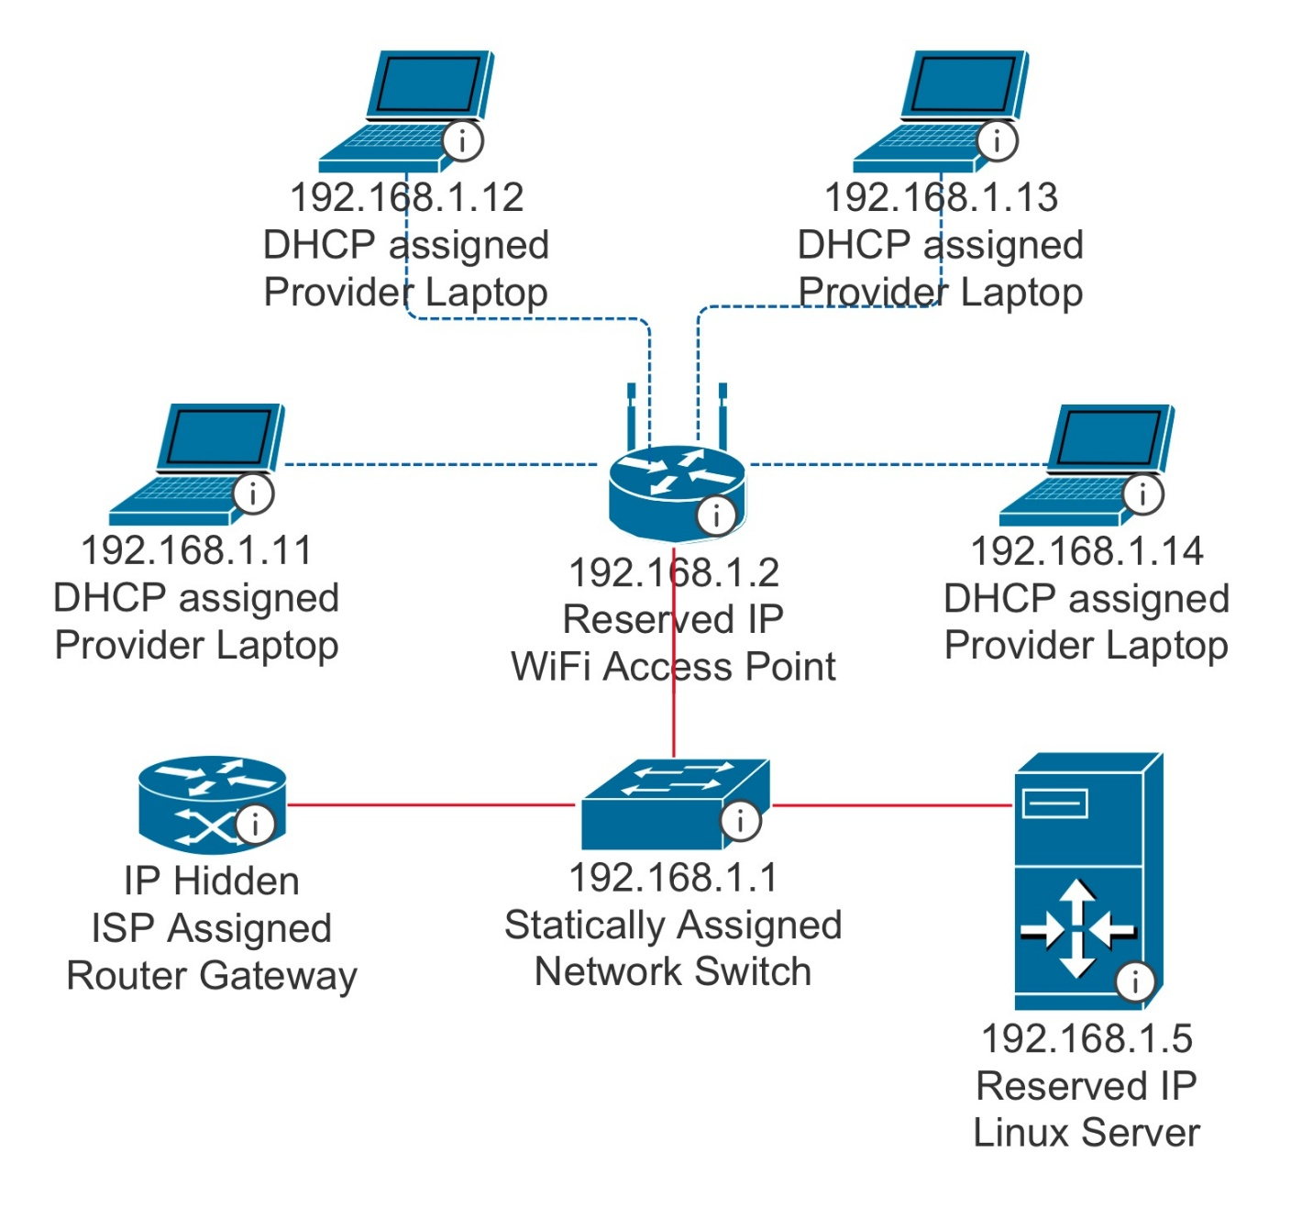
We created a network diagram to guide building our technology solution, including planned network addressing schemes.

Appendix B

Code snippet of Bash backup script
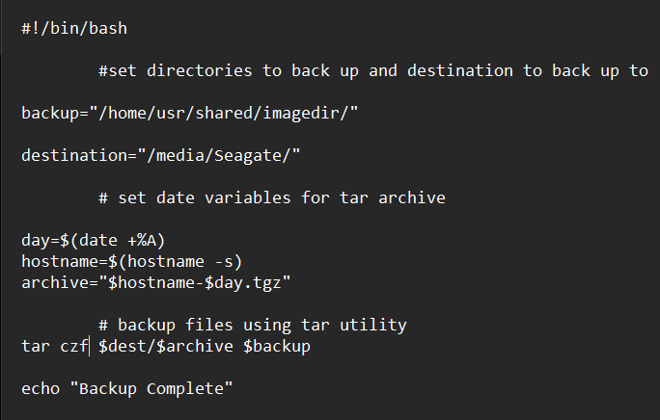
Screen capture of our Bash backup script.

Appendix C

Screenshot of the shared directory
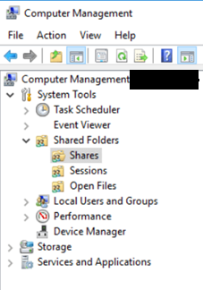
Screenshot of the new shared directory, accessed from a provider’s laptop. This image is redacted to remove network information.

