Assignment: HW 2

Class: ECE 5224

Name: Joshua Hopkins

VT ID: Hopkinsjg1

Date: February 24th, 2025

* Problem 1:
  + DC Resistance:

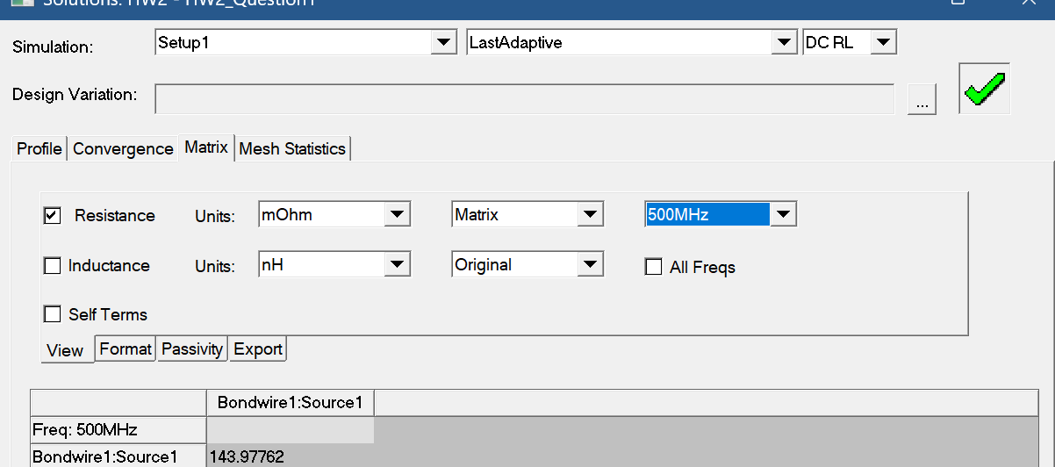

* + AC Resistance at 500 MHz:

* + Wire bond:

* Problem 2
  + Ribbon DC Resistance:

* + Ribbon AC at 500 MHz:

* + Ribbon Bond:

* + Problem 1 and 2 Results:

|  |  |  |  |
| --- | --- | --- | --- |
| Component and Parameter | Calculation (mΩ) | ANSYS Q3D (mΩ) | Percent Error % |
| Wire Bond DC Resistance | 120.4 | 143.977 | 16.3755322 |
| Wire Bond AC Resistance at 500 MHz | 467.3 | 460.83 | 1.403988456 |
| Ribbon DC Resistance | 37.8 | 37.804 | 0.010580891 |
| Ribbon AC Resistance at 500 MHz | 127.4 | 195.798 | 34.93294109 |

* Problem 3a:
  + Length 10mm:

* + Length 15mm:

* + Length 20mm:

* + Problem 3a Results and Plot:

|  |  |
| --- | --- |
| **Length (mm)** | **Simulated Inductance at 500 MHz (nH)** |
| 10 | 8.325 |
| 15 | 14.341 |
| 20 | 18.645 |
|  |  |
| **Length (mm)** | **Calculated Simplified Inductance (nH)** |
| 10 | 8.618600932 |
| 15 | 14.14429672 |
| 20 | 20.00979059 |
|  |  |
| **Length (mm)** | **RoT Inductance (nH)** |
| 10 | 10 |
| 15 | 15 |
| 20 | 20 |

* Problem 3b:

I believe the reason why the simulated values are less in most cases and more in one case is since the simulation is taking the actual bond material and all of the extra parameters of the wire, seen below, into detail when performing the analysis.

The simulation is also being run at a 500 MHz frequency and is probably considering the skin and proximity effects of the wire bond. When using the RoT, it’s not considering anything b/c the wire bond is the “ideal” wire in this case. Below you can see the results for an “ideal” bond with no bends and how the length is basically the same as the inductance.

