PHCP User Guide
The windows, a first calculation, and how to read the result

PHCP 1.5.0+ (v1.5.0-32-g05677b7) - Perl Hydraulic Calculation Program
Built 11 November 2026 from docs/USER_GUIDE.md
Copyright (c) 2026 Hycadia Pty Ltd

Contents
1. Getting PHCP 3
2. The model file 3
3. The text editor 4
4. Validate, then calculate 5
5. The results tables 6
6. Reading the result: accepted or not 7
7. The report 8
8. The PROJECT tab 9
9. The spreadsheet window 10
10. The isometric drawing 13
11. Water supply graph 14
12. Quick tools and the orifice plate 15
13. The pipe and fitting database 16
14. Supplies, pumps and check valves 17
15. Without a window: the command line and JSON 17
16. When something goes wrong 17

This guide is for a designer using PHCP to calculate a sprinkler, hydrant or hose reel system. It walks through the three windows, a first calculation, and how to read the result. Every command of the model language is in the PHCP Reference Manual. How the program works, how it is tested and what it does not do are in the README on GitHub.
The pictures are taken from the programs themselves by tools/doc_screenshots.pl, which CI runs on every pull request. Each one shows examples/02_full_network.phc after VALIDATE and CALCULATE. That example has two supplies (a tank with a booster pump, and a town main), pressure devices, sprinklers, a hydrant and a hose reel.

1. Getting PHCP
On Windows, download the programs from the latest release on GitHub (Releases, under Assets):
Program | What it is
phcp_editor.exe | the text editor: the model as command lines. Start here
phcp_sheet.exe | the spreadsheet: the same model as grids of pipes, nodes, supplies and devices
phcp_isometric.exe | the isometric drawing: the same model drawn on a 30-degree grid
phcp.exe | the command-line program: a model in, a report or JSON out

Each is a single file with the pipe and fitting database inside. Nothing needs installing. All four read and write the same .phc file, so a model can be started in one window and finished in another.
From source (any system with Perl 5.38 or later, and Perl/Tk for the windows):
perl phcp_editor.pl model.phc
perl phcp_sheet.pl model.phc
perl phcp_isometric.pl model.phc
perl phcp.pl model.phc report.pdf
The examples/ folder holds worked models. 02_full_network.phc is the one in the pictures, and 01_single_branch.phc is the simplest.

2. The model file
A model is a plain-text .phc file, one command a line, in capitals:
WATER T1 0.0 200 // a supply: node, elevation, pressure
NODE J1 0.0
SPRINKLER X2 10.0 -50 80 // node, elevation, K-factor (negative: a catalogue K), minimum pressure
USE BORE 120
PIPE M1 J2 A 30 150 2E T // name, from, to, length, size, fittings
The file's head holds the title, project details, units and calculation options. In the windows those are set in the PROJECT tab (section 8), not typed. // starts a comment. The reference manual has every command, its fields and its units.

3. The text editor
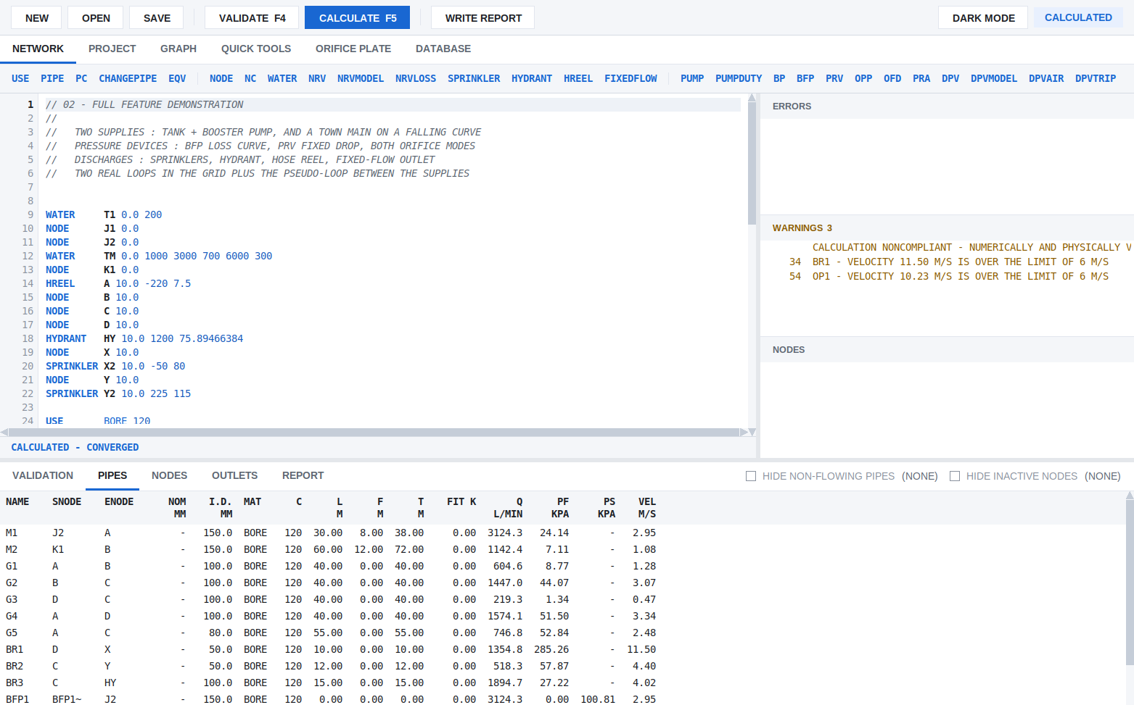
The text editor after a calculation
From the top:
- Toolbar. NEW, OPEN and SAVE; VALIDATE (F4) and CALCULATE (F5); WRITE REPORT (Ctrl+R). On the right, DARK MODE, and the state of the model: NOT VALIDATED, VALIDATED or CALCULATED.
- Tabs. NETWORK (the model), PROJECT, GRAPH, QUICK TOOLS, ORIFICE PLATE and DATABASE.
- Command strip. Every network command, in four groups: pipes; nodes and outlets; pumps and devices; design areas and supply graphs. A click starts a line with that command.
- The editor. Command words are blue, a name being defined is bold, and comments are grey. A line in error has a pale red band and a red line number. After Enter, the likely next line is offered in grey (the next pipe name, starting where the last pipe ended). Enter or Tab accepts it, and anything else discards it. Ctrl+Space in a pipe type or a fitting string lists the codes.
- Status bar (under the editor). The field template of the command the cursor is on, with the current field highlighted. After a calculation it shows that line's results. While a calculation runs it says COMPUTING, with what is being done and the seconds gone.
- ERRORS, WARNINGS, NODES (right). Live as you type: lines the reader refuses, the last calculation's warnings, and nodes that are undefined or unconnected. A click goes to the line.
- Results (bottom). VALIDATION, PIPES, NODES, OUTLETS and REPORT (section 5).
The grey bands between the panes can be dragged, and the mouse wheel scrolls whichever pane is under the pointer. Ctrl+Z and Ctrl+Y undo and redo.
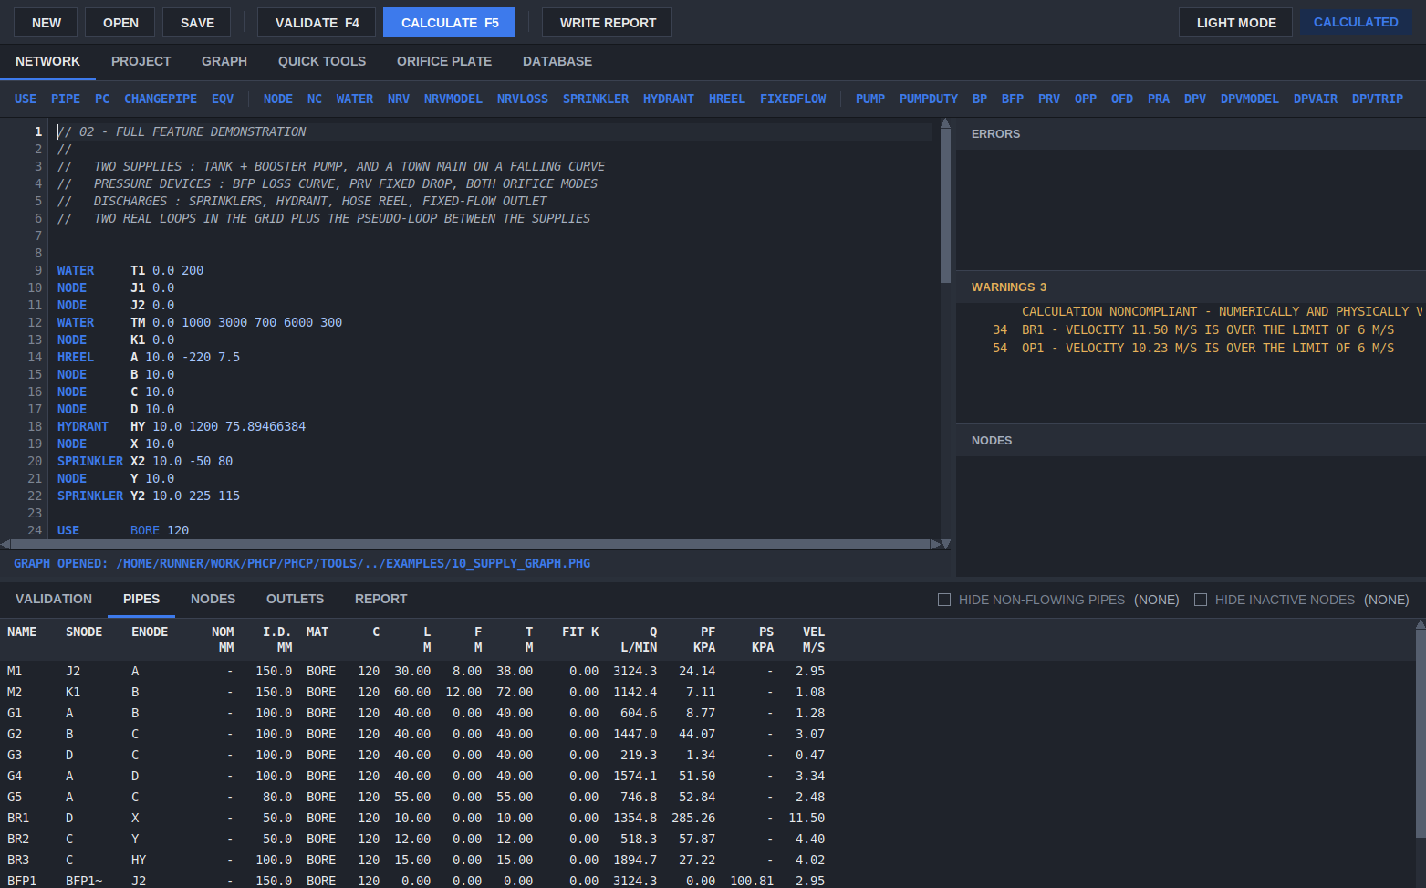
Dark mode
VIEW > DARK MODE, or the DARK MODE button, switches the window to the dark palette. Each window remembers its own choice.

4. Validate, then calculate
CALCULATE is available only when the model is exactly as it was when it last passed VALIDATE. Any edit, in the editor or the PROJECT tab, turns it off again.
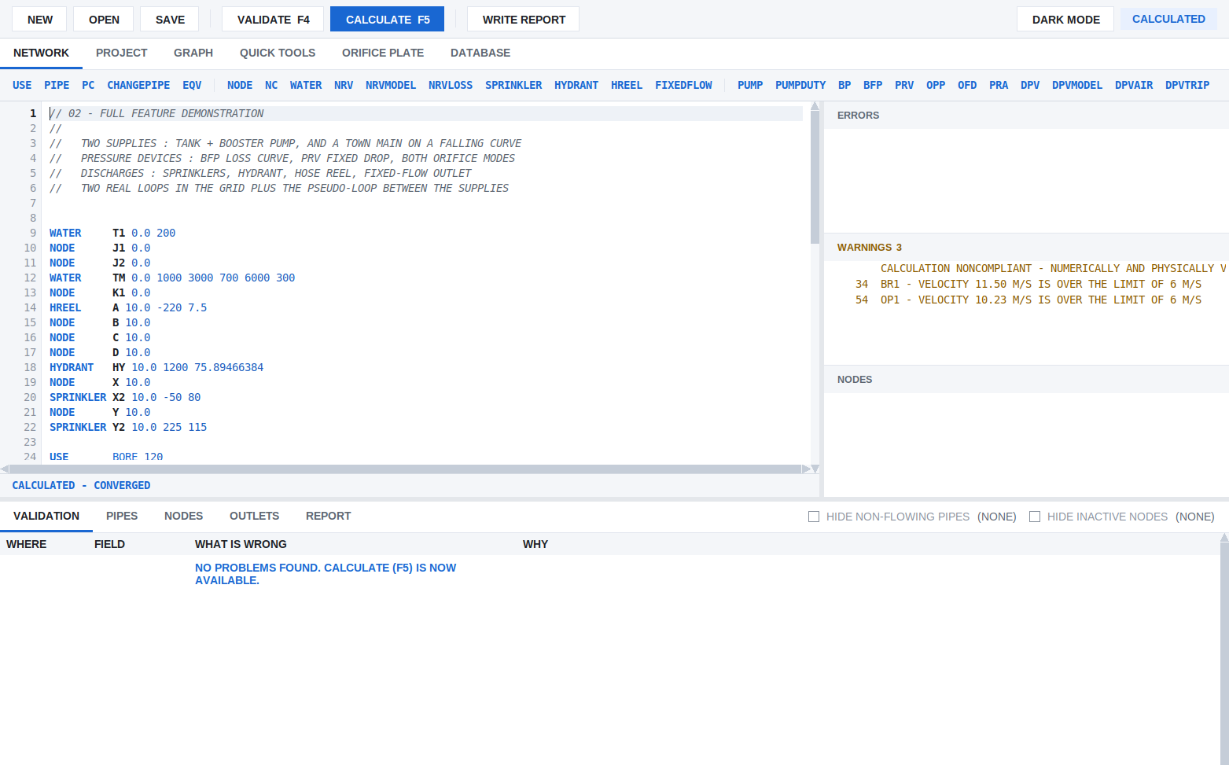
The VALIDATION tab
VALIDATE (F4) checks every line, the settings, and the network's structure as the solver will see it. Each problem is a row:
Column | Holds
WHERE | the line, or PROJECT TAB
FIELD | the field at fault
WHAT IS WRONG | the problem
WHY | what the program needs, in plain words; for a short line, how the command is written

A click on a row goes to the field and selects it. When there are no problems, the tab says so and CALCULATE (F5) is available.
CALCULATE solves the network by the Hardy Cross method, then checks the solution again from scratch (section 6). A large grid, a design area search or auto sizing can take a while. The status bar shows what is being done and the window stays responsive.

5. The results tables
PIPES (in the first picture) has one row a pipe: its ends, nominal and internal diameter, material, C factor, length, fitting and total equivalent length, flow Q, friction loss PF, loss across a device PS, and velocity. A right click on the headings chooses from 21 columns, including Reynolds number, Darcy friction factor and the formula used. A click on a heading sorts by it.
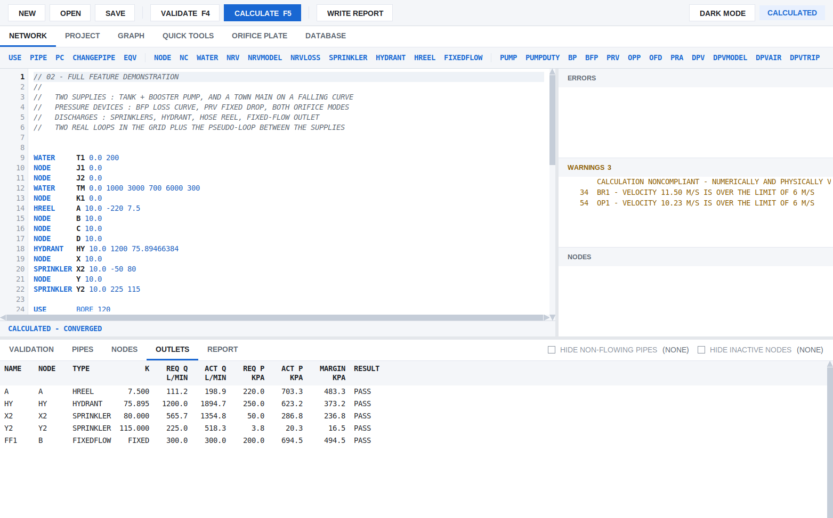
The OUTLETS tab
OUTLETS lists every sprinkler, hydrant, hose reel and fixed flow: the required and achieved flow and pressure, the margin, and PASS or FAIL. NODES lists every node's elevation, pressure and discharge. HIDE NON-FLOWING PIPES and HIDE INACTIVE NODES shorten long tables. The count beside each is how many rows it would hide.

6. Reading the result: accepted or not
A calculation that converges is not automatically an accepted design. PHCP checks every solve again from the final flows and pressures, and gives one of four results. The same result appears on the cover sheet, in the report, in the JSON and in the editor's WARNINGS:
Result | Meaning | What to do
ACCEPTED | numerically and physically valid, and every design requirement met | nothing; this is PHCP's own check, not an independent certification
NONCOMPLIANT | a valid calculation, but the design fails: an outlet short of its flow or pressure, a velocity over the limit set, the supply short of the demand, a pump duty missed, or part of the system cut off from its supply | change the design
REJECTED | converged, but not a physically valid answer, for example a supply or backflow preventer passing water backwards | correct the model
INDETERMINATE | no settled, converged solution | see section 16

The example in the pictures is NONCOMPLIANT: the WARNINGS list says so on its first line, and two branch pipes exceed 6 m/s. Section 14 of the report lists every failed requirement on its own.

7. The report
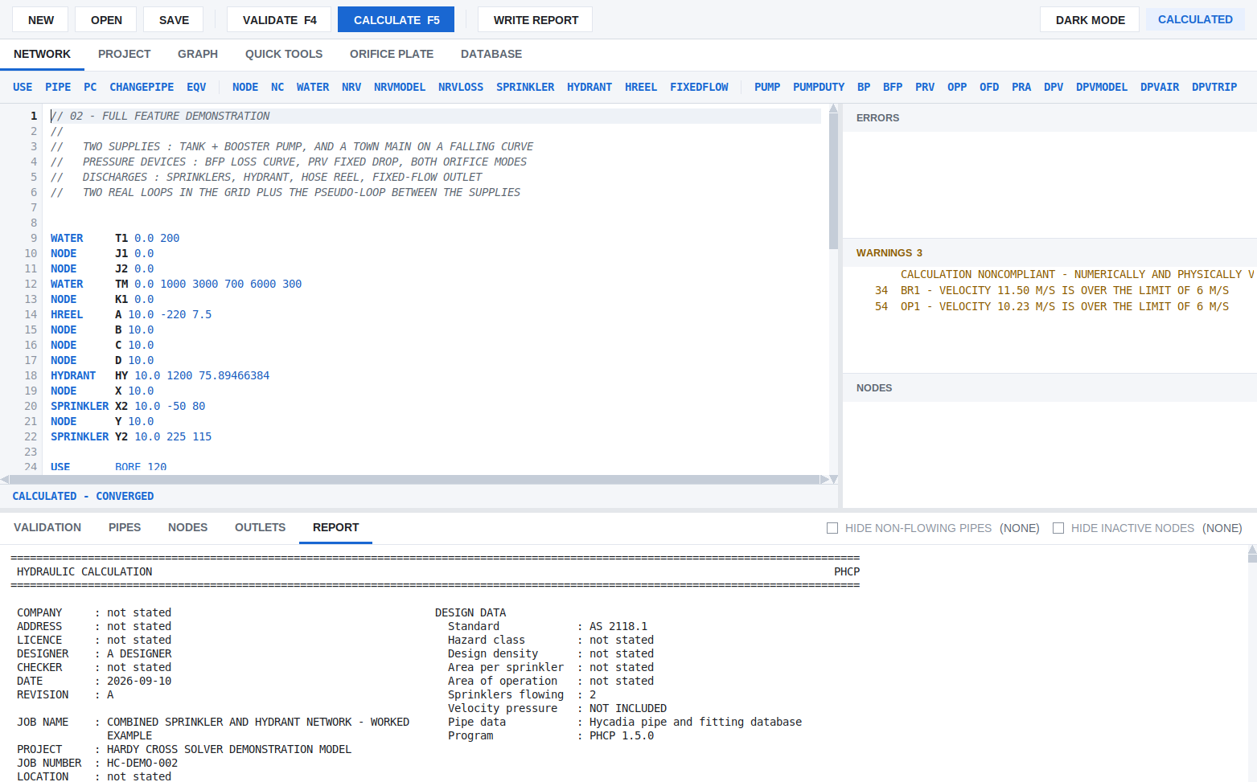
The REPORT tab
The REPORT tab shows the calculation report as it will be printed. WRITE REPORT (Ctrl+R) saves it as PDF (.pdf) or plain text (.txt), and validates and calculates first if needed. The report is monospace 7-bit ASCII, so it reads the same in any viewer. It has:
- the cover sheet: the project details and design basis from the PROJECT tab, the program version, and the result (section 6);
- the pipe schedule, the node and outlet tables, the flow path from the supply to the governing outlet, and the supply against the demand, with the margin;
- the supplies, pumps and check valves (Section 10), any dry pipe valve times, design areas and scenarios that the model has;
- validation (Section 14): every numerical, physical and design check, with its worst value and tolerance;
- any water supply graph named by SUPPLYGRAPH, as an appendix.

8. The PROJECT tab
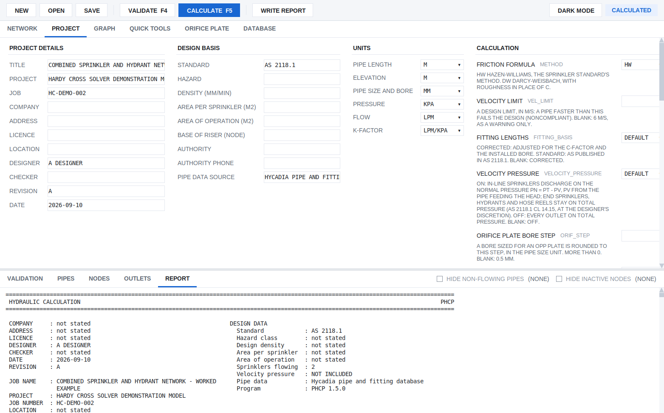
The PROJECT tab
The editor holds the network only. The PROJECT tab holds what goes at the head of the .phc file:
- PROJECT DETAILS and DESIGN BASIS: what goes on the report's cover sheet;
- UNITS: each a drop-down, with the default marked;
- CALCULATION: the friction formula (Hazen-Williams or Darcy-Weisbach), the velocity limit, the fitting basis, velocity pressure, the orifice bore step and the rest. Each has a plain label, its .phc name beside it, and a line saying what it does and what a blank means. The rarely needed solver settings are under SOLVER - ADVANCED.
A setting typed into the network instead is marked as an error that says where it belongs.

9. The spreadsheet window
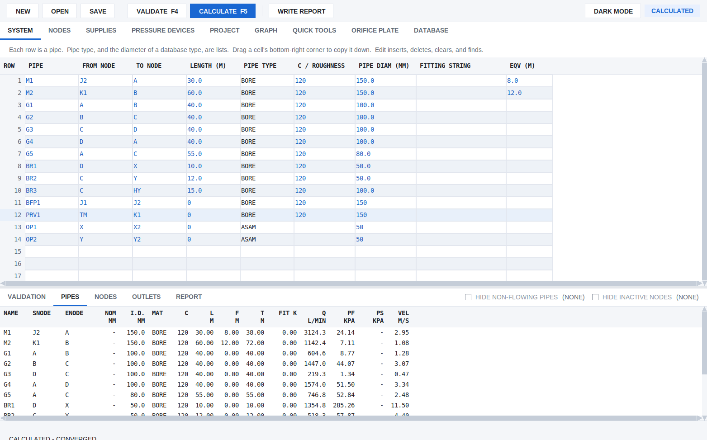
The spreadsheet: the SYSTEM grid
phcp_sheet is the same engine and the same file with the network as grids instead of command lines. The PROJECT, GRAPH, QUICK TOOLS, ORIFICE PLATE, DATABASE and results tabs are the editor's.
Tab | Holds
SYSTEM | one row a pipe: from node, to node, length, pipe type, C or roughness, diameter, fittings, extra equivalent length
NODES | every node named in SYSTEM: type, elevation, fixed flow, minimum flow and pressure, K
SUPPLIES | each supply's static pressure and its flow/pressure points
PRESSURE DEVICES | a table for each of PUMP, BP, BFP, PRV, OPP, OFD and PRA

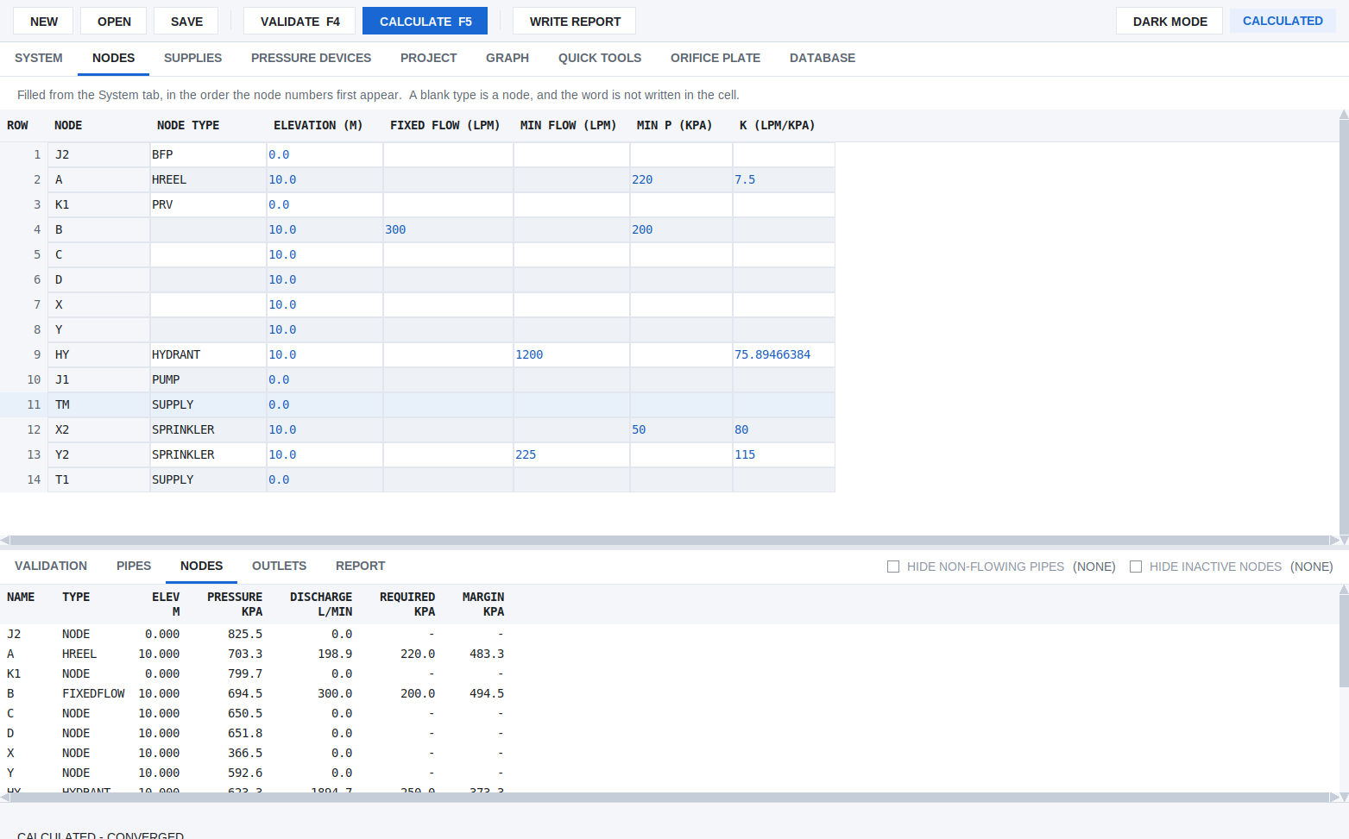
The NODES grid
Typing in the grids:
- PIPE TYPE, PIPE DIAM and NODE TYPE are lists. Typing completes a match; Tab keeps it and moves on; Down walks the other matches.
- A blank pipe type takes the row above's, as a USE line does. A run of the same type and size carries on by itself.
- Enter on the last SYSTEM row adds a row. Drag a cell's bottom-right corner to copy it down, or Ctrl+D to copy it into the next row.
- EDIT inserts, deletes and clears rows, and FIND and REPLACE work on one grid or all of them.
- Nodes, supplies and devices are filled from the SYSTEM grid: insert or delete a pipe there and the others follow.
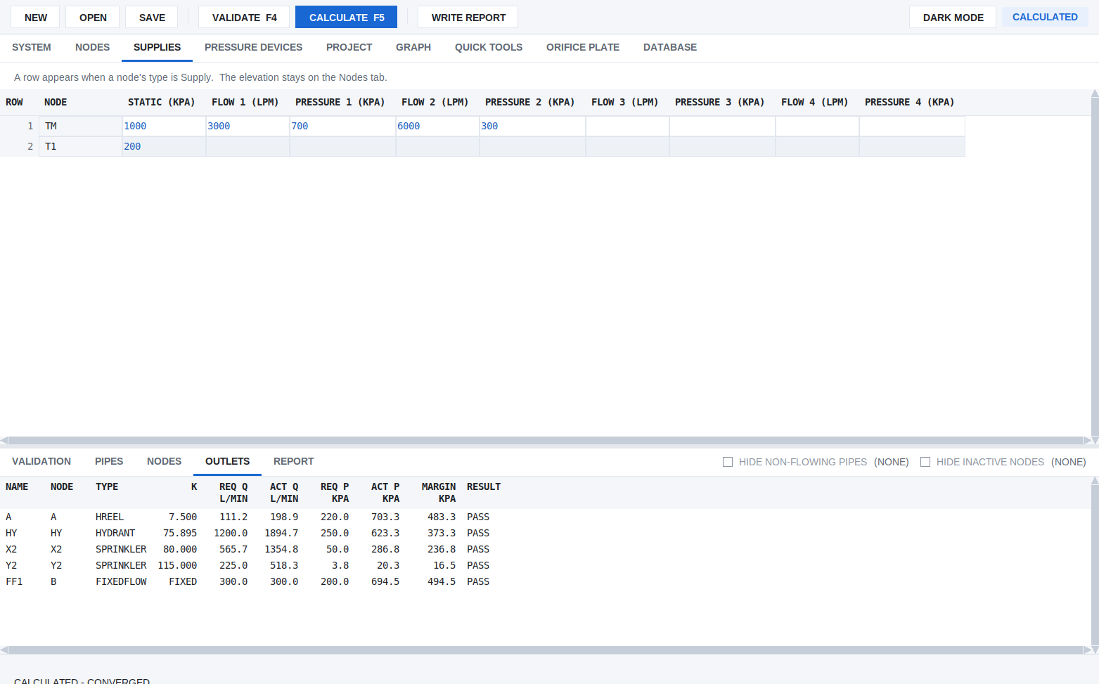
The SUPPLIES grid
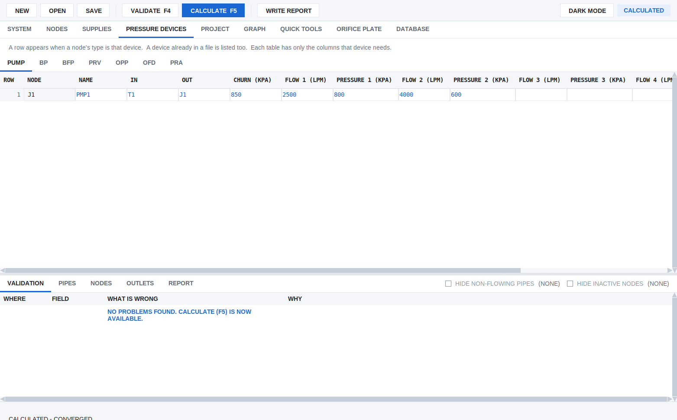
The PRESSURE DEVICES tables
Lines the grids do not edit (design areas, supply graphs, check valves, dry pipe valves, scenarios) are kept in the file exactly as written. Edit them in the text editor.

10. The isometric drawing
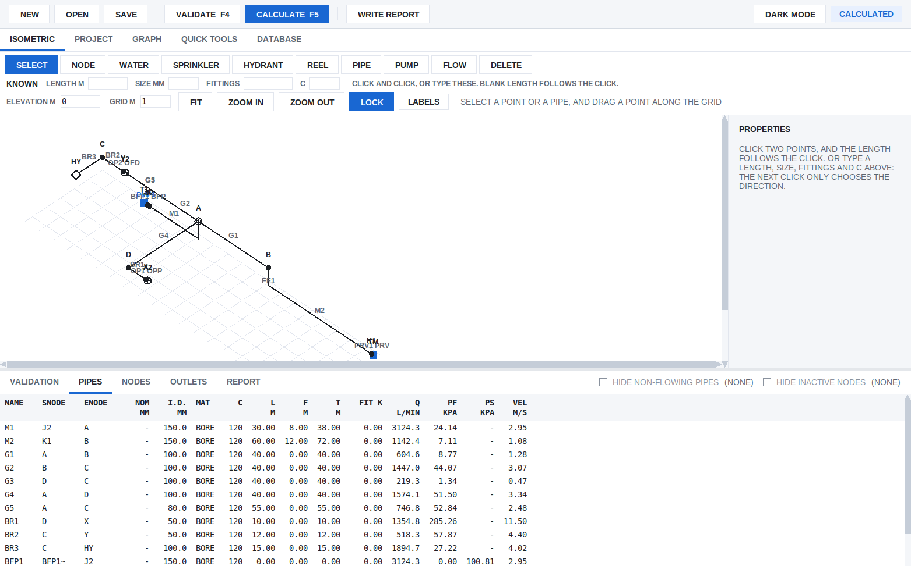
The isometric drawing
phcp_isometric draws the same model on a 30-degree grid, with elevation on the vertical axis. The results tabs are the editor's.
- Placing. Choose a tool (NODE, WATER, SPRINKLER, HYDRANT, REEL, PIPE, PUMP, FLOW) and click the grid.
- Drawing a pipe. Click one point, then the next: the length is the distance between them. Or type the LENGTH, SIZE, FITTINGS and C under KNOWN first; the next click then only chooses the direction. Clicking a point that already exists joins it.
- SELECT drags a point along the grid. The selected pipe or point has its properties on the right; Return writes a field.
- LOCK (on by default) keeps every pipe along the grid axes. FIT scales the whole network into view. LABELS chooses what is written on the drawing.
Where each point sits is saved as //ISO comment lines, which the calculation ignores. A model without them is laid out from its pipes and elevations when it is opened, as in the picture.

11. Water supply graph
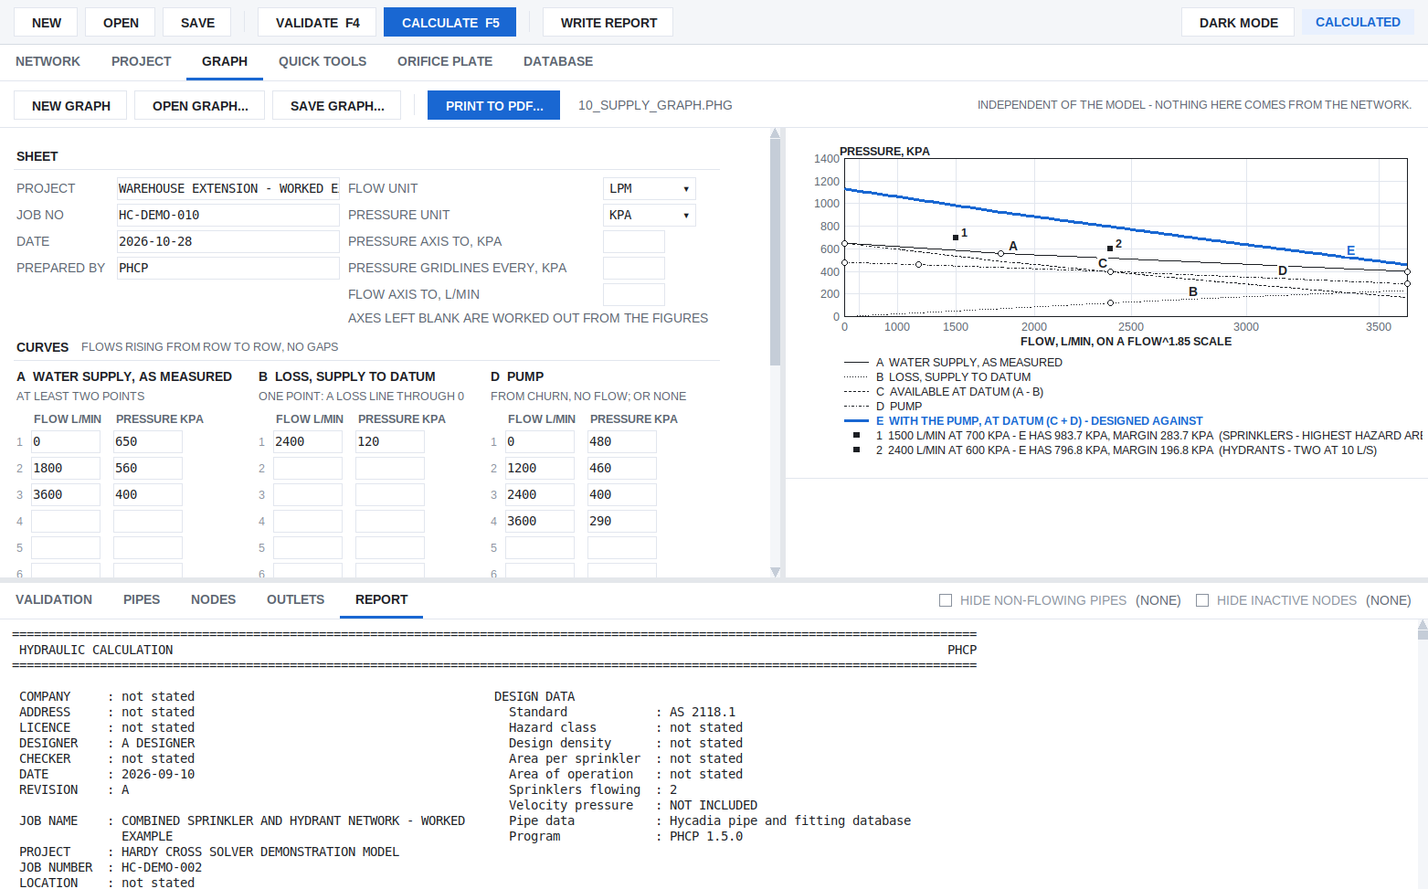
The GRAPH tab
The GRAPH tab draws a water supply graph on Q^1.85 paper from figures typed in, such as a flow test and a pump data sheet. It does not use the model. The curves are:
Curve | What it is
A | the water supply as measured (at least two points)
B | the loss from the supply to the datum: pipework, meter, backflow device, height
C | the supply available at the datum, A - B
D | a pump curve from churn, or none
E | the supply with the pump, C + D

Up to ten DUTY points are each compared with the curve designed against (E with a pump, C without), with the margin or shortfall. A problem is listed under the graph, and a click goes to its field. PRINT TO PDF writes an A4 sheet. SAVE GRAPH and OPEN GRAPH keep the figures in a .phg file. SUPPLYGRAPH town.phg in a model adds the graph to that model's report. The picture is examples/10_supply_graph.phg.

12. Quick tools and the orifice plate
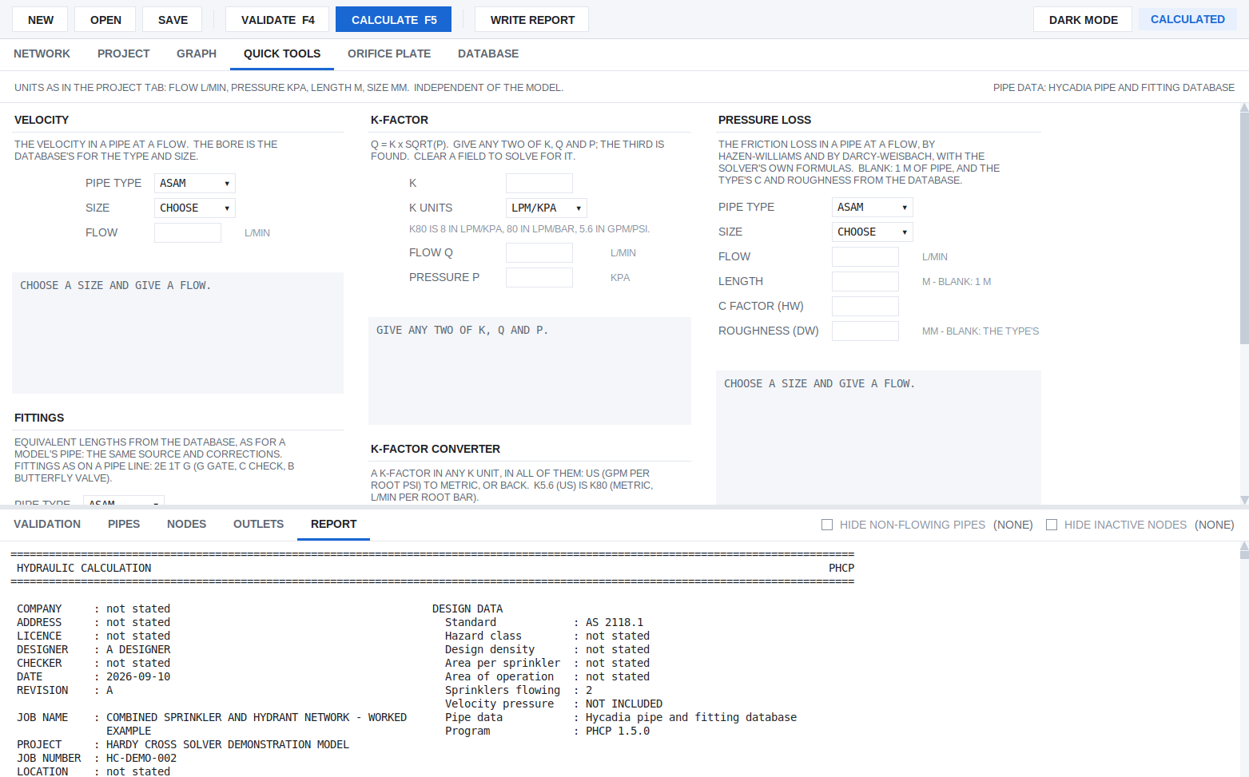
QUICK TOOLS
QUICK TOOLS has five calculators that answer as you type, in the PROJECT tab's units, independent of the model:
- VELOCITY in a pipe at a flow;
- FITTINGS: the equivalent length of a fitting string;
- K-FACTOR: give any two of K, Q and P to get the third;
- K-FACTOR CONVERTER between unit systems;
- PRESSURE LOSS in a pipe at a flow, by Hazen-Williams and Darcy-Weisbach.
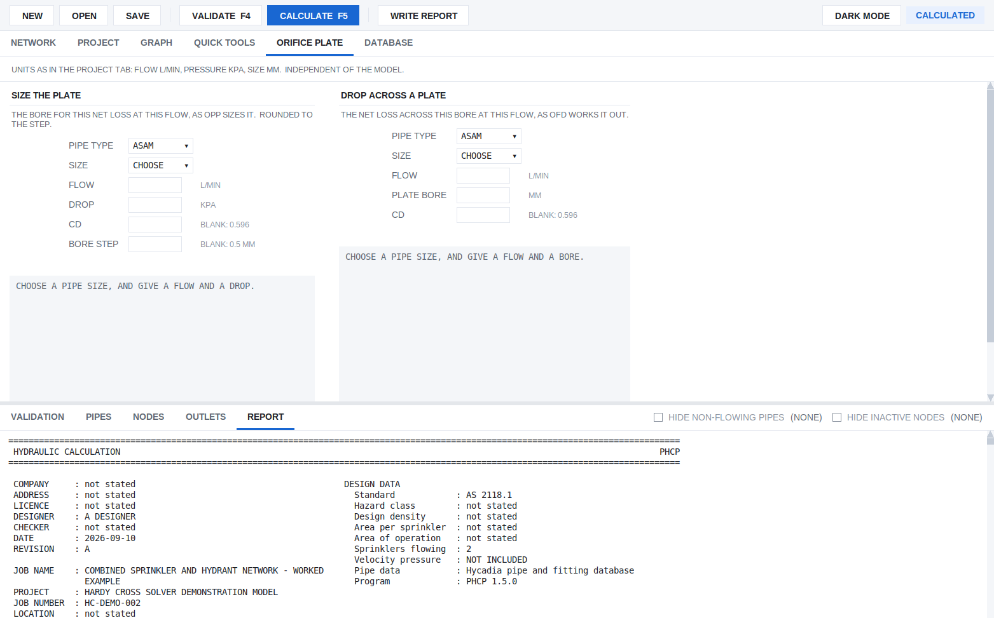
ORIFICE PLATE
ORIFICE PLATE gives either the bore that produces a given net loss at a flow, or the net loss across a given bore. It uses the same calculation as the model's OPP and OFD lines.

13. The pipe and fitting database
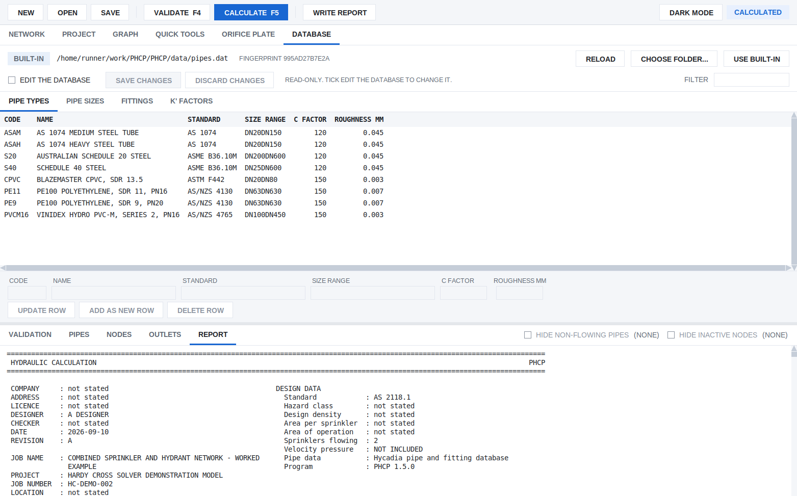
DATABASE
The DATABASE tab shows the pipe types (bores by nominal size, C factor, roughness) and the fitting equivalent lengths that every calculation uses. Filter to find an entry. Tick EDIT THE DATABASE to change one. A team can share one database by choosing a team folder here. The report states which database a calculation used.

14. Supplies, pumps and check valves
- Several supplies. With more than one WATER line, the report gives each supply's operating point and its share of the flow, and PHCP finds the joint demand.
- Pumps follow their curve. A pump with a check valve that would run backwards is shut, and the network is solved again.
- A check valve at a supply is not assumed. Give one with NRV <SUPPLY> <CV> [CRACK] (and NRVMODEL for its make and model). With the valve's data sheet, NRVLOSS gives its loss as a flow and loss curve instead of a Cv; NRV then gives CV 0. A supply with a check valve that would take water in shuts and gives nothing. If every supply that can reach part of the network has shut, that part has lost its supply: the result is NONCOMPLIANT and the outlets cut off are named. Without an NRV line, a supply that takes water in makes the result REJECTED. Section 10 of the report has a SUPPLY CHECK VALVES table: each valve's state, flow, pressure and loss.
- Dry pipe valves (DPV) take their loss from the database or the model. DPVAIR and DPVTRIP give ESTIMATED trip and transit times.

15. Without a window: the command line and JSON
phcp.exe model.phc report.pdf the report as PDF
phcp.exe model.phc report.txt ...or as text
phcp.exe --json model.phc the results as JSON, for another program
phcp.exe --strict model.phc exit 0 for ACCEPTED only
phcp.exe model.phc --save save the results back into the model, as a comment block at its end
phcp.exe model.phc --annotate out.phc with auto sizing: the chosen sizes written into a copy
The exit code says the result:
Exit | Result
0 | ACCEPTED, or NONCOMPLIANT without --strict
1 | INDETERMINATE: the results must not be used
2 | the model could not be read, or its network is broken; nothing was solved
3 | REJECTED: the results must not be used
4 | NONCOMPLIANT, with --strict

A script that treats 0 as approved must use --strict, or read approved in the JSON. The README section "Calling PHCP from another program" has the JSON layout.

16. When something goes wrong
You see | Likely cause
CALCULATE is greyed out | the model has changed since it last passed VALIDATE; press F4
a red line in the editor | the reader refuses it; the status bar and the VALIDATION tab say why
a node in the NODES list | defined but connected to nothing, or named by a pipe and never defined
REJECTED: a supply taking water in | a weaker supply is being back-fed. Add a check valve (NRV) if one is installed
NONCOMPLIANT: LOSS OF SUPPLY | every check valve that could feed part of the system is shut; the outlets named get no water
INDETERMINATE | the solve did not settle. Look for a device switching back and forth (a pump or check valve on the edge of opening), a pipe of zero length, or extreme sizes
a curve marked extrapolated | a supply, pump or loss curve used beyond its last point; give a point further out
the calculation is slow | large grids take time with Hardy Cross; every loop correction is traceable in the report. The status bar shows progress

If a model behaves in a way you cannot explain, report it with the .phc file. A model that is refused when it should not be, or accepted when it should not be, is a defect.

