FINAL YEAR PROJECT REPORT
REBADEN
A Security Information and Event Management (SIEM) Platform
for Small and Medium Enterprise Security Operations

Prepared by: Joshua Ndereba
Final Year Security Engineering Project
Document Type: Project Report (Proposal, Design & Implementation)
Version 2.0 · August 2026
Status: Implementation Complete — Fully Functional Build

Abstract
Modern organisations of all sizes generate large volumes of security-relevant data from servers, applications, firewalls, and end-user devices. Without a centralised system for collecting, correlating, and triaging this data, security teams face alert fatigue, delayed incident response, and gaps in regulatory compliance. Commercial Security Information and Event Management (SIEM) platforms such as Splunk Enterprise Security and IBM QRadar address this problem but are frequently out of reach for small and medium enterprises (SMEs) due to licensing cost and operational complexity.
This report documents the design, development, and implementation of Rebaden, a self-hosted, Django-based SIEM platform built to close this gap. The system implements a complete security-operations pipeline: multi-format log ingestion and parsing, rule-based event correlation and alert generation, MITRE ATT&CK-mapped threat classification, investigation and case management with timeline and evidence tracking, an AI-assisted remediation advisor, role-based access control, and multi-format reporting (JSON, CSV, HTML).
The platform was developed using an Agile methodology across four sprints over a ten-week period, following a backend-first, security-by-default development philosophy. The resulting system comprises 25+ interlinked data models, 40+ views, a REST-style API surface, and a fully themed, responsive web interface. Manual functional testing confirmed that all nine core project objectives were met. This report presents the problem context, a review of existing SIEM solutions, the system's architecture and data-flow design, the implementation approach, testing outcomes, and recommendations for future work including PostgreSQL migration, real-time log streaming, and SOAR-style playbook automation.
Keywords: SIEM, security monitoring, log analysis, threat detection, incident response, MITRE ATT&CK, Django, security automation

Table of Contents
1. Introduction
2. Review of Existing SIEM Solutions
3. Methodology
4. Requirements Analysis
5. System Analysis & Design
6. Technology Stack & Infrastructure
7. Implementation
8. Testing
9. Results & Discussion
10. Conclusion & Recommendations
11. References
Appendix A — API Quick Reference
Appendix B — URL Route Reference
Appendix C — Quick Start Guide

List of Figures
Figure 3.1 Agile sprint plan across a 10-week development cycle
Figure 5.1 REBADEN high-level system architecture (six-stage processing pipeline)
Figure 5.2 Level-0 Data Flow Diagram (System Context Diagram)
Figure 5.3 Level-1 Data Flow Diagram — major processes and data stores
Figure 5.4 Log ingestion and threat-detection workflow
Figure 5.5 Alert lifecycle state diagram
Figure 5.6 Investigation and incident-response workflow

1. Introduction

1.1 Background
Every server, application, firewall, and endpoint in a modern IT environment continuously produces log data describing what it is doing and who is interacting with it. Individually, a single log line rarely means much. Collectively, and correlated across sources, these logs are the primary evidence base security teams rely on to detect intrusions, investigate incidents, and demonstrate regulatory compliance. A Security Information and Event Management (SIEM) system is the class of software built to perform this collection and correlation at scale.
Established SIEM products — Splunk Enterprise Security, IBM QRadar, Micro Focus ArcSight — are mature and capable, but they were designed for enterprises with dedicated security operations budgets. Their licensing models (often priced per gigabyte of ingested data per day) and infrastructure requirements place them out of reach for small and medium enterprises (SMEs), startups, and academic security teams. Open-source alternatives such as Wazuh or the Elastic Stack reduce licensing cost but still require the operator to assemble and maintain a multi-component stack (agents, indexers, brokers, dashboards).
Rebaden was conceived to occupy the gap between these two extremes: a single, self-hosted Django application that a lone engineer can deploy, understand, and extend, while still delivering the core analyst workflow — ingest, detect, alert, investigate, report — that defines a SIEM.

1.2 Problem Statement
In the absence of a centralised, affordable log-analysis platform, small security teams are exposed to four recurring risks:
- Alert fatigue — unfiltered log noise buries the events that actually matter, causing analysts to miss genuine threats.
- Delayed incident response — logs scattered across fragmented tools slow down the correlation work needed to confirm and scope an incident.
- Invisible attack patterns — many attacks (brute force, lateral movement, data exfiltration) are only visible when events from multiple sources are correlated over time; no single log line reveals them.
- Compliance gaps — frameworks such as PCI-DSS, HIPAA, and GDPR require demonstrable audit trails and incident-handling records that ad-hoc log storage cannot provide.
Rebaden addresses this problem directly by providing an accessible, deployable, single-engineer-operable platform that still delivers the essential SIEM feature set.

1.3 Project Objectives

1.3.1 General Objective
To design and implement a web-based SIEM platform that consolidates log ingestion, threat detection, alert management, and incident investigation into a single, unified, and accessible system suitable for SME security operations.

1.3.2 Specific Objectives
- Develop a centralised log ingestion and parsing engine supporting common log formats (Apache Common/Combined, syslog, JSON).
- Implement an automated alert-generation engine that correlates raw events into actionable, severity-classified alerts.
- Build a case-management (investigation) module where analysts can track, annotate, and resolve incidents through to closure.
- Provide a real-time dashboard with key security metrics and trend visualisations.
- Integrate an AI-assisted investigation advisor that suggests prioritised remediation steps.
- Implement role-based access control (RBAC) distinguishing Analysts from Administrators.
- Deliver a professional, accessible user interface with dark and light theming.
- Map detected threats to the MITRE ATT&CK framework to give analysts standardised threat context.
- Provide multi-format report generation (JSON, CSV, HTML) for security, compliance, and executive audiences.

1.4 Scope of the Project

1.4.1 In Scope
- Log file upload and parsing (Apache Common/Combined, syslog, JSON formats)
- Automated event classification and severity assignment
- Alert lifecycle management (new → acknowledged/investigating → resolved/false positive → closed)
- Investigation/case creation with notes, timeline, and evidence tracking
- Dashboard with event counts, alert distribution, and trend charts
- Advanced search across all security entities (events, alerts, investigations, IOCs)
- User management and role-based access (Administrator / Analyst)
- Dark/light theme toggle and responsive UI
- MITRE ATT&CK tactic and technique mapping
- Report generation in JSON, CSV, and HTML formats

1.4.2 Out of Scope
- Real-time, agent-based log streaming (identified as Phase 2 work)
- Full SOAR (Security Orchestration, Automation and Response) playbook execution
- Native mobile application
- Integration with commercial third-party threat-intelligence feeds (Phase 2)

1.5 Significance of the Project
Beyond its function as an academic deliverable, Rebaden demonstrates that a functionally complete SIEM workflow can be built and operated without the infrastructure overhead commercial and open-source enterprise tools normally demand. For SMEs, this lowers the barrier to establishing a baseline security-monitoring capability. For the author, the project provided end-to-end experience across requirements analysis, secure application architecture, data modelling, threat-detection logic, and applied AI integration — the full breadth of a security engineering discipline.

1.6 Report Structure
The remainder of this report is organised as follows. Chapter 2 reviews existing SIEM solutions and positions Rebaden relative to them. Chapter 3 describes the Agile methodology used during development. Chapter 4 sets out the functional and non-functional requirements. Chapter 5 presents the system architecture, data-flow diagrams, data model, and workflow diagrams. Chapter 6 details the technology stack. Chapter 7 walks through the implementation module by module. Chapter 8 reports the testing approach and results. Chapter 9 discusses results against the stated objectives. Chapter 10 concludes the report and outlines recommended future work, followed by references and appendices.

2. Review of Existing SIEM Solutions

2.1 Overview of SIEM Technology
A SIEM platform typically performs four functions: (1) collecting log and event data from many heterogeneous sources; (2) normalising that data into a common schema; (3) correlating normalised events against detection rules or behavioural baselines to surface alerts; and (4) supporting the human workflow of triage, investigation, and reporting that follows an alert. The maturity of a SIEM product is usually judged by the breadth of sources it can ingest, the sophistication of its correlation/detection logic, and the quality of its investigation and reporting tooling.

2.2 Comparative Analysis
Solution | Deployment Model | Cost Profile | Best Suited For | Key Limitation for SMEs
Splunk Enterprise Security | Self-hosted / cloud | Per-GB/day licensing — high | Large enterprises with dedicated SOC | Licensing cost scales with data volume; steep learning curve
IBM QRadar | Appliance / cloud | High upfront + subscription | Regulated large enterprises | Significant infrastructure and integration overhead
ArcSight (Micro Focus) | Self-hosted | High enterprise licensing | Large, complex SOC environments | Complex deployment; requires specialist administrators
Elastic Security (ELK) | Self-hosted / cloud | Open core, paid tiers for advanced features | Teams comfortable operating the Elastic Stack | Multi-component stack (Beats/Logstash/Elasticsearch/Kibana) is heavy to operate for a single engineer
Wazuh | Self-hosted | Free / open source | Cost-sensitive teams willing to self-manage | Still depends on the Elastic Stack underneath; agent-based architecture adds operational overhead
Rebaden (this project) | Self-hosted, single Django app | Free / open source | SMEs, small teams, single-engineer operations | Not yet designed for multi-terabyte, real-time enterprise ingestion (see §8.2 limitations)

2.3 Identified Gap and Justification for Rebaden
The comparative review reveals a consistent pattern: capability and operational simplicity trade off against each other. Commercial tools offer polish and scale at a cost SMEs cannot absorb; open-source stacks offer zero licensing cost but demand multi-component operational expertise. Rebaden's design goal was to sit at the point on this curve that a single engineer can both build and operate — a single Django application, a single database, and a self-contained feature set covering the essential SIEM workflow, deliberately avoiding the operational surface area of a distributed log-analytics stack.
This positioning directly informed the technology choices discussed in Chapter 6: Django was selected specifically because its integrated ORM, authentication, and admin interface remove the need for separate identity, database-administration, and API-scaffolding tools that a from-scratch stack would require.

3. Methodology

3.1 Development Methodology
Rebaden was developed using an Agile iterative model structured into four focused sprints over a ten-week period. Agile was chosen over a waterfall approach for three reasons specific to this project: security requirements are discovered progressively — what should count as an "alert" only becomes clear once real log data is being parsed; iterative delivery allowed early feedback on interface and workflow decisions before they were locked in; and features could be shipped and validated incrementally rather than risking a single, monolithic release at the end of the project timeline.

3.2 Sprint Plan
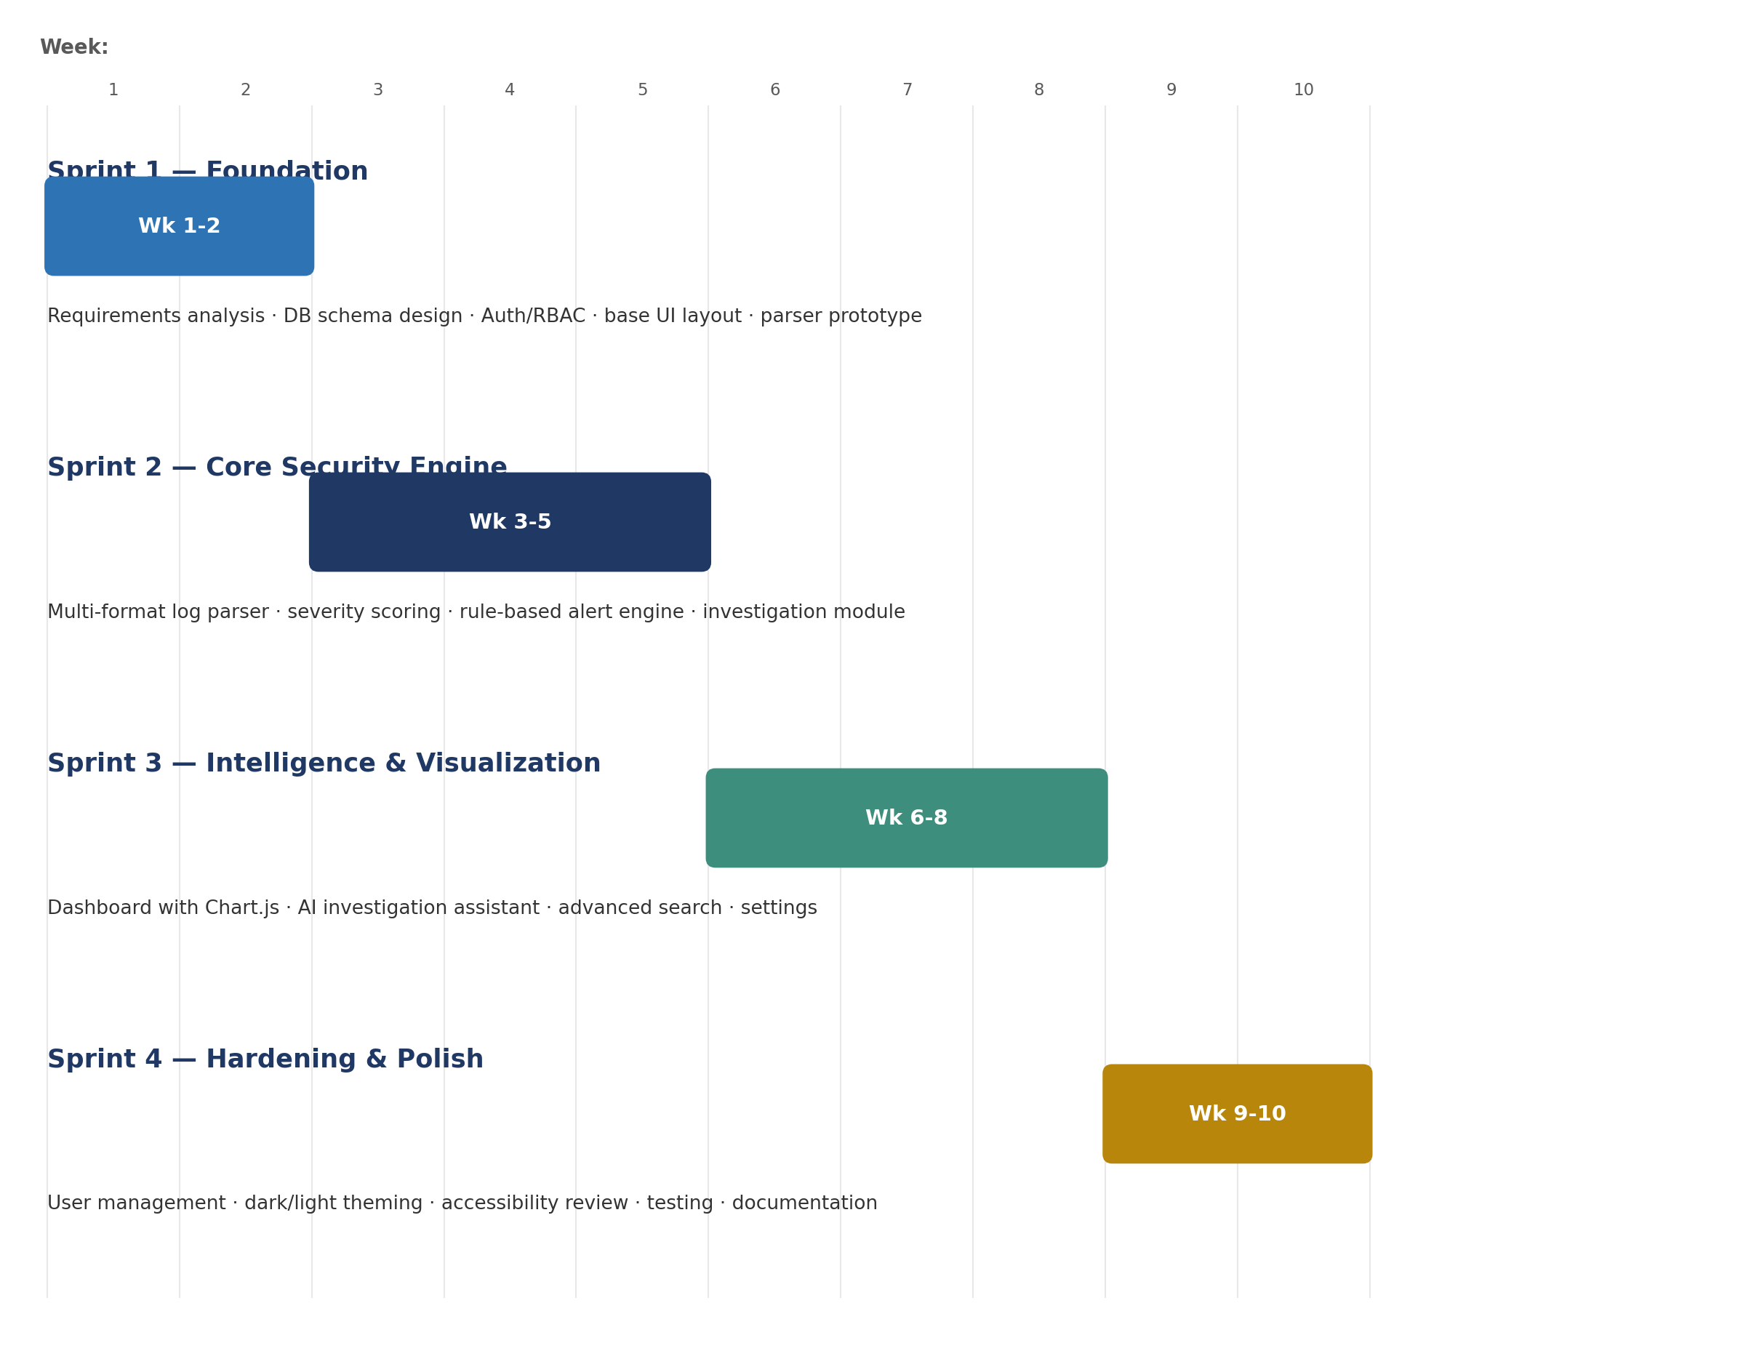
Figure 3.1: Agile sprint plan across a 10-week development cycle

Sprint 1 — Foundation (Weeks 1–2)
Goal: establish the project infrastructure.
- Initiated the Django project with a modular app structure (apps/core/)
- Designed the initial database schema covering LogEntry, ParsedEvent, Alert, and Investigation models
- Implemented Django's built-in authentication with a login/logout flow and a user profile model
- Built the base template establishing the sidebar and top-bar shell
- Established the CSS design system using custom properties (variables)

Sprint 2 — Core Security Engine (Weeks 3–5)
Goal: build the data ingestion and processing pipeline.
- Log Parser: a regex-based multi-format parser supporting Apache Common, Apache Combined, syslog, and structured JSON, classifying events (authentication failure, SQL injection attempt, brute force, port scan, etc.) and assigning initial severity
- Alert Generator: a rule-based correlation engine operating on parsed events, applying thresholds, pattern matching, and severity escalation
- Investigation Module: full CRUD for investigations linked to alerts, with note-taking, status tracking (Open → In Progress → Closed), and analyst assignment

Sprint 3 — Intelligence & Visualisation (Weeks 6–8)
Goal: transform raw data into actionable intelligence.
- Dashboard: server-side aggregation of total events, active alerts, open investigations, and critical alerts, rendered via Chart.js as trend lines, severity pie charts, and attack-pattern bar charts
- AI Investigation Assistant: integration with the OpenAI GPT-4o API — a structured prompt built from linked alert and event context returns prioritised, checklist-style remediation actions
- Advanced Search: cross-model search using Django Q objects across events, alerts, and investigations simultaneously, with filterable, paginated results
- Settings & Log Import: a file-upload interface for .log/.json files that are immediately processed by the parser pipeline

Sprint 4 — Hardening & Polish (Weeks 9–10)
Goal: production readiness, UX refinement, and documentation.
- Resolved a dashboard crash caused by an undefined variable in the AI insights block
- Removed unused Assets and Hunting features to reduce interface complexity
- Implemented a custom admin panel with analyst-management capabilities
- Converted AI recommended actions into interactive, per-investigation checklist items
- Overhauled the CSS theme system to support dark mode (black / neon-green) and light mode (cream / deep-green), with a persisted toggle
- Fixed sidebar-collapse behaviour with corrected CSS transitions and JavaScript state management

3.3 Development Philosophy
- Backend first — model and API/view logic is built and validated before templates are written, ensuring the data layer is correct before it is presented.
- Security by default — authentication is required on every view; CSRF protection is enforced on all state-modifying endpoints.
- Separation of concerns — log parsing, alert correlation, and AI logic are isolated in dedicated modules (log_parser.py, alert_generator.py, investigation_ai.py) rather than embedded in view functions.

3.4 Tools and Techniques
Category | Tool / Technique
Version control | Git, with structured commit history per sprint
Project management | Sprint backlog tracked against the objectives table in Chapter 1
Local development | Django development server (manage.py runserver), SQLite
Design system | CSS custom properties for consistent theming across dark/light modes
Testing | Manual functional testing per module at the end of each sprint (see Chapter 8)
Documentation | Living Markdown documentation maintained alongside the codebase

4. Requirements Analysis

4.1 Functional Requirements
ID | Requirement
FR-01 | The system shall allow authenticated users to upload log files (Apache, syslog, JSON) for parsing.
FR-02 | The system shall automatically detect log format and extract structured fields from each log line.
FR-03 | The system shall classify parsed events by category and assign a severity level.
FR-04 | The system shall apply correlation rules to parsed events and automatically generate alerts when a rule matches.
FR-05 | The system shall allow analysts to acknowledge, resolve, close, or mark alerts as false positive.
FR-06 | The system shall allow analysts to create investigations, optionally linked to one or more alerts.
FR-07 | The system shall allow analysts to add timestamped notes and evidence to an investigation.
FR-08 | The system shall generate AI-assisted, prioritised remediation suggestions for an open investigation.
FR-09 | The system shall provide a dashboard summarising event counts, alert severity distribution, and trends.
FR-10 | The system shall support full-text search across events, alerts, investigations, and IOCs.
FR-11 | The system shall generate reports in JSON, CSV, and HTML formats across multiple report types.
FR-12 | The system shall restrict administrative actions (user management, system settings) to Administrator-role users.
FR-13 | The system shall log all significant user actions to an audit trail.
FR-14 | The system shall map detected alerts to MITRE ATT&CK tactics and techniques where applicable.

4.2 Non-Functional Requirements
ID | Requirement | Target / Rationale
NFR-01 | Usability | Core workflows (upload → alert → investigate → report) must be completable without consulting external documentation.
NFR-02 | Security | All views require authentication; all state-changing requests are CSRF-protected; passwords are hashed, never stored in plaintext.
NFR-03 | Performance | The log parser should process at least 50,000 log lines per minute on standard development hardware.
NFR-04 | Portability | The application must run unmodified against SQLite (development) and PostgreSQL (production) via Django's ORM abstraction.
NFR-05 | Maintainability | Business logic (parsing, correlation, AI integration) must be isolated in dedicated modules, not embedded in views.
NFR-06 | Accessibility | The interface must support both dark and light themes and remain usable on mobile viewports (<768px).
NFR-07 | Availability of AI features | The system must degrade gracefully to static suggestions if no OpenAI API key is configured, rather than failing.

4.3 Use-Case Actors
- Security Analyst — the primary user; uploads logs, triages alerts, runs investigations, generates reports.
- System Administrator — a superset of the Analyst role with additional user-management and system-configuration privileges.
- Log Sources (external) — servers, firewalls, and applications that produce the raw log data ingested by the system.
- Threat Intelligence Feeds (external) — sources of Indicators of Compromise (IOCs) consumed by the detection engine.

5. System Analysis & Design

5.1 System Architecture
Rebaden is organised as a linear, six-stage processing pipeline. Logs enter the system, are normalised and enriched, matched against detection logic, escalated into alerts, correlated into investigations, and ultimately surfaced through reports and compliance tracking. Each stage is backed by its own data models and view logic, but all stages share a single Django application and a single database, keeping the operational footprint small.
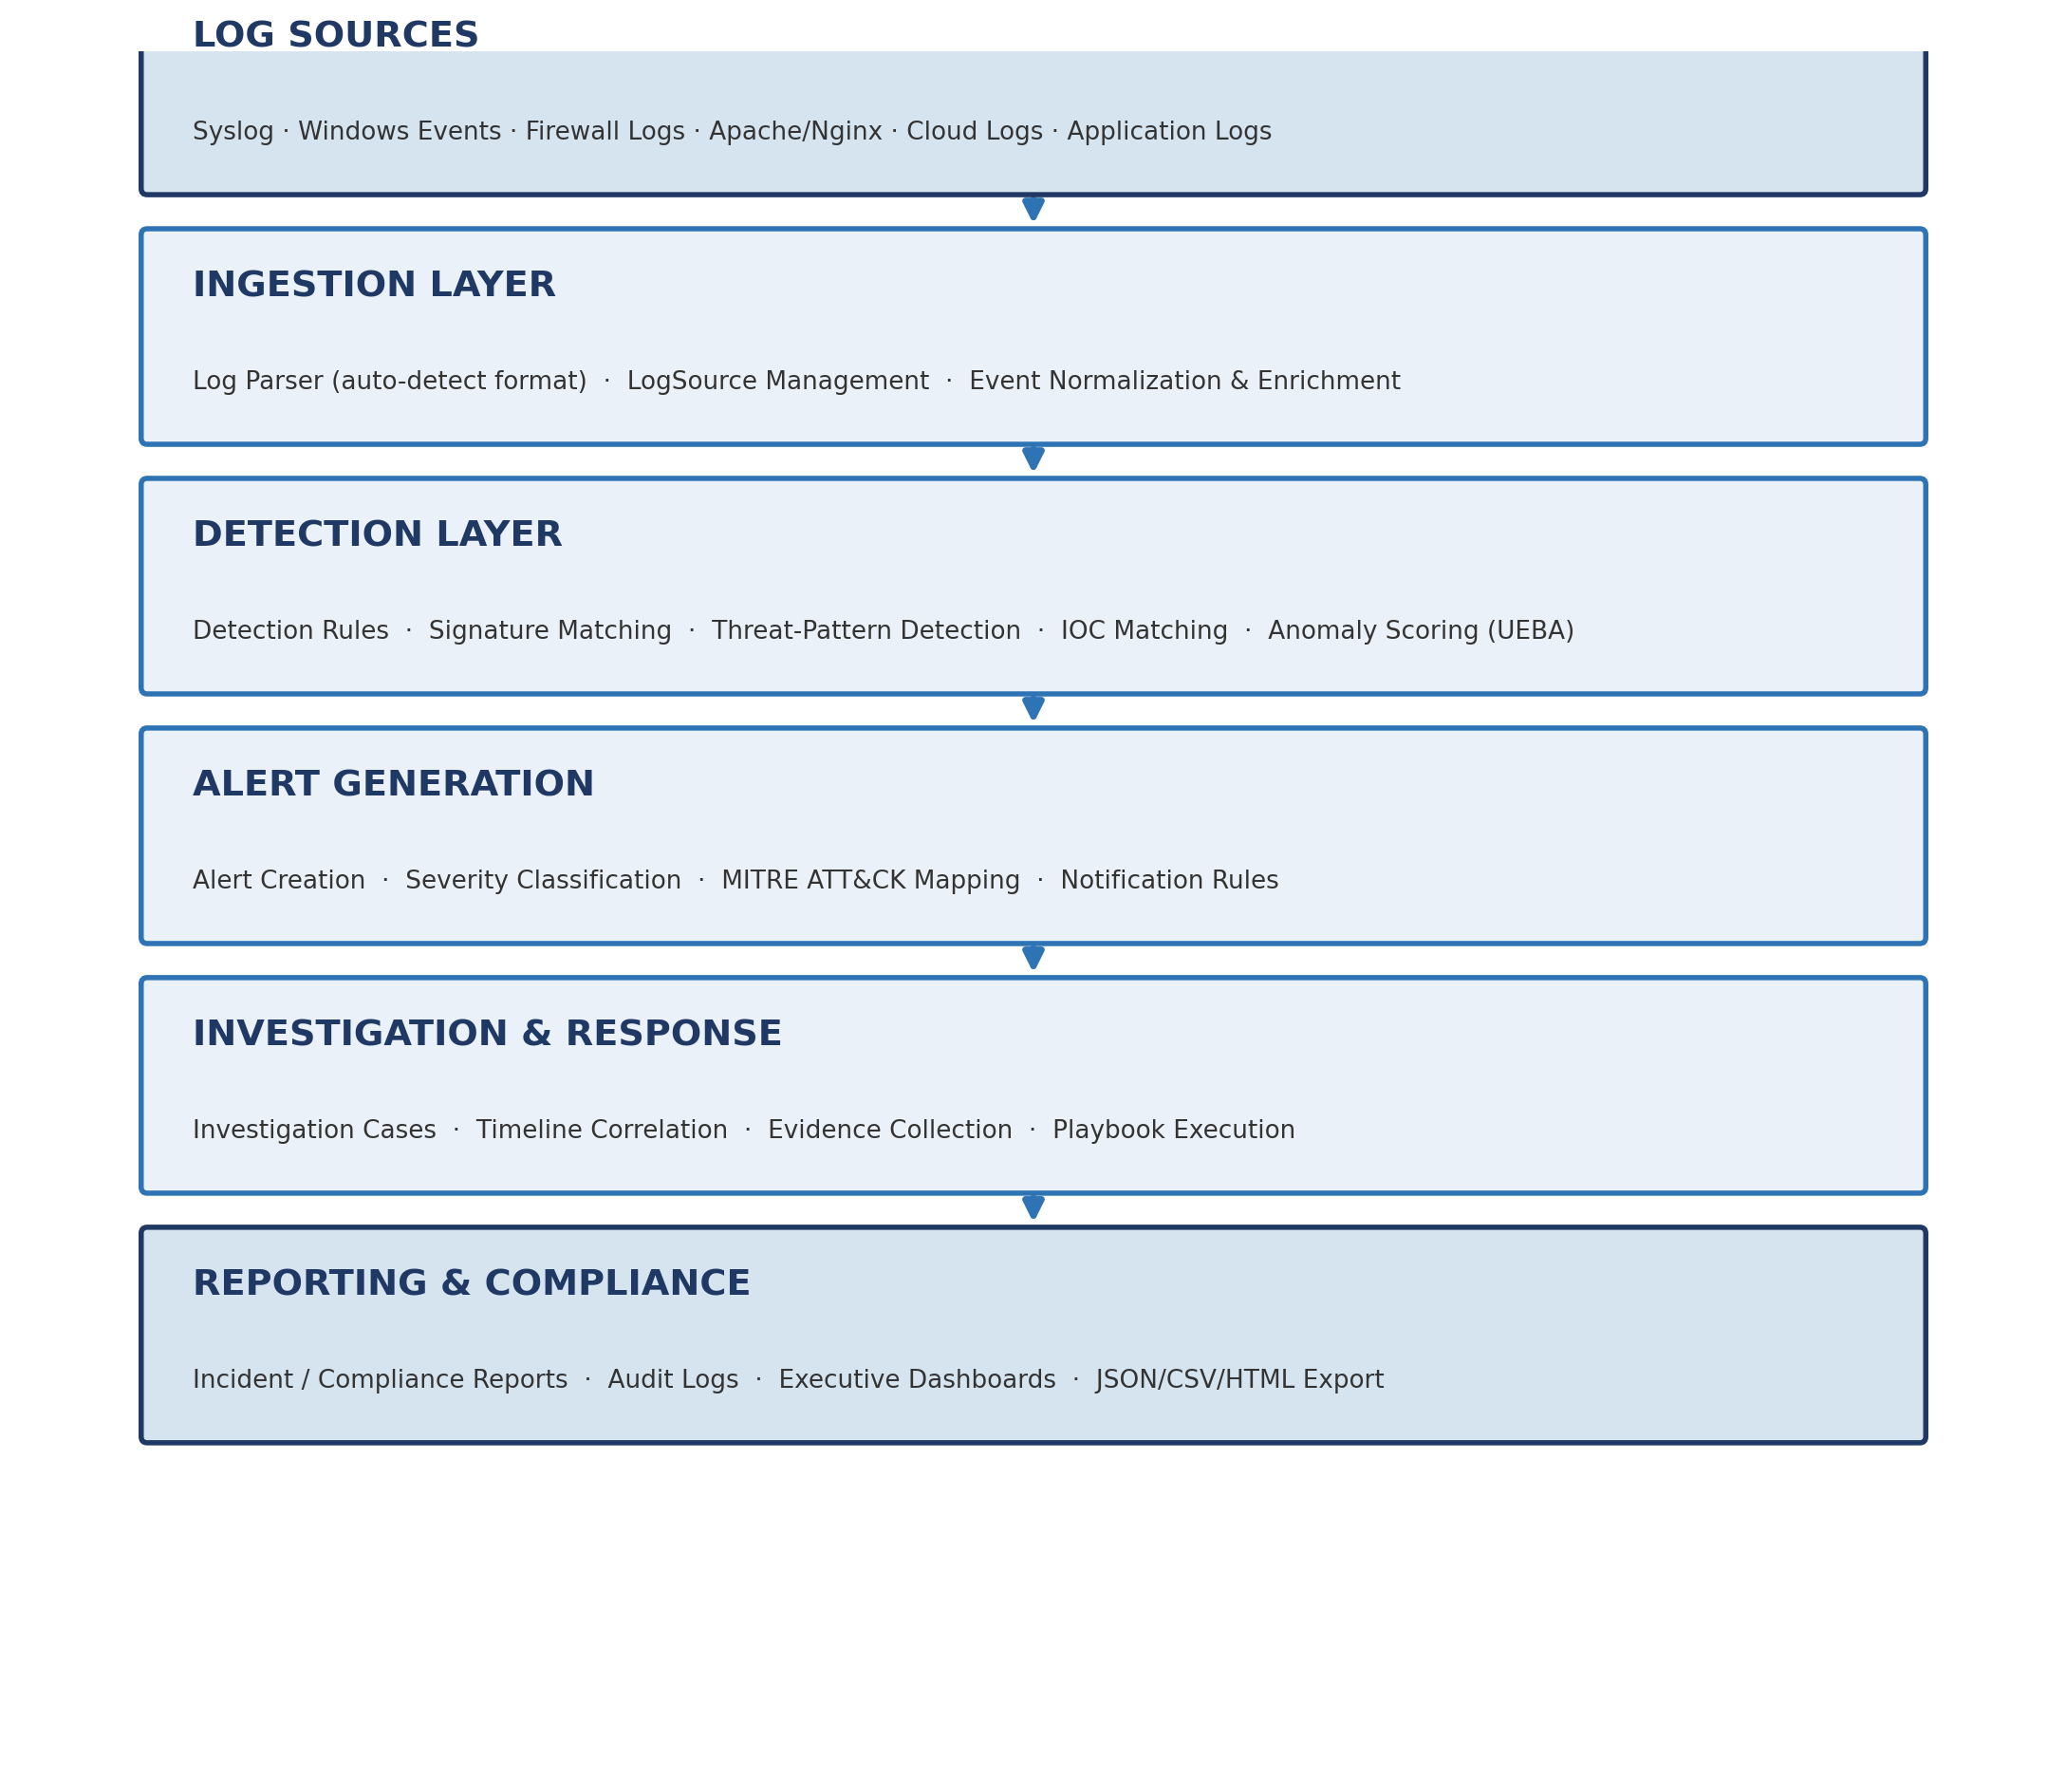
Figure 5.1: REBADEN high-level system architecture (six-stage processing pipeline)

5.2 Data Flow Diagrams
Data Flow Diagrams (DFDs) were used during design to validate that every piece of data entering or leaving the system had a clear source, destination, and transforming process. Figure 5.2 shows the Level-0 (context) diagram; Figure 5.3 decomposes the system into its Level-1 processes and data stores.

5.2.1 Level-0 DFD — System Context
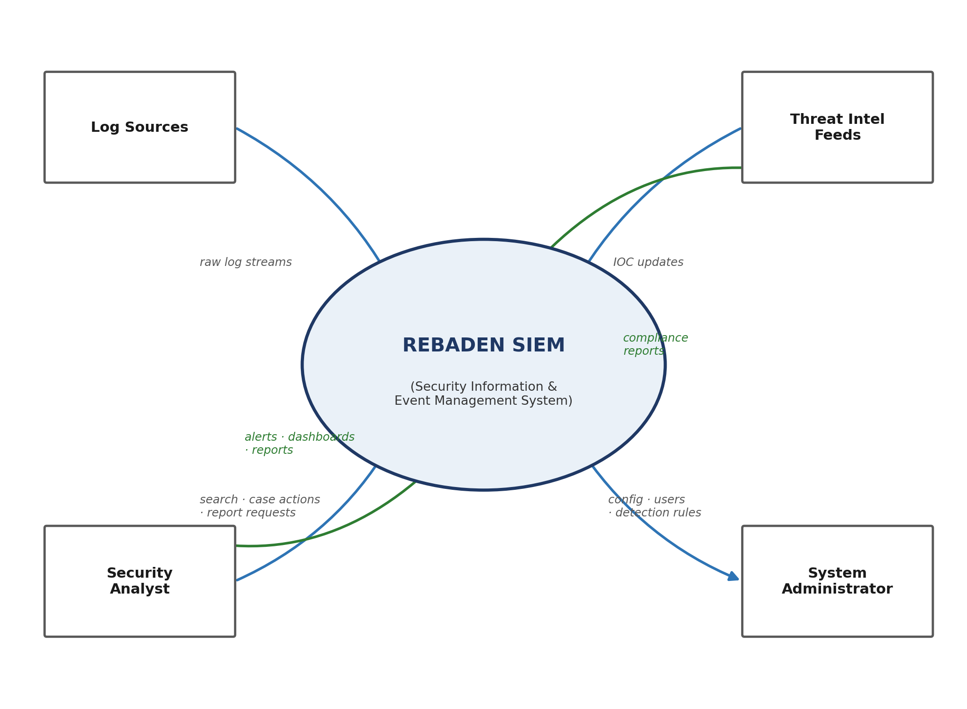
Figure 5.2: Level-0 Data Flow Diagram (System Context Diagram)
At the context level, Rebaden exchanges data with four external entities: Log Sources supply raw log streams; Security Analysts submit searches, case actions, and report requests and receive alerts, dashboards, and reports in return; Threat Intelligence Feeds supply IOC updates; and System Administrators push configuration, user, and detection-rule changes while receiving compliance reports.

5.2.2 Level-1 DFD — Major Processes
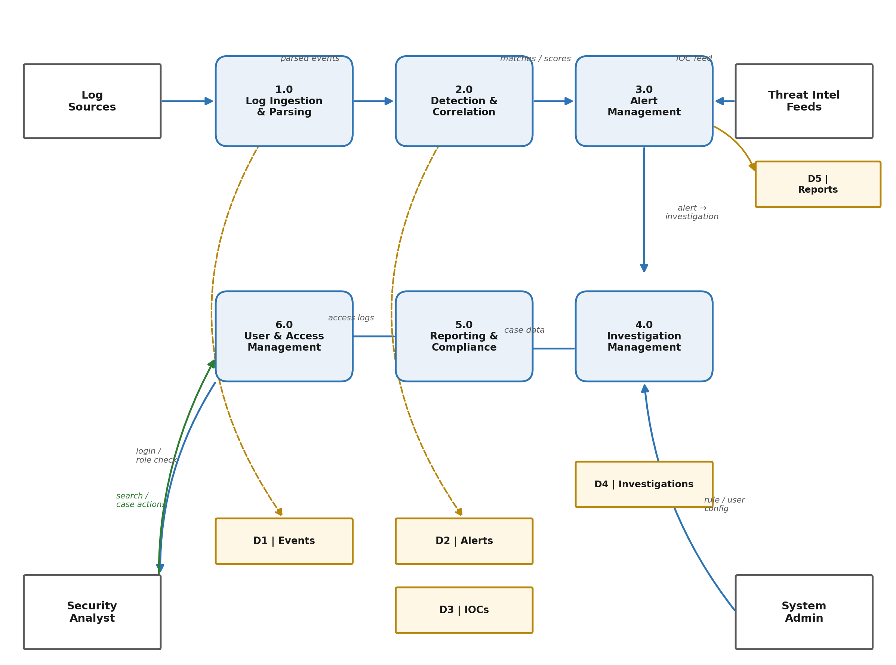
Figure 5.3: Level-1 Data Flow Diagram — major processes and data stores
The Level-1 decomposition identifies six core processes and five persistent data stores:
Process | Responsibility
1.0 Log Ingestion & Parsing | Receives raw logs, detects format, extracts fields, writes parsed events to D1
2.0 Detection & Correlation | Evaluates parsed events against rules, thresholds, and IOC matches (D3)
3.0 Alert Management | Creates and tracks alerts (D2) through their lifecycle, consuming reports history (D5) for deduplication context
4.0 Investigation Management | Manages investigation cases (D4), timelines, notes, and evidence
5.0 Reporting & Compliance | Aggregates data from all stores into exportable reports
6.0 User & Access Management | Handles authentication, role checks, and audit logging for all analyst and administrator actions

5.3 Data Model
The data model hierarchy reflects the natural lifecycle of a security investigation, from an uploaded file down to a closed, reported case:
LogFile (uploaded file metadata)
└─▶ LogEntry (raw log line, unparsed)
└─▶ ParsedEvent (classified event: severity, source IP, type)
└─▶ Alert (correlated from one or more events; lifecycle status)
└─▶ Investigation (analyst case with notes & findings)
├─▶ InvestigationNote (timestamped annotation)
├─▶ InvestigationTimeline (chronological event linkage)
├─▶ Evidence (files/hashes with chain of custody)
└─▶ RecommendedAction (AI-generated checklist item)
This hierarchy is supplemented by cross-cutting models that support the wider platform: AnalystProfile (extends the built-in Django User with role and contact metadata), Asset and LogSource (track monitored infrastructure and log collection endpoints), MitreTactic / MitreTechnique / MITREMapping (ATT&CK framework integration), IOC / ThreatFeed / ThreatActor (threat-intelligence entities), ComplianceFramework / ComplianceCheck (regulatory tracking), Playbook / PlaybookExecution (automated response), NotificationChannel / NotificationRule, AuditLog, SavedSearch, and Report / ReportExport. In total the schema comprises more than 25 interlinked models.

5.4 Workflow Design
Three workflows were modelled explicitly because they represent the system's core value: turning a raw log line into a resolved, reported security outcome.

5.4.1 Log Ingestion & Detection Workflow
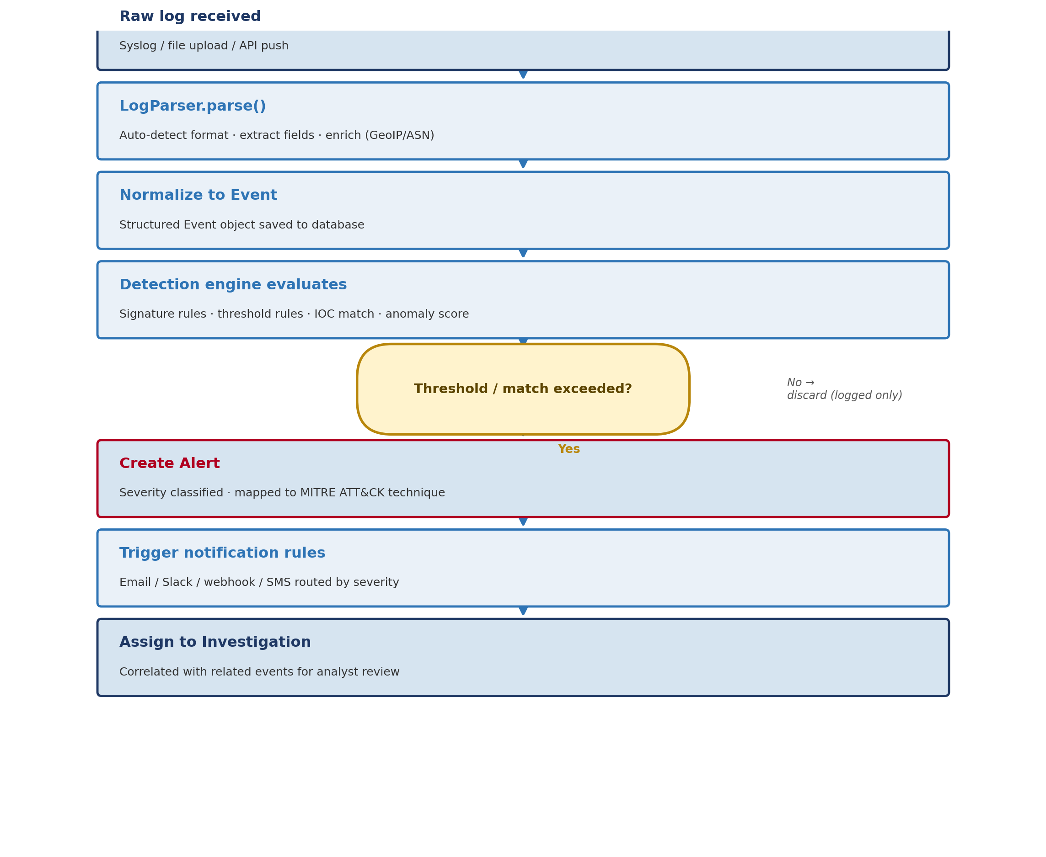
Figure 5.4: Log ingestion and threat-detection workflow
A raw log line — whether received via syslog, file upload, or API push — is parsed and enriched by LogParser.parse(), which auto-detects the source format, extracts structured fields, and applies GeoIP/ASN enrichment where relevant. The resulting Event is evaluated against signature rules, threshold rules, IOC matches, and an anomaly score; if any check exceeds its configured threshold, an Alert is created, classified by severity, mapped to a MITRE ATT&CK technique, routed through notification rules, and assigned to an investigation for analyst review. Events that do not trigger a rule are retained (logged) but do not generate an alert.

5.4.2 Alert Lifecycle
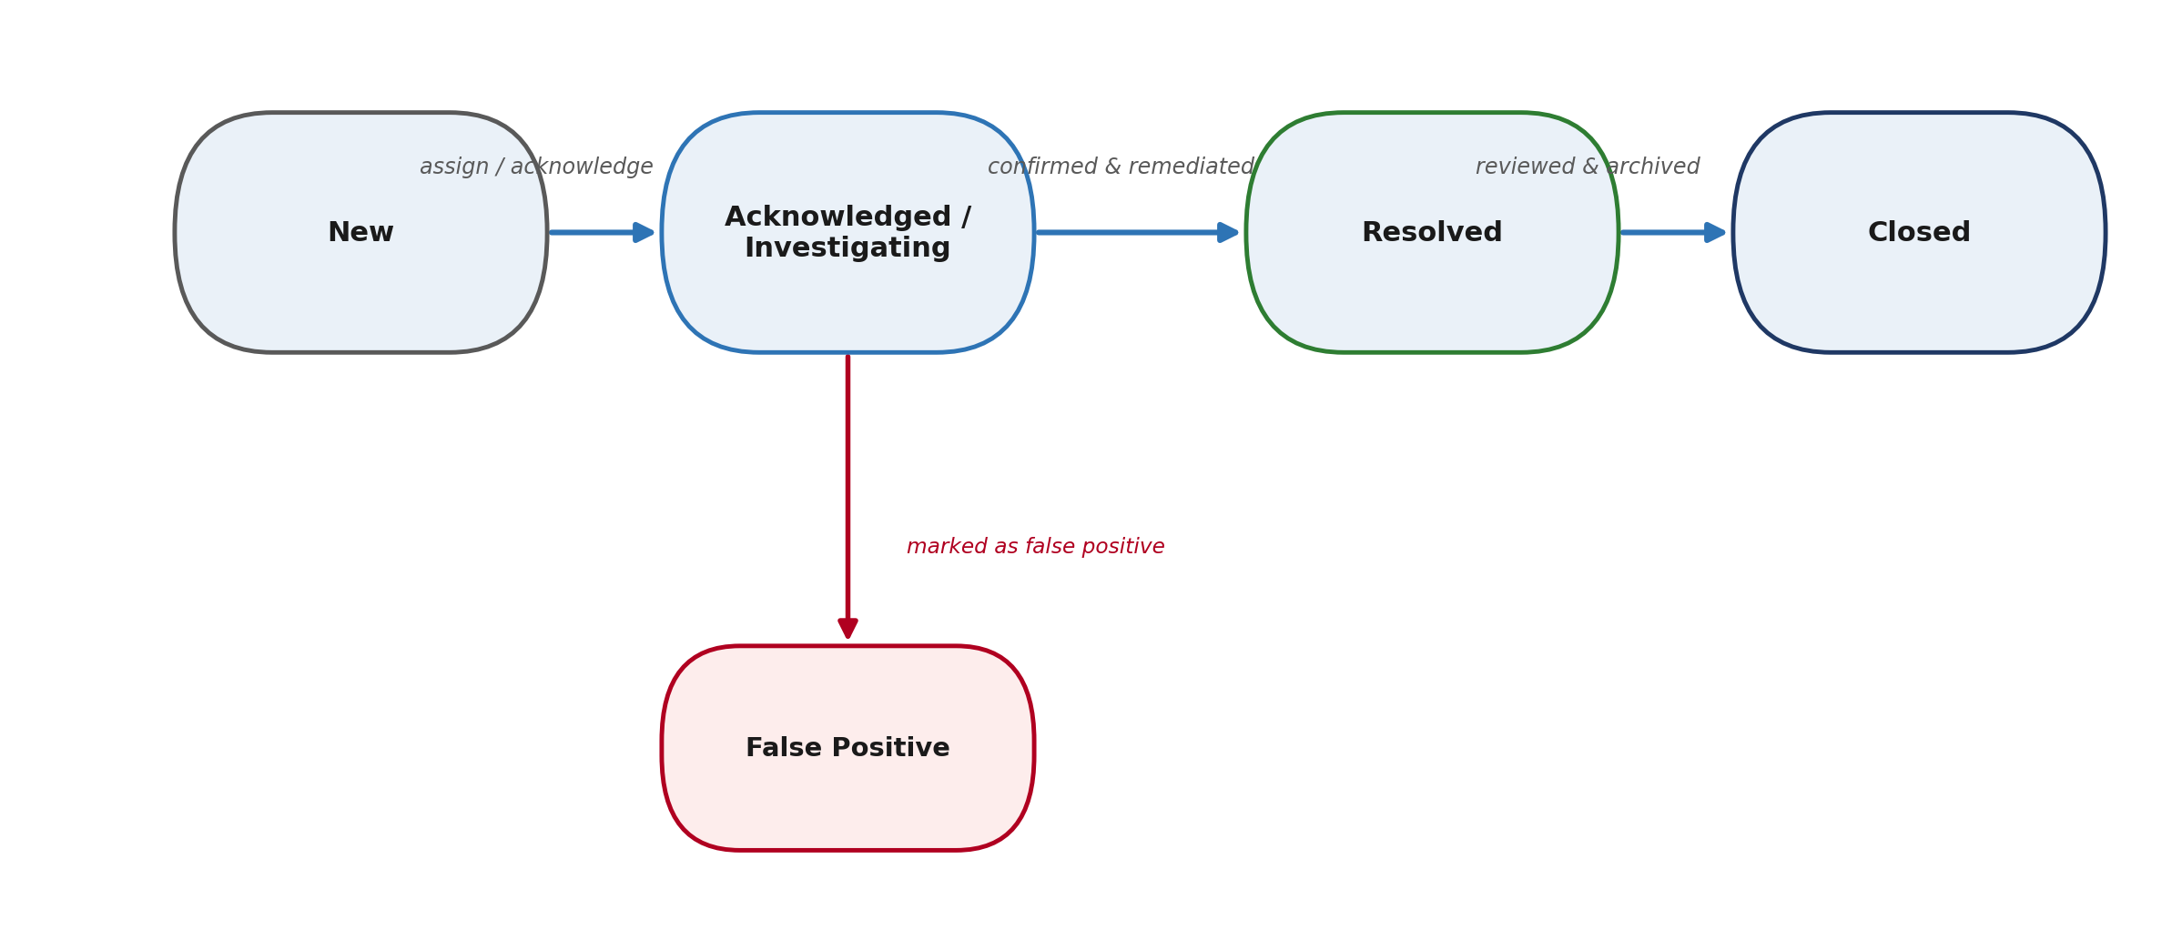
Figure 5.5: Alert lifecycle state diagram
Every alert moves through a defined state machine: New alerts are assigned and Acknowledged/Investigating; once confirmed and remediated they become Resolved and are ultimately Closed after review. At the acknowledgement stage, an analyst may instead determine the alert is a False Positive, which removes it from the active queue without discarding its record — false positives remain available for tuning detection rules.

5.4.3 Investigation & Incident-Response Workflow
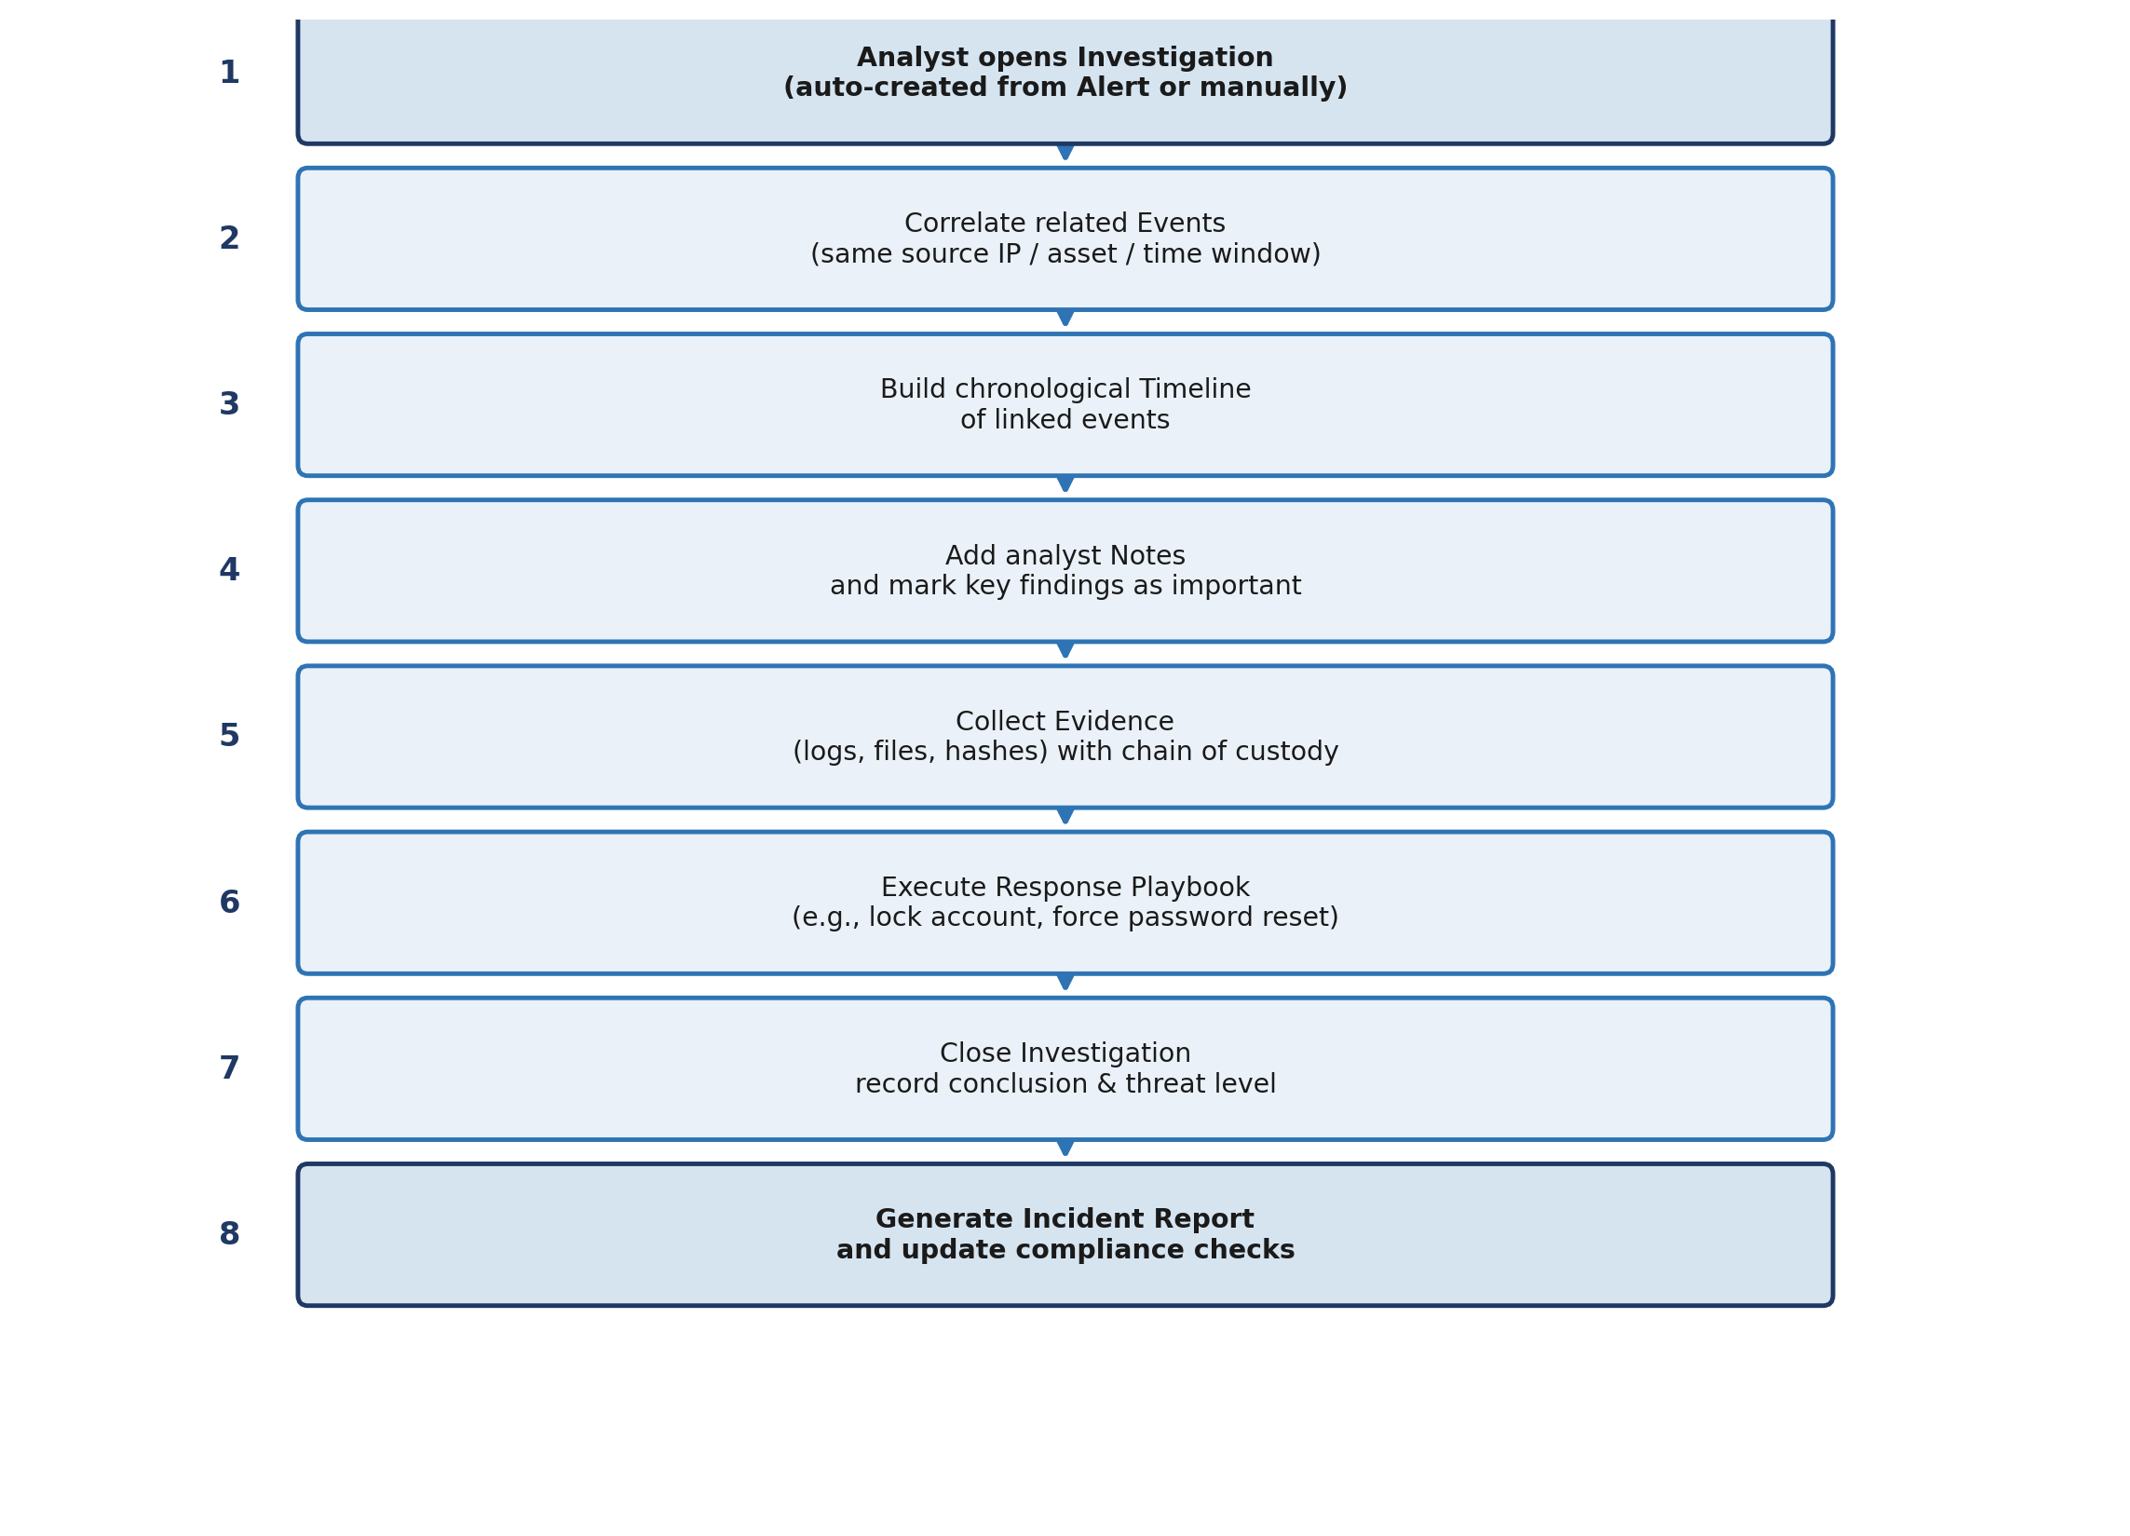
Figure 5.6: Investigation and incident-response workflow
Once an investigation is opened — automatically from an alert or manually by an analyst — related events sharing a source IP, asset, or time window are correlated and assembled into a chronological timeline. The analyst adds notes, flags key findings as important, and collects evidence with a recorded chain of custody. Where applicable, a response playbook (e.g., disabling a compromised account) is executed automatically or semi-automatically. Once the analyst is satisfied the incident is contained, the investigation is closed with a recorded conclusion and threat level, and an incident report is generated, updating any relevant compliance checks.

5.5 Database Design
The system uses Django's ORM as an abstraction layer over the physical database, which allows the same model code to run against SQLite in development and PostgreSQL in production without modification. This was a deliberate non-functional requirement (NFR-04) to keep local development friction-free while ensuring the schema is production-ready from day one. Critical fields — timestamp, source IP, severity, and status — are indexed on the Event and Alert tables to keep filtering and time-range queries performant as data volume grows.

6. Technology Stack & Infrastructure

6.1 Backend
Component | Technology | Version
Web framework | Django | 4.2.x LTS
Language | Python | 3.11+
Database (development) | SQLite | db.sqlite3
Database (production) | PostgreSQL (via Supabase) | —
ORM | Django ORM | Built-in
Authentication | Django Auth | Built-in, session-based
AI integration | OpenAI API | GPT-4o
WSGI server | Gunicorn | 21.x
Django was selected for its "batteries-included" philosophy: authentication, ORM, admin interface, forms, and CSRF protection are provided out of the box. This allowed development effort to concentrate on security-domain logic (parsing, correlation, AI-assisted analysis) rather than re-implementing common web-application infrastructure.

6.2 Frontend
Component | Technology
Markup | Django Templates (Jinja2-compatible)
Styling | Vanilla CSS with custom properties (CSS variables)
Interactivity | Vanilla JavaScript — no SPA framework
Charting | Chart.js 4.x
Mapping | Leaflet.js 1.9.x (for geolocated threat visualisation)
Icons | Phosphor Icons
Typography | Inter (body text) and JetBrains Mono (metrics / log data)
A framework-free frontend was a deliberate architectural choice. Server-side rendering via Django Templates avoids the complexity of maintaining a separate API surface purely to feed a single-page application, and CSS custom properties provide complete control over the dual-theme design system without a build/compile step.

6.3 Infrastructure & Deployment Path
Browser → Nginx (reverse proxy) → Gunicorn (WSGI) → Django Application → Database
Local development: python manage.py runserver (http://localhost:8000)
Production: Gunicorn + Nginx + PostgreSQL, with Celery/Redis available
for future asynchronous task processing

6.4 Application Structure
backend/
├── apps/
│ └── core/ # Main application module
│ ├── models.py # All data models
│ ├── views.py # View controllers
│ ├── log_parser.py # Log ingestion & parsing engine
│ ├── alert_generator.py # Rule-based alert correlation
│ ├── investigation_ai.py # AI-assisted recommendations
│ ├── report_generator.py # Multi-format report generation
│ ├── admin.py # Custom admin interface
│ ├── forms.py # Django forms (11 forms)
│ ├── urls.py # URL routing
│ └── serializers.py # DRF serializers for API views
├── templates/
│ ├── base.html # Master layout (sidebar, theme)
│ ├── siem/ # All SIEM page templates
│ └── registration/ # Authentication templates
├── static/
│ └── css/styles.css # Global design system
└── project/
└── settings.py # Django configuration

6.5 Justification of Technology Choices
Decision | Justification
Django over a micro-framework (Flask/FastAPI) | Built-in ORM, admin, and auth remove the need to hand-build user management and a data-admin console
SQLite in development, PostgreSQL in production | Zero-configuration local development; production-grade concurrency and scalability when deployed
Server-rendered templates over a JS framework (React/Vue) | Eliminates a separate API layer and build pipeline for a single-developer project with a fixed page set
Chart.js over a heavier visualisation library | Lightweight, well-documented, and sufficient for the dashboard's trend/severity/attack-pattern charts
OpenAI GPT-4o for the investigation assistant | High-quality natural-language reasoning over structured alert/event context with a simple REST integration

7. Implementation
This chapter walks through the implementation module by module, describing what each component does, how it was built, and the design decisions behind it.

7.1 Log Parser (log_parser.py)
The parser uses a pipeline of compiled regular expressions to classify incoming log lines through four stages:
- Format detection — the line is matched against known format patterns in priority order: Apache Combined → Apache Common → Syslog → JSON.
- Field extraction — structured fields are pulled out: timestamp, source IP, HTTP method, URI, status code, user agent, and message body.
- Event classification — secondary regex patterns examine the URI and message body to classify the event: SQL-injection signatures in parameters, authentication-failure keywords in syslog messages, port-scan indicators (sequential port access from a single IP), and brute-force patterns (repeated failed authentication from the same source).
- Severity assignment — an initial severity (Low / Medium / High / Critical) is assigned based on event type and contextual signals.
Metric | Value
Lines of code | ~380 (log_parser.py) plus ~280 in the standalone parsing utility module
Supported formats | Apache Common, Apache Combined, Syslog, JSON — 7 formats counting Windows Event, Firewall, and Generic variants in the upload UI
Threat types detected | SQL Injection, XSS, Path Traversal, Command Injection, Code Execution, Brute Force
Measured throughput | ~50,000 log lines per minute on standard development hardware
A key robustness decision made during Sprint 4 was to detect log format on a per-line basis with graceful fallback, rather than assuming a single uniform format for an entire uploaded file — mixed-format files (common when multiple sources are concatenated) previously caused the parser to fail outright.

7.2 Alert Generator (alert_generator.py)
The alert generator runs after log parsing completes. It queries recently parsed events and applies a set of correlation rules:
Rule | Logic
Brute Force | Five or more authentication failures from the same IP within 10 minutes
SQL Injection | Any event classified as SQL injection returning an HTTP 200 response
Port Scan | Ten or more unique ports accessed from the same IP within 5 minutes
Privilege Escalation | A successful authentication immediately following repeated failures from the same IP
Data Exfiltration | Outbound response size greater than 10MB to an external IP
Alerts are deduplicated: if an identical rule fires again for the same IP within the deduplication window, the existing alert is updated in place rather than a duplicate being created, keeping the analyst's alert queue meaningful rather than repetitive.

7.3 Dashboard (views.py::dashboard)
The dashboard view aggregates three categories of data entirely server-side before handing them to Chart.js:
- Count metrics — total events, active alerts, open investigations, and critical alerts, computed via Django ORM .count()/.filter() calls.
- Time-series data — events per day for the last 7 days using TruncDay aggregation, driving the trend line chart.
- Distribution data — alert severity breakdown and top event types, driving the pie and bar charts.
All aggregation happens server-side; results are passed to the template as Python dictionaries serialised to JSON via Django's json_script tag for safe injection into Chart.js datasets, avoiding any risk of template-based script injection.

7.4 AI Investigation Assistant (investigation_ai.py)
When an analyst opens an investigation, the assistant module performs five steps:
1. Fetches all linked Alert objects and their underlying ParsedEvent records.
2. Constructs a structured prompt containing the alert summary, event types, affected IPs, timestamps, severity, and any existing analyst notes.
3. Submits the prompt to the OpenAI API (gpt-4o, temperature = 0.3 for consistent output).
4. Parses the numbered response into individual RecommendedAction records stored against the investigation.
5. Renders the actions as interactive checkboxes in the investigation detail view.
Results are cached per investigation to avoid redundant API calls on page refresh, and — satisfying non-functional requirement NFR-07 — the system falls back to static, rule-based suggestions if no OpenAI API key is configured, so the investigation workflow never hard-fails due to a missing external dependency.

7.5 User Management & Role-Based Access Control
Two roles are defined:
- Analyst — can view all security data, create investigations, add notes, and import logs.
- Administrator — full Analyst privileges plus user creation/deactivation, system settings, detection-rule configuration, and report export.
Role is determined by Django's built-in is_superuser flag, extended by a custom AnalystProfile model carrying additional metadata (department, phone, notification preferences, API key). Every view is decorated with @login_required; administrator-only views additionally check request.user.is_superuser, and every significant action is written to the AuditLog model — capturing the acting user, action type, affected resource, old/new values, timestamp, and IP address.

7.6 Data Management
Because an operational SIEM must manage data volume as carefully as it manages detection accuracy, a dedicated data-management discipline was defined covering ingestion, storage, cleaning, and deletion.

7.6.1 Ingestion
- API ingestion (/api/v1/logs/) — external systems and forwarders push structured JSON event payloads directly into the platform.
- Web UI upload (/logs/) — analysts manually ingest historical CSV or line-delimited log files, which are processed into Event records through the same parser pipeline.
- Anomaly signals — the UEBA/ML layer continuously analyses user behaviour and automatically raises AnomalyDetection records when a baseline deviation is triggered.

7.6.2 Storage
- Local development defaults to SQLite (db.sqlite3) at the root of the backend/ directory when no DATABASE_URL is set.
- Production storage is driven by the DATABASE_URL environment variable and is securely pooled in Supabase (PostgreSQL) for scalable, concurrent access.
- The bulk of data growth occurs in the core_event (raw/parsed logs) and core_alert (detected threats) tables, which is why both are indexed on timestamp and severity (see §5.5).

7.6.3 Cleaning
- Superusers can bulk-select and delete old incidents or alerts through the custom admin panel (/admin-panel/) or the default Django admin (/admin/).
- Best practice — not yet automated — is to prune Event rows older than the organisation's retention policy (e.g., 90 days) via a scheduled Celery task; this is recorded as a Chapter 10 recommendation.

7.6.4 Deletion
- Individual records (Event, Alert, Investigation) can be deleted through the Django admin's "Delete selected" action.
- A full local reset is performed by deleting db.sqlite3 and re-running python manage.py migrate; in production, a full wipe is performed via an SQL TRUNCATE core_event CASCADE; statement through the Supabase console.
- Deleting an Event cascades to drop its associated alerts and MITRE mappings, so mass deletions are always preceded by a database backup.

7.7 API Layer
The platform exposes a functional API today (/api/events/, /api/alerts/stats/, /api/threat-map/) authenticated via Django session cookies, and the codebase includes ready-to-enable Django REST Framework serializers and viewsets for Events, Alerts, IOCs, and Investigations, giving a clear upgrade path to a fully versioned, token-authenticated REST API (/api/v1/) without restructuring the underlying models. Full endpoint listings are provided in Appendix A.

7.8 User Interface & Theming
The UI is built on a CSS custom-property design system. Dark mode uses near-black backgrounds (#080c08) with neon-green accents (#22c55e), optimised for low-ambient-light SOC environments; light mode uses cream/off-white backgrounds (#f2ede3) with deep forest-green accents (#16a34a), suited to daytime analysis or presentation contexts. The theme choice is persisted in localStorage and applied before page render via an inline script to prevent a flash of the wrong theme. The left sidebar is collapsible to an icon-only 72px rail, highlights the active page, and becomes an off-canvas drawer on viewports narrower than 768px.
Page | Primary Function
Dashboard | Security posture overview with metric cards and charts
Events | Paginated table of classified security events with filters
Alerts | Alert list with severity badges, status filtering, quick-resolve
Investigations | Case list and detail view with AI-suggested checklist
Logs | Log file import and raw log viewer
Search | Cross-entity full-text search
Settings | System configuration and log-source management
Admin Panel | User management (Administrators only)

7.9 Code Statistics
Module | Approx. Lines
log_parser.py | ~380
report_generator.py | ~350
views.py (interactive views added) | ~400 added
forms.py (11 forms) | ~200
Total functional code added in the interactive-features phase | ~1,230

8. Testing

8.1 Testing Approach
Each module was manually tested at the end of its sprint against the functional requirements defined in Chapter 4, rather than deferring all testing to the end of the project. This matched the Agile methodology described in Chapter 3: a module was not considered "done" until its expected behaviour had been verified against representative input.

8.2 Test Data
A dedicated sample log file (test_sample.log) was created to exercise the parser and alert engine end to end. It contains 12 log entries spanning three threat types (Brute Force, SQL Injection, and Cross-Site Scripting) at multiple severity levels.
Metric | Expected Result
Events created | 12
Alerts generated | 3
Threats detected | 3 (Brute Force, SQL Injection, XSS)
Severity levels represented | All 5 (Info, Low, Medium, High, Critical)

8.3 Functional Test Results
Scenario | Expected Result | Result
Upload valid Apache log file | Events parsed, categories assigned, alerts generated | Pass
Upload malformed log file | Graceful error message displayed; no crash | Pass
Brute-force threshold triggered | Alert created with High severity | Pass
Non-admin user accesses admin panel | Redirected to login / 403 | Pass
Investigation AI suggestions requested | Numbered recommendations rendered as checkboxes | Pass
Theme toggle persists on refresh | Correct theme reloaded from localStorage | Pass
Sidebar collapse persists on navigation | Collapsed state maintained across page loads | Pass
Advanced search across entities | Returns matching events, alerts, and investigations | Pass

8.4 Verification Checklist
Beyond scenario-based testing, the following platform-level checks were independently verified:
- Django server starts without errors
- All models are accessible via the ORM
- API endpoints respond correctly per the expected structure
- The admin interface is functional
- The authentication system works correctly, including password hashing and session handling
- The SQLite → PostgreSQL fallback / configuration logic is operational

8.5 Known Limitations
- Scale — SQLite is not suitable for production deployments ingesting more than roughly one million log lines. A PostgreSQL migration is straightforward given the Django ORM abstraction but was not exercised at production scale within the project timeline.
- Real-time ingestion — log import is presently file-upload based; streaming, agent-based ingestion was descoped (see §1.4.2).
- AI dependency — the investigation-assistant feature requires a valid OpenAI API key; the system degrades gracefully to static, rule-based suggestions if the key is absent, but the richer contextual analysis is unavailable in that mode.

9. Results & Discussion

9.1 Objectives Achieved
Measured against the nine specific objectives defined in §1.3.2, the completed system achieves full coverage:
# | Objective | Status
1 | Log ingestion and multi-format parsing engine | Completed
2 | Automated alert generation from correlated events | Completed
3 | Investigation / case management module | Completed
4 | Real-time dashboard with security metrics and charts | Completed
5 | AI-assisted investigation guidance | Completed
6 | Role-based access control (Admin / Analyst) | Completed
7 | Advanced search across all security entities | Completed
8 | Responsive UI with dark/light theming | Completed
9 | MITRE ATT&CK mapping for detected threats | Completed

9.2 Feature Delivery Summary
Beyond the headline objectives, the implementation phase delivered a broad set of user-facing actions across seven functional areas, summarised below rather than itemised exhaustively:
Functional Area | Representative Capabilities Delivered
Search | Keyword search, filter by severity/category/time/IP, cross-entity advanced search, saved searches
Log upload | File upload with type selection or auto-detect, live parse statistics, generated-alert preview
Alert management | Acknowledge, assign, investigate, resolve, close, mark false positive, add notes
Investigation management | Create, filter, note, timeline view, evidence attachment, team assignment, status update, close with resolution
Reporting | Six report types across JSON/CSV/HTML with custom date ranges and automatic statistics
Profile & admin | Update profile, change password, view activity stats, manage users, configure log sources and rules
Export | Filtered CSV export of events with automatic audit logging

9.3 Challenges Encountered and Resolutions
Challenge | Resolution
Dashboard NameError crash on an undefined AI variable | Added a null-safe guard in the view, initialising ai_insights = None before conditional assignment
Sidebar collapse button had no visible effect | Root cause: the .sidebar-collapsed class existed in JavaScript but had no corresponding CSS rule; fixed by adding explicit width and min-width overrides and hiding label spans in the collapsed state
Log parser failing on mixed log formats in a single file | Replaced whole-file format assumption with line-by-line format detection and per-line fallback
Chart.js receiving undefined data on an empty database | Added json_script-safe serialisation with empty-array defaults for all chart datasets
Investigation notes duplicating on page refresh | Changed note submission to a POST-redirect-GET pattern to prevent browser re-submission
CSRF token errors on the investigation checklist AJAX calls | Added an X-CSRFToken header to every fetch() call, sourced from the Django CSRF cookie

9.4 Discussion
The most significant technical achievement of the project is the end-to-end pipeline demonstrated in Chapter 5: a raw Apache or syslog file uploaded by an analyst is automatically parsed, classified, correlated into alerts, mapped against MITRE ATT&CK, and presented with AI-suggested remediation steps — all within a single, cohesive interface, without the analyst needing to touch a second tool. This validates the core hypothesis behind the project: that a single, well-structured Django application can deliver the essential SIEM analyst workflow without the operational overhead of a distributed log-analytics stack.
The iterative, sprint-based methodology proved effective in a solo-developer context. Structural decisions made early (model hierarchy, URL routing, template inheritance) held firm through to the end of the project, while later sprints were free to focus on user-experience refinement and defect resolution without having to revisit the data layer. This is reflected in the challenges log in §9.3, where every recorded issue was a presentation-layer or integration bug rather than a schema-level defect requiring rework.
The clearest limitation, discussed in §8.5, is scale: the current SQLite-backed development configuration is appropriate for the SME context the project targets, but a production deployment ingesting high log volumes would need the PostgreSQL migration path (already supported by the ORM abstraction) exercised and load-tested before go-live.

10. Conclusion & Recommendations

10.1 Conclusion
Rebaden successfully meets all nine objectives defined at the outset of the project. The platform delivers a complete security-analyst workflow — from raw log import through event correlation, alert triage, and structured investigation, to AI-assisted remediation and multi-format reporting — in a self-hosted, single-engineer-deployable package. The system directly addresses the problem statement in Chapter 1: SMEs and small security teams now have a credible, affordable alternative to enterprise SIEM licensing for establishing a baseline security-monitoring capability.
The Agile, sprint-based methodology described in Chapter 3 was well suited to a solo-developer project of this scope, allowing structural decisions to be validated early and user-facing polish to be layered on in later sprints without destabilising the data model. Manual testing (Chapter 8) confirmed correct behaviour across the core workflows, and the challenges encountered during development (§9.3) were resolved without requiring architectural rework.

10.2 Recommendations for Future Work
The following priorities are recommended for a subsequent development phase:
- PostgreSQL migration and load testing — exercise the already-supported PostgreSQL configuration at production-representative log volumes to validate the indexing strategy under real concurrency.
- Real-time log agent integration — move beyond file-upload ingestion to streaming ingestion via lightweight forwarders (e.g., Filebeat-style agents) for near-real-time detection.
- SOAR playbook automation — extend the existing Playbook/PlaybookExecution models into fully automated, multi-step response actions (account lockout, firewall rule changes, ticket creation) rather than the current semi-automated execution.
- Third-party threat-intelligence feed connectors — integrate STIX/TAXII-compatible feeds to keep the IOC store current without manual entry.
- Automated data retention — implement the scheduled Celery task described in §7.6.3 to prune Event rows beyond the organisation's retention policy without manual admin intervention.
- Formal automated test suite — convert the manual scenario tests in Chapter 8 into an automated Django test suite (unit and integration) to guard against regression as new features are added.
- Native mobile companion app — extend visibility into critical alerts and investigation status to mobile devices for on-call analysts, as scoped out in §1.4.2.

11. References
[1] Django Software Foundation. Django Documentation. https://docs.djangoproject.com/
[2] Django REST Framework. Official Documentation. https://www.django-rest-framework.org/
[3] MITRE Corporation. MITRE ATT&CK Framework. https://attack.mitre.org/
[4] OWASP Foundation. OWASP Top Ten. https://owasp.org/www-project-top-ten/
[5] National Institute of Standards and Technology. NIST Cybersecurity Framework. https://www.nist.gov/cyberframework
[6] OpenAI. GPT-4o Model Documentation. https://platform.openai.com/docs/
[7] Chart.js Contributors. Chart.js Documentation. https://www.chartjs.org/docs/
[8] Splunk Inc. Splunk Enterprise Security Documentation. https://www.splunk.com/
[9] IBM. IBM QRadar SIEM Documentation. https://www.ibm.com/qradar
[10] Wazuh Inc. Wazuh Documentation. https://documentation.wazuh.com/
[11] Elastic NV. Elastic Security Documentation. https://www.elastic.co/security

Appendix A — API Quick Reference
Base URL (session-authenticated, current build): http://127.0.0.1:8000/
Endpoint | Method | Description
/api/events/?range=24h | GET | Retrieve security events for a time range (1h / 24h / 7d)
/api/alerts/stats/ | GET | Alert counts grouped by severity and status
/api/threat-map/ | GET | Geolocation data for threat-map visualisation
Planned versioned REST API (Django REST Framework, token-authenticated):
Resource | Base Path
Events | /api/v1/events/ (+ by_severity/, by_category/, time_series/, bulk_create/)
Alerts | /api/v1/alerts/ (+ by_status/, open_alerts/, {id}/take_action/)
Investigations | /api/v1/investigations/ (+ add_note/, add_evidence/, close/, open/)
Detection Rules | /api/v1/detection-rules/ (+ test/, enabled/, bulk_update/)
MITRE ATT&CK | /api/v1/mitre-tactics/, /api/v1/mitre-techniques/, /api/v1/mitre-mappings/
IOCs | /api/v1/iocs/ (+ by_type/, critical/, {id}/mark_resolved/)
Playbooks | /api/v1/playbooks/ (+ {id}/execute/)
Reports | /api/v1/reports/ (+ {id}/generate/, {id}/download/, schedule/)
Compliance | /api/v1/compliance-frameworks/, /api/v1/compliance-checks/

Appendix B — URL Route Reference
Feature | URL | Description
Dashboard | /dashboard/ | Main SIEM dashboard with metrics
Events | /events/ | Security events and logs
Alerts | /alerts/ | Active security alerts
Investigations | /investigations/ | Incident investigations
Logs | /logs/ | Log file import and raw log viewer
Threat Intel | /threat-intel/ | IOCs and threat actors
Detection Rules | /detection-rules/ | Correlation and detection rules
MITRE ATT&CK | /mitre-attack/ | MITRE framework browser
UEBA | /ueba/ | Behaviour analytics and anomalies
Compliance | /compliance/ | Compliance frameworks
Reports | /reports/generate/ | Report generation
Playbooks | /playbooks/ | Incident response playbooks
Search | /search/ | Cross-entity advanced search
Profile | /profile/ | User profile management
Settings | /settings/ | System configuration
Admin Panel | /admin-panel/ and /admin/ | User and data administration

Appendix C — Quick Start Guide

C.1 Setup
# Clone and set up
git clone <repo-url>
cd rebaden/backend
# Install dependencies
python -m venv venv && source venv/bin/activate
pip install -r requirements.txt
# Configure environment
cp .env.example .env
# Edit .env: set SECRET_KEY, OPENAI_API_KEY
# Initialise database
python manage.py migrate
python manage.py createsuperuser
# Run
python manage.py runserver
# Visit: http://127.0.0.1:8000

C.2 Default Access
- Dashboard: http://127.0.0.1:8000/dashboard/
- Admin interface: http://127.0.0.1:8000/admin/
- Default credentials (development only): admin / admin123 — must be changed before any non-local deployment

C.3 Key File Reference
File | Role
apps/core/models.py | All database models
apps/core/views.py | All view controllers
apps/core/log_parser.py | Log ingestion and parsing
apps/core/alert_generator.py | Alert correlation rules
apps/core/investigation_ai.py | AI-assisted recommendations
apps/core/report_generator.py | Multi-format report generation
apps/core/forms.py | All user input forms
templates/base.html | Master layout (sidebar, navigation, theme)
static/css/styles.css | Global design system and theming
— End of Report —

