# M08 Final Project

Joshua Stumpf

12/4/23

SDEV 140 - Intro. to Software Development

**Validation testing**

* **Test data and results:**

**1-Test Case 1: Adding a Valid Task**

Input: "Read a book"

Expected Outcome: "Read a book" is added to the "House" category.

**2-Test Case 2: Adding an Empty Task**

Input: ""

Expected Outcome: a window that tells the user to enter a valid task.

**3-Test Case 3: Adding a Task with Non-Alphabetic Characters**

Input: "1234"

Expected Outcome: Error is displayed, prompting the user to enter a valid task.

**4-Test Case 4: Toggling Task Status**

Assuming there's a task "Clean the house" in the "House" category with status "Not Done".

Input: Click on "Toggle Task" button for "Clean the house"

Expected Outcome: Status of the task should change to "Done".

**5-Test Case 5: Deleting a Task**

Assuming there's a task "Do laundry" in the "House" category.

Input: Click on "Delete Task" button for "Do laundry"

Expected Outcome: The task should be removed.

**6-Test Case 6: Viewing Task Details**

Assuming there's a task "Finish homework" in the "School" category with status "Not Done".

Input: Click on "View Details" button for "Finish homework"

Expected Outcome: ("Task: Finish homework

Status: Not Done"). Should appear in a new window.

* **Data tested against:**

tasks = {

"House": [("Clean the house", False), ("Do laundry", False)],

"School": [("Finish homework", False), ("Study for exam", False)],

"Gym": [("Curl Ups exercise", False)]

}

* **What I had to fix:**

I had to control the input data by adding an if statement that makes sure the user input is a string that isn’t empty and free of any numeric data.

* **Screenshots:**

**Case 1: Cases 2 and 3:**

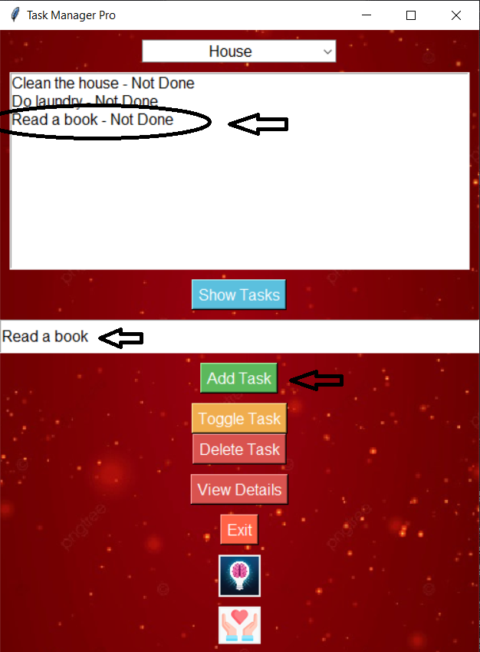 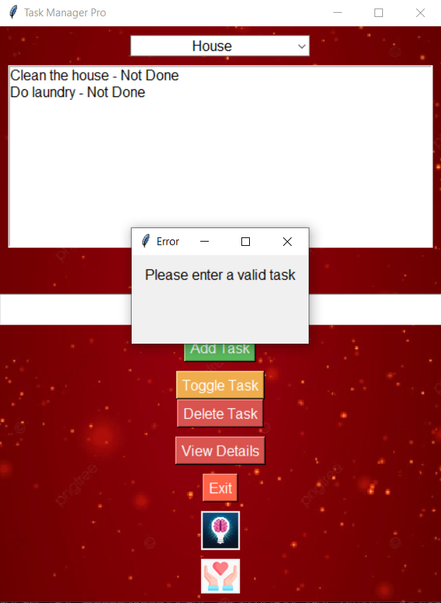

**Case 4: Case 5**

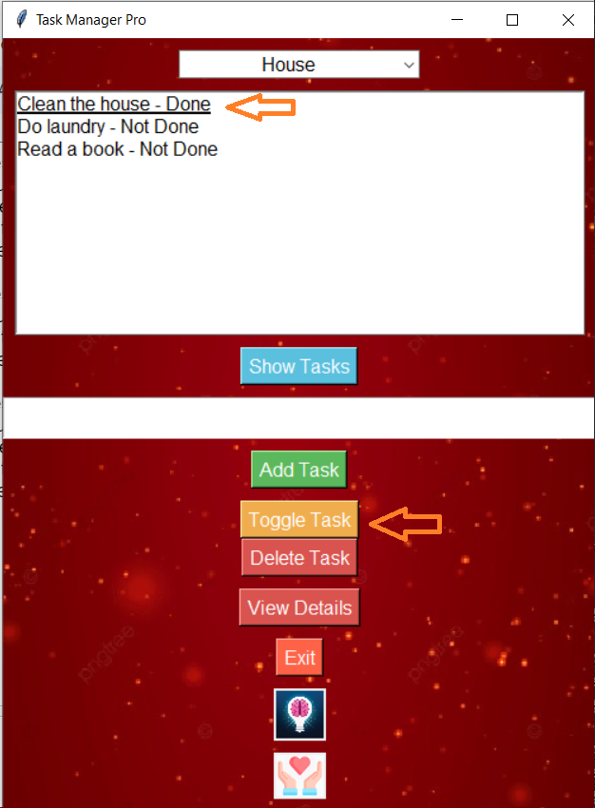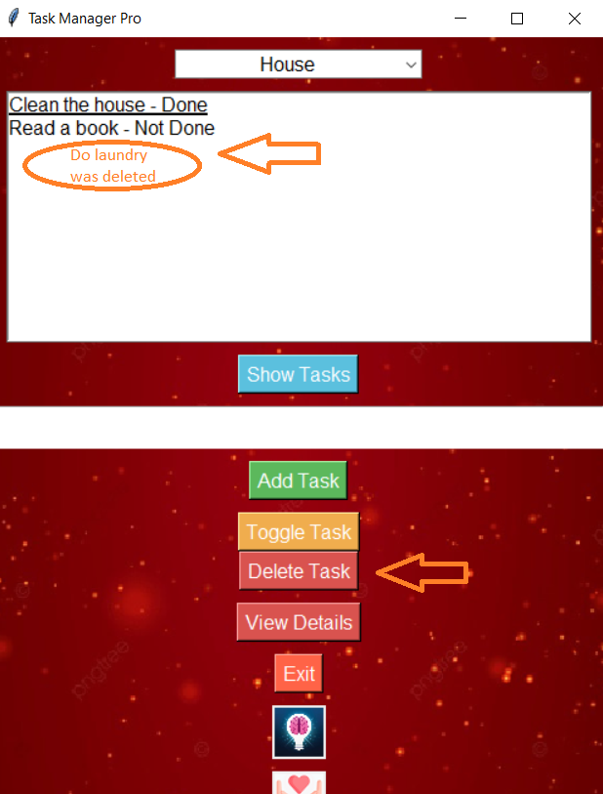

**Case 6:**

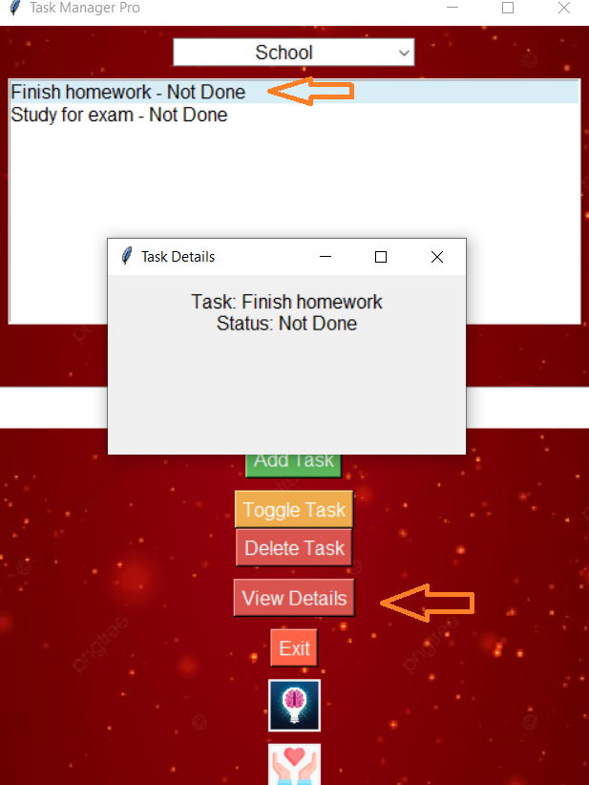

**User manual:**

* Task manager pro is a program that helps you manage your day to day tasks. Currently there are 3 categories: House, School, and Gym.
* Choose a category and click the “Show Tasks” button, various tasks will appear and
* their status (Done / Not Done) next to them.
* You can toggle tasks using the “Toggle Task” button.
* You can add a task by entering a valid task name in the small text field. (alphabetical letters and spaces. Numeric data is invalid.)
* In order to delete a task, select it and click the “Delete Task” button.
* To see further details on a task, select it and click the “Show Details” button and it will display the name and status of the selected task.
* If you want to exit the program, click the “Exit” button.