Assignment 6

Project description:
The project primarily involves the use of a python script, sqlpt.py. to automate the testing of sites’ responses to potential problematic inputs. It then generates a few short lines of code to show which forms in the target page are reported what sort of responses. This can then be analysed to aid in fuzz testing. It should work with all sites that do not dynamically load their forms, which should include most sites carrying more sensitive data. Includes a selector to generate baseline test data to allow for comparison with fuzz tested inputs.

To facilitate testing, a webapp using Flask running the Jinja framework was set up, which mimics a paper trading site, that comes with user profiles and related authentication means (i.e. password checks). The underlying python code has been set up to allow for ease of toggling the vulnerability of certain SQL calls by helping the program decide on whether to run less secure code using standard python string concatenation, or more specialised operators that should be less impacted by SQL injection attacks.

Design and implementation
There are a few parts of the project:
- Pentesting script:
- sqlpt.py: the script to launch the fuzz test
- Dummy target site scripts:

Their design and implementation are as follows:
sqlpt.py:
- Contains fields within the code that allow for the selection of the site to test.
- First runs get_data() to get site information to characterise the site, and extract form action data
- Next, for each form action, runs, for that form:
  - generate_payload(), to generate custom fuzztest payload for the form
  - locally uses relative path data to generate payload destinations
  - runs test_payload() to launch payload, getting site response code for analysis
- Collects all site response data (and optionally baseline test data) and presents it in a nice report to show which forms are vulnerable to fuzz.

This runs on a number of sub-functions, which work as follows:
- def get_data():
  - Runs beautifulSoup to extract information required to characterise each form and its inputs. Neatly puts the data into a dict with schema forms[action]=[inputfield1, inputfield2, …]
- def generate_payloads(fields, warheads):
  - For a list of fields, and a list of warheads, generates payloads of the form:
    - Payloads[warhead]={“field1”:warhead, “field2”:warhead}, for different warheads.
  - This is used for later testing, where different warheads are sent as inputs to different form actions.
- def test_payload(URL, payload):
  - Submits the payload to the target URL, which is the action of the form (i.e. current_URL>action)
  - Records in a list critical parameters like response status code, page char length, and page byte length. Also gets a flag for whether the status code >= 500.

Performance test results
The code was tested against two webapps ran using Flask and Jinja, one of which was created by me. For the one created by me, I added code that could induce vulnerability to fuzz testing, by means of using string concatenation instead of standard SQL parametisation, or not, depending on a flag. In both cases the program behaved correctly, noting the right error values and flagging forms as vulnerable, or safe. The program also ran correctly against the webapp not created by me, which was quite unsafe in itself from my analysis. Screenshots detailing each test are shown below.

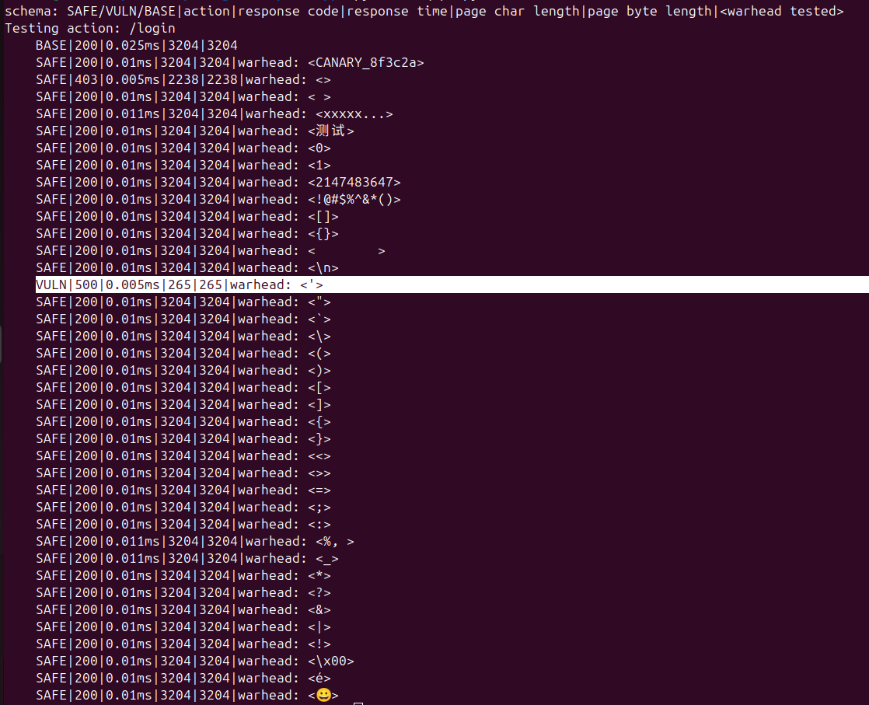
Test results from when own code was made to be vulnerable to SQL injection attacks of the form “ ‘ “, which would break the code and induce an error 500. The other discrepancies with the base case were to be expected by design of the webapp.

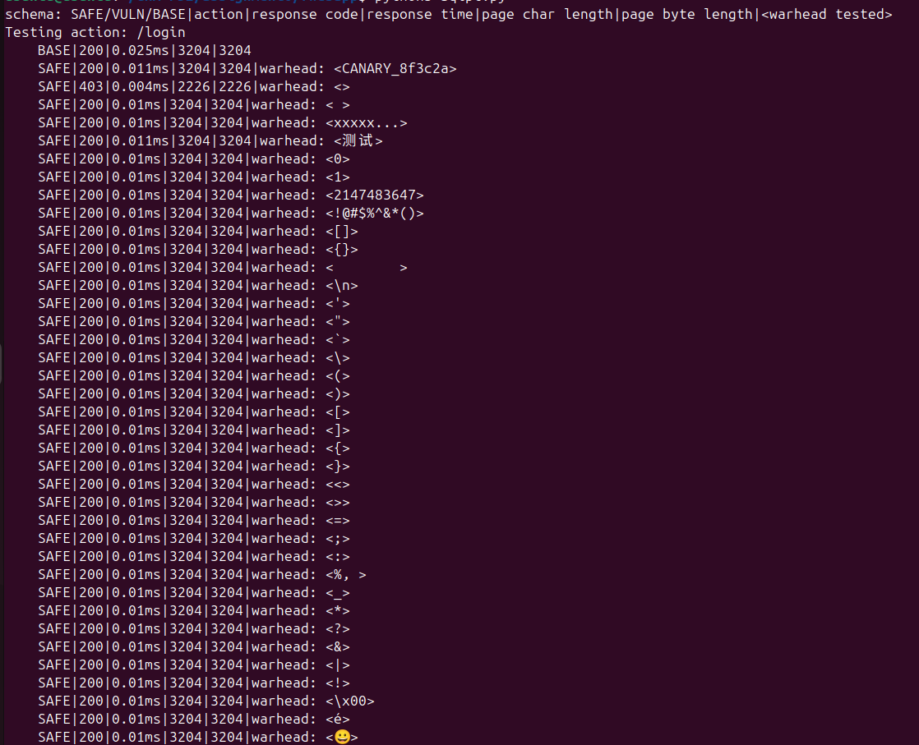
Test results from when I made my webapp safe

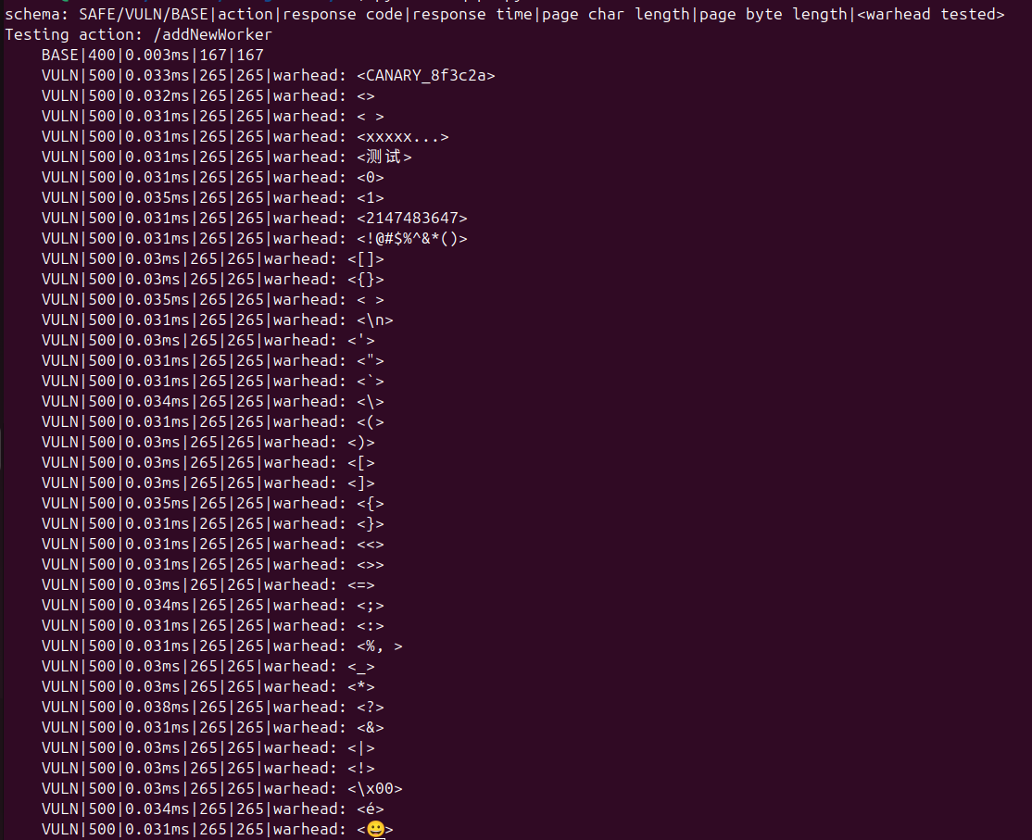
Test results from test against open source Flask webapp. Program clearly cannot handle a great majority of possible fuzz inputs, and can only handle very perfect inputs, like those I provided in my baseline test.

