Assignment 4
Question 2
Returns the address of a function pointer

Question 3
Offset | Output | Notes
8 | Target Function Ptr: 0x4011dc | Just a pointer
24 | Target Function Ptr: 0x4011dc  Success! Malicious function Called!  Segmentation fault (core dumped) | Somehow called a malicious function
30 | Target Function Ptr: 0x4011dc  Segmentation fault (core dumped) | Went too far and hit kernel
40 | Target Function Ptr: 0x4011dc  Segmentation fault (core dumped) | Went too far and hit kernel
60 | Target Function Ptr: 0x4011dc  Segmentation fault (core dumped) | Went too far and hit kernel

Question 4
buf only holds 16 bytes. Therefore, an offset of 24 allows for the filling of these 16, and the full filling of the next 8 memory bytes, which is also the saved RBP, since no local variables are saved/initialised.

Question 5
When the program is run with a small input less than 16 bytes, there are sufficient bytes in buf to store them. Therefore, the necessary number of bytes in buf are filled and that is that. However, when an excessive number of offset is used, the pointer tries to write to an address that is too far beyond buf and into non-editable territory, leading to the segmentation fault.

Question 6
Buf offset | Address | Content
0 | 0x4011DC | ef
1 | 0x4011E4 | be
2 | 0x4011EC | ad
3 | 0x4011F4 | de

Question 7
It is so as it does not impose any limits on the length of the string it is copying, and is just blindly copying information, even if it inadvertently triggers buffer overflow issues.

strcat may be able to avoid this, as it concatenates inputs. It can therefore be used to allow for only the relevant inputs to be inputted, while concatenating any other buffer overflow attack characters.

Question 11
Prompt for input of username and password do not reach segmentation fault.
Prompts for name, department, system command, and response data are vulnerable to segmentation fault with sufficiently long responses. With long enough data inputs, the data is truncated and used as the input for that field, and the excess data used for the next ones and so on. This enables determination of the number of characters expected by the program for the field.

Question 12
An offset size of 264 causes a segfault.

Question 13
It says win is at: 0x401216
It says main is at: 0x401679
Running exploit.py with modified parameters yields:
=====================================
ACCESS GRANTED
=====================================
FLAG: CTF{S3CURITY_CWM_WIN_2_EZ}

The offset used was 264, and target_address 0x401216

Question 18
The program iteratively checks each character, and on seeing a correct one, sleeps for a finite time. However, it immediately returns an output once it sees a mismatch. Therefore when one finds a correct leading character, there is necessarily a longer delay for a response than if there were a wrong leading character.

Question 19
On can brute force test characters iteratively, and thereby get the password.

Question 20
Guess | Time (ms)
0 | 0
1 | 0
2 | 0
3 | 0
4 | 0
5 | 2.1
6 | 0
7 | 0
8 | 0
9 | 0

Question 21
5. This tells me the first value of the password is 5

Question 22
Guess | Time (ms)
50 | 2.2
51 | 4.2
52 | 2.2
53 | 2.2
54 | 2.2
55 | 2.2
56 | 2.2
57 | 2.2
58 | 2.2
59 | 2.2

Question 25
Program was not able to determine the password, possibly due to some sort of bug.
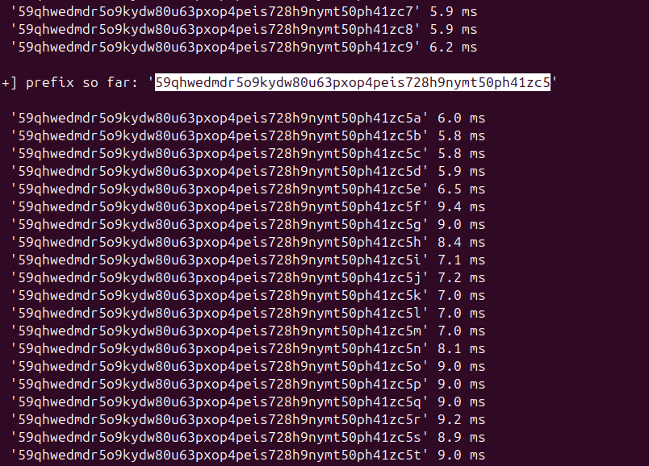
Question 26
New algorithm:

def _vulnerable_check(username: str, password: str) -> bool:
"""
Assumes that the time.sleep function in the case where a correct char is detected is inevitable (e.g. due to some backend process that cannot be removed). Assumes that password length are usually less than 200 characters.
"""
if username != SECRET_USERNAME:
return False

for i, ch in enumerate(password):
if i >= len(SECRET_PASSWORD) or ch != SECRET_PASSWORD[i]:
time.sleep(DELAY_PER_CHAR) # Added false delay to simulate effect of delay from inout of correct char
return False
time.sleep(DELAY_PER_CHAR)
time.sleep(DELAY_PER_CHAR*200) #Added false delay to increase absolute general delay time, so that changes in delay time are absorbed into general delay variance

return len(password) == len(SECRET_PASSWORD)

The solution above does not fundamentally eliminate the side channel, since delays due to the detection of a correct or wrong char may fundamentally come with differences in how the chars are handled (e.g. differences in loading stuff on the backend). It instead seeks to make it much harder to notice difference in behaviours from chars.

Question 27
I would scrutinise them more closely, and not as blindly believe that they are invulnerable despite correctness of their implementation as I had previously believed. Ideally I’d also have access to their code to enable assessment on my end. If this isnt possible I’d probably invest in pentesting to see if I could cover their vulnerabilities somehow.

