# **KPI Requirements:**

1. **Total Revenue**

SELECT SUM(total_price) AS Total_Revenue

FROM pizza_sales



1. **Total Order**

SELECT COUNT(DISTINCT order_id) AS Total_Order

FROM pizza_sales;



1. **Average Order Value**

SELECT (SUM(total_price) / COUNT(DISTINCT order_id)) AS Average_Order

FROM pizza_sales;



1. **Total Pizza Sold**

SELECT SUM(quantity) AS Total_Pizza_Sold

FROM pizza_sales;



1. **Average Pizza per order**

SELECT CAST(CAST(SUM(quantity) AS DECIMAL(10,2)) / CAST(COUNT(DISTINCT order_id) AS DECIMAL(10,2)) AS DECIMAL(10,2)) AS Average_pizza

FROM pizza_sales



# **Chart Requirements**

1. **Daily Trend for total orders**

SELECT

DAYNAME(STR_TO_DATE(order_date, '%d-%m-%Y')) AS order_day,

COUNT(DISTINCT order_id) AS total_order

FROM pizza_sales

WHERE order_date IS NOT NULL

GROUP BY DAYOFWEEK(STR_TO_DATE(order_date, '%d-%m-%Y')), DAYNAME(STR_TO_DATE(order_date, '%d-%m-%Y'))

ORDER BY DAYOFWEEK(STR_TO_DATE(order_date, '%d-%m-%Y'));

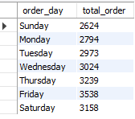

1. **Monthly Trend for total orders**

SELECT

MONTHNAME(STR_TO_DATE(order_date, '%d-%m-%Y')) AS order_month,

COUNT(DISTINCT order_id) AS total_order

FROM pizza_sales

WHERE order_date IS NOT NULL

GROUP BY MONTH(STR_TO_DATE(order_date, '%d-%m-%Y')), MONTHNAME(STR_TO_DATE(order_date, '%d-%m-%Y'))

ORDER BY MONTH(STR_TO_DATE(order_date, '%d-%m-%Y'));

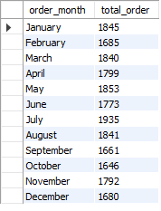

1. **Percentage of sales by pizza category**

SELECT pizza_category, SUM(total_price) * 100 / (SELECT SUM(total_price) FROM pizza_sales ) AS Pizza_PCT_by_cat

FROM pizza_sales

GROUP BY pizza_category;

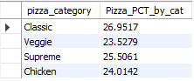

1. **Percentage of sales by pizza size**

SELECT pizza_size, SUM(total_price) * 100 / (SELECT SUM(total_price) FROM pizza_sales ) AS Pizza_PCT_by_size

FROM pizza_sales

GROUP BY pizza_size;

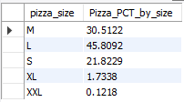

1. **Total pizza sold by pizza category**

SELECT pizza_category, SUM(quantity) AS Total_pizza_sold

FROM pizza_sales

GROUP BY pizza_category;

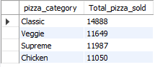

1. **Top 5 best Seller by revenue**

SELECT pizza_name, SUM(total_price) AS Total_Revenue

FROM pizza_sales

GROUP BY pizza_name

ORDER BY SUM(total_price) DESC

LIMIT 5;

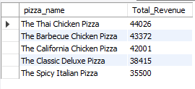

1. **Top 5 best Seller by quantity**

SELECT pizza_name, SUM(quantity) AS Total_Quantity

FROM pizza_sales

GROUP BY pizza_name

ORDER BY SUM(quantity) DESC

LIMIT 5;

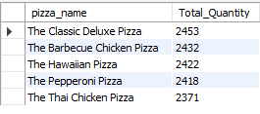

1. **Top 5 best Seller by order**

SELECT pizza_name, COUNT(order_id) AS Total_Order

FROM pizza_sales

GROUP BY pizza_name

ORDER BY COUNT(order_id) DESC

LIMIT 5;

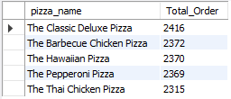

1. **Bottom 5 best Seller by revenue**

SELECT pizza_name, SUM(total_price) AS Total_Revenue

FROM pizza_sales

GROUP BY pizza_name

ORDER BY SUM(total_price) ASC

LIMIT 5;

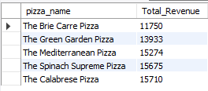

**10) Bottom 5 best Seller by quantity**

SELECT pizza_name, SUM(quantity) AS Total_Quantity

FROM pizza_sales

GROUP BY pizza_name

ORDER BY SUM(quantity) ASC

LIMIT 5;

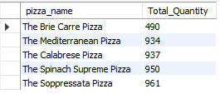

**11) Bottom 5 best Seller by order**

SELECT pizza_name, COUNT(order_id) AS Total_Order

FROM pizza_sales

GROUP BY pizza_name

ORDER BY COUNT(order_id) ASC

LIMIT 5;

