5.1 Screenshots of output and its function
Figure 1: Program Main Menu Interface
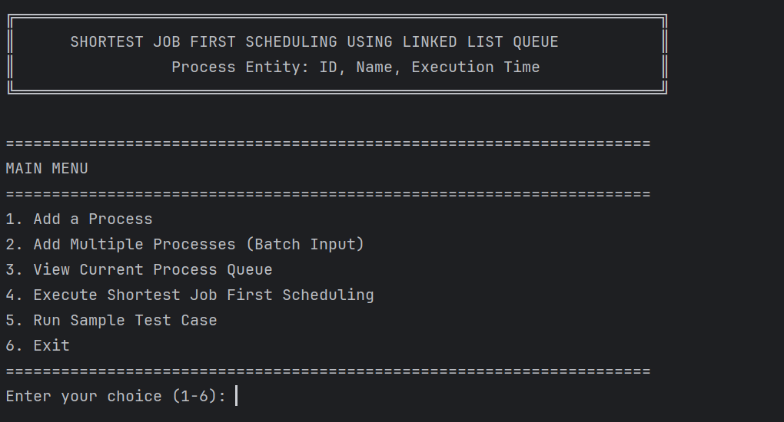

This screenshot shows the main menu of the SJF Scheduler program. The menu displays six options for user interaction: adding single processes, adding multiple processes in batch, viewing the current process queue, executing the SJF scheduling algorithm, running a sample test case, and exiting the program. This demonstrates the structured and user-friendly interface design.The numbers displaying from 1-6 has their own job and function which will be shown in the following screenshots.

Figure 2: Single Process Input Screen
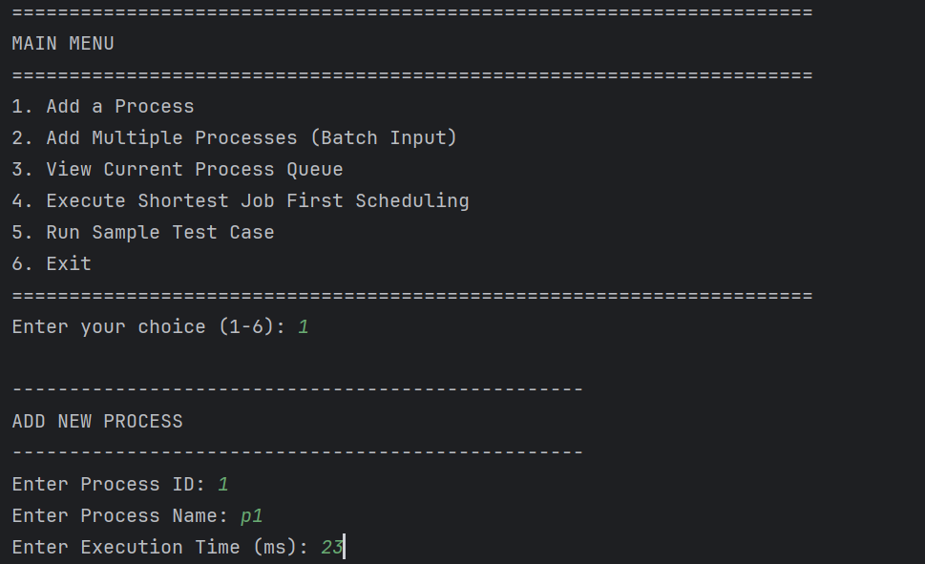
This screenshot captures the interface for adding a single process to the scheduler. The user has selected option 1 and is entering details for process p1 with execution time 23ms. The program prompts for Process ID, Process Name, and Execution Time, showing individual process entry functionality.
Figure 3: Process Addition Confirmation

This screenshot shows the confirmation message after successfully adding process p1 to the queue. The message confirms that process p1 (ID: 1) with execution time 23ms has been added to the priority queue. The checkmark symbol provides clear visual feedback of successful operation.
Figure 4: Batch Process Input Interface

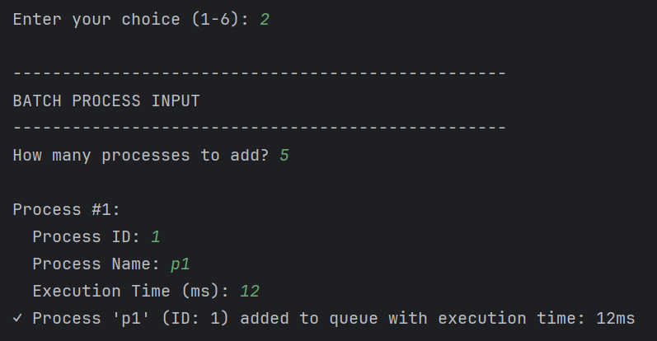
This screenshot demonstrates the batch input mode for adding multiple processes simultaneously. The user has selected option 2 and is entering 5 processes. The first process p1 with execution time 12ms is shown being entered, showcasing the program's batch processing capability.

Figure 5: Batch Process Addition Progress
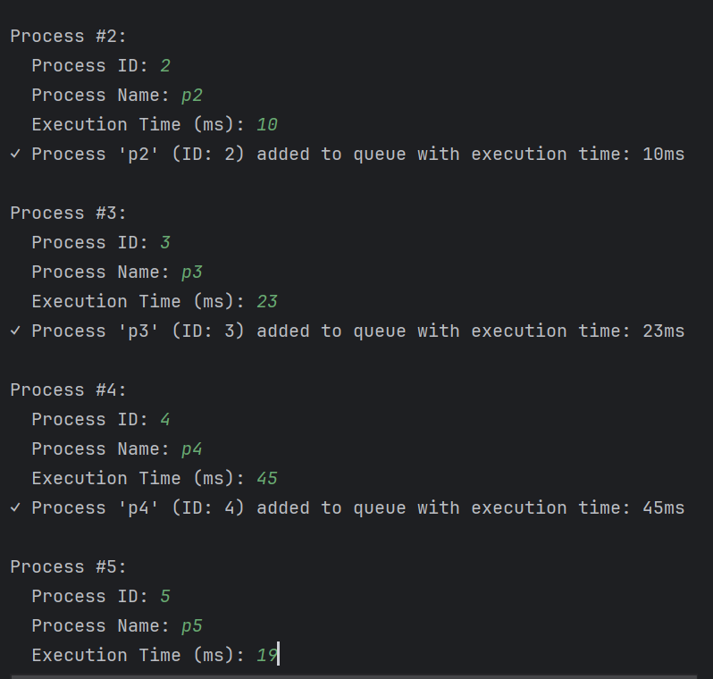
This screenshot continues the batch input process, showing the addition of processes p2 through p5. Each process receives individual confirmation: p2 (10ms), p3 (23ms), p4 (45ms), and p5 (19ms). This demonstrates organized handling of multiple process entries.
Figure 6: Sorted Process Queue Display

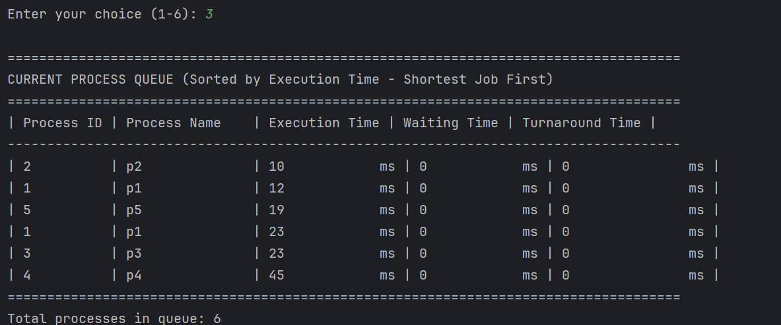
This screenshot presents the current process queue sorted by execution time in SJF order. The processes are automatically arranged in ascending order of execution time: p2(10ms), p1(12ms), p5(19ms), p1(23ms), p3(23ms), p4(45ms). This is the core SJF sorting in action.
Figure 7: SJF Execution Process (Part 1)

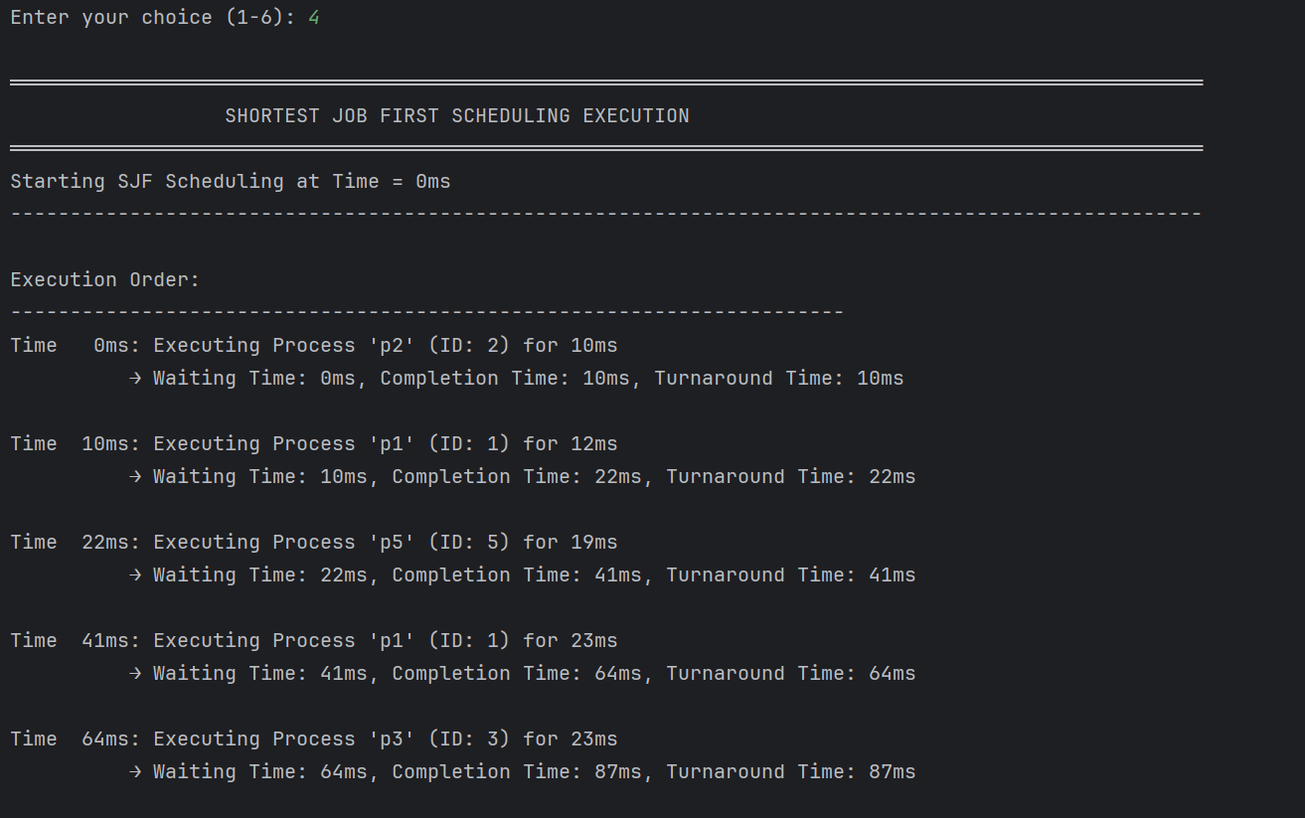
This screenshot captures the first part of SJF scheduling execution. Processes execute in sorted order: p2 at time 0ms (waiting time: 0ms), p1 at time 10ms (waiting time: 10ms), and p5 at time 22ms (waiting time: 22ms). The timeline shows how waiting time accumulates.
Figure 8: SJF Execution Results (Part 2)

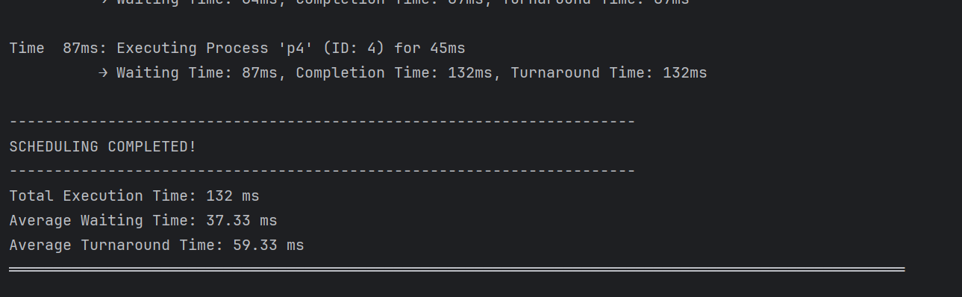
This screenshot shows completion of SJF execution with performance metrics. All 6 processes complete execution by time 132ms. The final calculations show average waiting time of 37.33ms and average turnaround time of 59.33ms, validating SJF effectiveness.
Figure 9: Sample Test Case Setup

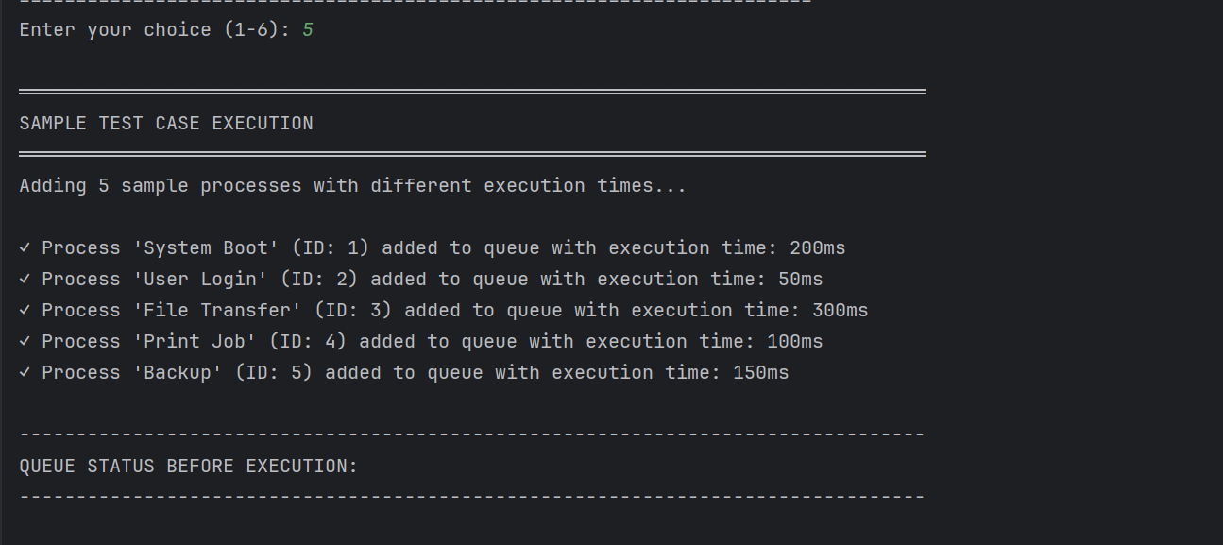
This screenshot demonstrates the sample test case feature. Five realistic processes are automatically added: System Boot (200ms), User Login (50ms), File Transfer (300ms), Print Job (100ms), and Backup (150ms). This feature is useful for quick program demonstration.
Figure 10: Sample Test Queue Status

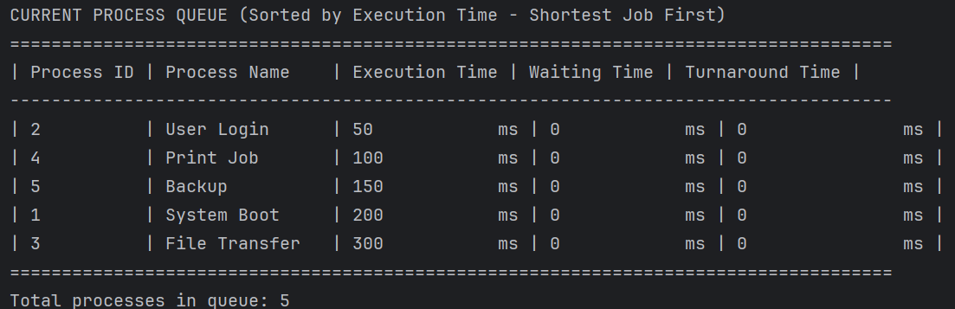
This screenshot shows the sorted queue of sample processes before execution. The processes are correctly sorted by SJF: User Login(50ms), Print Job(100ms), Backup(150ms), System Boot(200ms), File Transfer(300ms). This confirms SJF sorting with descriptive names.

Figure 11: Sample Test Execution Results

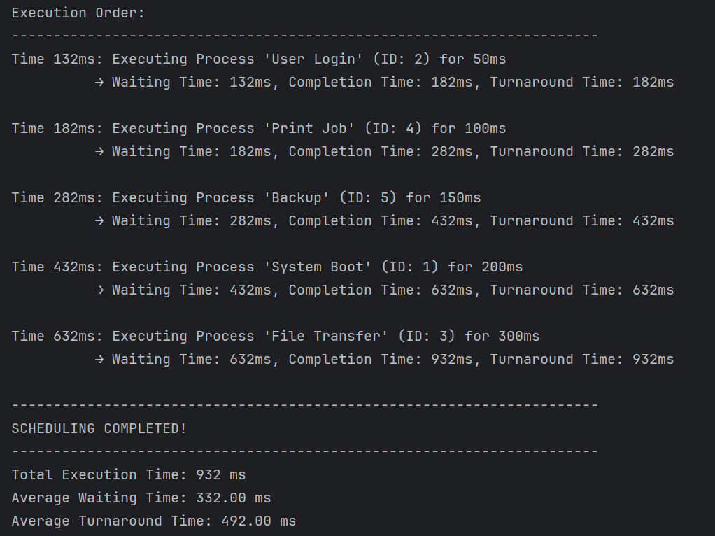
This screenshot presents execution results of the sample test case. Total execution time is 932ms, with average waiting time of 332.00ms and average turnaround time of 492.00ms. This demonstrates SJF performance on realistic workload examples.
Figure 12: Program Termination

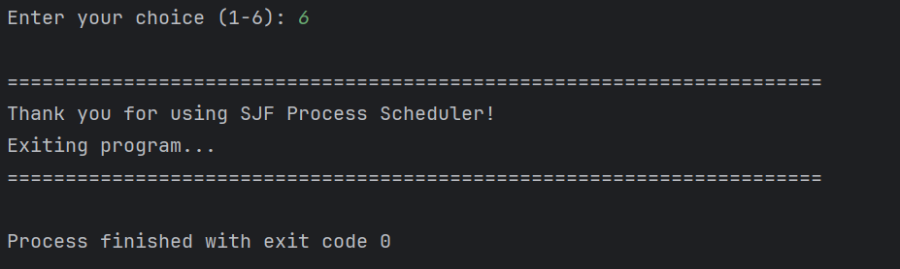
This final screenshot shows the program's graceful termination. The user selects option 6 to exit, and the program displays a thank you message with exit code 0, indicating successful completion and proper program closure.
5.2 Sample output
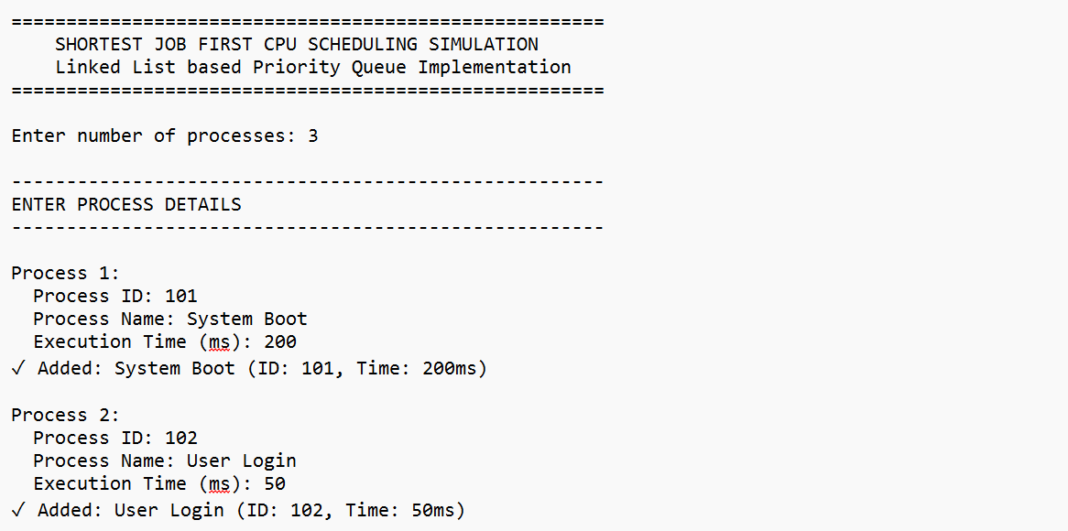
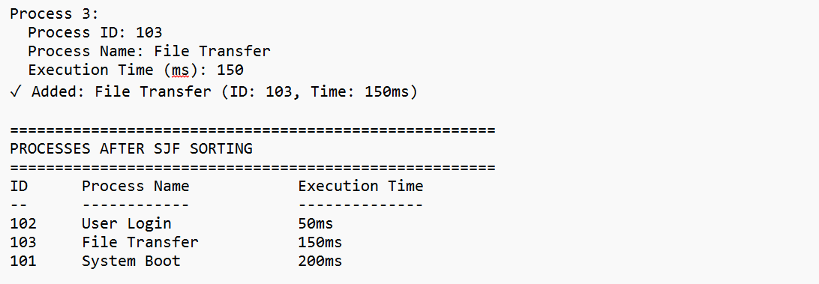
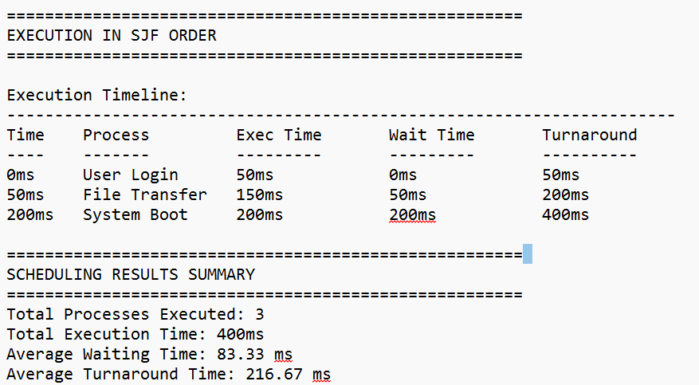
5.2.1 Analysis of Sample Output
- Sorting Verified: Processes automatically sorted as 50ms, 150ms, 200ms
- SJF Execution: Shortest job (User Login) executes first
- Time Calculations:
  - Waiting times: 0ms, 50ms, 200ms
  - Turnaround times: 50ms, 200ms, 400ms
- Performance Metrics:
  - Average Waiting Time: 83.33ms
  - Average Turnaround Time: 216.67ms

