1. **Introduction**

**Background and problem**

Heavy concentration of restaurants provides a lot of convenience to the citizens of the city, but also increases possibility of crime. The city of Montreal would like to update their police surveillance and patrol patterns based on the heavy populated areas during times when people come out to eat. The city of Boston has had a similar problem 2 years ago, and they have implemented a plan upgrade their security based on clusters of restaurants, bars, and food courts. The city council of Montreal would like to know if there is any similarities in terms of the clustering of restaurants between Montreal and Boston, and to see if it would be prudent to implement a similar plan on Montreal.

1. **Data gathering and cleaning**

**Data Source**

To properly locate the different restaurants around the two cities, we decided to use Four Square to pinpoint the exact location of each restaurant under each search query, with a radius of 10000 units, centered around a predetermined hotel at the center of each city. The idea is to get a general mapping of the entire area, then use the scattering plot to do clustering analysis.

**Data cleaning**

After gathering the data from Four Square and concatenating them together, we started to clean the data. There were a lot of information that made view the data difficult, so we took some columns off. After reviewing the data, we concluded by deleting the replicas of restaurants that showed up in more than one query.

1. **Data Analysis**

Due to certain technical difficulties, we were not able to produce a full plot diagram of the two cities. However, we converted the latitude and longitude coordinates into Numpy arrays and plotted it on a scatter plot, shown on the next page:

Figure 1: Boston

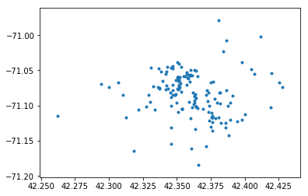

Figure 2: Montreal

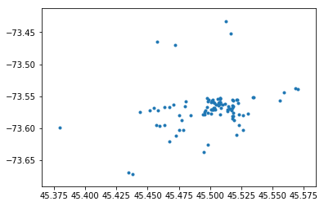

Initial review of the results, compared with the maps of the city, shows that with the City of Boston, most restaurants are scattered fairly evenly, especially closer to the center, while the City of Montreal has a heavy concentration west of the St. Lawrence river, while the rest is fairly scarcely scattered. Further clustering analysis supports this initial finding, as shown below:

Figure 3: Boston’s clusters

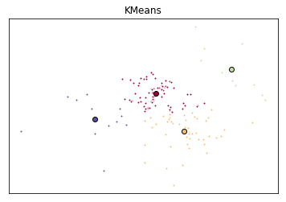

Figure 4: Montreal’s clusters

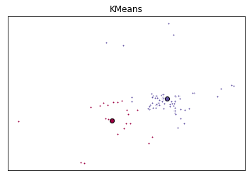

1. **Conclusion**

Unfortunately, there was not a lot of similarities in terms of the clustering of restaurants between Boston and Montreal. The city council would well advised to seek a new and different security plan for the citizens of Montreal.