Software Requirements Specification
(SRS)
Security Incident Mapping (SIM)
Web Application

Prepared for: Systems Analysis and Design Course
Document Version: 1.0
Date: July 10, 2026
A university academic project submitted in partial fulfilment of coursework requirements.

1. Introduction

1.1 Purpose
The purpose of this document is to define the software requirements for the Security Incident Mapping (SIM) Web Application. It describes the system's intended functionality, features, and constraints to guide the design, development, and evaluation of the system for this academic project.

1.2 Scope
The SIM system is a web-based application that allows university students and staff to report security incidents occurring on campus. Reported incidents are displayed on an interactive map and managed by administrators, who can verify reports and update their status. The system covers incident reporting, map visualization, status tracking, and basic administrative management. It does not include emergency dispatch, real-time GPS tracking of personnel, or integration with external law-enforcement systems.

1.3 Objectives
- Provide a simple and accessible way for users to report security incidents on campus.
- Visualize reported incidents on an interactive map for situational awareness.
- Allow administrators to verify, manage, and update the status of reported incidents.
- Maintain an organized record of incident history for monitoring and reporting purposes.
- Improve the speed and transparency of campus security incident management.

2. System Overview
The Security Incident Mapping (SIM) system enables users to report security incidents such as theft, robbery, fire, accidents, and assault through a simple web form. Once submitted, each incident is plotted on an interactive campus map so that users and administrators can see where incidents are occurring. Administrators use a dedicated dashboard to review incoming reports, verify their authenticity, and update their status as they are addressed — from Pending, to In Progress, to Resolved. Together, these features give the university a centralized platform for reporting, visualizing, and managing campus security incidents.

3. Major Components and Their Interactions

3.1 Component Descriptions
User
Any student, staff member, or campus community member who logs into the system to report an incident, view the incident map, or track the status of their own reports.
Login Module
Handles authentication for both regular users and administrators. It verifies credentials against the Database and grants access to the appropriate module based on user role.
Incident Reporting Module
Allows authenticated users to submit new incident reports, including title, category, description, location, and an optional image. Submitted reports are sent to the Database.
Incident Map Module
Retrieves incident data from the Database and displays it as markers on an interactive map. Users can search and filter incidents by category or date.
Administrator Module
Provides administrators with tools to review, verify, and update the status of reported incidents, and to generate summary reports from the stored data.
Database
Stores all system data, including user accounts, incident reports, categories, statuses, and verification records. All modules read from and write to the Database.

3.2 Architecture Diagram
The diagram below illustrates how the major components of the SIM system interact. The User authenticates through the Login Module, which grants access to the Incident Reporting, Incident Map, and Administrator modules. All three modules communicate with the central Database to store and retrieve incident data.
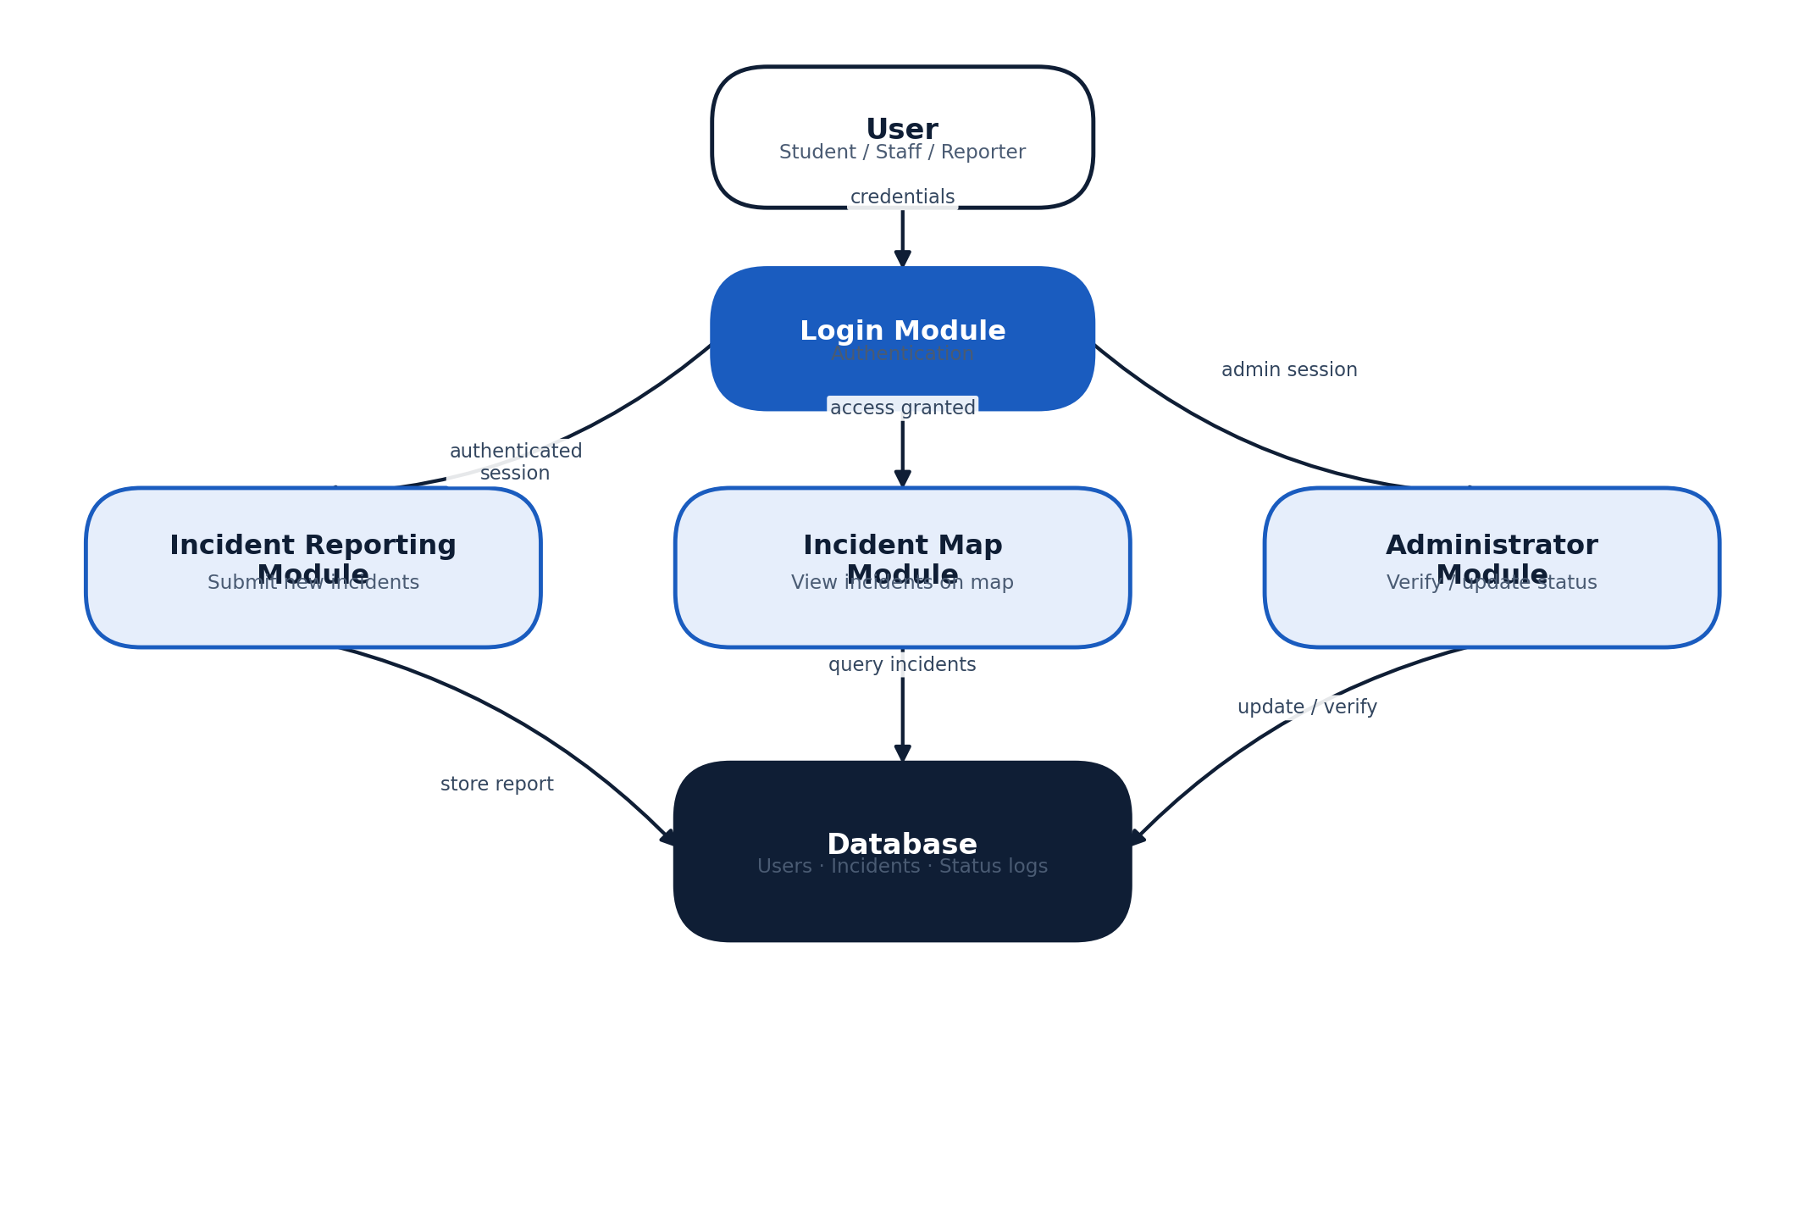
Figure 1: SIM System Architecture and Component Interaction

4. Functional Requirements
The table below lists the core functional requirements of the SIM system.
ID | Requirement | Description
FR-1 | User Registration / Login | Users must be able to create an account and log in using a valid email and password before accessing reporting features.
FR-2 | Report Incident | Logged-in users can submit a new incident report with a title, category, description, location, and an optional photo.
FR-3 | View Incident Map | Users can view a map showing the location of reported incidents, filtered by category or date.
FR-4 | Track Incident Status | Users can check the current status (Pending, In Progress, Resolved) of any incident they reported.
FR-5 | View Incident History | Users can view a list of all incidents they have previously reported.
FR-6 | Administrator Login | Administrators log in through a secure, role-restricted login to access the Admin Module.
FR-7 | Verify Incident | Administrators can review a submitted report and mark it as verified or unverified.
FR-8 | Update Incident Status | Administrators can change an incident's status as it moves through the response process.
FR-9 | Generate Reports | Administrators can generate a summary report of incidents (e.g., by category, status, or time period).
FR-10 | Logout | Users and administrators can securely end their session at any time.

5. Non-Functional Requirements
In addition to functional behavior, the SIM system must satisfy the following quality attributes.
Attribute | Requirement
Performance | The system should load pages and return search or map results within 3 seconds under normal load.
Security | User credentials must be stored securely, and only authenticated administrators may access the Admin Module.
Reliability | The system should function correctly and consistently, with incident data preserved without loss.
Usability | The interface should be simple and intuitive, requiring minimal training for new users.
Scalability | The system should support a growing number of users and incident records without performance loss.
Maintainability | The system should be structured in modules so that features can be updated or fixed independently.
Availability | The system should be accessible to users at all times, except during scheduled maintenance.

6. Assumptions and Constraints
The following assumptions and constraints apply to the design and use of the SIM system:
- Users must have access to the internet to use the system.
- Users must have a modern, up-to-date web browser (e.g., Chrome, Firefox, Edge, Safari).
- Administrative functions (verifying incidents, updating status, generating reports) require an authenticated administrator account.
- The system assumes users provide accurate and honest information when submitting incident reports.
- The system is designed for use within a university campus context and is not intended to replace official emergency services.

7. Conclusion
The Security Incident Mapping (SIM) Web Application provides a centralized, straightforward platform for reporting, visualizing, and managing security incidents on campus. By combining an accessible reporting tool, an interactive incident map, and an administrative dashboard, the system improves the speed, transparency, and organization of campus security operations. This SRS document serves as the foundation for the design and development of the SIM system as part of the Systems Analysis and Design coursework.

