Exercise: Building a dashboard
- Download all the provided .pbix files.

- Upload to a created workspace in Power BI Service.

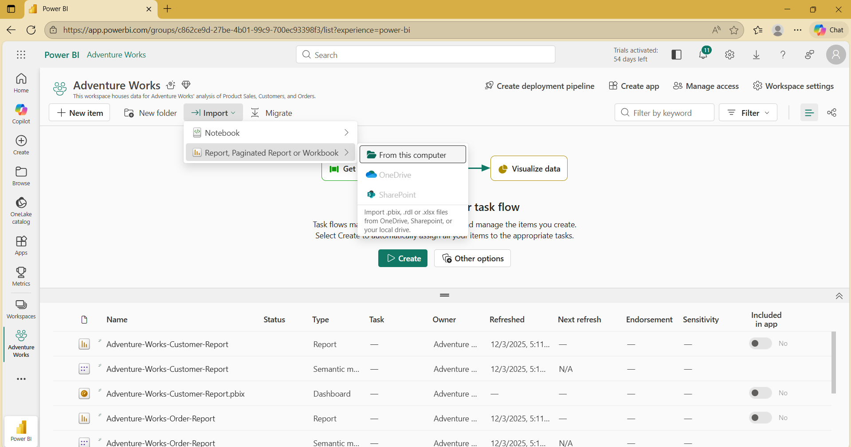

- Once everything is uploaded, proceed to creating a new dashboard.
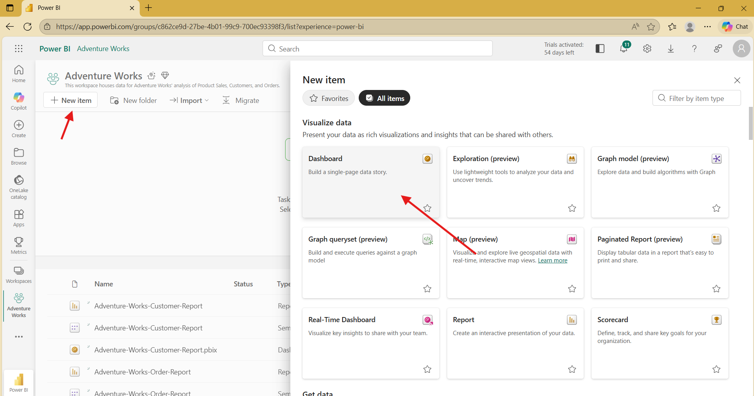
- Proceed to pin live reports to the dashboard from one of the uploaded reports.
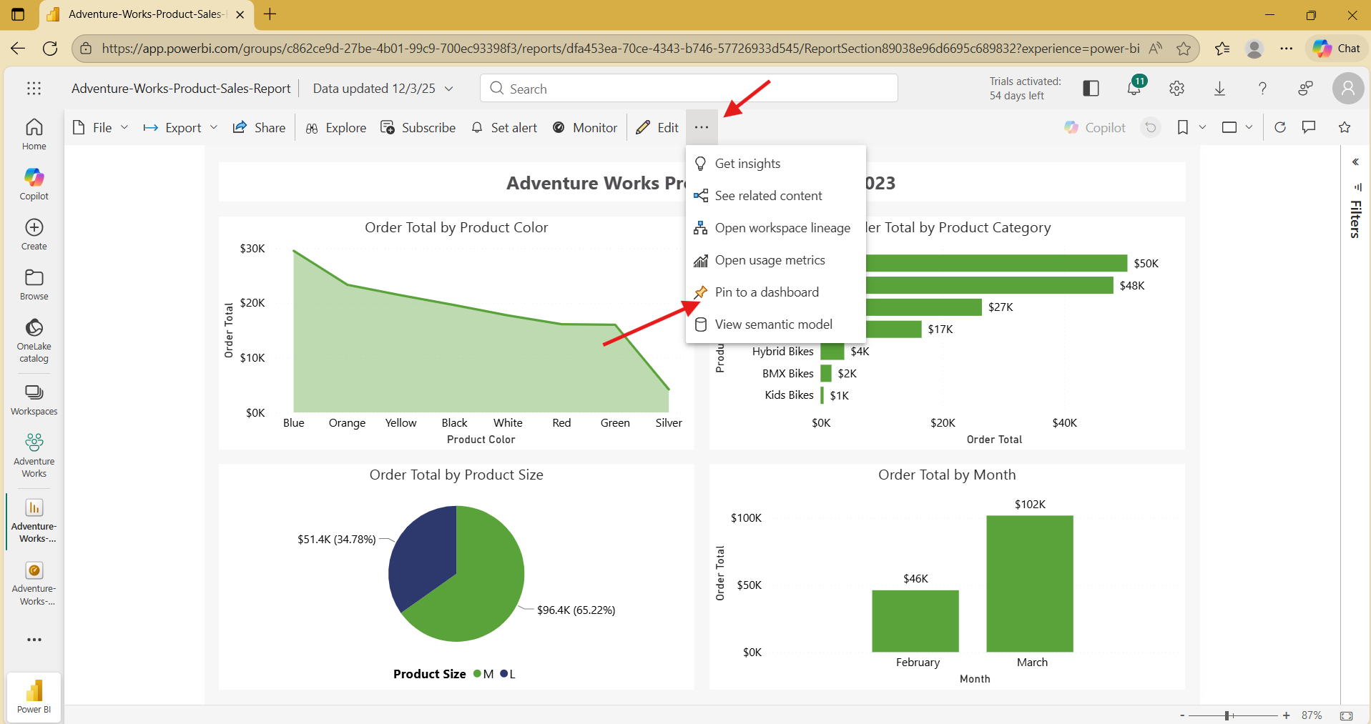

- Select the created dashboard within the Power BI Service, then Pin Live
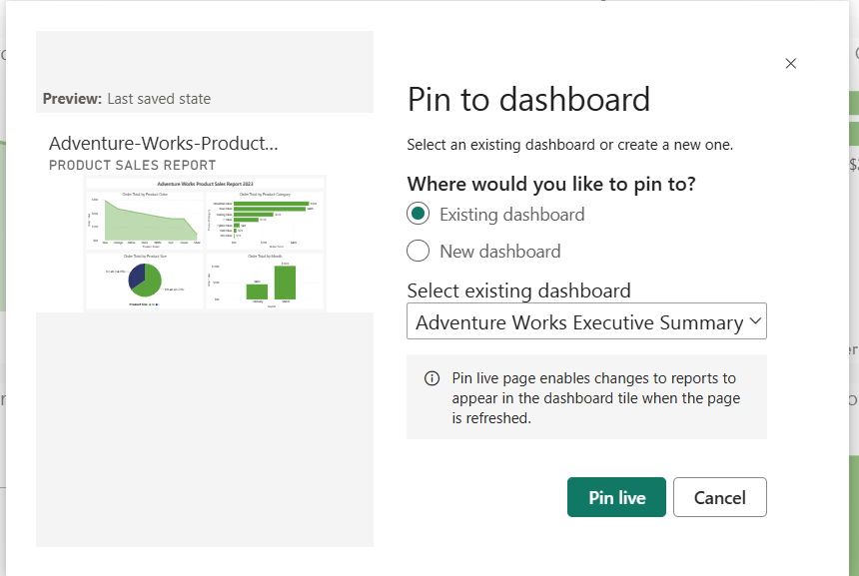
*** Repeat these steps to all of the uploaded reports
- Lastly, add quick insights. Locate the Report type of the uploaded reports, click the ellipsis then find Quick Insights.
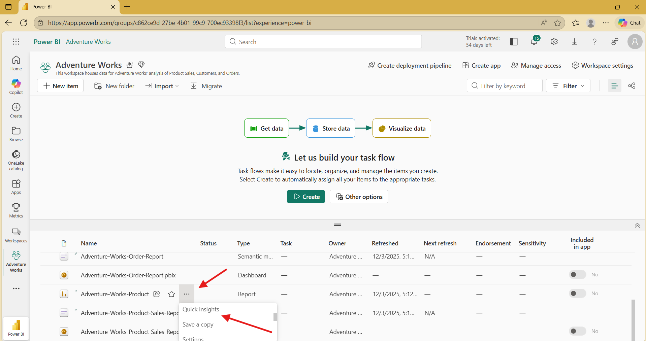
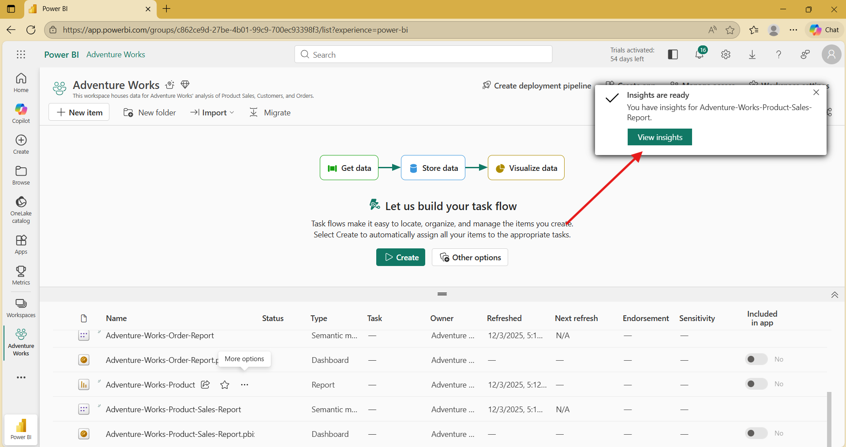
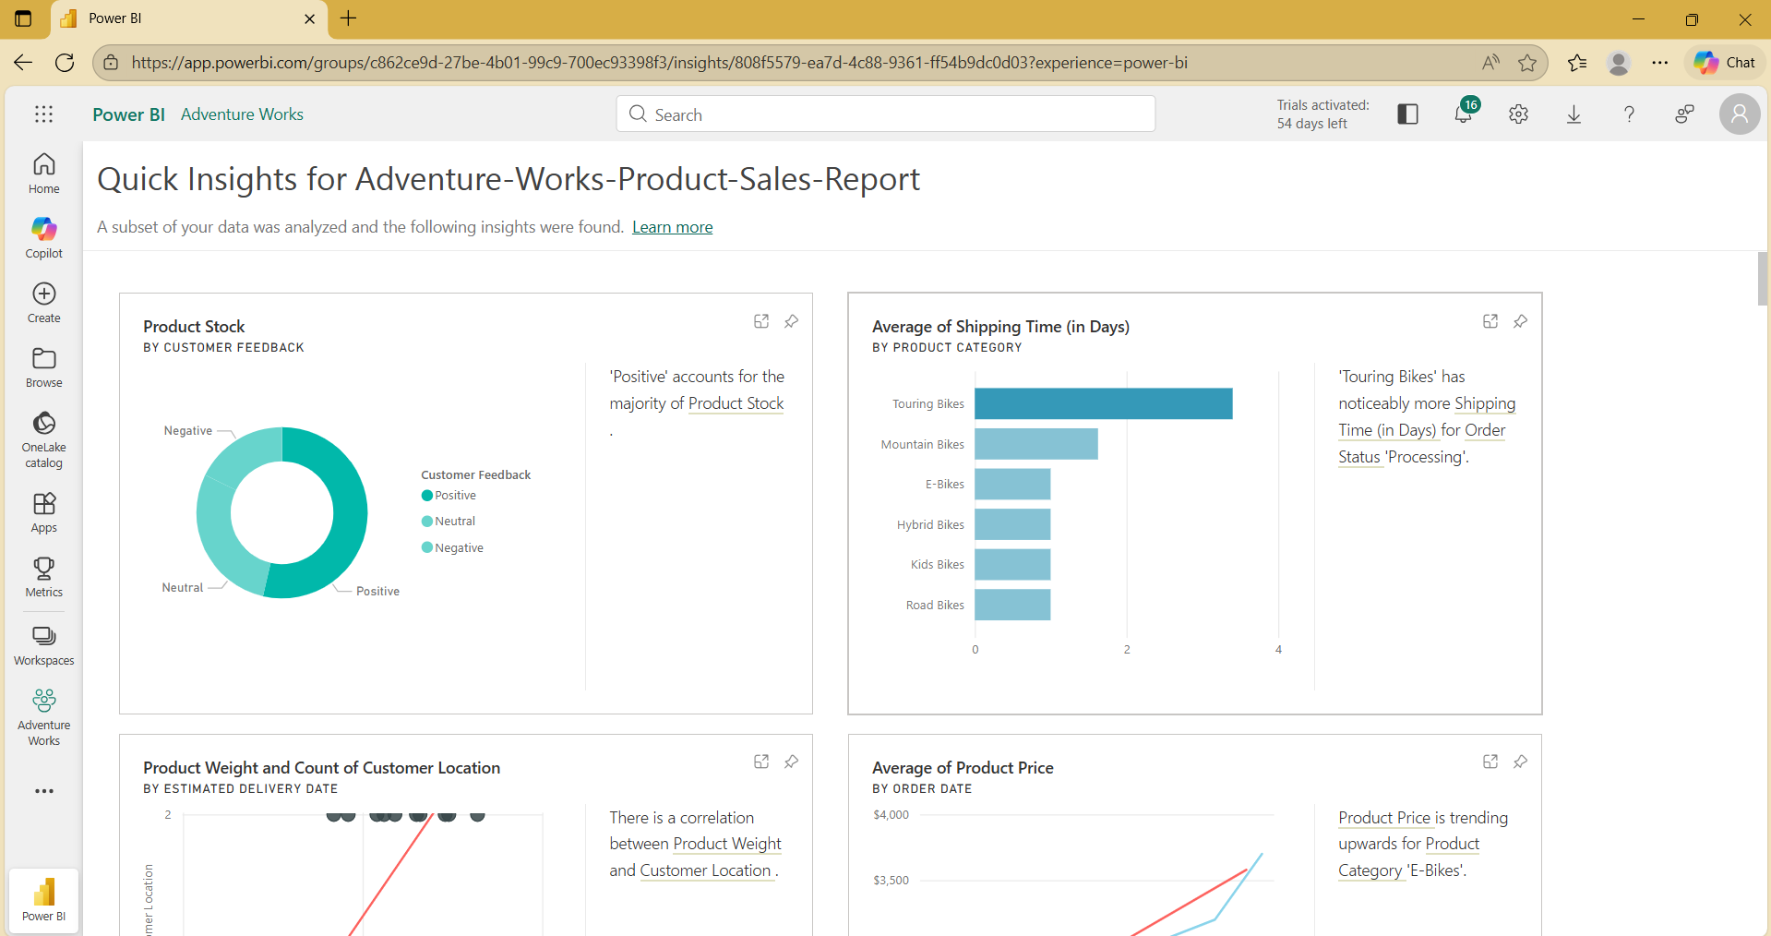

- From the generated insights, you can also pin this to the created dashboard. Just click on the pin icon at the top right of the visualizations.
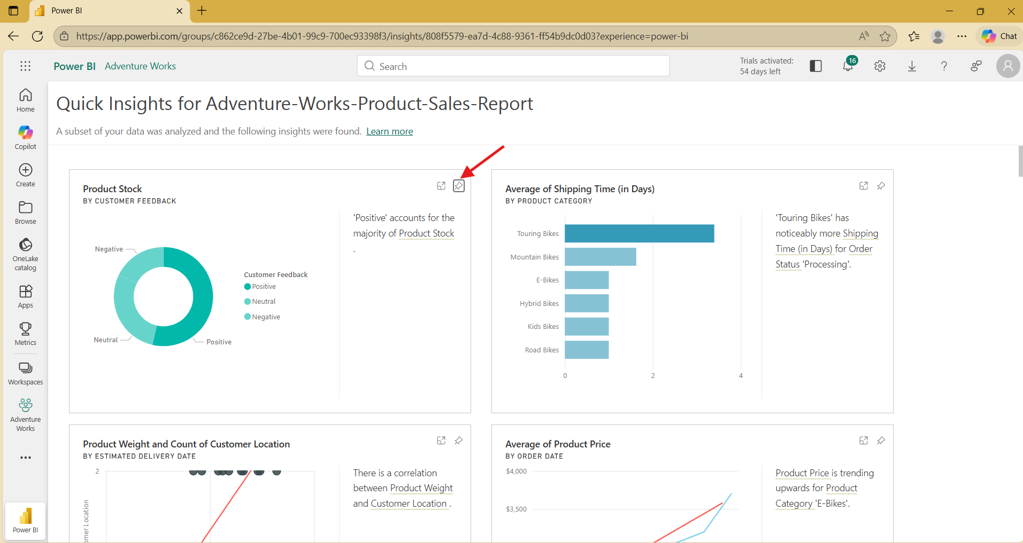
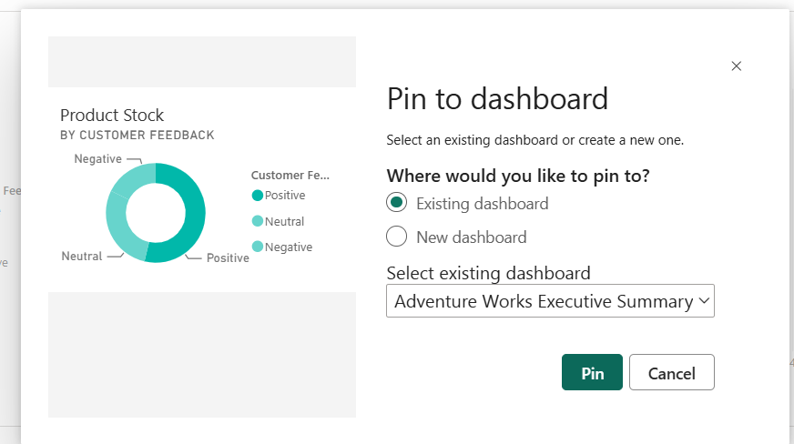
*** Repeat these steps to all of the uploaded reports

