Joshua Anaya

CST 370

Final

02/21/18

#1

Function has no created output. InOrder() shows BST below. Balanced BST achieved by sorting array and finding median item in array as root. As it uses select sort, time consumption would be O(n2) as it runs through the loop n times to update the location of each element.

SelectSort ->A

Median – (0-A.length)/2

Pull median to front of array(a[0])

For()

Insert(A[i])

#2 inOrder displays BST from left, root, right.

inOrder display:

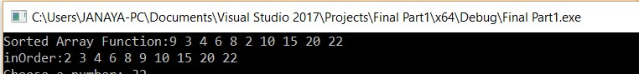

#3

LeafHeight uses recursion to find a leaf and track the links to find the height of the leaf (from the root). The time complexity is O(n) as with recursion, we loop through the BST once to find which node is a leaf and which is not.

LeafHeight()

{ Return LeafHeight(myRoot)//access myRoot }

LeafHeigth(BinNode \*root)

{

if(root == NULL)

return; //no root means no leaf;

if(no children) //means leaf

cout <<”height of Leaf” << root->data << : << leafHeight(root->left) + LeafHeight(root->right) +1; if (root->left)

LeafHeight(root->left); recursion until leaf found; If(root->right)

LeafHeight(root->left); recursion until leaf found;

LeafHeight displays found leafs but not showing height correctly:

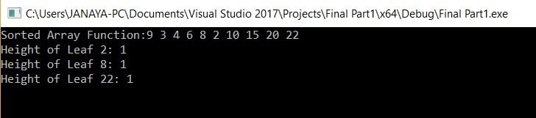

#4

NewSearch() reused parts of search provided to loop through BST. Num variable used to hold value of closest larger number to selected number. Results displayed if found, not found but larger number in array, or chosen number larger than all numbers in array. Time complexity of O(n) as it cycles through each element to find match.

Locptr = myRoot

Int num;

Bool found;

While(not found and locptr not null)

If(item > locptr->data) and num > locptr -> data) num=locptr->data

if(item< locptr->data)

locptr = locptr->left //update to new locptr for another pass else if(same for right)

else

update num <- locptr as it was found

update found to true because found

output results

found

not found but larger number in array

not found no larger number in array

New search chosen number found in array:

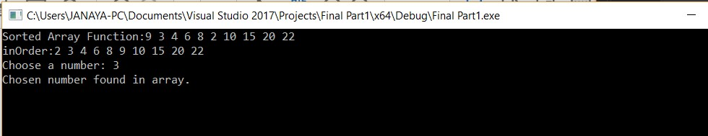

New Search chosen number not found:

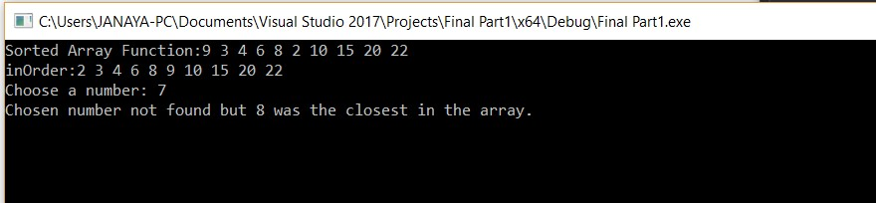

New Search chosen number too large:

