Retail Operations Workflow – iCount System
Prepared by: Your Name
Date: September 06, 2025

Executive Summary
This proposal outlines the development of the iCount system...

Project Timeline (Editable Gantt Table)
Phase | Start | End | Duration (days) | Timeline Bar
Phase 1: Requirements & DB Schema | Sep 08, 2025 | Sep 23, 2025 | 15 | ███████
Phase 2: Product Catalog & Barcode | Sep 23, 2025 | Oct 13, 2025 | 20 | ██████████
Phase 3: Ordering & Shipment | Oct 13, 2025 | Nov 07, 2025 | 25 | ████████████
Phase 4: Expiration Pre-Alerts | Nov 07, 2025 | Nov 22, 2025 | 15 | ███████
Phase 5: Sales Integration | Nov 22, 2025 | Dec 12, 2025 | 20 | ██████████
Phase 6: Goods Receipt | Dec 12, 2025 | Dec 27, 2025 | 15 | ███████
Phase 7: Inventory Counting | Dec 27, 2025 | Jan 11, 2026 | 15 | ███████
Phase 8: Item Creation & Control | Jan 11, 2026 | Jan 21, 2026 | 10 | █████
Phase 9: Discounts & Promos | Jan 21, 2026 | Jan 31, 2026 | 10 | █████
Phase 10: Spoilage & Transfers | Jan 31, 2026 | Feb 10, 2026 | 10 | █████
Phase 11: Data Adjustments | Feb 10, 2026 | Feb 15, 2026 | 5 | ██
Phase 12: Exporting & Variance Reports | Feb 15, 2026 | Feb 25, 2026 | 10 | █████
Note: You can adjust the 'Timeline Bar' column manually by resizing columns or editing blocks.

Project Timeline (Static Chart)
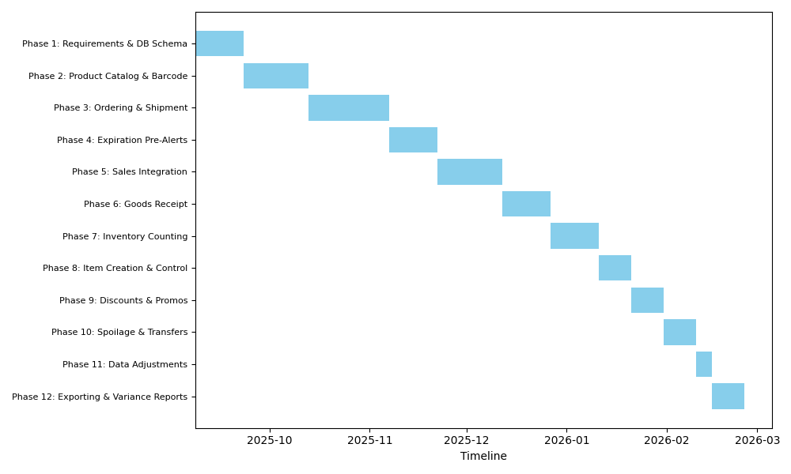

Project Cost Breakdown
